Dayanand Education Society’s

Dayanand Science College, Latur Maharashtra, India
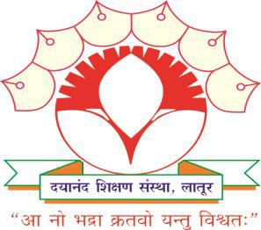

ATR

Preparation and Formulations of different Perfumes in Chemistry Laboratory
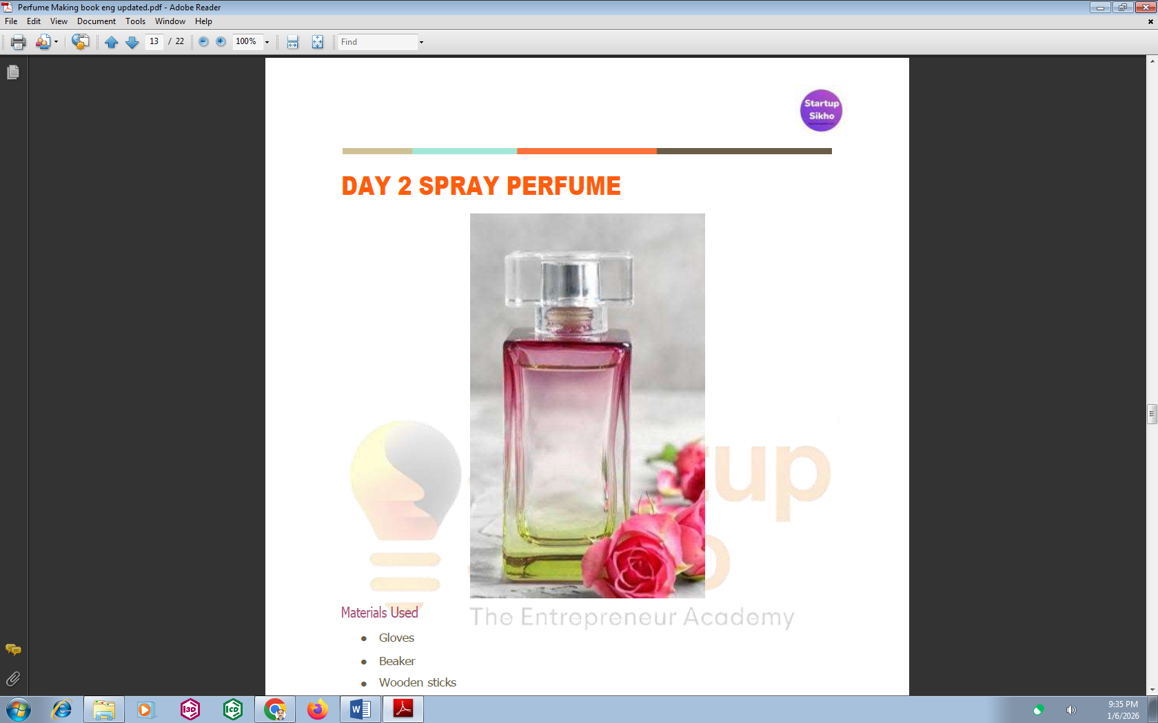


By

Prof. R. S. Shinde,
Skill Based Project Coordinator,
Department of Chemistry, Dayanand Science College, Latur,
Maharashtra, India. www.dsclatur.org

Event: District Level Outreach program

Sr. No. | Title | Information
1. | Name of Department | Chemistry
2. | Title of Event | Preparation and Formulations of different Perfumes in Chemistry Laboratory
3. | Date or Duration | 22 December to 29 December 2025
4. | Venue of the Event | Chemistry Lab. Dayanand Science College, Latur
5. | Sponsor/ Collaboration | Dayanand Education Society, Latur
6. | Level of Event | College Level
7. | Aims of the Event | To provide B.Sc. Chemistry students with a fundamental understanding of the chemistry of fragrances, including the nature, synthesis, and properties of aromatic compounds used in perfumery.
 | Objectives of the Event | To develop practical skills in formulation, blending, and evaluation of perfumes, while familiarizing students with natural and synthetic fragrance materials, essential oils, fixatives, and solvents. .
8. | Beneficiaries/  Participants | UG students– 4
9. | Number of Participants for Perfume making | 4
10. | Name of Chief Guest,  Speakers | Prof. R. S. Shinde
11. | Name of Coordinator | Prof. R. S. Shinde
12. | Photographs | Attached
13. | Evidence Produced | Laboratory practical Photo, Demo Photographs, Paper Cuttings, Attendance of course participants
14. | Outcomes of the Event | To introduce quality control, safety, and regulatory aspects of the fragrance industry, thereby enhancing students’ employability, creativity, and entrepreneurial potential in the fields of perfumery, cosmetics, and allied chemical industries.
15. | Any other information/ Live Demo Presentation | For live Demo Total students, teachers and non-teaching staff (11 th , 12 th , UG, PG) Present in this program = 300
16. | Other Major staff/ Students / Institution involved in the organization of activity | All teaching and nonteaching Staff, Principal, HoD, Program coordinator, all senior college Staff, Chief President, Secretary of Dayanand Education society, Latur, guest all management members of DES, 11th , 12th , students UG and PG students etc.
17 | Name and Signature of organizing Secretary and convener | Prof. R. S. Shinde  Program Coordinator

Coordinator IQAC coordinator Principal

Report on Skill-Based Project and Hands-on Demonstration

1. Title of the Activity: Preparation and Formulation of Different Types of Perfumes
2.Name of the Institution: Dayanand Science College, Latur
3. Department: Department of Chemistry
4. Academic Year: 2025-26 (Sem-IV)
5. Participants: Students of B.Sc. Second Year (Major Chemistry)
6. Nature of Activity:
- Skill-Based Project, Hands-on Practical Training
- Demonstration / Presentation (Demo)

7. Guidance
Project Guide: Prof. R. S. Shinde, Department of Chemistry, Dayanand Science College, Latur

8. Objectives of the Project
- To provide hands-on experience in the preparation and formulation of perfumes
- To understand the chemistry of fragrance compounds, essential oils, solvents, and fixatives
- To develop practical laboratory skills and creativity among students
- To expose students to industrial and entrepreneurial aspects of perfumery
- To enhance skill-based learning as per curriculum guidelines

9. Description of the Skill-Based Project
As per the guidelines of Dayanand Education Society, Latur, the Department of Chemistry assigned a skill-based project titled “Preparation and Formulation of Different Types of Perfumes” to B.Sc. Second Year Chemistry students. Under the expert guidance of Prof. R. S. Shinde, students successfully completed the project in the Chemistry Laboratory. The project involved:
- Study of natural and synthetic fragrance materials
- Selection of essential oils and aromatic compounds
- Use of solvents such as ethanol
- Role of fixatives in perfume stability
- Formulation of different types of perfumes such as floral, fruity, herbal, and oriental fragrances
- Evaluation of fragrance quality and stability
Students actively participated in laboratory work, maintained proper records, and followed safety and quality protocols during experimentation.

10. Hands-on Presentation / Demonstration (Demo)
After successful completion of the project, the students organized a hands-on presentation and live demonstration on the preparation and formulation of different types of perfumes in the Chemistry Laboratory.
Audience:
- Students ( 11th science, 12th Science, UG, PG )
- Faculty members, non-teaching staff
- Honorable Principal,
- Respected Management Members of Dayanand Education Society, Latur
Highlights of the Demonstration:
- Live demonstration of perfume formulation techniques
- Explanation of chemical principles involved in perfumery
- Display of prepared perfume samples
- Interaction and discussion with faculty and management
- Demonstration of practical skills acquired during the project
The presentation created enthusiasm among students and showcased the effectiveness of skill-based learning.
11. Outcomes of the Activity
- Students gained practical knowledge of applied chemistry
- Improved laboratory skills and confidence
- Enhanced understanding of perfumery and cosmetic chemistry
- Encouraged innovation and entrepreneurial thinking
- Strengthened industry-oriented and skill-based education

12. Conclusion
The skill-based project on Preparation and Formulation of Different Types of Perfumes was successfully completed by B.Sc. Second Year Chemistry students under the guidance of Prof. R. S. Shinde. The hands-on demonstration further reinforced experiential learning and highlighted the importance of applied chemistry. The activity was highly appreciated by students, teachers, the Principal, and the management of Dayanand Education Society, Latur.

Acknowledgement
We express our sincere gratitude to the Management of Dayanand Education Society, Latur, for providing excellent financial support, infrastructure and continuous support to carry out this skill-based project successfully. We are highly thankful to our Honorable Principal, Dayanand Science College, Latur, for his constant encouragement and valuable guidance throughout the project work.


