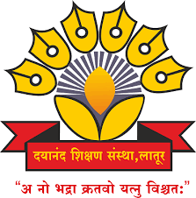
Dayanand Education Society’s
Dayanand Science College, Latur

PERSONAL DETAILS
Name: Deep Balaji Birajdar
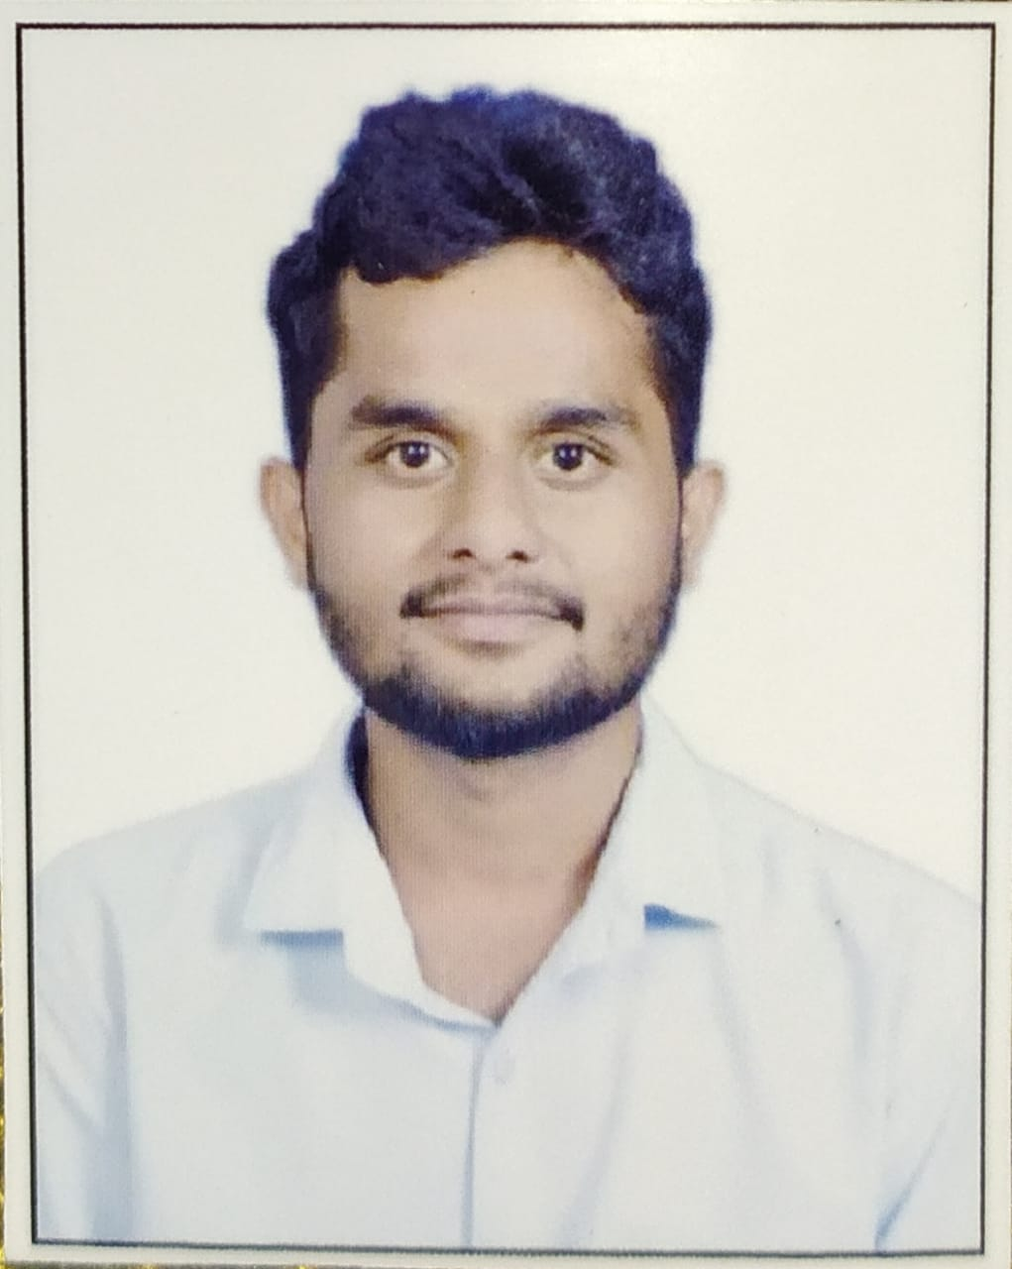
Date of Birth: 14-06-2000
Phone: 9405407004
E-Mail: deepbirajdar814@gmail.com

JOB DESCRIPTION
Unique ID:
Position: Assistant Professor
Date of Appointment: 1/08/2025
Date of retirement:
Department: Computer Science
Type of Association(Yes/No)
- Permanent Faculty :
- CHB :
- Adjunct Faculty (Contract) :Contract
- Visiting Faculty :

EDUCATION QUALIFICATION
Degree | Institute | University | Year of passing | Grade / percentage
Ph.D.
M.Phill
NET
SET
M. Sc. (CS)
B.Tech | Tatyasaheb Kore Institute of Engineering and Technology | Shivaji University, Kolhapur | 2023 | 8.41 CGPA
B.Sc.
HSC | Dayanad Science College Latur | Swami Ramanand Teerth Marathwada University (SRTMU), Nanded | 2019 | 68%
SSC | Dr. K. D Shendge English School Umarga | -- | 2017 | 95.20%

WORK / TEACHING EXPERIENCE
Department | Institute/college | University | Tenure/ duration

COURSES TAUGHT
Department | Institute/college | University | Papers taught

INDUSTRY EXPERINCE

- YES

OTHERS EXPERINCE

- No

RESEARCH EXPERINCE

- No

RESEARCH GUIDANCE

Sr. No | Name of Students | Research Topic | Joining Date | Completed Date

AREA OF SPECIALIZATION

AREA OF SPECIALIZATION: Digital Image Processing

PROJECTS CARRIED OUT
Sr. No. | Project Title | Major/ Minor | Funding Agency | Fund Received | Date of Completion

PATENTS FILLED & GRANTED
Sr. No. | Title of Invention | Publication Date | Granted Date | Application No | National / International

RESEARCH PUBLICATION NO OF PAPERS PUBLISHED

Sr. No. | Name of Authors | Title of the paper | Year of publication, Name of Journal, Volume & Page Nos. | Referred or Non Referred | ISBN / ISSN No. | Level (Int./ Nat./ State/ Local) | Impact Factor | Active Link
 |  |  |  |  |  | 7 | 8 | 9

BOOK PUBLICATION
Sr. No. | Name of Authors. | Publication | Title of the book | Year of publication | ISBN / ISSN No. | Level (Int. / Nat. / State. / Local)
1 | 2 | 3 | 4 | 5 | 6 | 7

BOOK CHAPTER PUBLICATION
Sr. No. | Name of Authors. | Title of Chapter | Year of publication | ISBN / ISSN No. | Level (Int. / Nat. / State. / Local)
1 | 2 | 3 | 4 | 5 | 6
Nil | Nil | Nil | Nil | Nil | Nil

CONFERENCE / WORKSHOP / SEMINAR ATTENDED
Sr. No | Workshop | Date | Sponsored | Organized BY

ORIENTATION AND REFRESHER COURSE

- No

TECHNOLOGY TRANSFER (USE OF ICT )

FACULTY DEVELOPMENT PROGRAM ATTENDED

1.

INVITED AS RESOURCE PERSON / INVITED TALKS

- No

AWARDS AND ACHIEVMENTS

- No

ADMINISTRATIVE TASK DONE
1.

OTHER CO-CURRICULAR ACTIVITIES.

ADDRESS:

Official: Beside Vaibhav Ganesh Temple, Vaibhav Nagar Khadgaon Road Latur

Residential – Beside Vaibhav Ganesh Temple, Vaibhav Nagar Khadgaon Road Latur

