Sr.  No. | Title of Inventions | Patent Number | Date of Filed | Date of Published | Status | International / National | Country
1 | 1,3,5-TRIAZINE PYRAZOLINE HYBRIDS AS ANTI-INFLAMMATORY AND ANTI-UROLITHIC AGENT | 201921016766A | 26-04-2019 | 17-05-2019 | Granted | National | Indian
2 | WATER PURIFYING AND FLAVOR INFUSION DEVICES | 347809-001 | 11-08-2021 | 23-09-2022 | Granted | National | Indian
3 | 1,3,4-THIADIAZOLE HYBRIDS AS ANTIFUNGAL AND ANTIBACTERIAL AGENTS | 202421012658 | 22-02-2024 | 15-03-2024 | In progress……. | National | Indian
4 | NANOSTRUCTURED, MN-DOPED, METAL-LIKE ZINC OXIDE FILMS FOR HIGH-PERFORMANCE AMMONIA DETECTION | 202025102202 | 23-04-2025 | 03-07-2025 | Granted | International | German

Link For online status check of patents

1. https://ipindiaservices.gov.in/PatentSearch/PatentSearch/ViewApplicationStatus
2. https://search.ipindia.gov.in/DesignApplicationStatus
3. https://www.dpma.de/english/index.html

1.
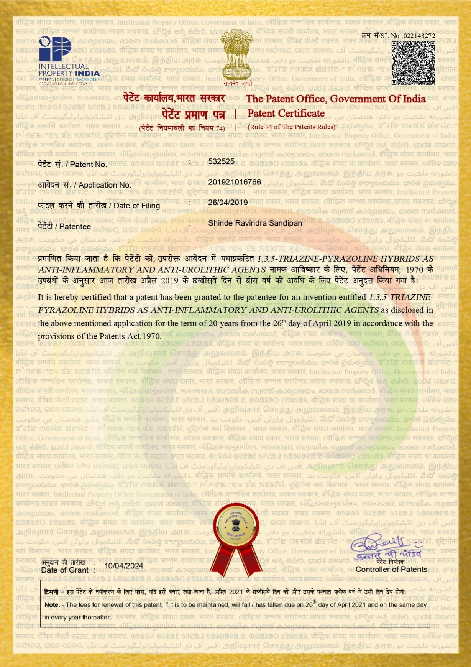

2.
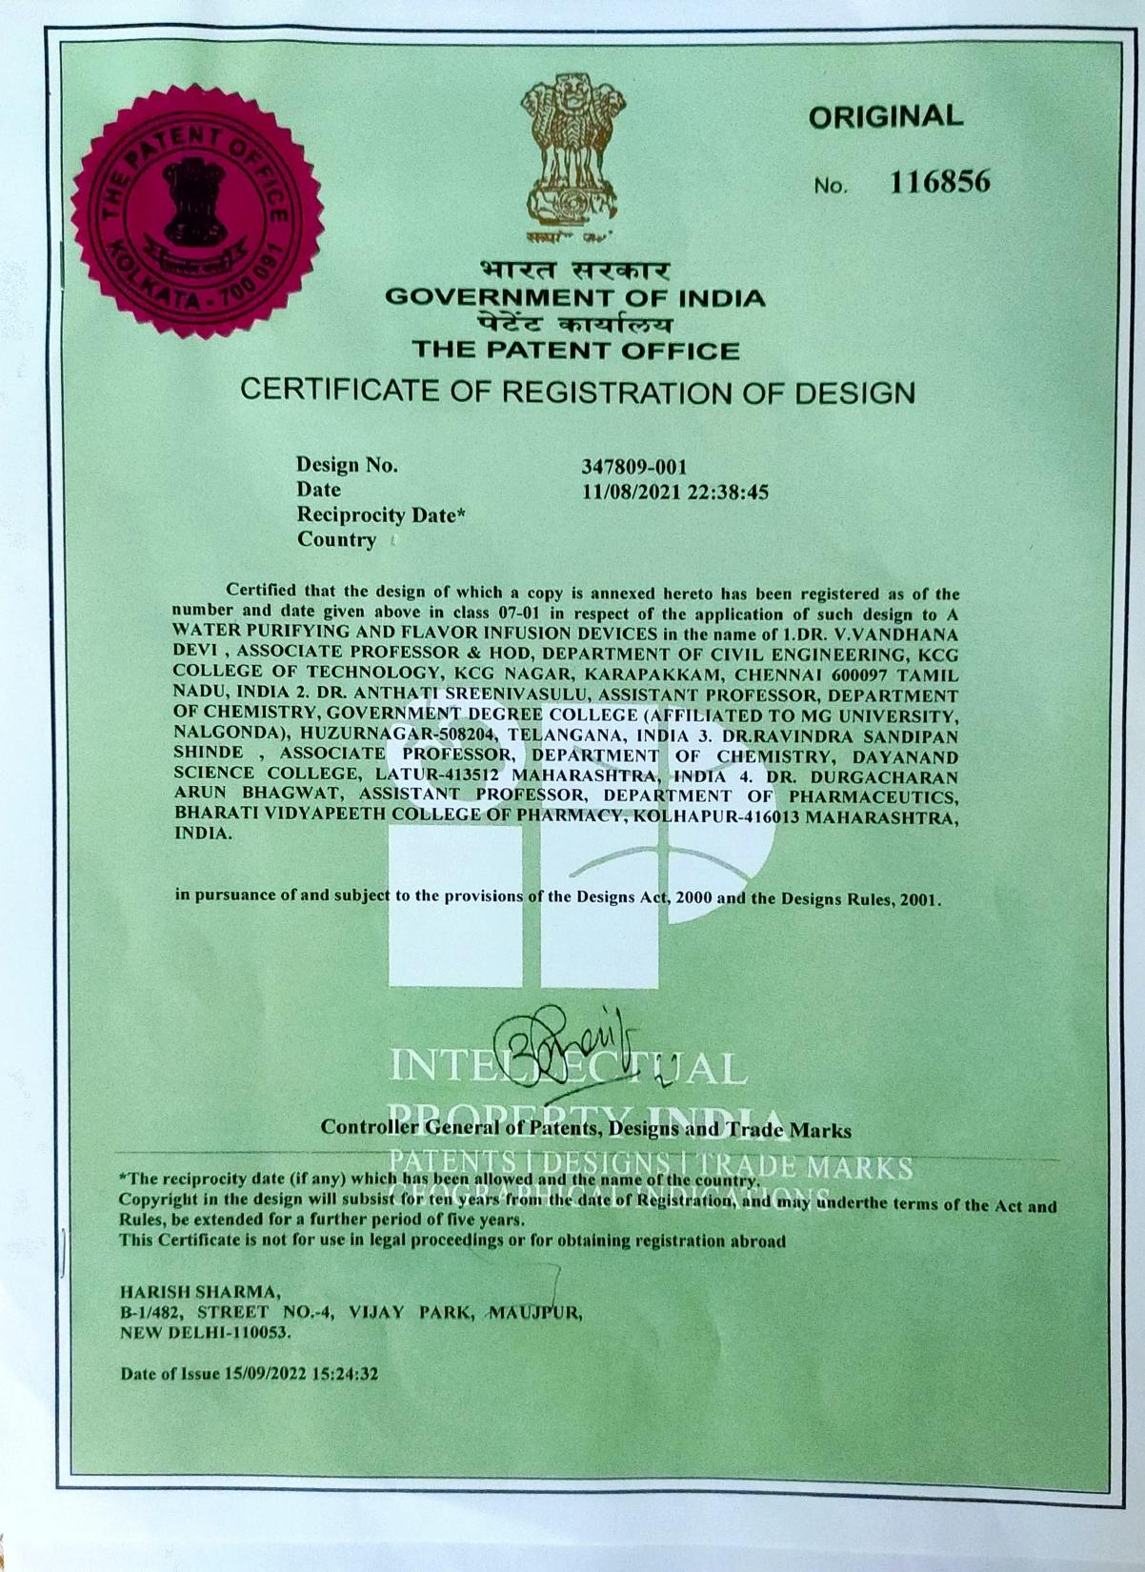

3.

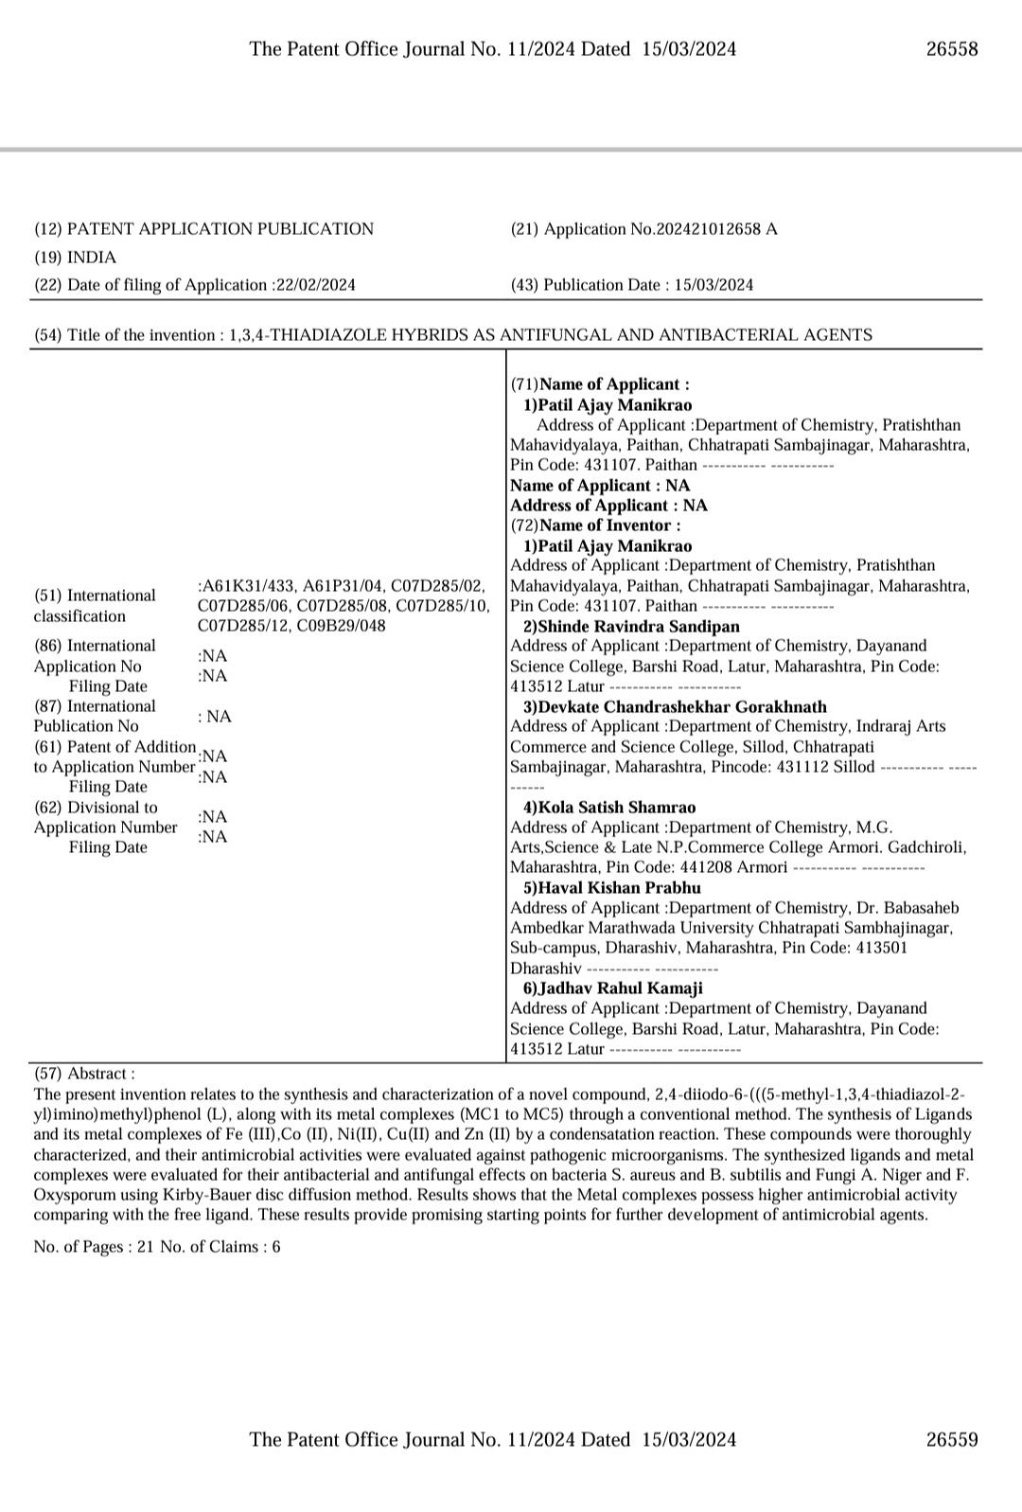

4.
