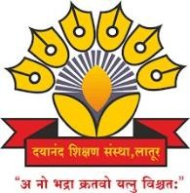
Dayanand Education Society’s

Dayanand Science College, Latur

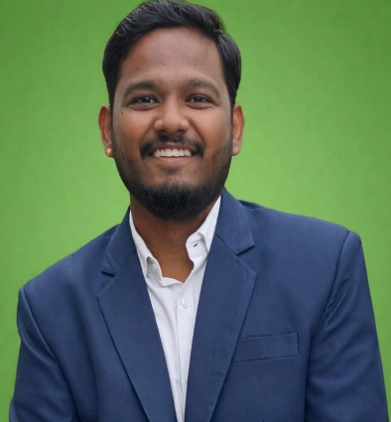
PERSONAL DETAILS
Name: Anuman Tukaram Banate
Date of Birth: 24/04/1997
Phone:7218572410
E-Mail: banateanuman@gmail.com

JOB DESCRIPTION
Unique ID :
Position: Assistant Professor
Date of Appointment: 16/06/2025
Date of retirement:
Department: Computer Science
Type of Association(Yes/No)
- Permanent Faculty :
- CHB :
- Adjunct Faculty (Contract) :Contract
- Visiting Faculty :

EDUCATION QUALIFICATION
Degree | Institute | University | Year of  passing | Grade /  percentage
Ph.D. | SRTMUN Sub Campus Latur | SRTMUN, Nanded | Pursuing
M.Phil.
NET | NTA |  | 2025 | Qualified
SET
M. Sc. (CS) | NES Science college Nanded. | SRTMUN | 2022 | 90.64%
B.Ed.
B.Sc. | NES Science college Nanded. | SRTMUN | 2020 | 65.49%
HSC | State board of Maharashtra |  | 2015 | 51.54%
SSC | State board of Maharashtra |  | 2013 | 66.20%

WORK / TEACHING EXPERIENCE
Department | Institute/college | University | Tenure/ duration
Computer Science | NES Science College Nanded | SRTMUN | 2024-25

COURSES TAUGHT
Department | Institute/college | University | Papers taught
Computer Science | NES Science College Nanded | SRTMUN | OA,Python,VB studio 6.0,Cloud Computing,Data Science with Python

INDUSTRY EXPERINCE

1. NO

OTHERS EXPERINCE

1. No

RESEARCH EXPERINCE

1. No

RESEARCH GUIDANCE

Sr. No | Name of Students | Research Topic | Joining Date | Completed Date
1

AREA OF SPECIALIZATION

AREA OF SPECIALIZATION: Theory of Computation

INDUSTRY EXPERINCE

- NO

OTHERS EXPERINCE

- Teaching Experience of 1 years.

RESEARCH EXPERINCE

- No

PROJECTS CARRIED OUT
Sr. No. | Project Title | Major/ Minor | Funding Agency | Fund Received | Date of Completion

PATENTS FILLED & GRANTED
Sr. No. | Title of Invention | Publication Date | Granted Date | Application No | National / International

RESEARCH PUBLICATION NO OF PAPERS PUBLISHED

Sr. No. | Name of Authors | Title of the paper | Year of publication, Name of Journal, Volume & Page Nos. | Referred or Non Referred | ISBN / ISSN No. | Level (Int./ Nat./ State/ Local) | Impact Factor | Active Link
 |  |  |  |  |  | 7 | 8 | 9

BOOK PUBLICATION
Sr. No. | Name of Authors. | Publication | Title of the book | Year of publication | ISBN / ISSN No. | Level (Int. / Nat. / State. / Local)
1 | 2 | 3 | 4 | 5 | 6 | 7

BOOK CHAPTER PUBLICATION
Sr. No. | Name of Authors. | Title of Chapter | Year of publication | ISBN / ISSN No. | Level (Int. / Nat. / State. / Local)
1 | 2 | 3 | 4 | 5 | 6
Nil | Nil | Nil | Nil | Nil | Nil

CONFERENCE / WORKSHOP / SEMINAR ATTENDED
Sr. No | Workshop | Date | Sponsored | Organized BY
1

ORIENTATION AND REFRESHER COURSE

- No

TECHNOLOGY TRANSFER (USE OF ICT )

FACULTY DEVELOPMENT PROGRAM ATTENDED

1.

INVITED AS RESOURCE PERSON / INVITED TALKS

- No

AWARDS AND ACHIEVMENTS

- No

ADMINISTRATIVE TASK DONE
1.

OTHER CO-CURRICULAR ACTIVITIES.

ADDRESS:

Official

Dayanand Science College Latur
Residential:

Prakash Nagar Latur

