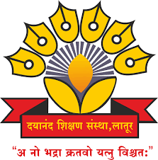
Dayanand Education Society’s
Dayanand Science College, Latur

PERSONAL DETAILS
Name: Aparna S. Sude
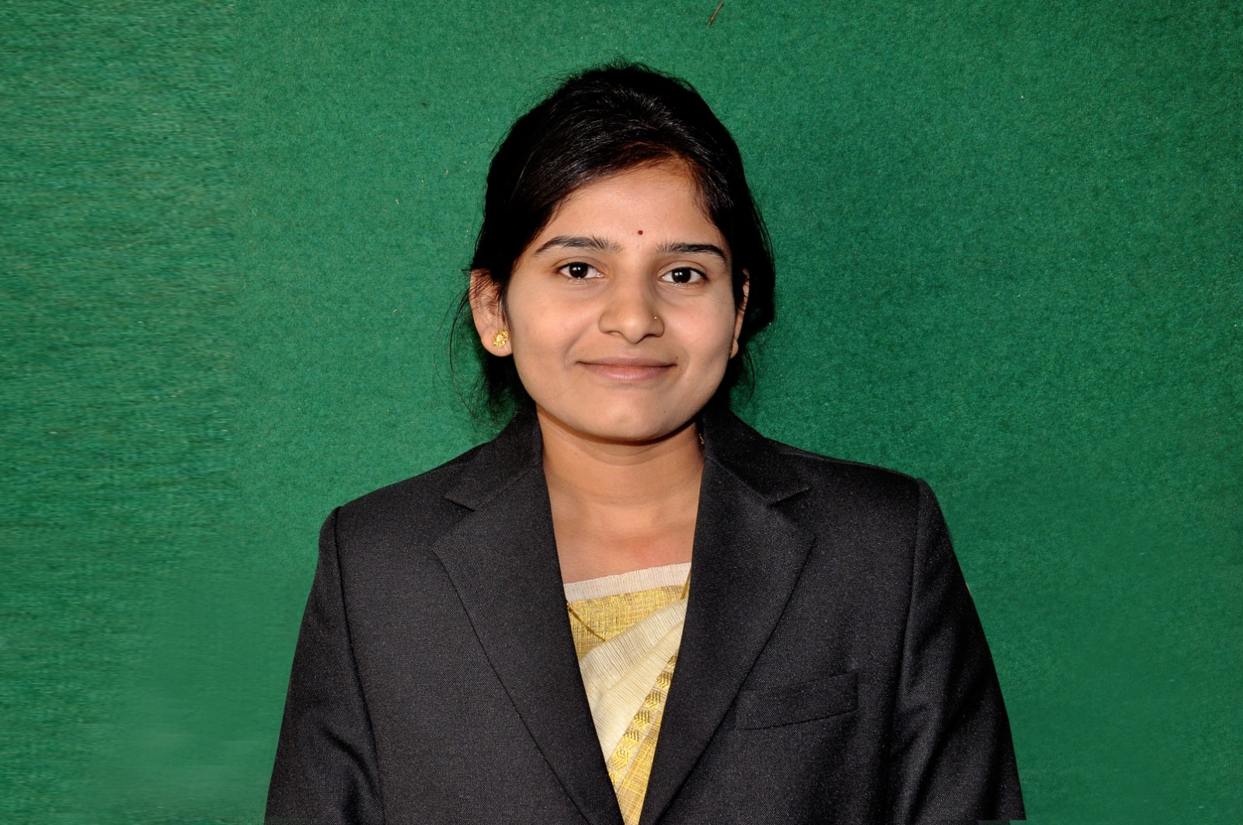

Date of Birth: 15/06/1995
Phone:9860879992
E-Mail: aparnaakutwad6171@gmail.com

JOB DESCRIPTION
Unique ID :
Position: Assistant Professor
Date of Appointment: 16 jun 2025
Date of retirement:
Department: Computer Science
Type of Association(Yes/No)
- Permanent Faculty : No
- CHB : No
- Adjunct Faculty (Contract) :Contract
- Visiting Faculty :No

EDUCATION QUALIFICATION
Degree | Institute | University | Year of passing | Grade / percentage
Ph.D. | Nil
M.Phill | Nil
NET | Nil
SET | Nil
M. Sc. (CS) | Nil
B.Ed. | Nil
B.E. | M.S.Bidve Engineering college, Latur | S.R.T.M.U.N. | 2016 | 72.20 %
Diploma | VDF school of Polytechnic, Latur | M.S.B.T.E. | 2013 | 69.55 %
SSC | Shri. Deshikendra Vidhyalaya Latur | Maharashtra State Board | 2010 | 84.00 %

WORK / TEACHING EXPERIENCE
Department | Institute/college | University | Tenure/ duration
Computer Science | Dayanand Science College, Latur | SRTMUN | 2018 to 2021 and 2025 Current

COURSES TAUGHT
Department | Institute/college | University | Papers taught
Computer Science | Dayanand Science College, Latur | SRTMUN | SE,OS,PHP,SQL,CN,ST

INDUSTRY EXPERINCE

- NO

OTHERS EXPERINCE

- Teaching Experience of 5 years.

RESEARCH EXPERINCE

- No

RESEARCH GUIDANCE

Sr. No | Name of Students | Research Topic | Joining Date | Completed Date

AREA OF SPECIALIZATION

AREA OF SPECIALIZATION:

PROJECTS CARRIED OUT
Sr. No. | Project Title | Major/ Minor | Funding Agency | Fund Received | Date of Completion

PATENTS FILLED & GRANTED
Sr. No. | Title of Invention | Publication Date | Granted Date | Application No | National / International

RESEARCH PUBLICATION NO OF PAPERS PUBLISHED

Sr. No. | Name of Authors | Title of the paper | Year of publication, Name of Journal, Volume & Page Nos. | Referred or Non Referred | ISBN / ISSN No. | Level (Int./ Nat./ State/ Local) | Impact Factor | Active Link
 |  |  |  |  |  | 7 | 8 | 9

BOOK PUBLICATION
Sr. No. | Name of Authors. | Publication | Title of the book | Year of publication | ISBN / ISSN No. | Level (Int. / Nat. / State. / Local)
1 | 2 | 3 | 4 | 5 | 6 | 7

BOOK CHAPTER PUBLICATION
Sr. No. | Name of Authors. | Title of Chapter | Year of publication | ISBN / ISSN No. | Level (Int. / Nat. / State. / Local)
1 | 2 | 3 | 4 | 5 | 6
Nil | Nil | Nil | Nil | Nil | Nil

CONFERENCE / WORKSHOP / SEMINAR ATTENDED
Sr. No | Workshop | Date | Sponsored | Organized BY

ORIENTATION AND REFRESHER COURSE

- No

TECHNOLOGY TRANSFER (USE OF ICT )

FACULTY DEVELOPMENT PROGRAM ATTENDED

1.

INVITED AS RESOURCE PERSON / INVITED TALKS

- No

AWARDS AND ACHIEVMENTS

- No

ADMINISTRATIVE TASK DONE
1.

OTHER CO-CURRICULAR ACTIVITIES.

ADDRESS:

Official

Dayanand Science College Latur
Residential:

Shubhash nagar barshi road, Latur

