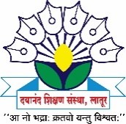
Dayanand Science College

INTERNAL COMPLAINTS COMMITTEE

2018-19 Activity Report
The following events were organized by the Internal Complaints Committee of Dayanand Science College, Latur during 2018-19.

Sr. No | Activity | Date | Beneficiary | Remark
1 | Self Defense Workshop For Girls “Mission Sahasi” | 18 December 2018 | Girls Students and faculty members | The main objective of this workshop was to create Awareness regarding safe and Security environment for each individual i.e.; woman and student at workplace and Society. The Trainer of this Program was Mr. Tukaram Giri, Member ABVP, Latur. For this Workshop.
2 | Competition on Laws for Women | 20 December 2018 | Girls Students and faculty members | National Woman Committee organized Competition Exam for Students. The aim of this Competition was to aware students about various laws and orders for the woman in our constitute.
3 | Sexual Harassment of women at workplace | 17 January 2019 | Girls Students and faculty members | The main objective of this workshop was to create Awareness regarding safe and Security environment for each individual i.e.; woman and student at workplace and Society. The Resource person for this Workshop. Was Dr. Poonam Nathani, (Assistant professor, Law College Latur.

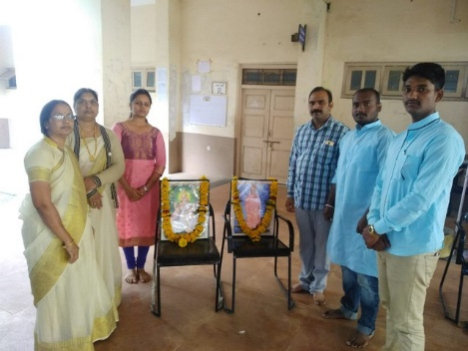
Sarswati Pujan of “Mission Sahasi“ program.

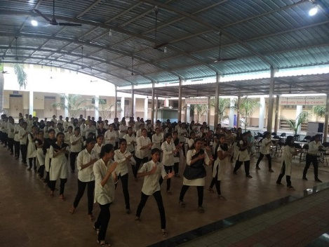
Students are practicing the tricks and skills of karate for self defence
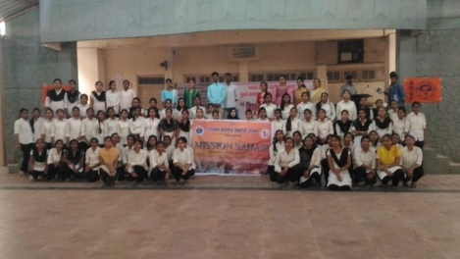
All participants of “Mission Sahasi” Program with trainer Mr. Tukaram Giri, Prof. Mrs. Jaju S. A. President of ICC.
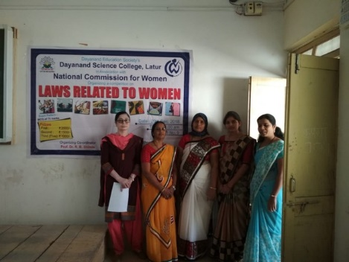
Staff present at competition organized by ICC under the guidence of National Commision for woman.

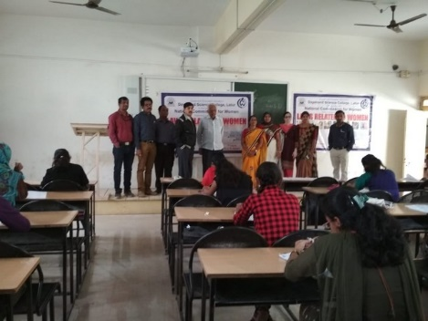
Principal Dr. j. s. dargad sir, Vice-principal dr. S. s. bellale sir , Guest R. H. Ladda Sir & other staff visited to Exam hall.
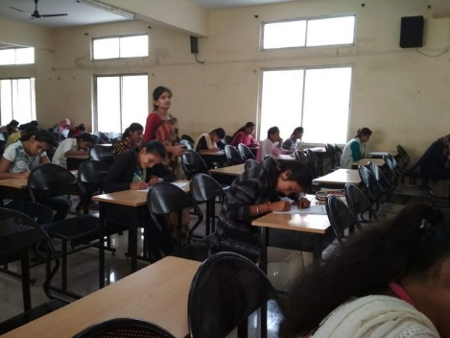
Students at exam hall.

