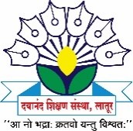
Dayanand Science College

INTERNAL COMPLAINTS COMMITTEE

2017-18 Activity Report
The following events were organized by the Internal Complaints Committee of Dayanand Science College, Latur during 2017-18.

Sr. No | Activity | Date | Beneficiary | Remark
1 | Guidelines on ICC and Awareness of  “Pratisad App”. | 29 September 2017 | Girls Students and faculty members | The main objective of this workshop was to create Awareness regarding safe and healthy environment for each individual i.e.; woman and student at workplace. The chief guest of Honor was Mrs. Anita Itabone, Damini Pathak, Latur, has given the information about rules and laws regarding the safety of girls and women and Pratisad app developed by police Department of Latur. She also explained Work of Damini Pathak Latur for the safety of girls.
2 | Self Defense Workshop For Girls | 23 July 2017 | Girls Students and faculty members | The main objective of this workshop was to trend the girls for their self-defense in case of any emergency. Mrs. Sunita Giri, Member of ABVP, latur. Was the trainer for the Program.

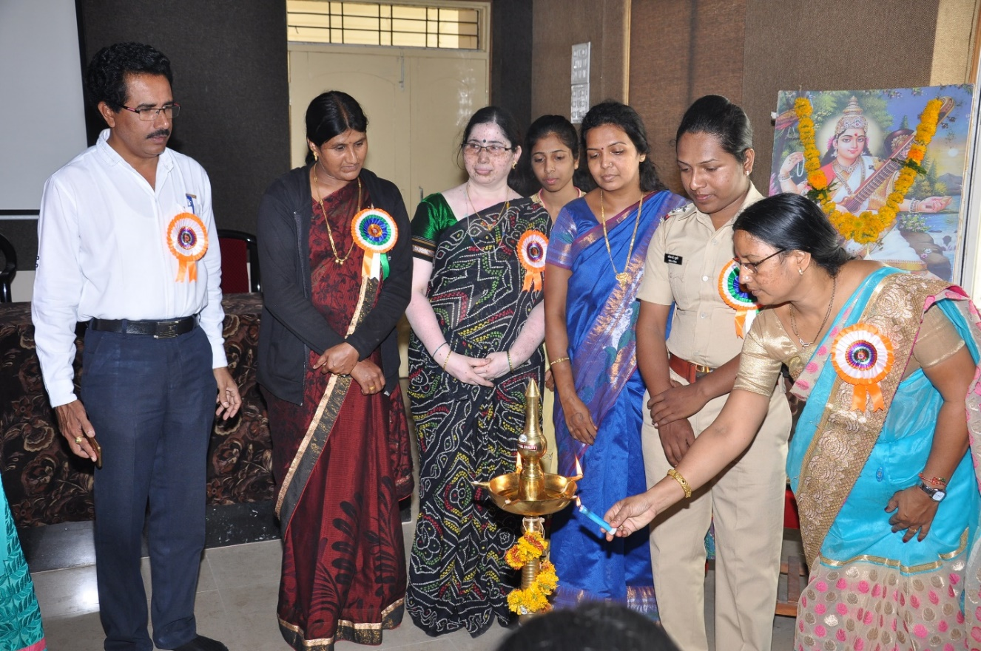
Mrs. Anita Itabone, PSI & Incharge of Damini Pathak, Latur, Inaugurating Guidelines on ICC and Awareness of “Pratisad App”. Programme.
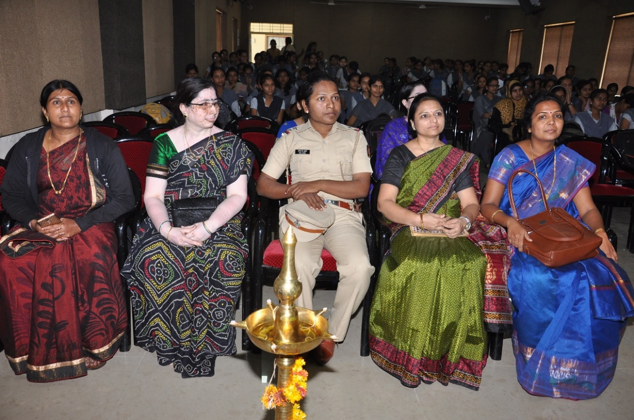
Mrs. Anita Itabone, and all Participants Watching the Film prepared by Girls Students on the occasion of Workshop for girls on “laws and orders for woman. Guidelines for laws.

