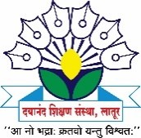
Dayanand Science College

INTERNAL COMPLAINTS COMMITTEE

2016-17 Activity Report
The following events were organized by the Internal Complaints Committee of Dayanand Science College, Latur during 2016-17.

Sr. No | Activity | Date | Beneficiary | Remark
1 | “Mahila Suraksha” for girls To protect themselves From Sexual harassment | 24 August 2016 | Girls Students and faculty members | The main objective of this workshop was to create Awareness regarding safe and healthy environment for each individual i.e.; woman and student at workplace. The chief guest of Honor was Mrs. Suvarna Umap, PSI Latur, has given the information about rules and laws regarding the safety of girls and women and Pratisad app developed by police Department of Latur.
2 | Workshop for girls on “laws and orders for woman..  - Janeev Jagruti Guidelines  - Guidelines for laws  - Guiding Principles of ICC | 27 February  2017 | Girls Students and Faculty members | The main objective of this workshop was to create Awareness regarding safe and healthy environment for each individual i.e.; woman and student at workplace.  - The chief guest of Honor was Shrimati. Chandrakala Bhargav, President of Nari Manch has aware the girls students about how to tackle with the injustice and how to use the laws for the Safety  - The Second resource person was Mrs. Madhavi Maske, PSI Latur had given information about Pratisad app developed by Latur police and How to take help From Police Department.  - The Third Resource person Mrs. Archana Somani, NGO Member Of Bhartiya Stree Shakti had explain the principle Guideline of ICC.

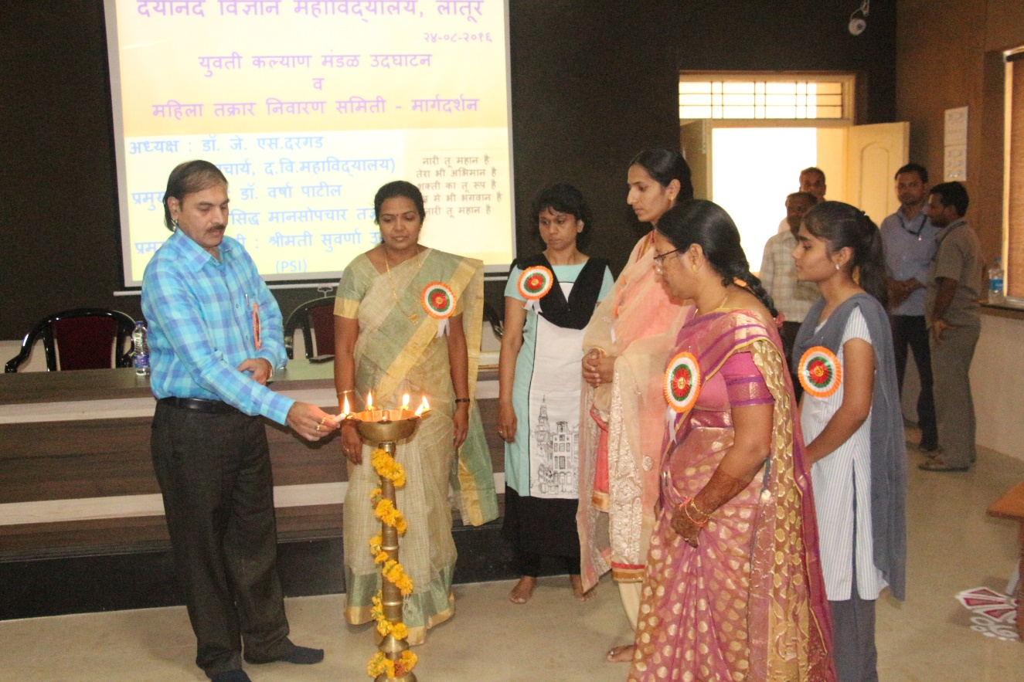
Inguagration Function of “Yuvati Kalyan Mandal & Guidance for Mahila Suraksha” Workshop by Guest Mrs. Suvarna Umap, PSI, Latur, and Principal Dr. J. S. Dargad.
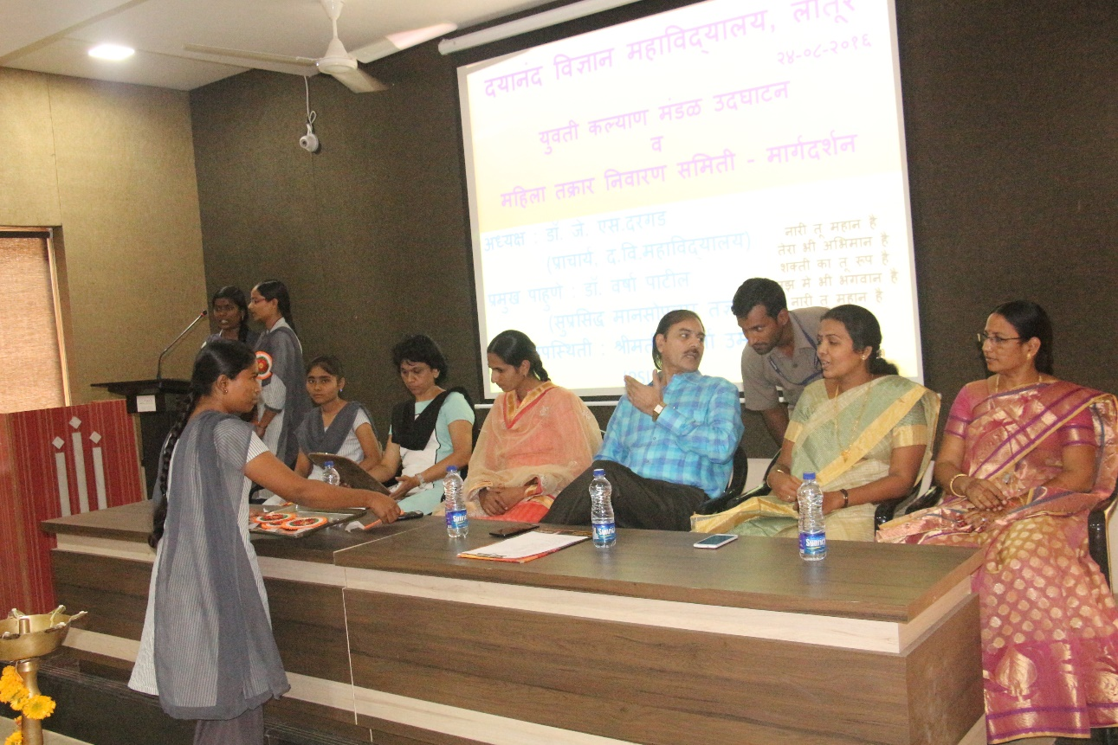
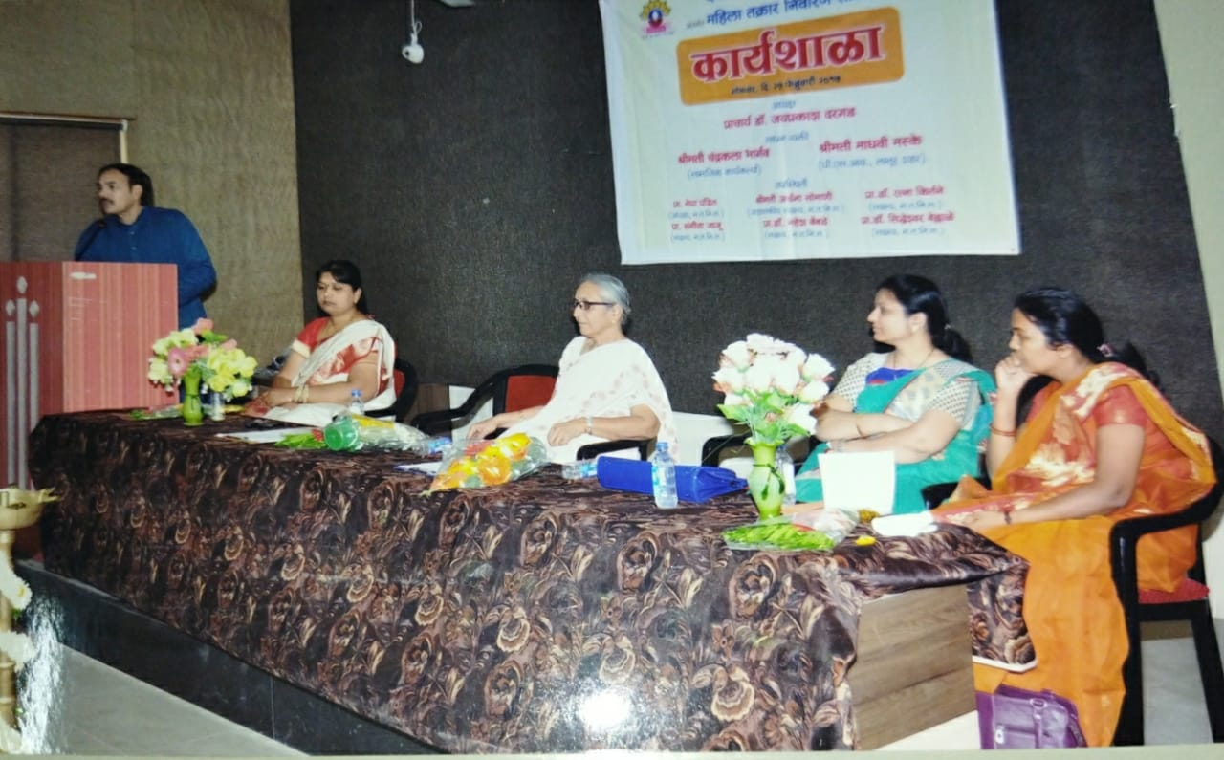
Addressing Principal Dr. J. S. Dargad on the occasion of workshop for Girls On “Laws and Orders for Woman.”

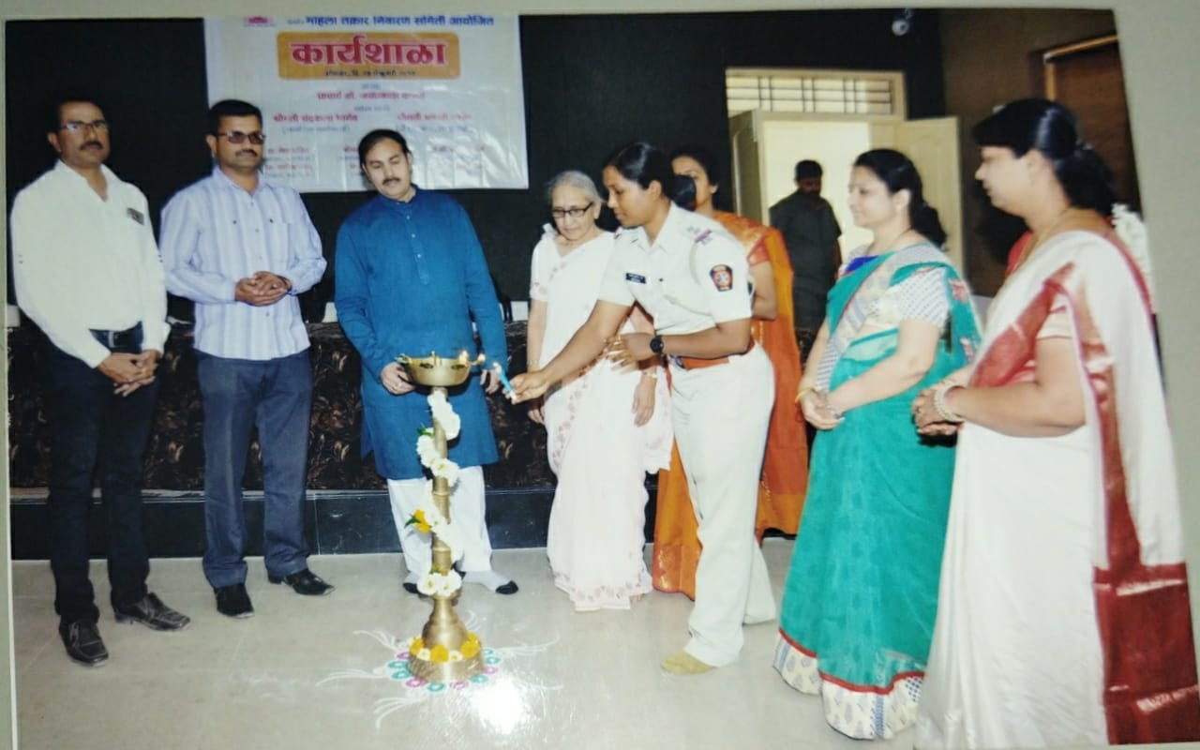
Enlightening The Lights by Hands of Mrs. Madhavi Maske, PSI Latur, on the occasion of Inauguration of Workshop.
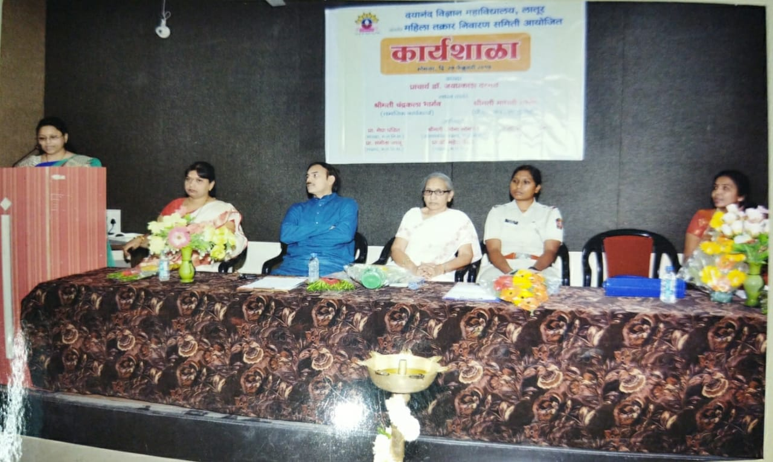
Mrs. Archana Somani, NGO,(Bhartiya Stree Shakati) addressing students on Guiding Principles of ICC
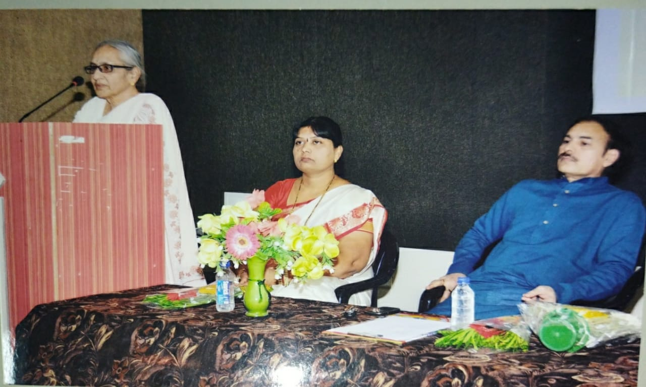
Smt. Chandrakala Bhargav,( President Nari manch, Latur) addressing students on Janeev Jagruti Guidelines

Prof. Mrs. Megha M. Pandit
President
Internal Complaints Committee

