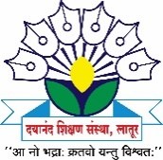
Dayanand Science College

INTERNAL COMPLAINTS COMMITTEE

2015- 16 Activity Report
The following events were organized by the Internal Complaints Committee of Dayanand Science College, Latur during 2015-16.

Sr. No | Activity | Date | Beneficiary | Remark
1 | Guidelines on ICC and work of ICC Committee | 14 August 2015 | Girls Students and faculty members | Training programs have been proposed by Maharashtra state commission for women and students of all gender, to create awareness in all colleges in Maharashtra. The main objective of this workshop was to create Awareness regarding safe and healthy environment for each individual i.e.; woman and student at workplace. The chief guest of Honor was Mrs. Shobha Parshetty, NGO, who is an eminent Social worker, working for the cause of Woman safety, Sexual harassment issues and Rehabilitation of women.

Prof. Mrs. Megha M. Pandit
President
Internal Complaints Committee

