Dayanand Science College Latur
Student Council
2018-2019
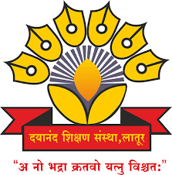

Dr.J.S.Dargad
Principal
Dayanand Science College Latur

Proffesor-In-Charge
Dr.A.M Chougule
Head
Dept.Of Industrial Chemistry

Committee (2018-2019)

Sr.No. | Name of Member | Designation
01 | Dr. A.M Chougule | Professor –In- Charge
02 | Prof M.M Pandit | Member
03 | Dr. M. A, Bembade | Member
04 | Dr, V, A Choudhari | Member
05 | Prof. R.K Jadhav | Member
06 | Dr. S.S Mahurkar | Member
07 | Prof .A.V.Bhosale(Jr) | Member
08 | - | Secretary student council

Activities (2018-2019)

Sr.No. | Name of Activities | Date | Chief Guest
01 | Organised Health cheke up programme | 23 January 2019 | 1.Dr.Avinah Patil  (general Physician Latutr)  2.Dr.Sangita Bajaj  ((Gynecologist)
02 | Annual Social Gathering | 3-4 Feb 2019 | Opening ceremony | Concluding ceremony
 |  |  | Mr.Firoj Rashid  (Popular Hindi and Urdu Poet) | Hon.Dr.Hariprasd Somani  (fomous Industrialist Latur)

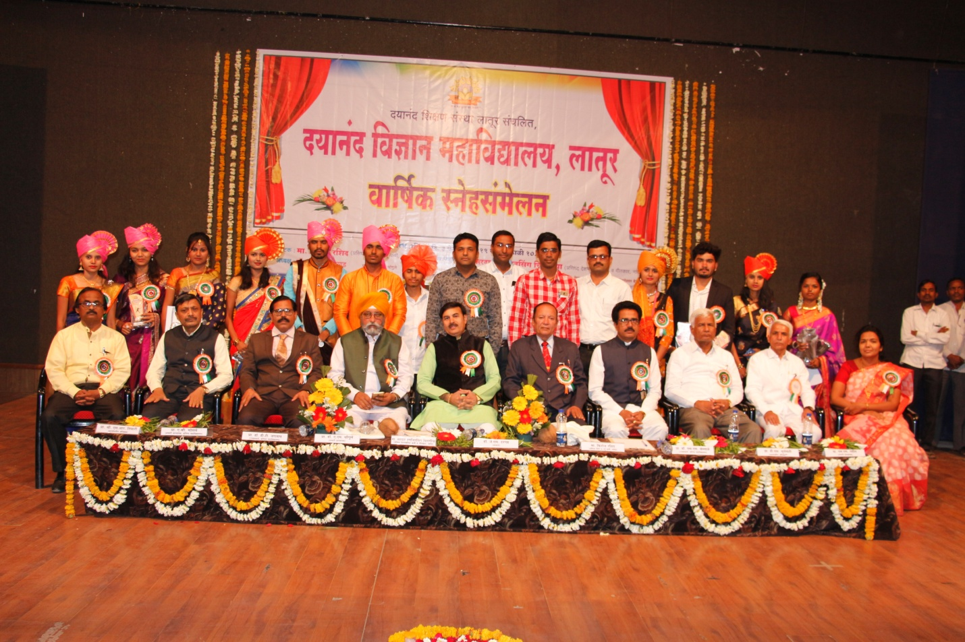
Cultural,sport,NSS,NCC Representatives and Student welfare committee with chief guest Hon. Firoj Rashid
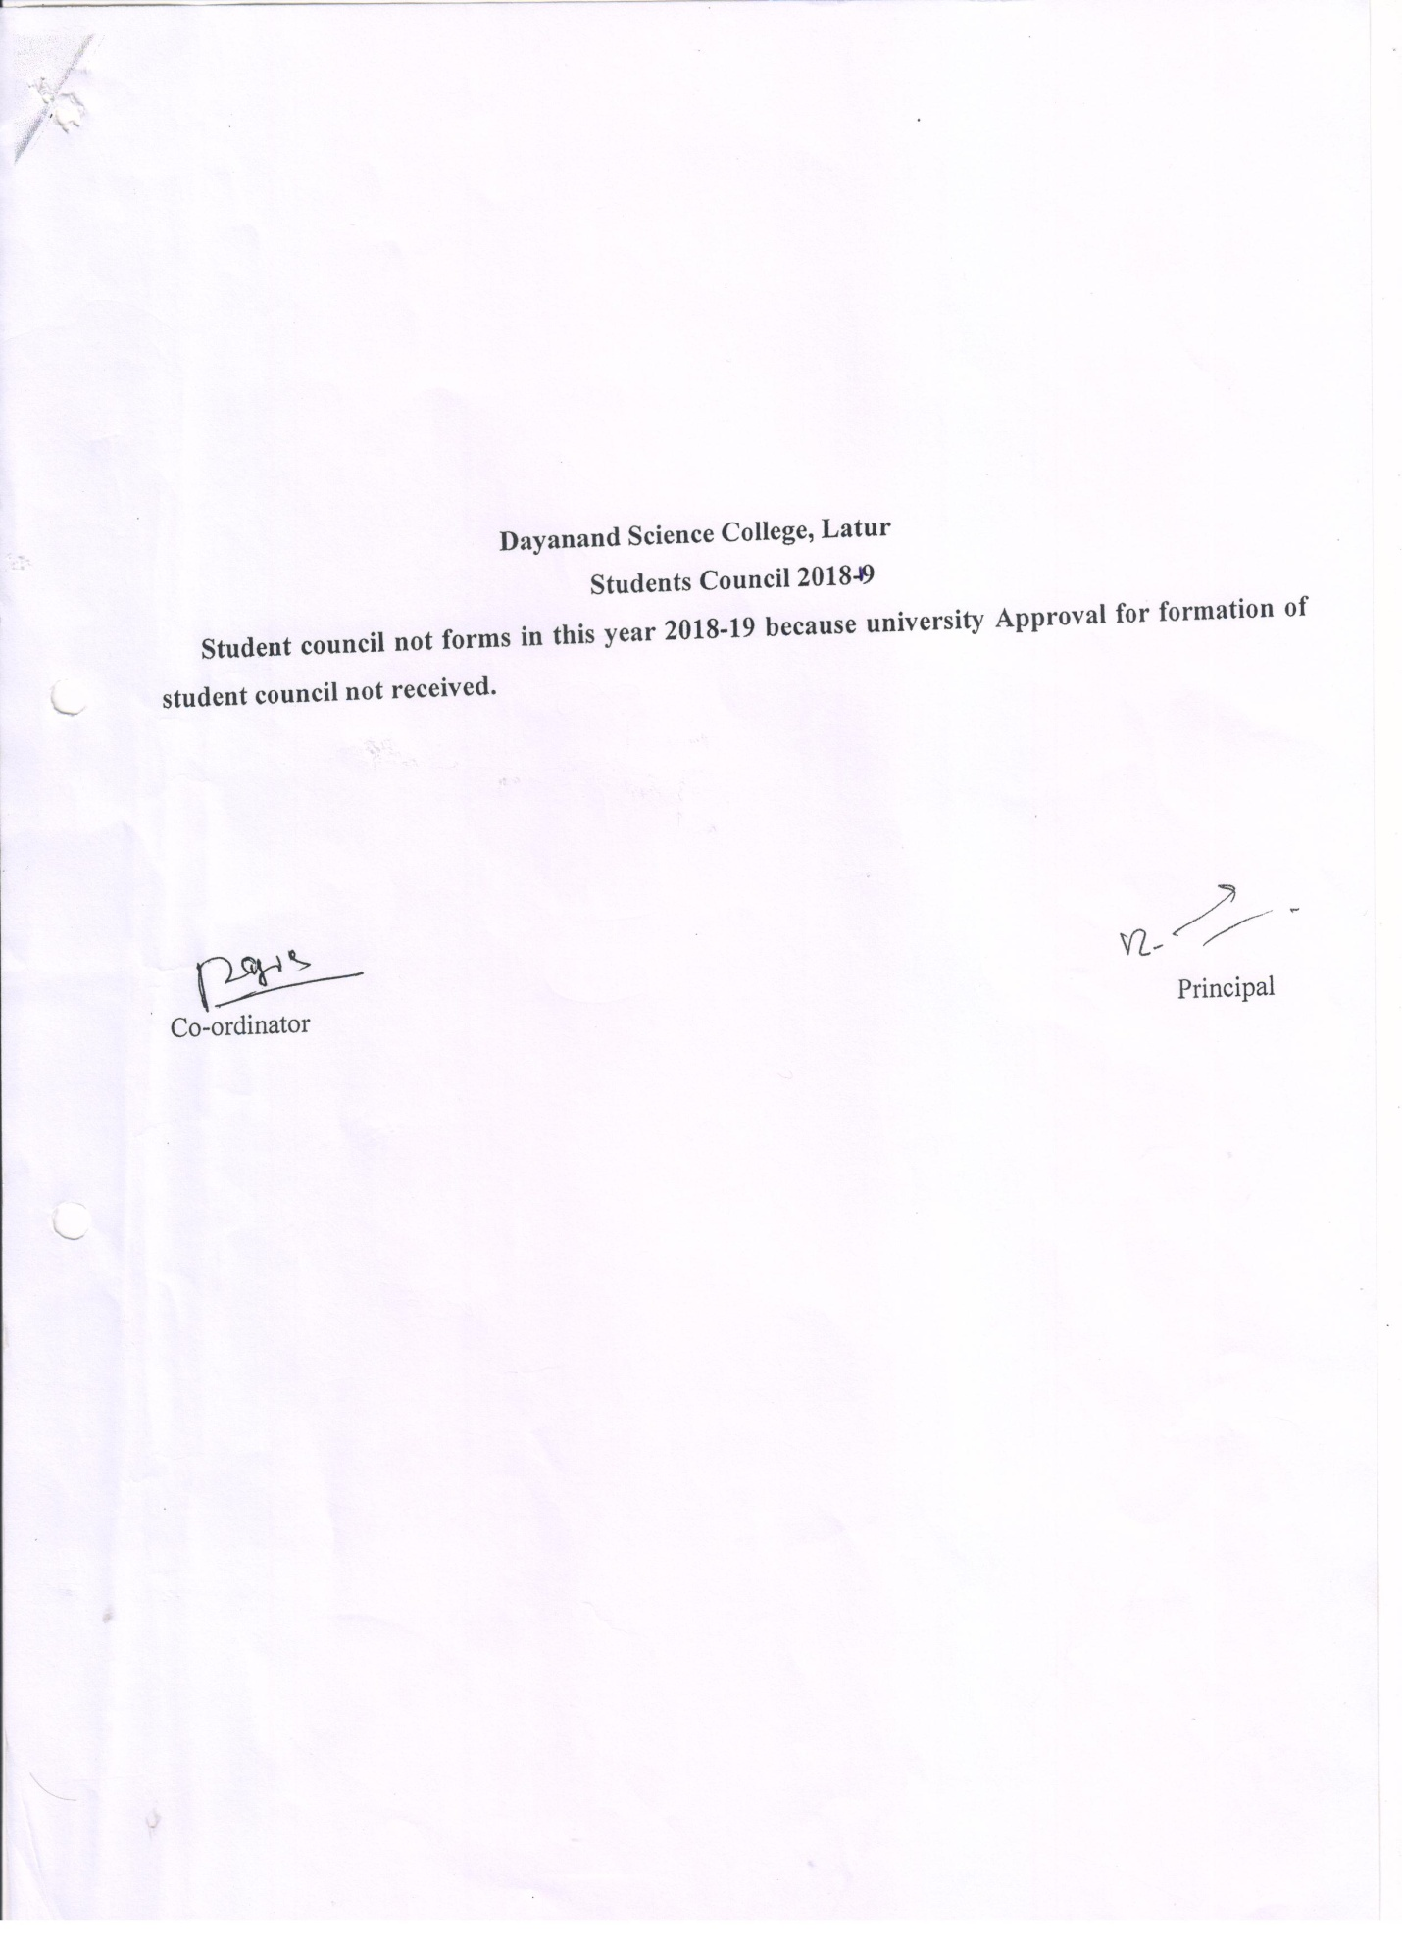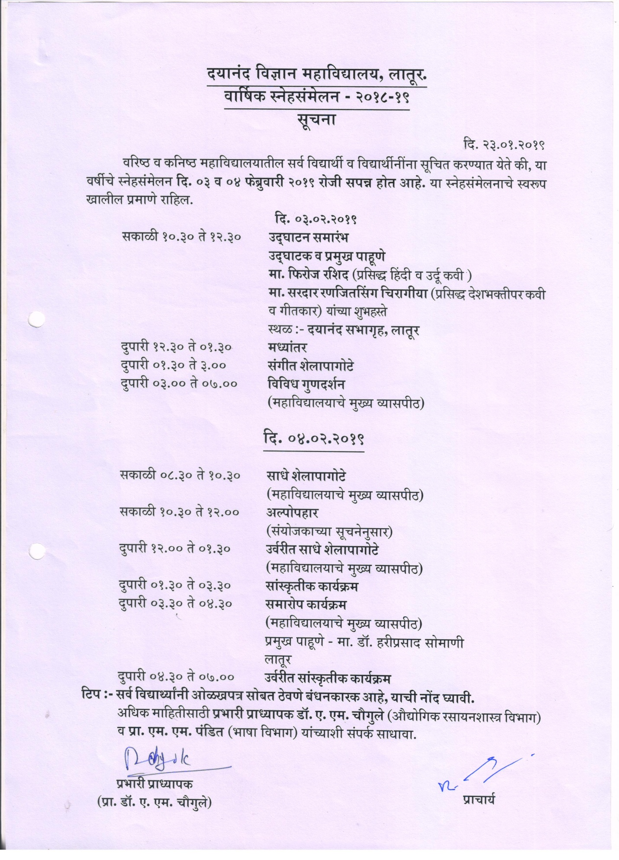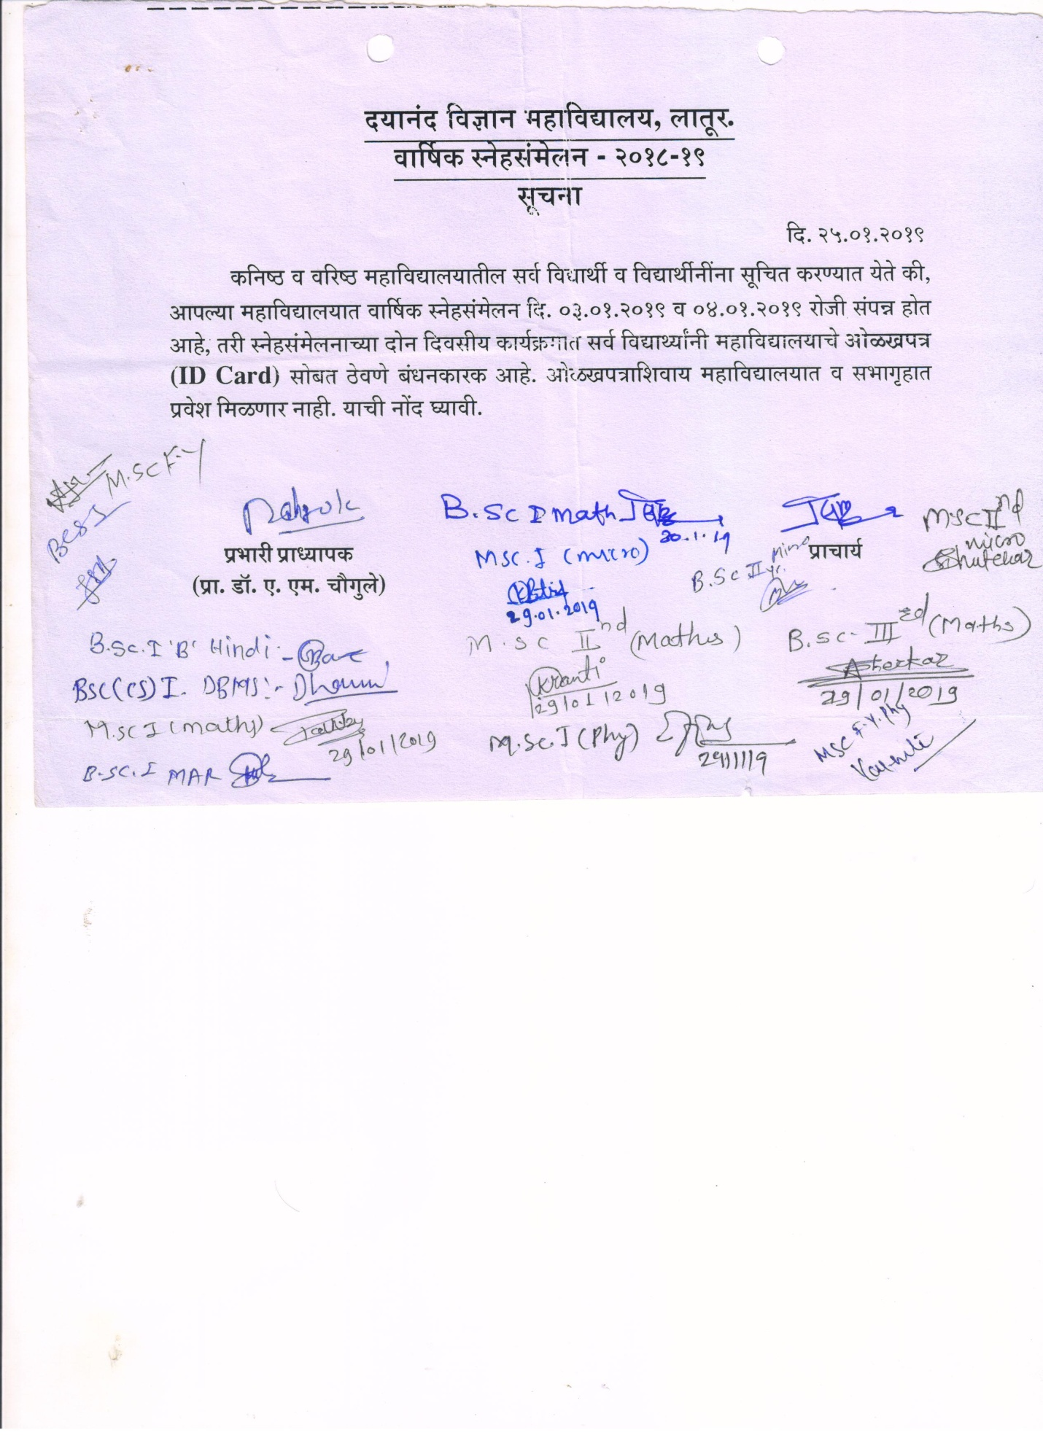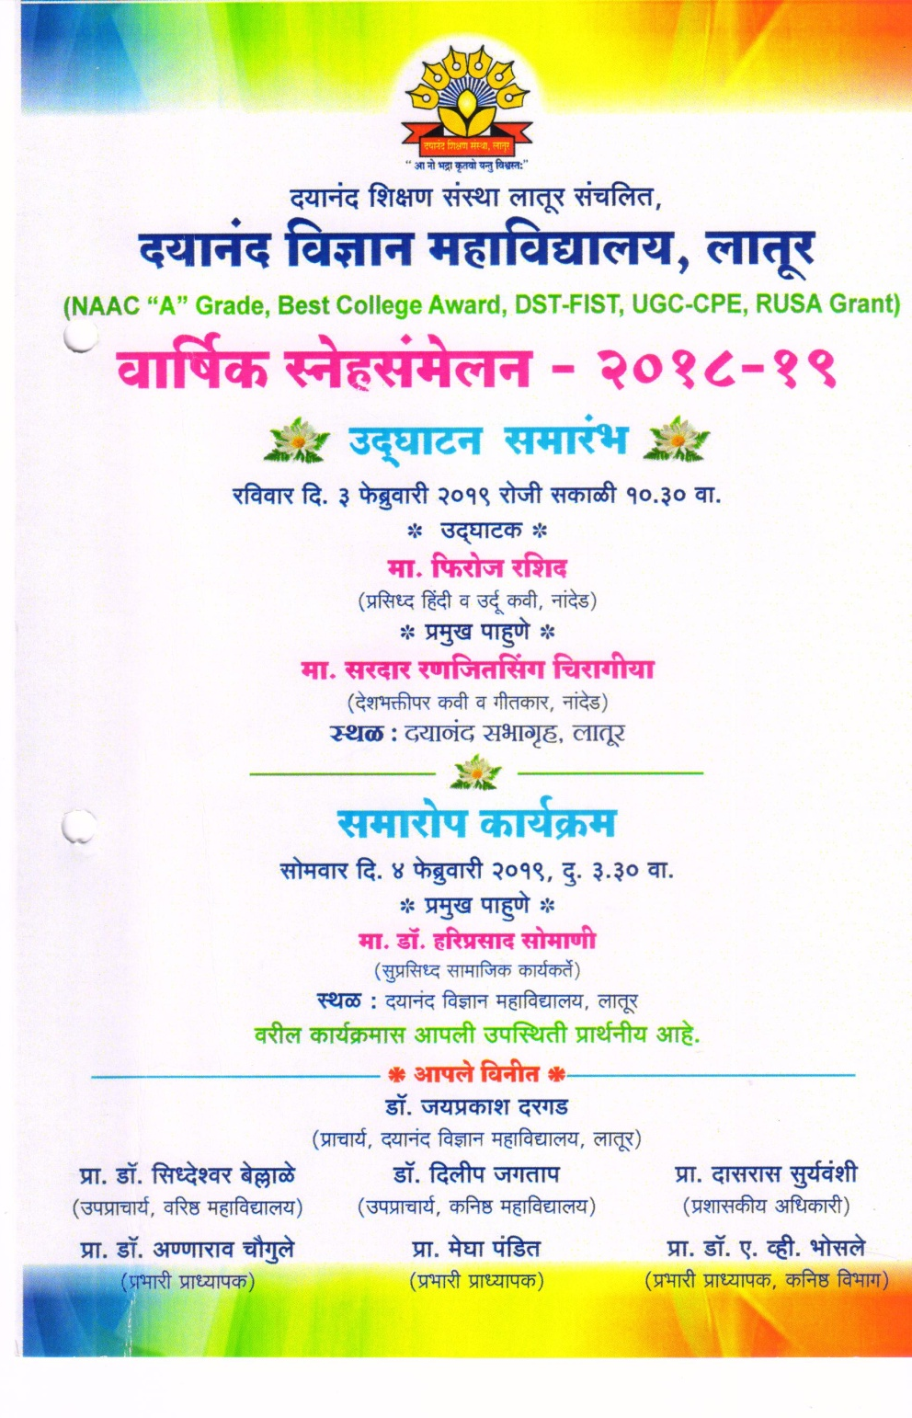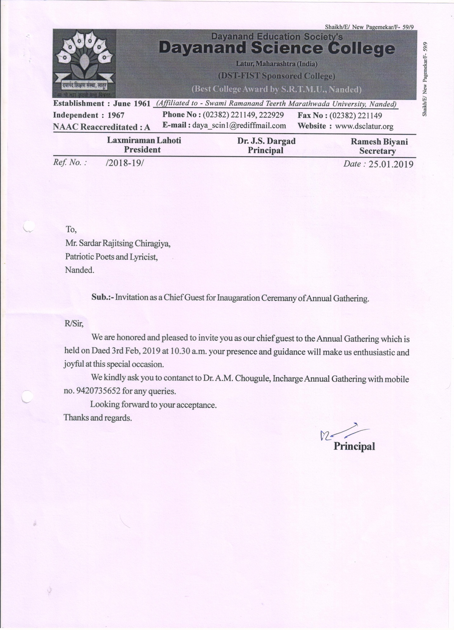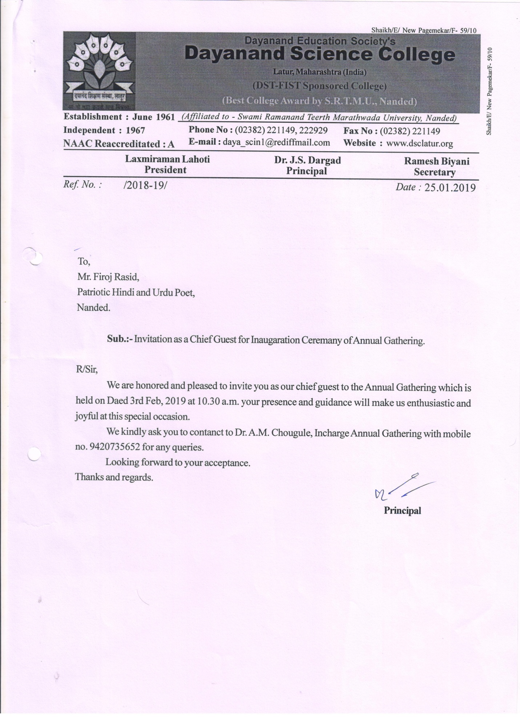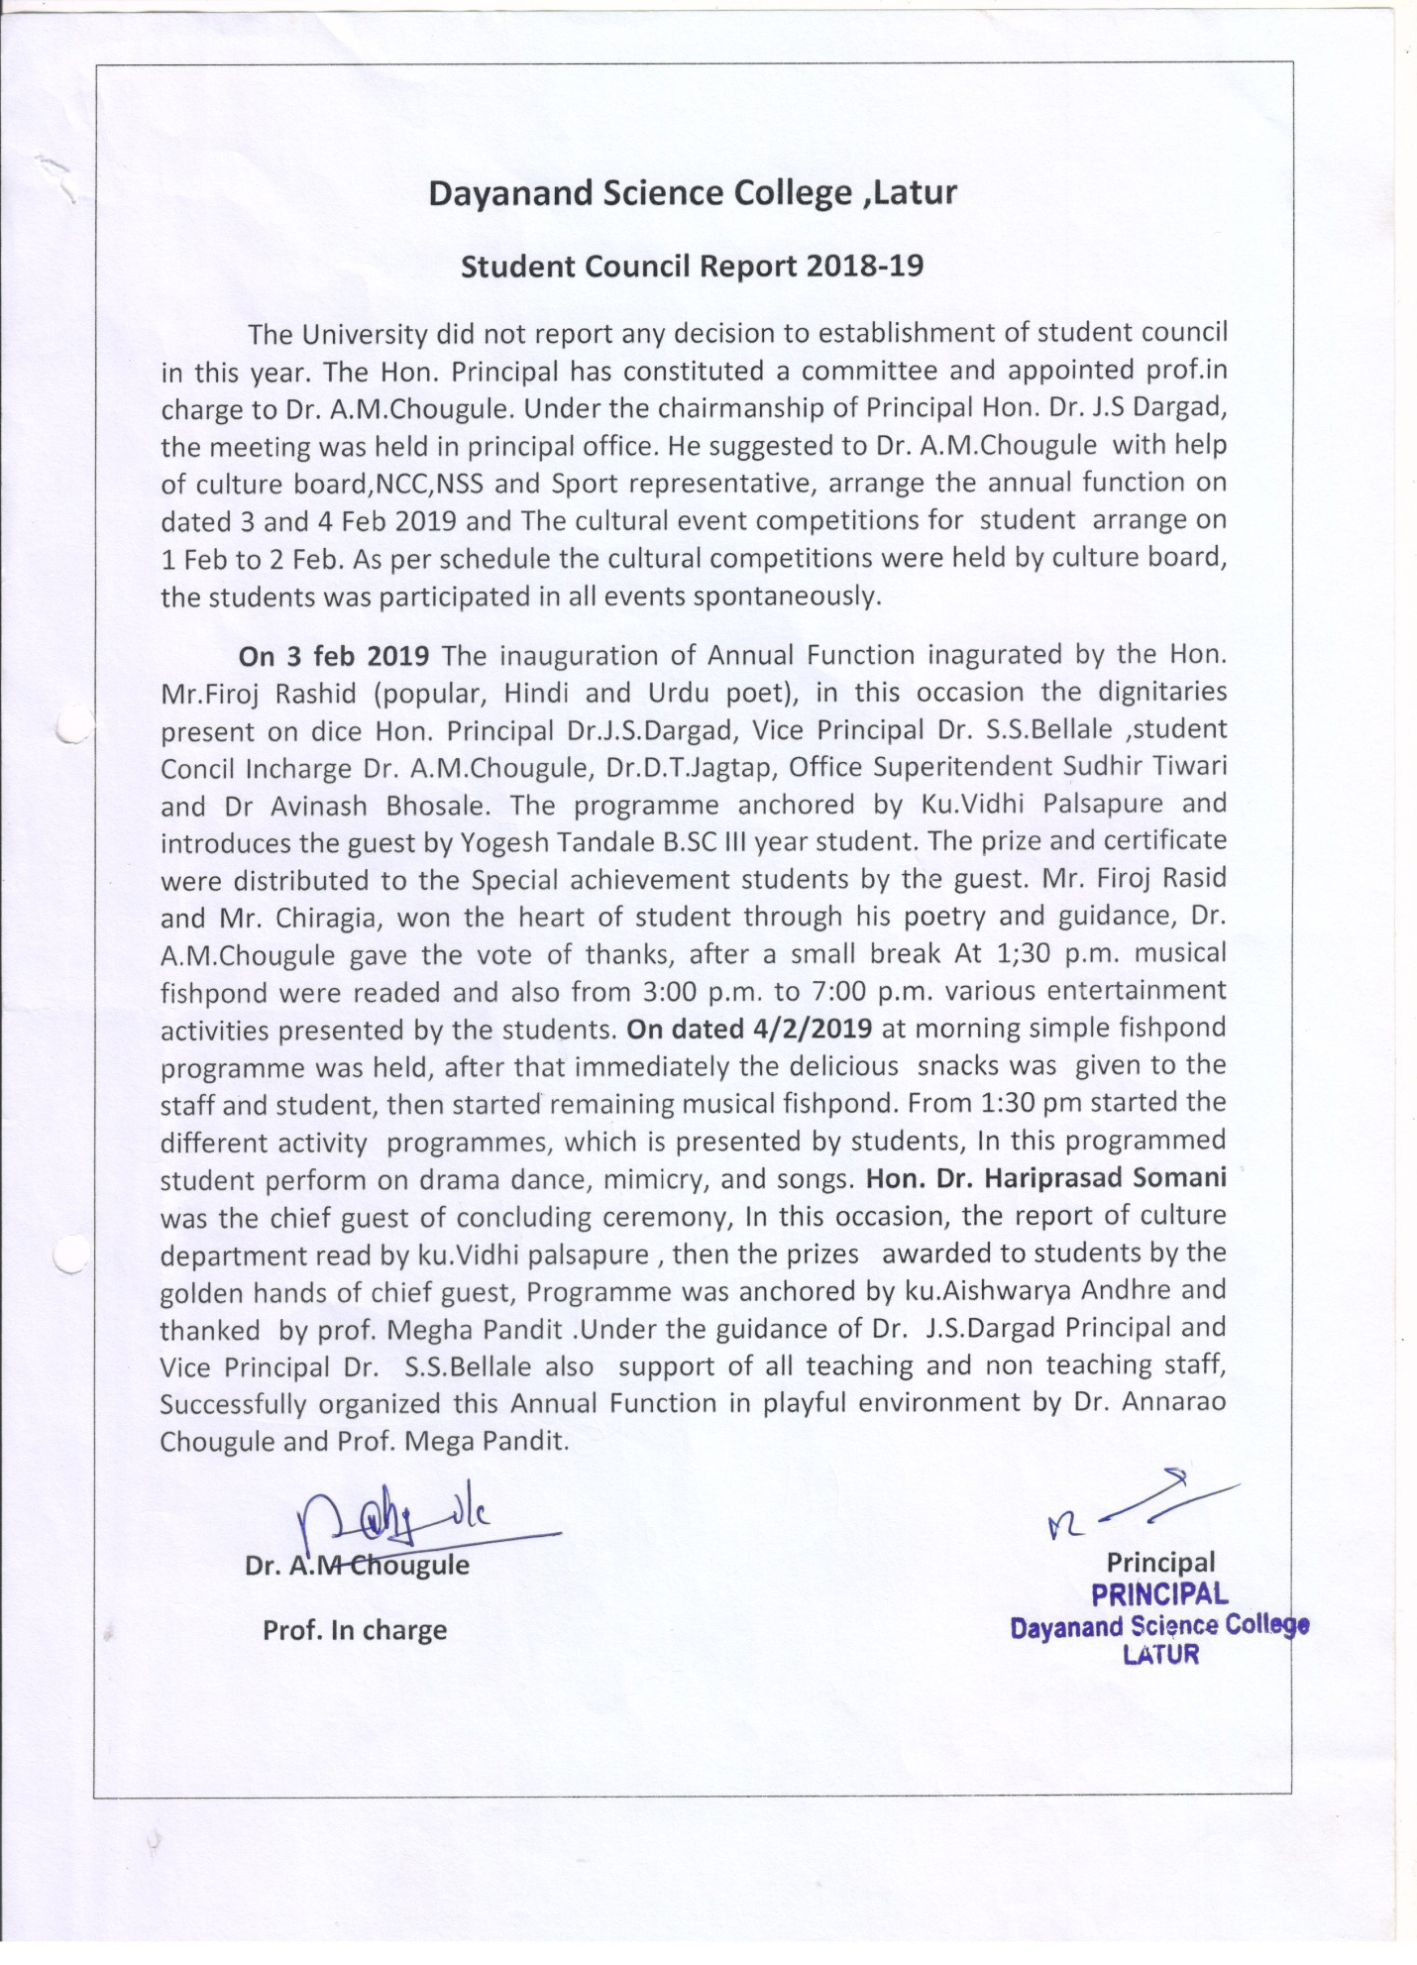
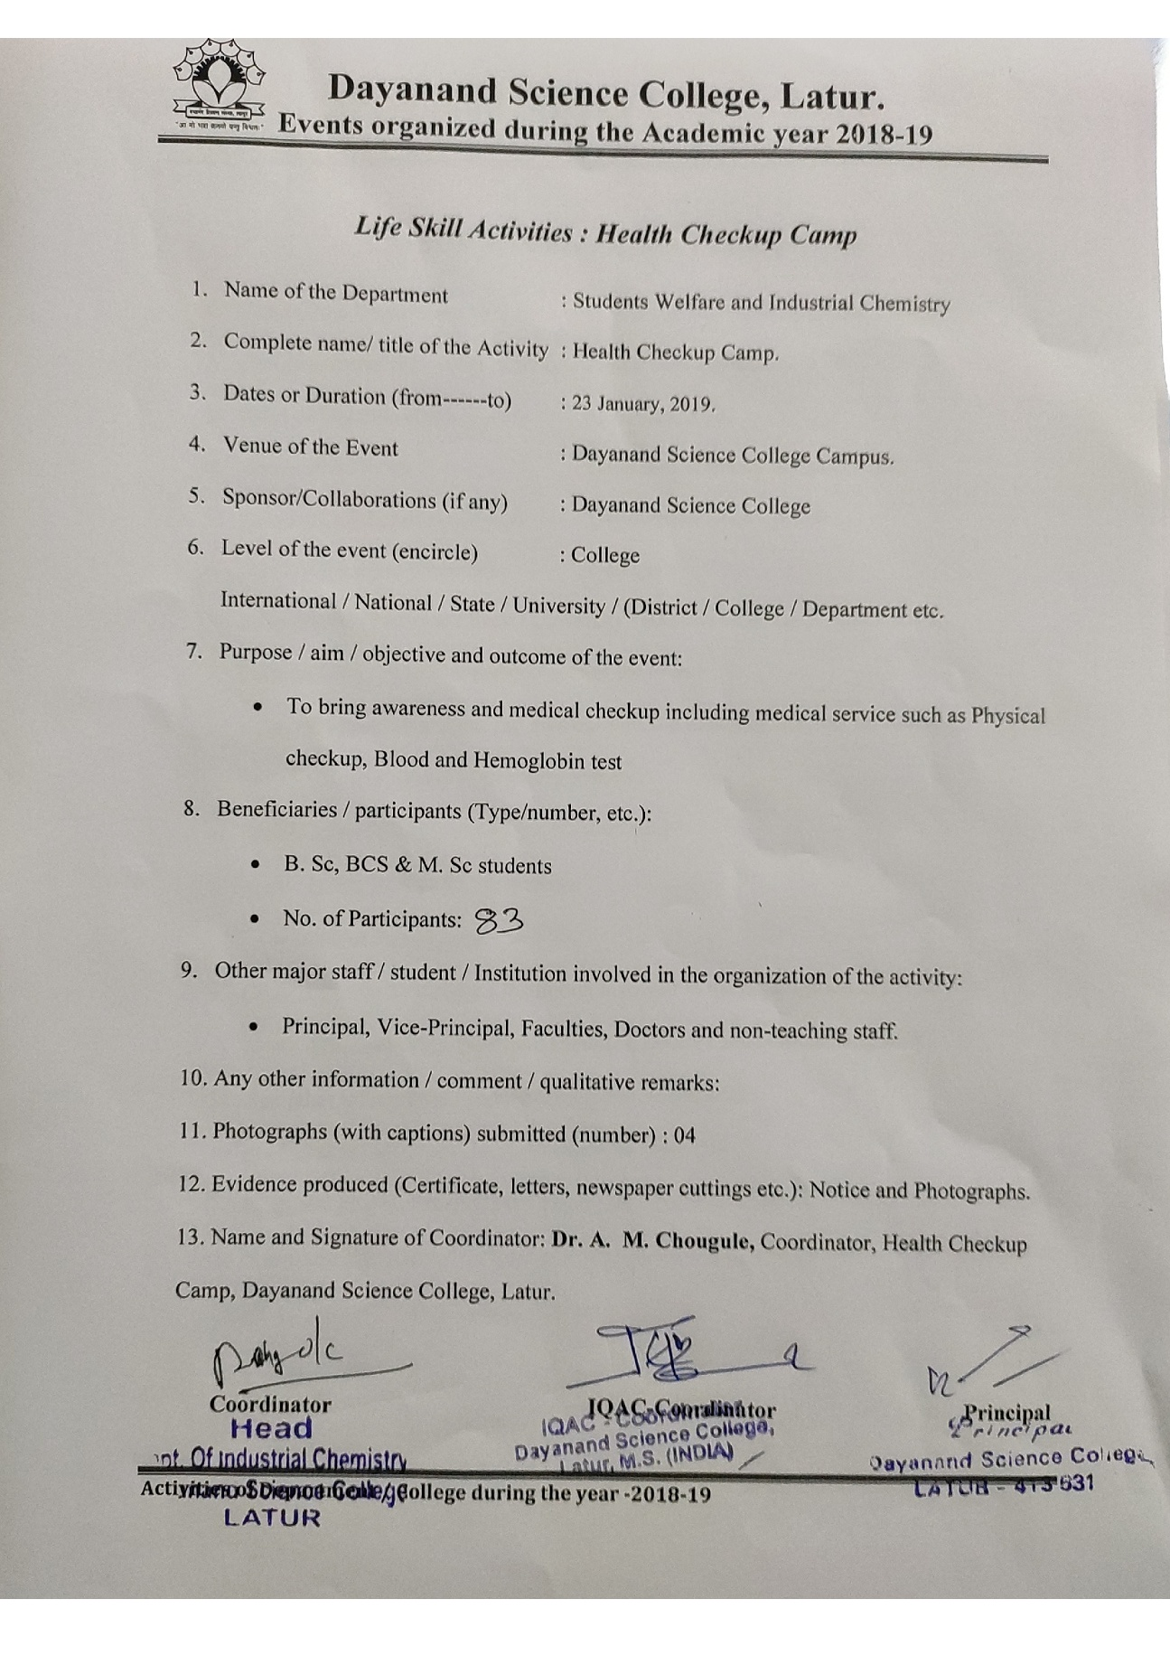Photo Gallery Opening Ceremony
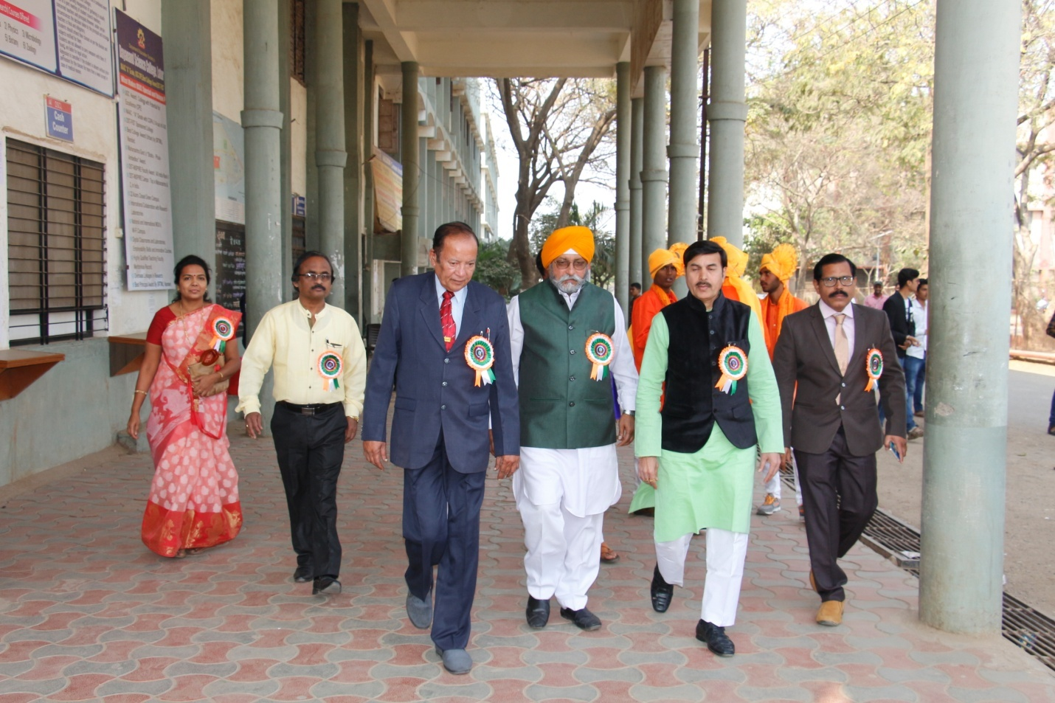
Hon. Chief Guest Firoz Rashid and Sardar Ranjitsingh Chiragiya along with Hon. Dr. J S Dargad and Wellfare Commite

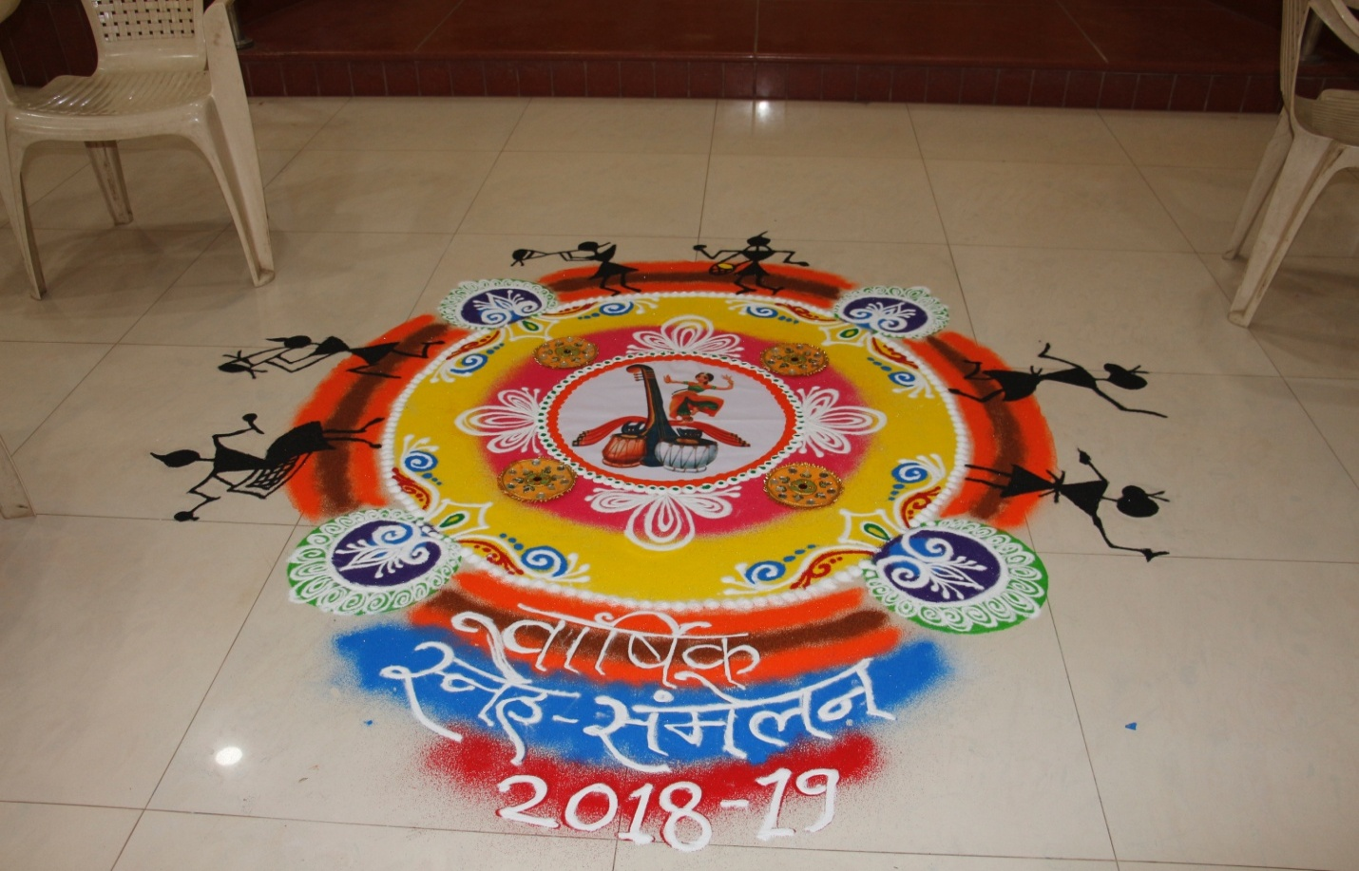

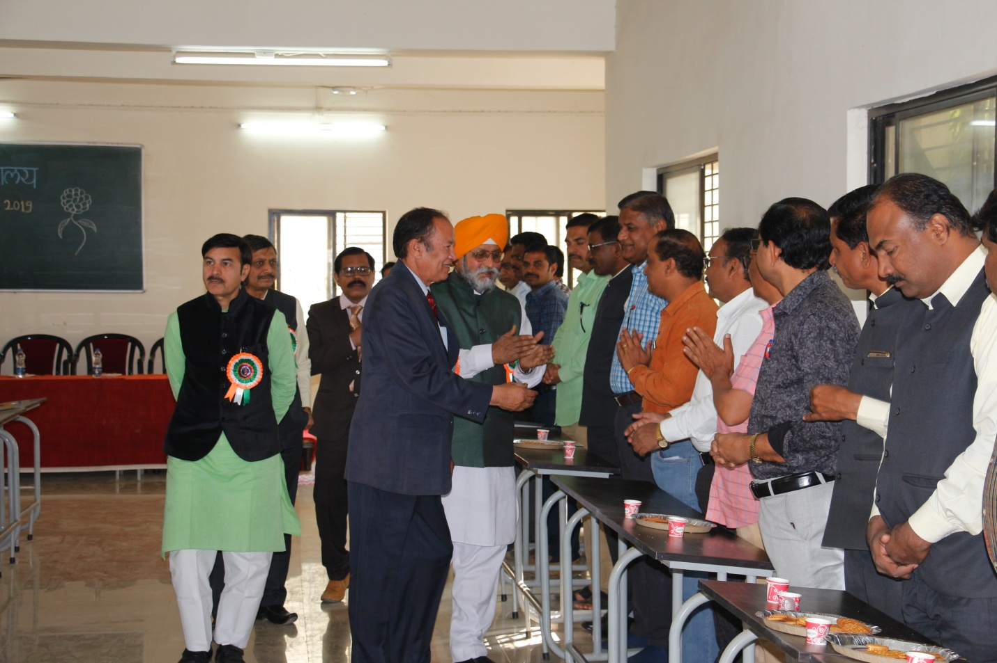
Hon. Chief Guest Firoz Rashid and Sardar Ranjitsingh Chiragiya along with Hon. Dr. J S Dargad Commite Iroduction programme with staff

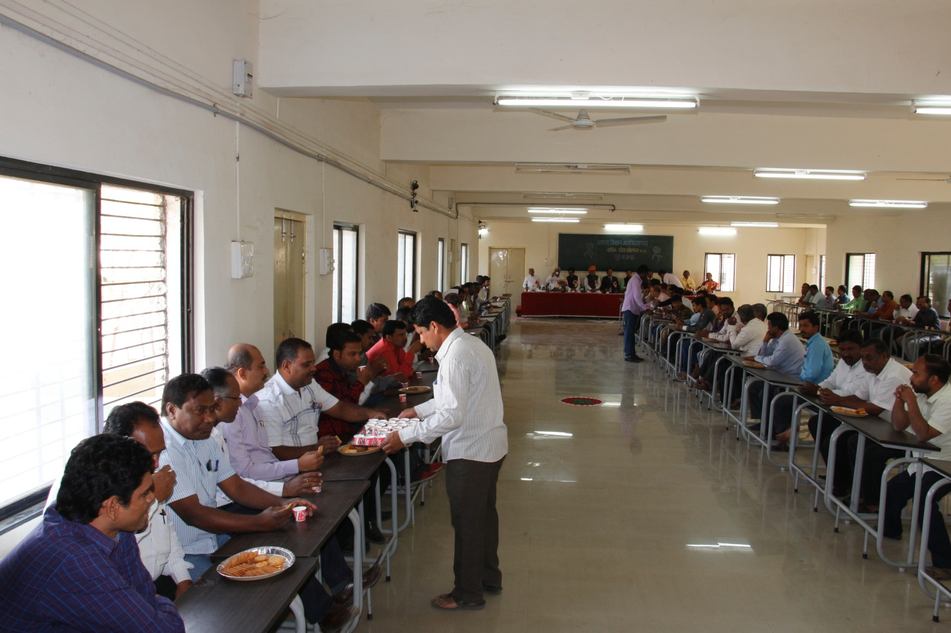
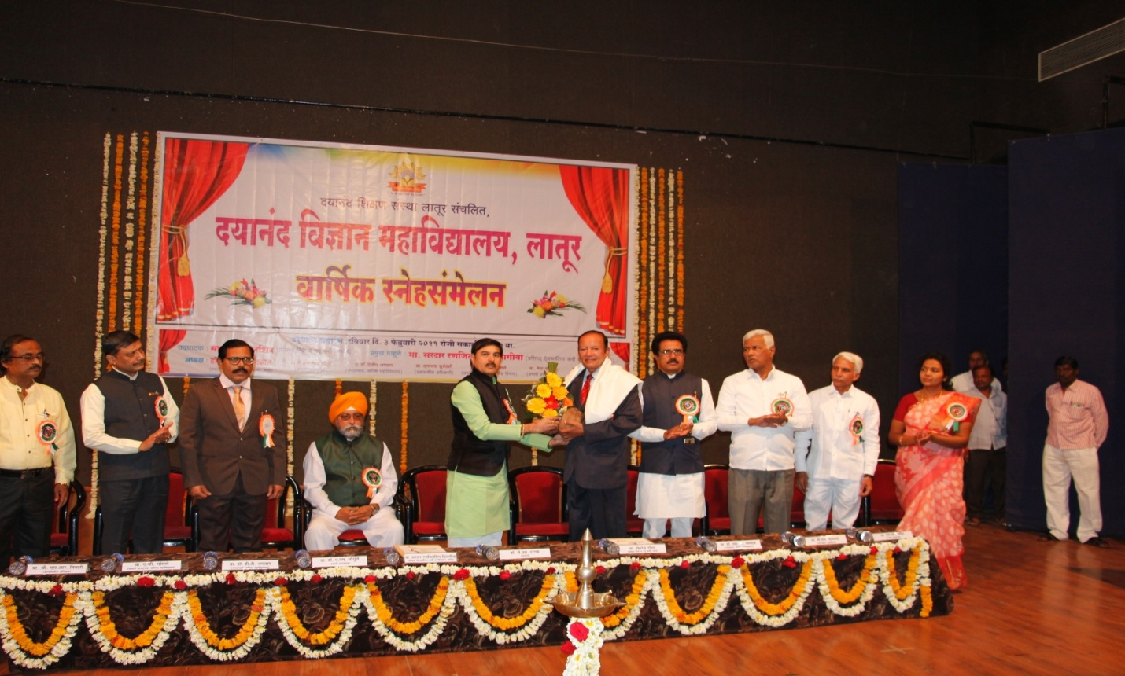

Hon. Chief Guest Firoz Rashid and Sardar Ranjitsingh Chiragiya Felicitate by Hon. Dr. J S Dargad
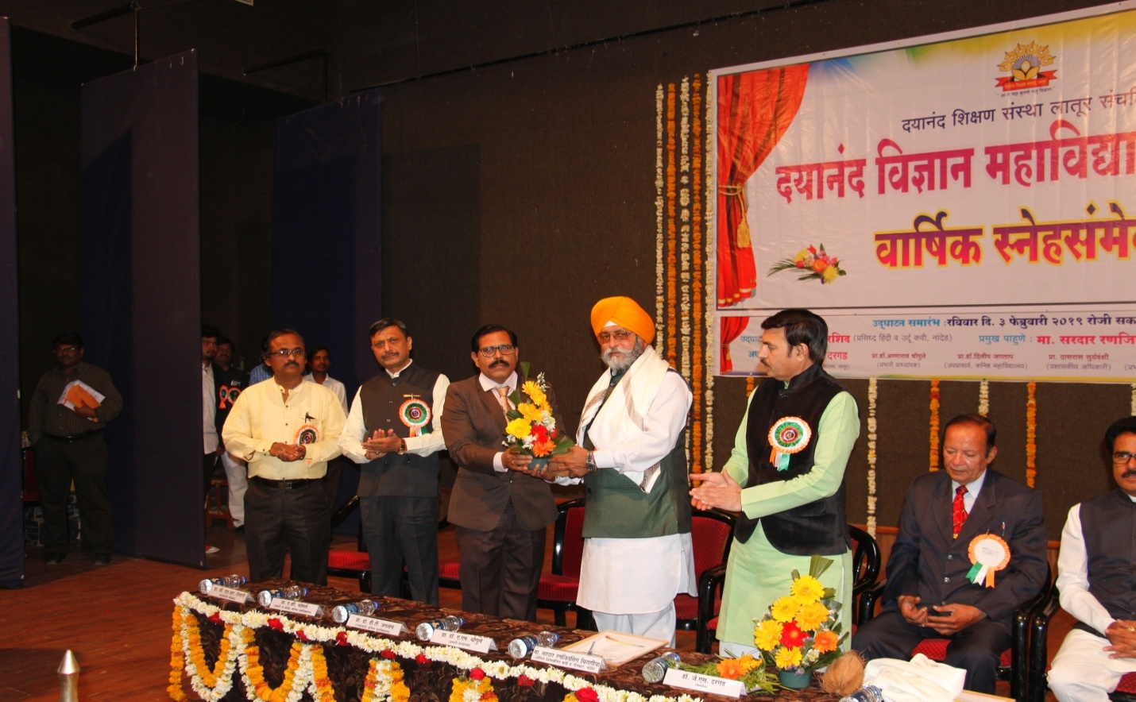

Hon. Chief Guest Firoz Rashid and Sardar Ranjitsingh Chiragiya Felicitate by Hon. Dr. A M Chougule
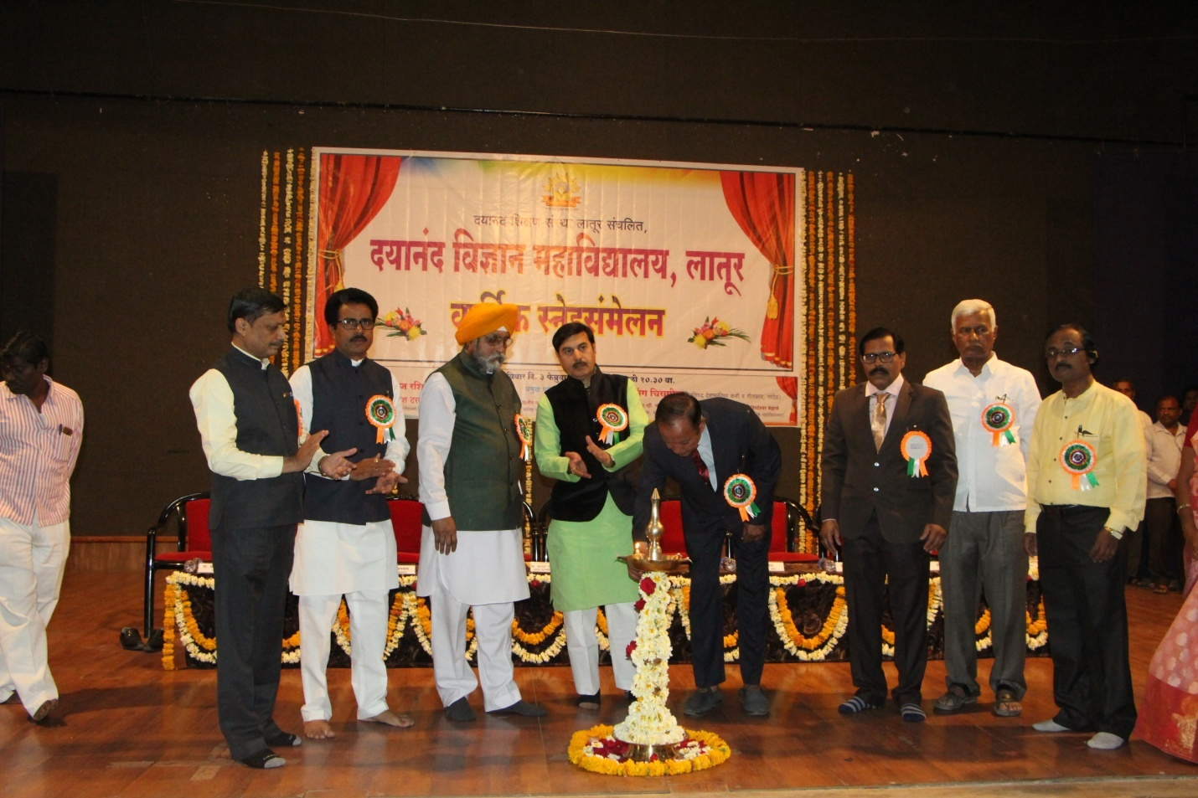
Hon. Chief Guest Firoz Rashid and Sardar Ranjitsingh Chiragiya Lighting Lamp of opening ceremony of annual function.

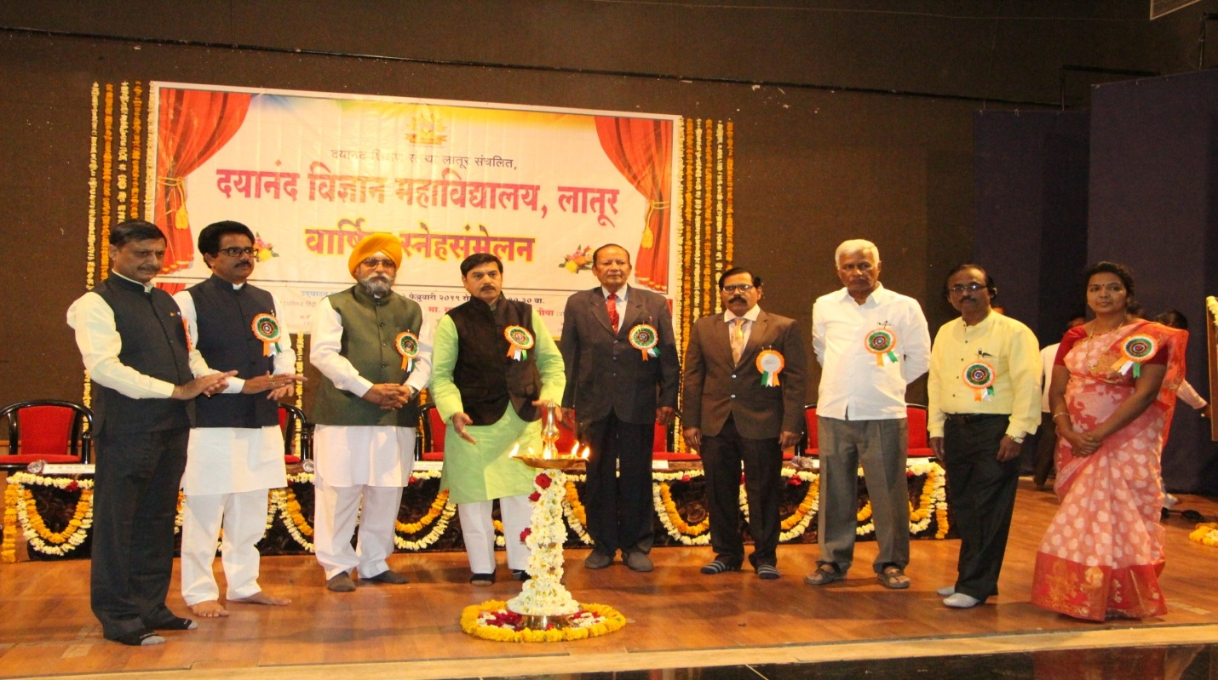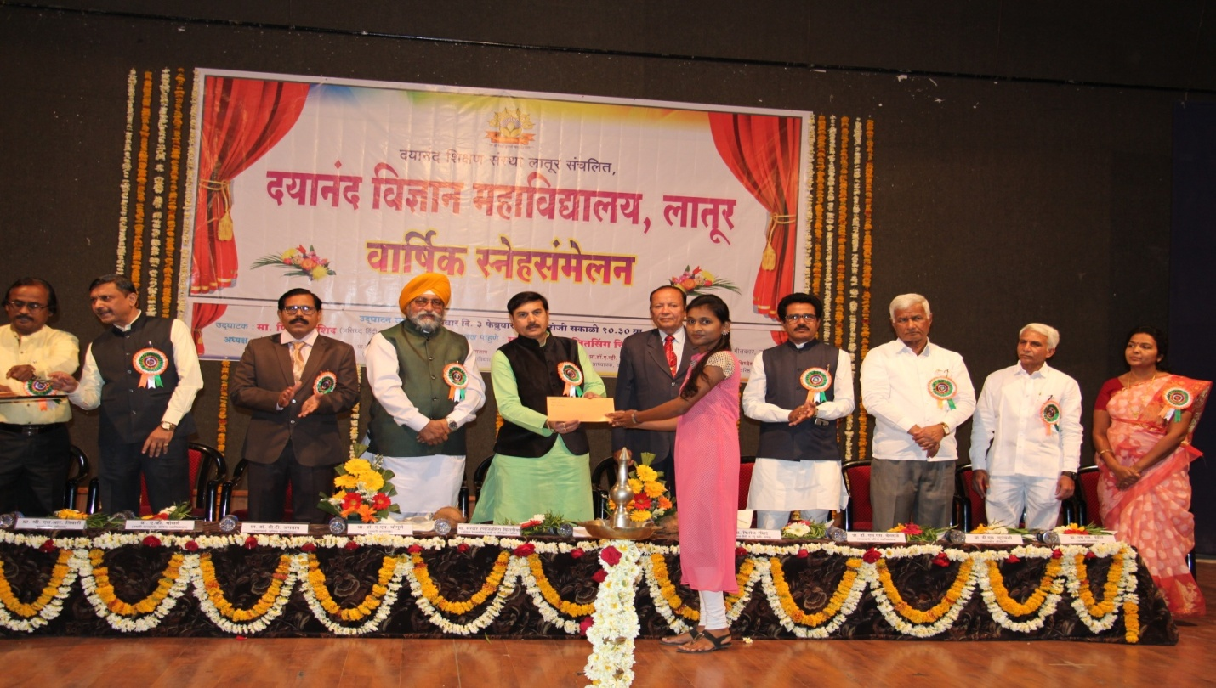
Felicitation of Merotories
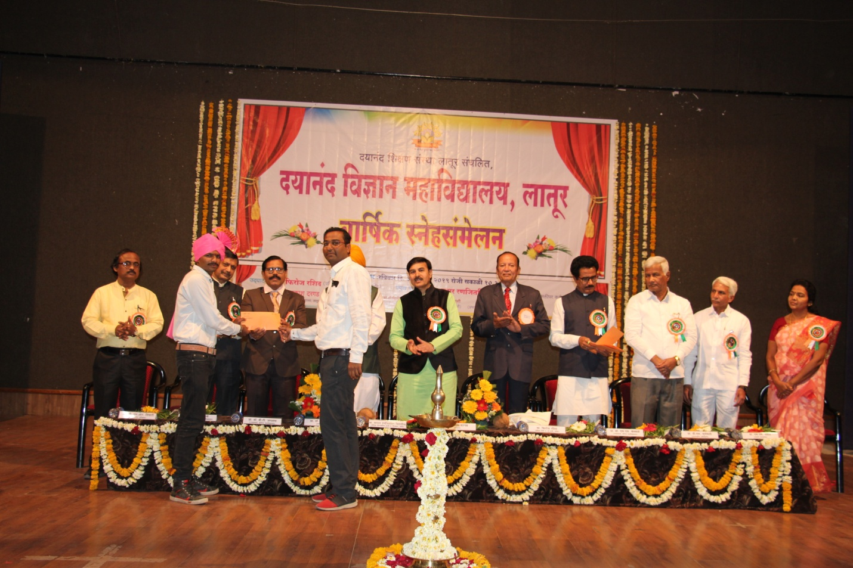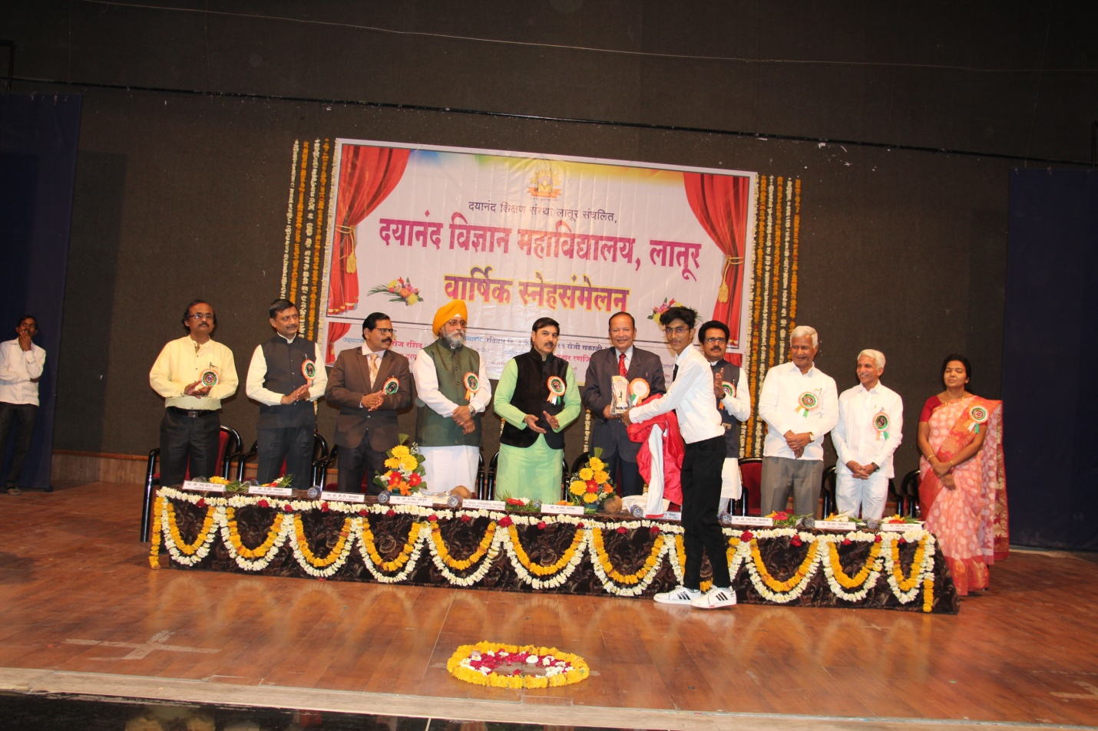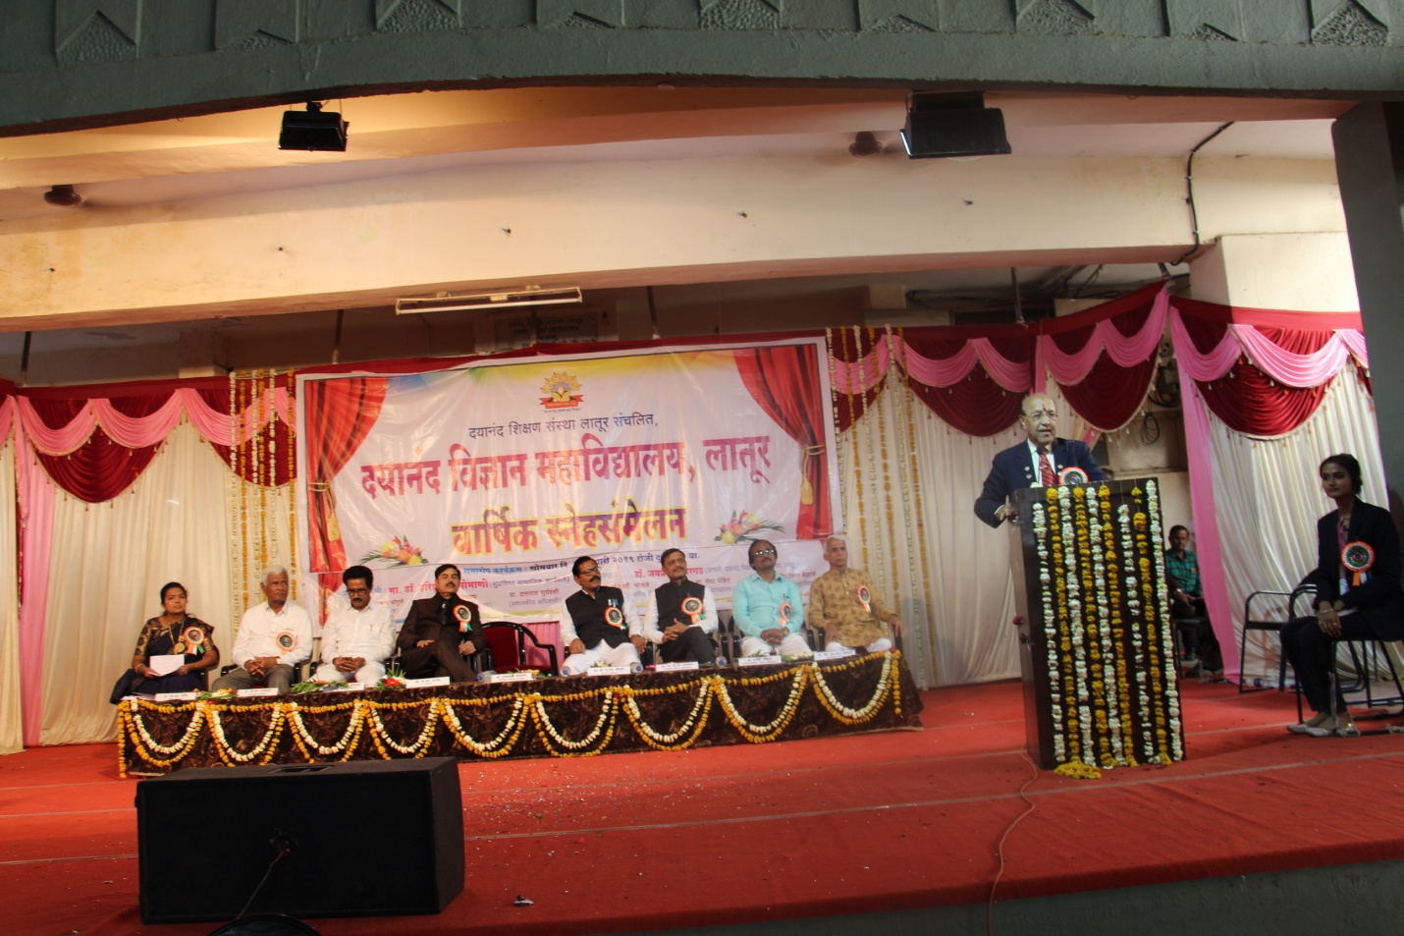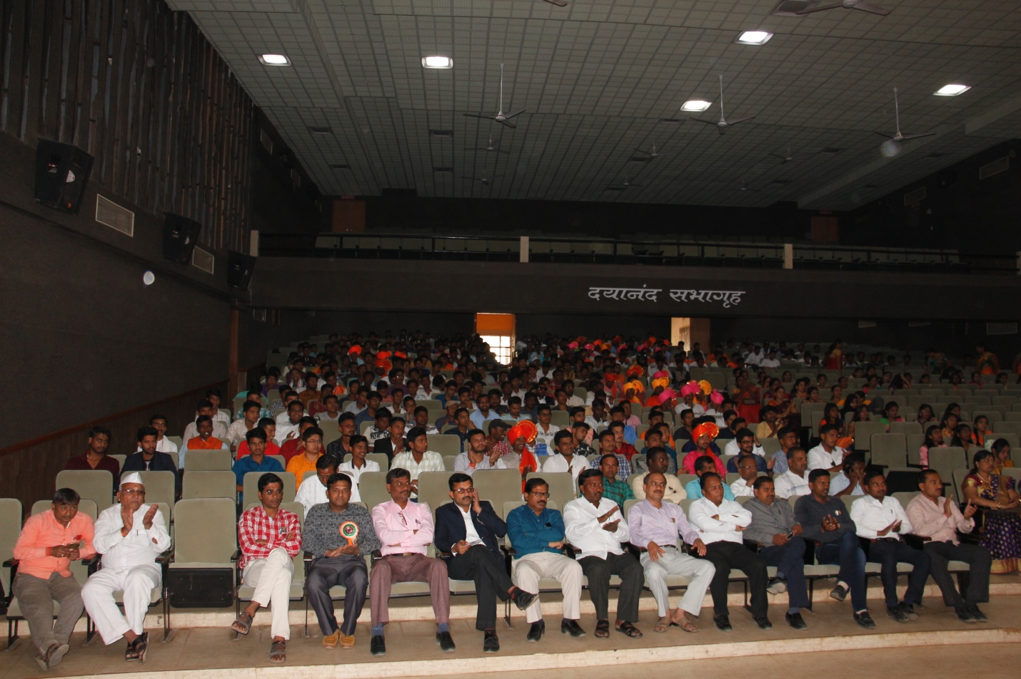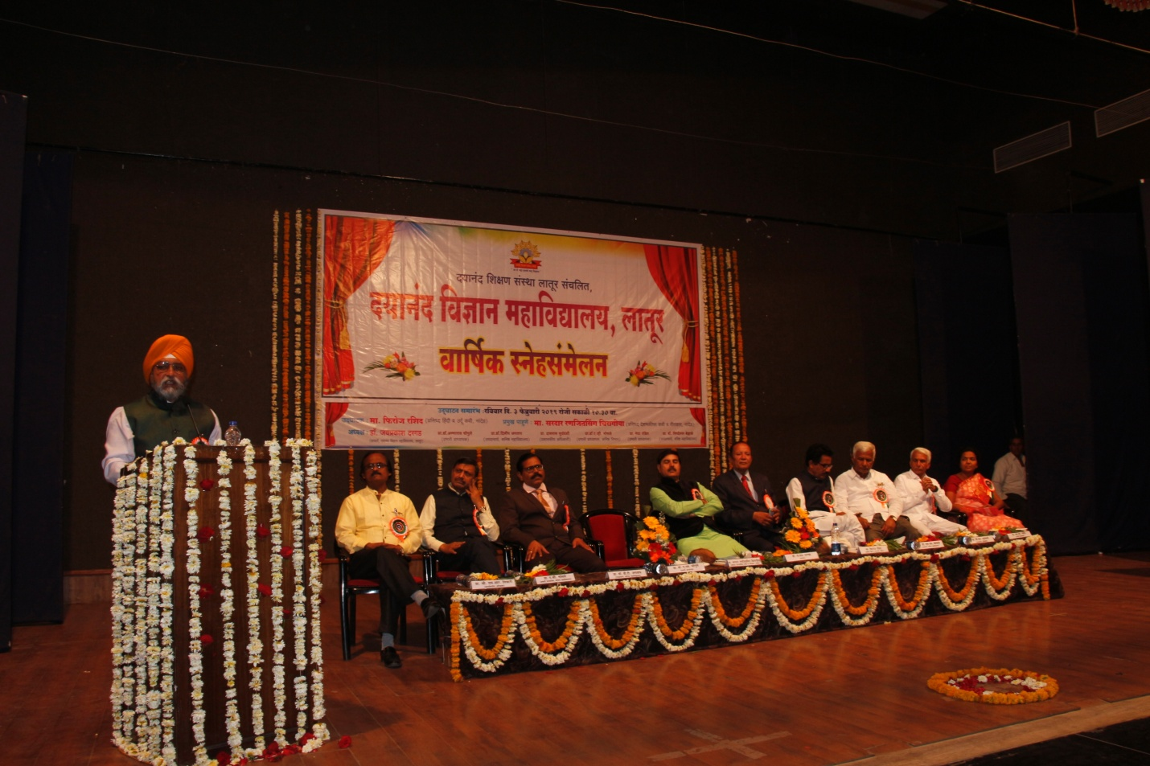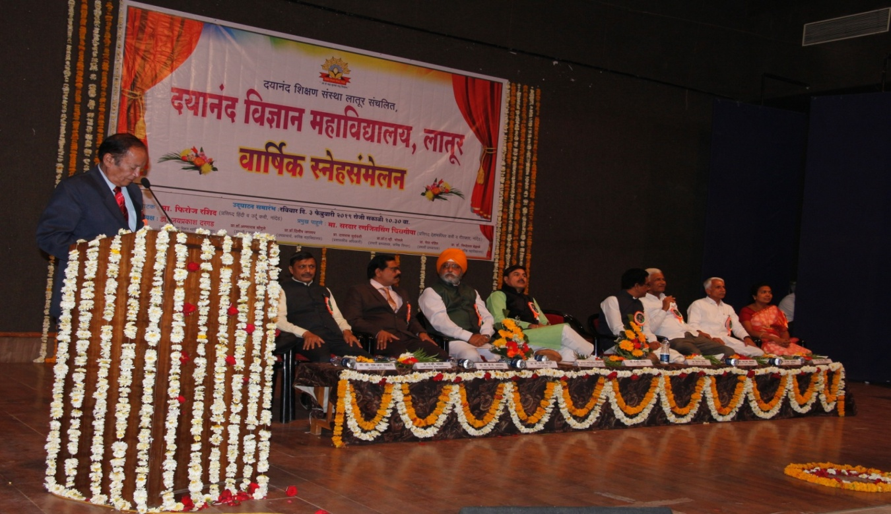
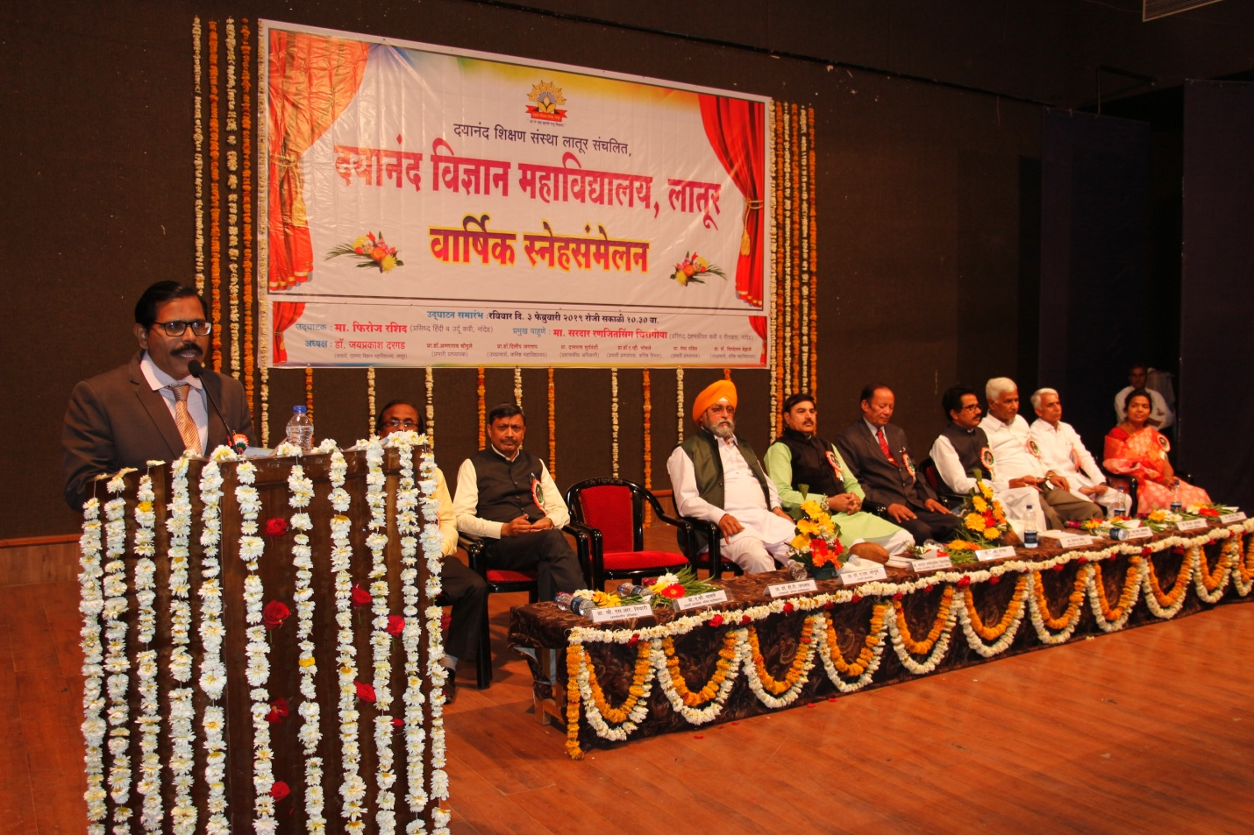

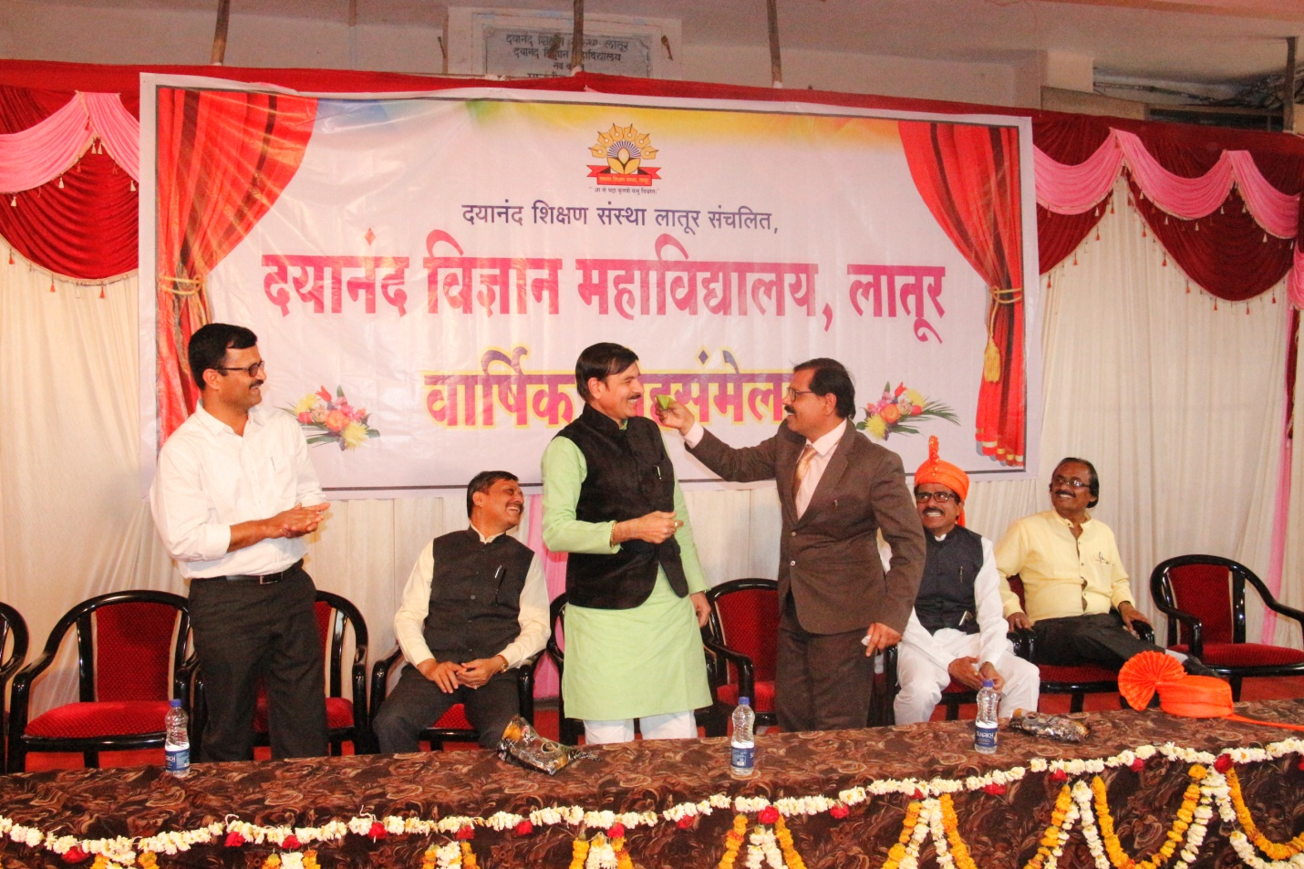
Events of Fishpond

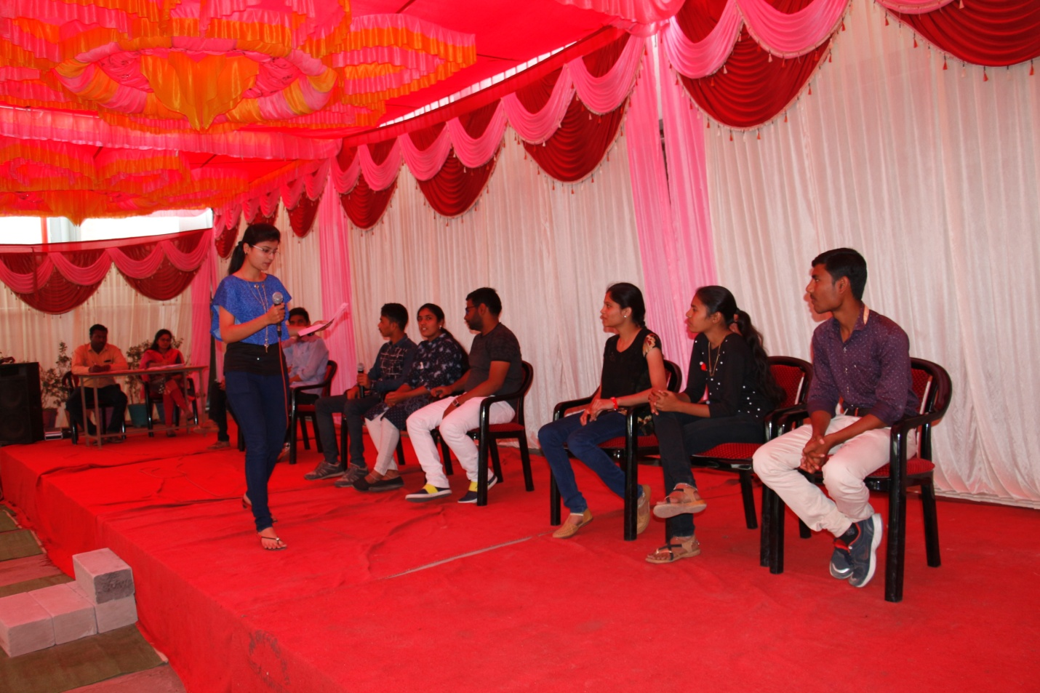
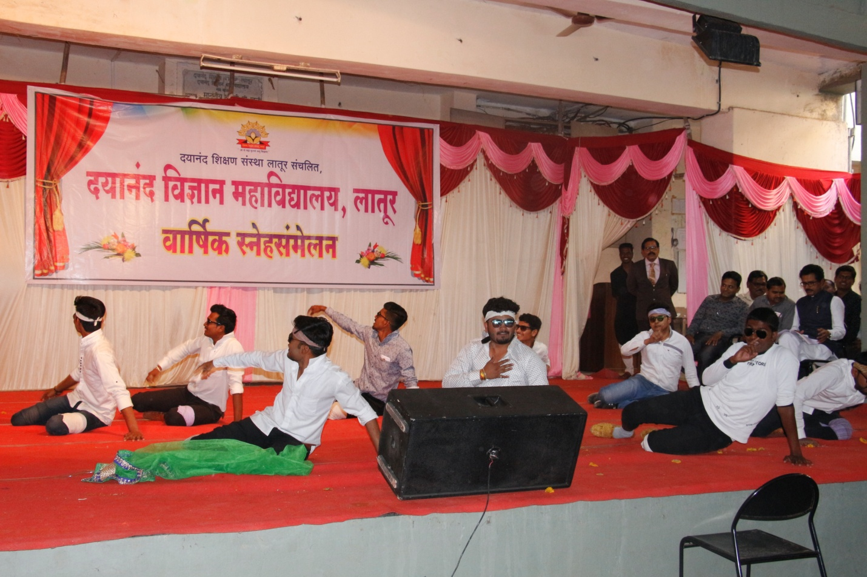

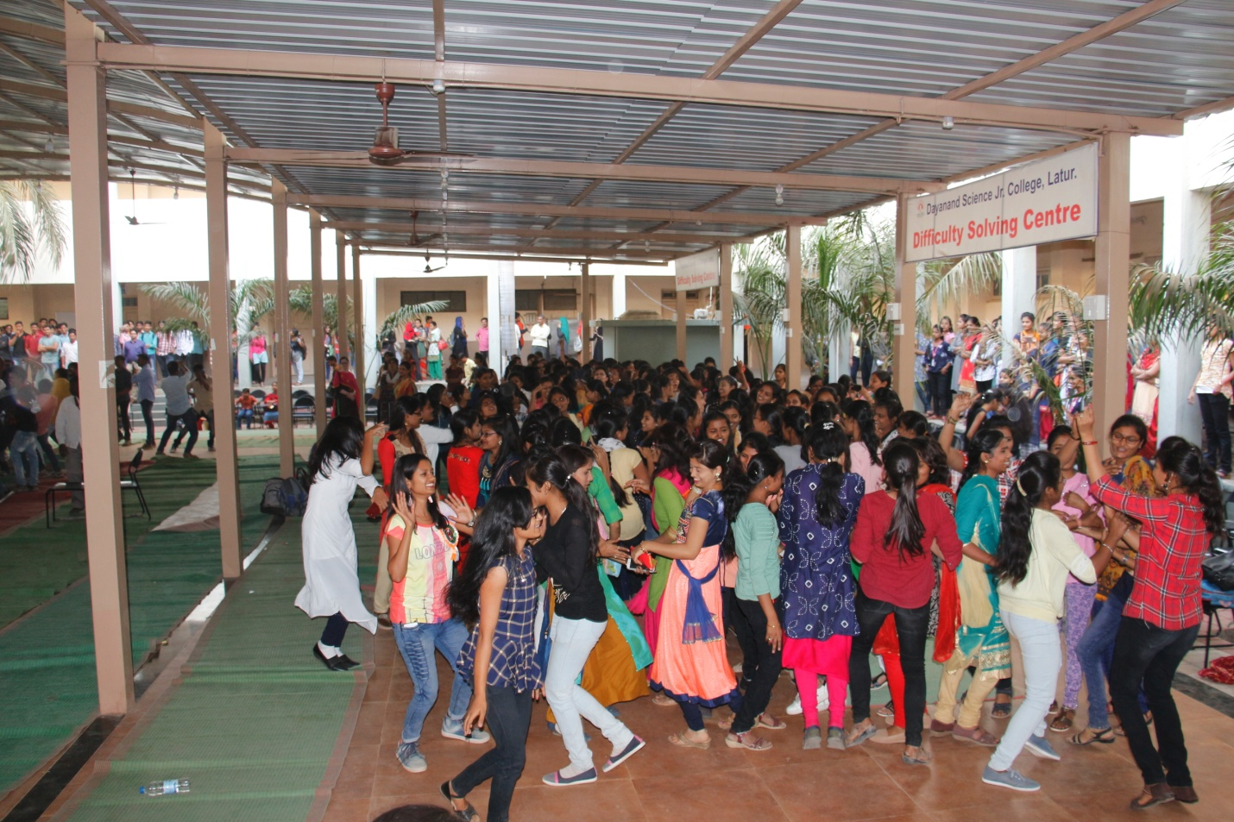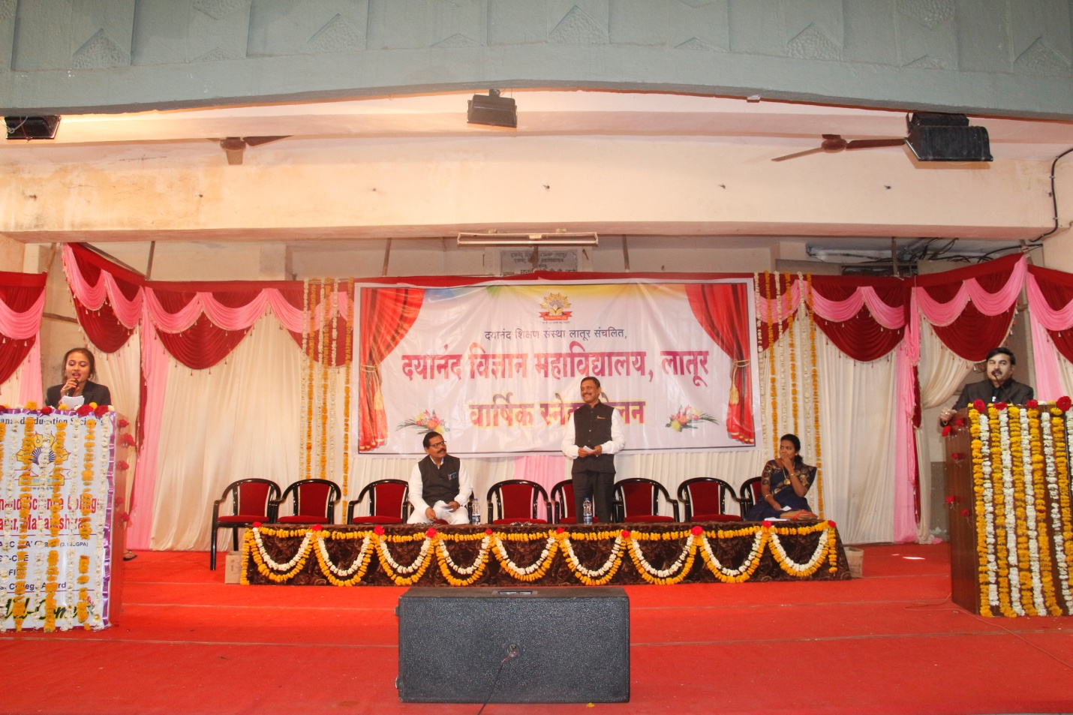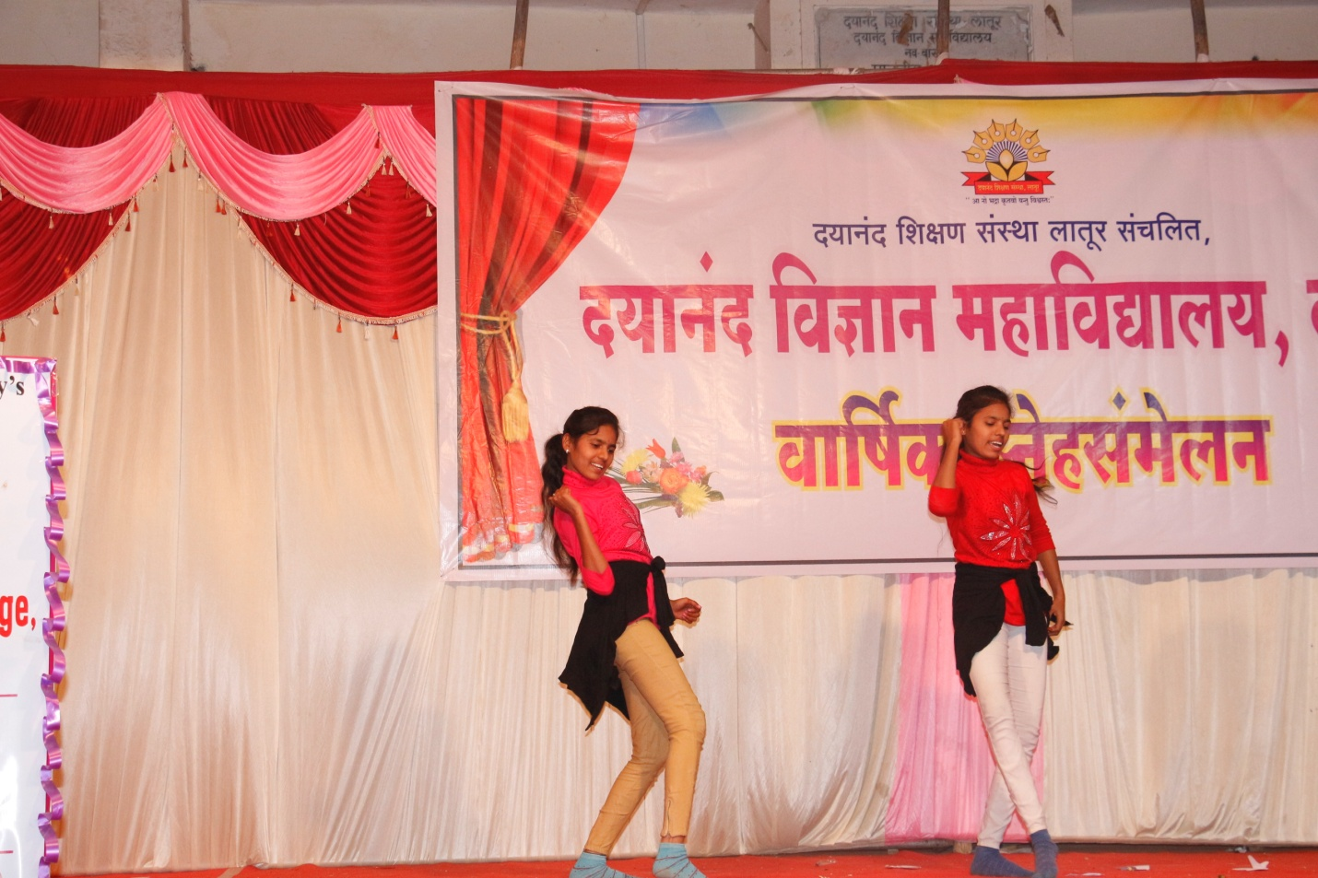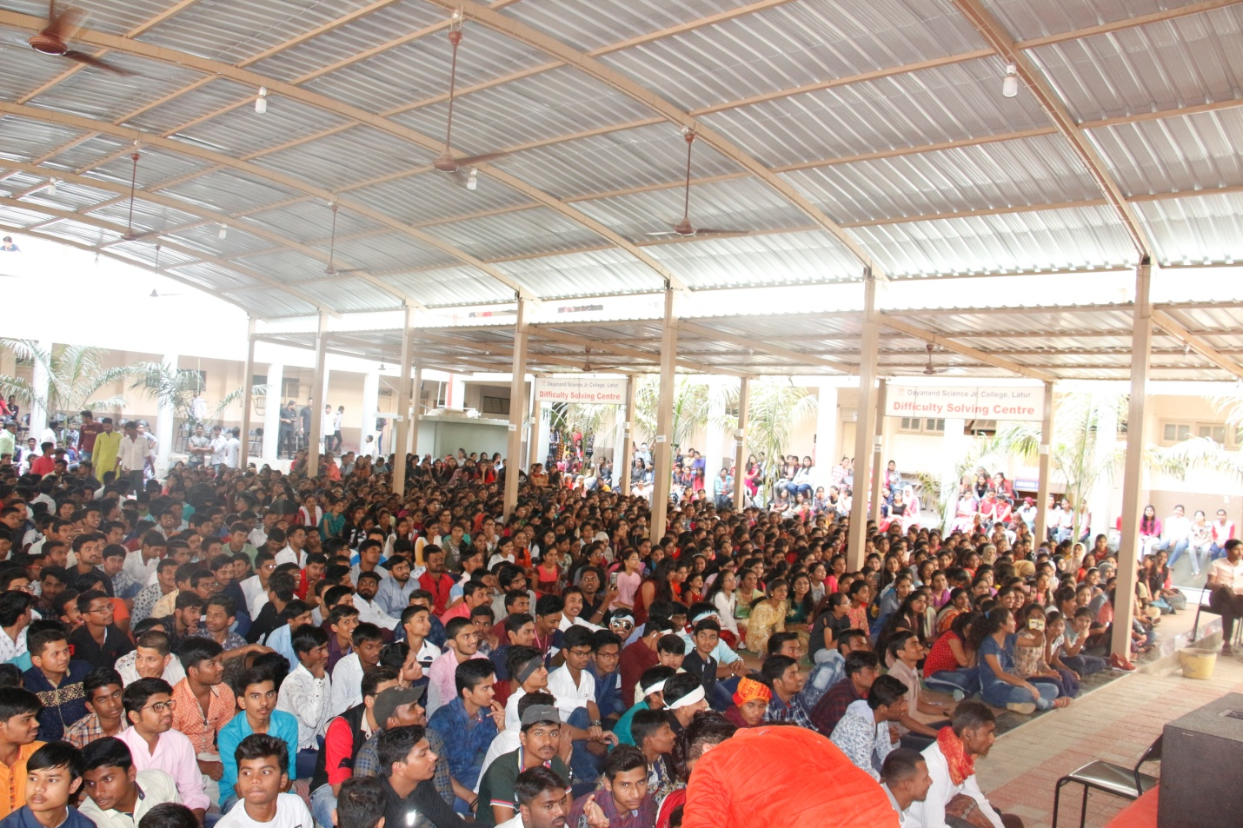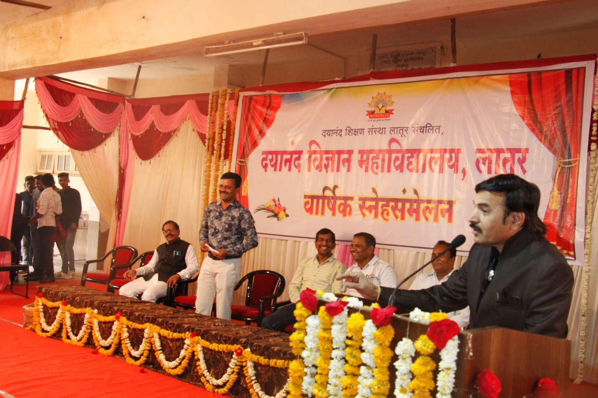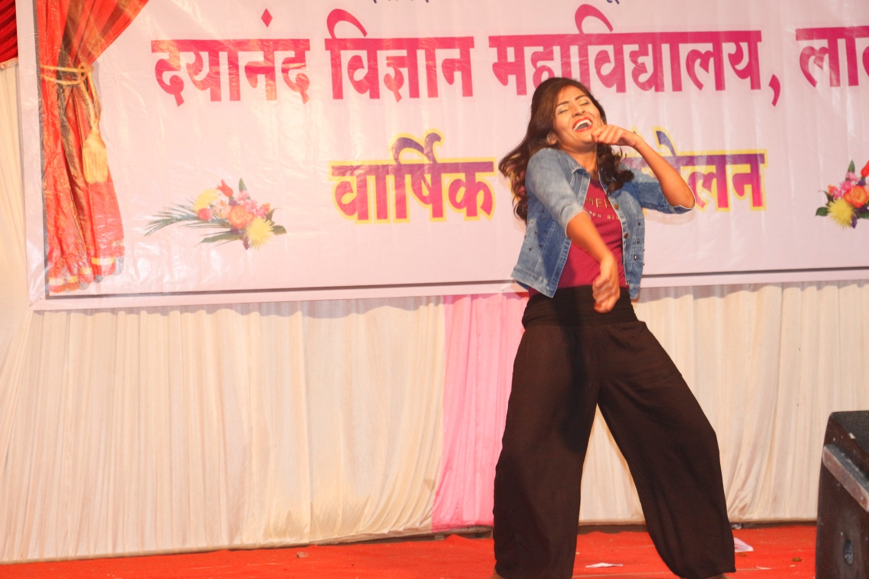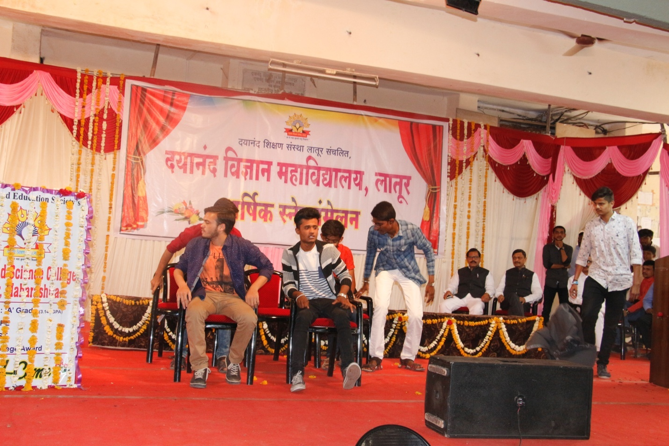

Photo Gallery Gathering Concluding Ceremony
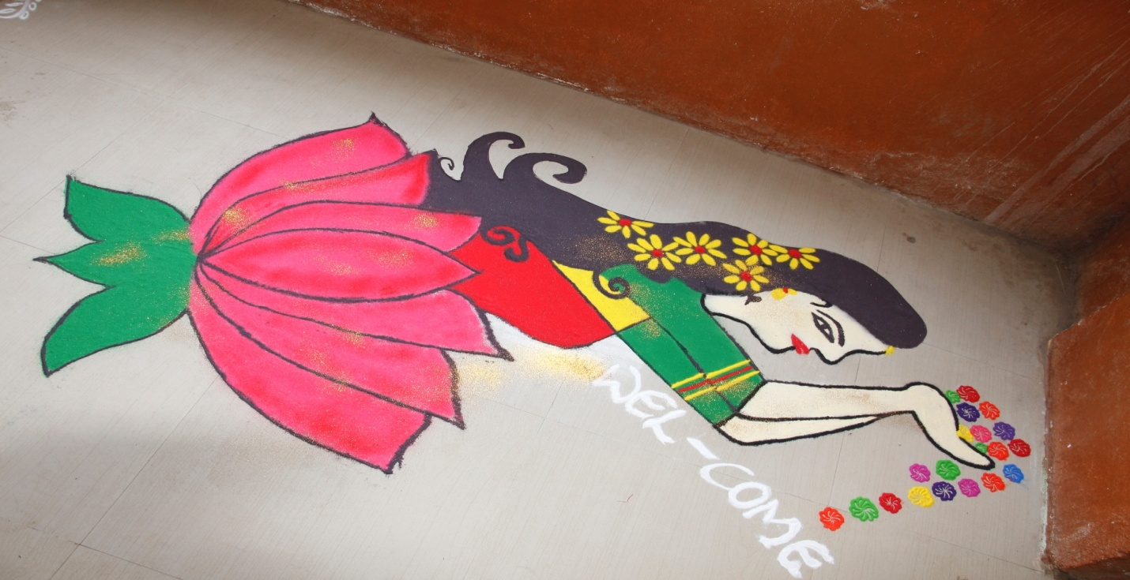
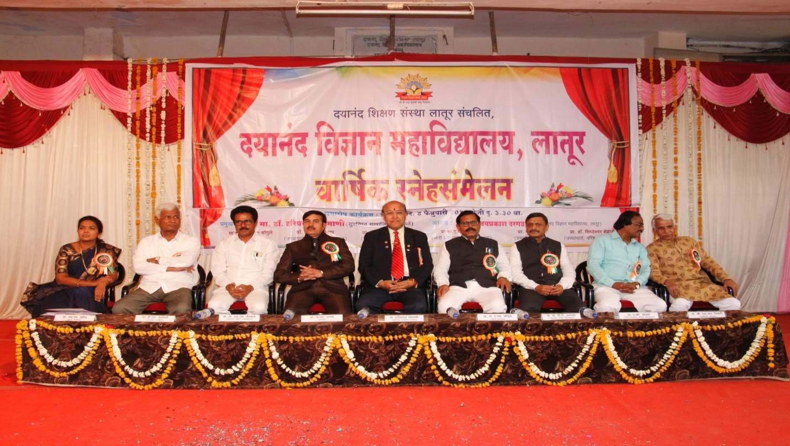
Hon. Chief Guest Dr. Hariprasad Somani Present in the concluding ceremony of Annual Function along with Hon. Dr. J S Dargad, Vice- Principle S. S Bellale, Dr. A M Chougule, Prof. Megha Pandit, Prof. Dasrao Suryawanshi, Dr. Avinash Bhosale, Sudhir Tiwari
Photo gallary health check up and workshop
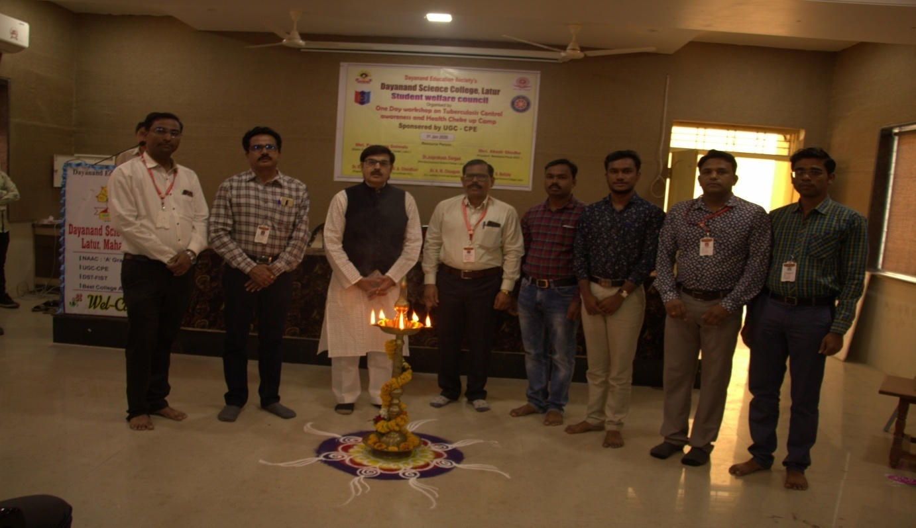

Inauguration Function of Health checkup camp in college premises
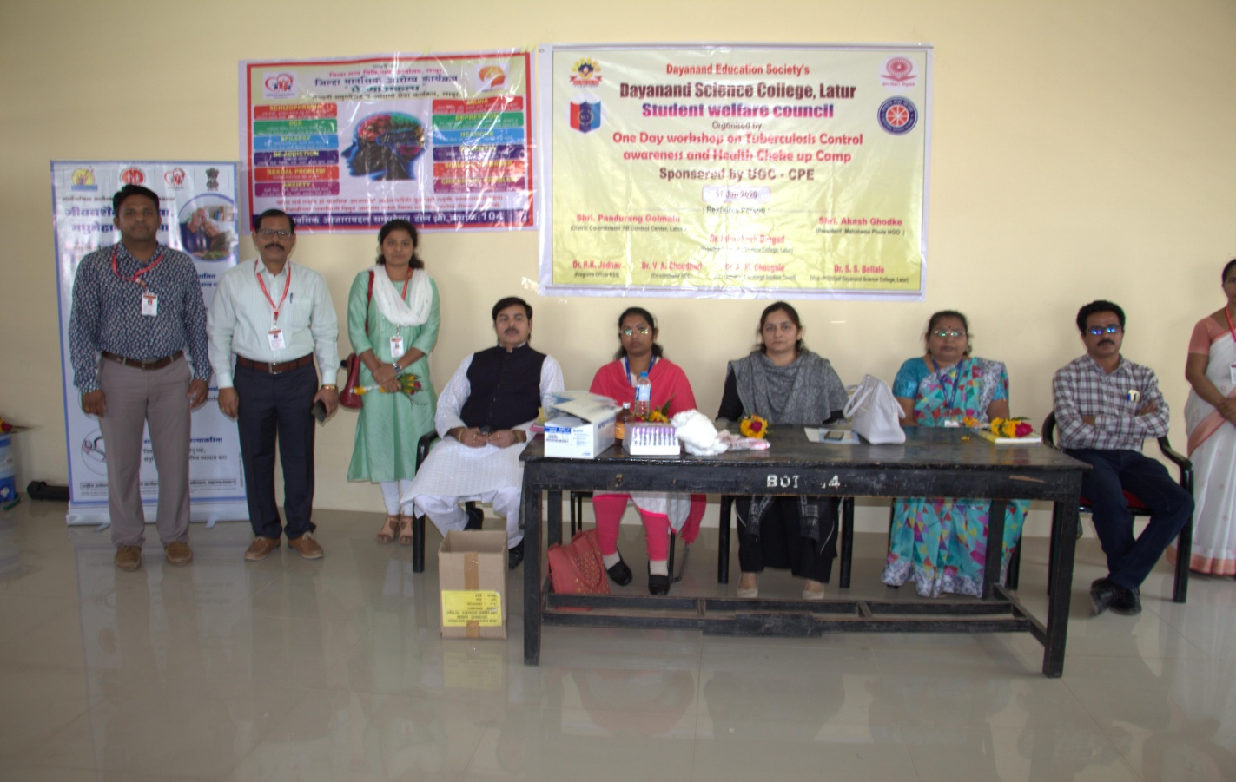
Health checkup camp for students

