Dayanand Science College Latur
Student Council
2017-2018
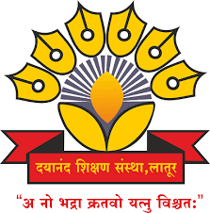

Dr.J.S.Dargad
Principal
Dayanand Science College Latur

Proffesor-In-Charge
Dr.A.M Chougule
Head
Dept.Of Industrial Chemistry

Student Welfare Committee (2017-2018)

Sr.No. | Name of Member | Designation
01 | Dr. A.M Chougule | Professor –In- Charge
02 | Prof M.M Pandit | Member
03 | Dr. M. A. Bembade | Member
04 | Dr. V. A Choudhari | Member
05 | Dr. G,H,Bane | Member
06 | Prof. R. K .Jadhav | Member
06 | Prof .A.V.Bhosale(Jr) | Member
07 | Prof .K. G Jadhav(Jr) | Member
 | Mahesh Pawar | Secretary student council

Activities (2017-2018)

Sr.No. | Name of Activities | Date | Chief Guest
01 | Student Council Opening Ceremony function | 1 January 2018 | Hon. Prashant More  (Famous poem and Singer)
02 | Annual Social Gathering | 2-3 Jan,2018 | Opening ceremony | Concluding  ceremony
 |  |  | Hon.Prakashji Nihlani  (Well known Humorous Poet) | Hon. G Shirikant  (Disttrict Collector Latur)

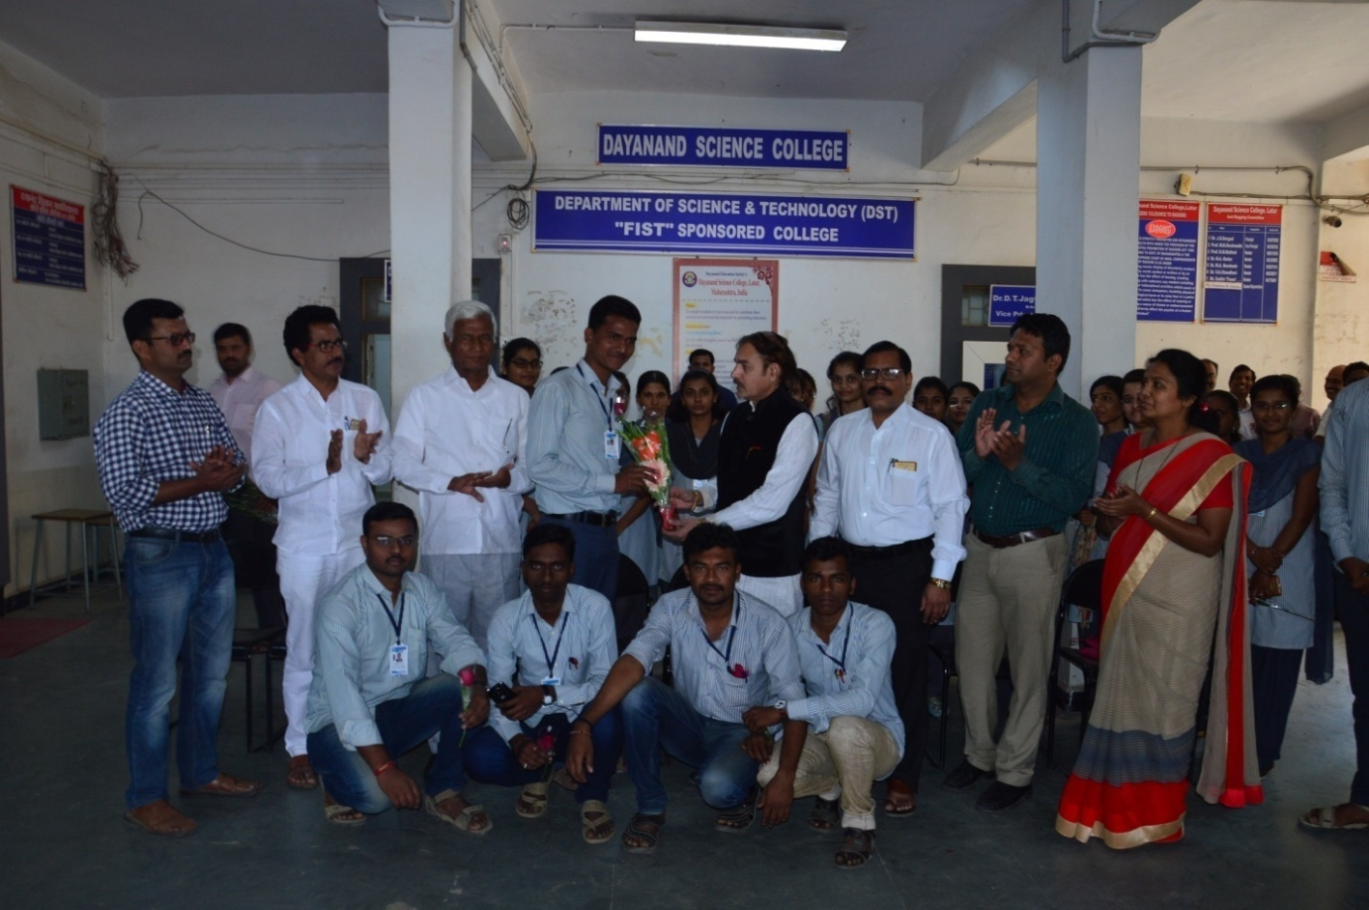
Hon, Principal Dr.J.S.Dargad Felicitated newly elected Student Council President Mr.Mahesh Pawar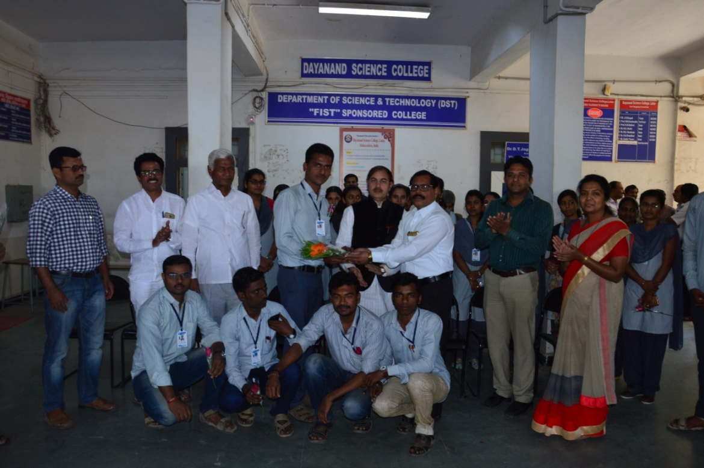
Student Council- In-charge Dr.A.M.Chougule Felicited newly elected Student Council President Mr.Mahesh Pawar

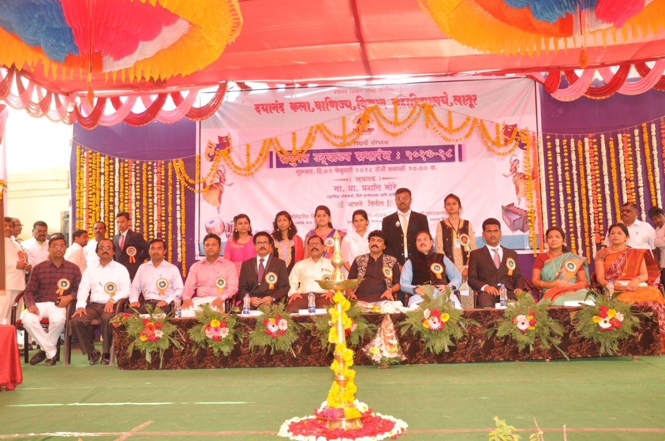Student Council committee,student council representatives with Chief Guest of Student council Hon.Prashant More along with Hon.Principal Dr.J.S. Dargad and Vice-Principal Dr.S.S Bellale,Student council Incharge Dr.A.M Chougule,
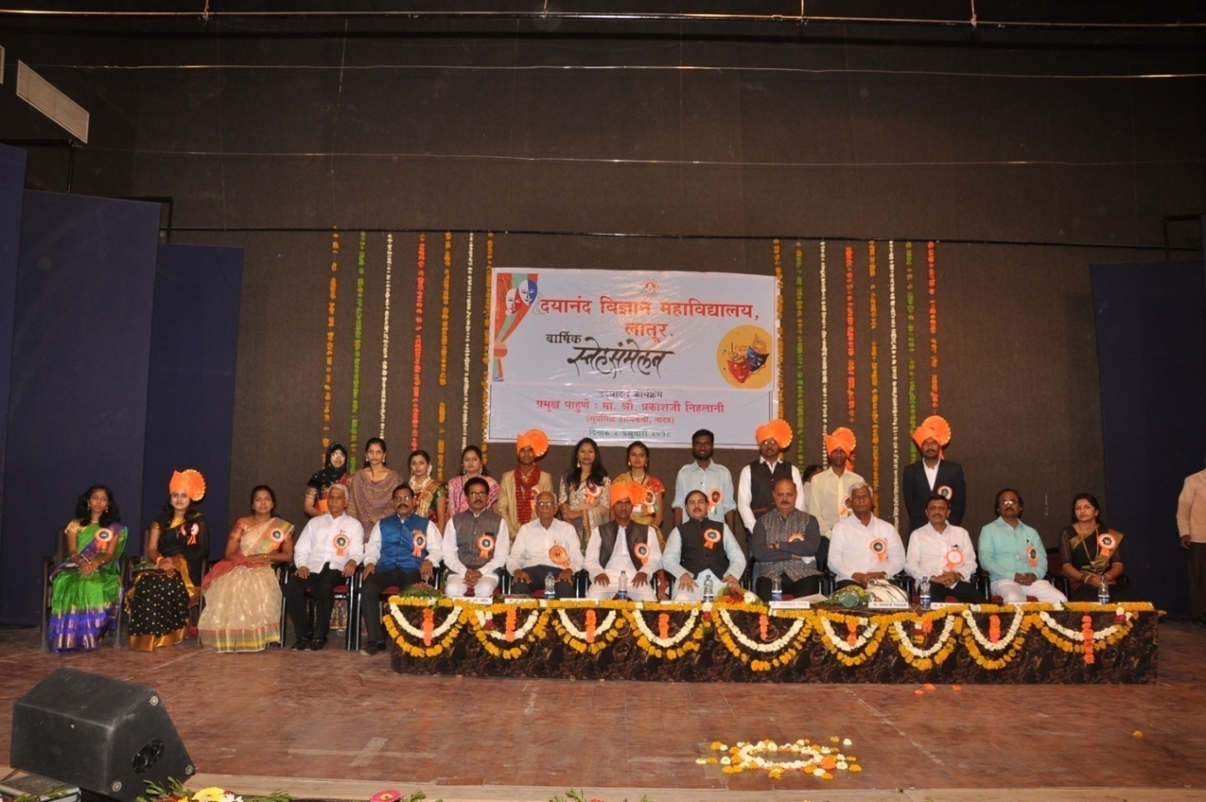
Student representative and student welfare committee with chief guest Annual Function Hon. Prakashji Nehalani along with Hon.Principal Dr.J.S. Dargad and Vice-Principal Dr.S.S Bellale,DrA.M Chougule,prof Megha Pandit,Shri Dasrao Suryawanshi,Dr V.T JagtapDr.Avinash Bhosle,Shri Sudhir Tiwari,Mahesh Pawar

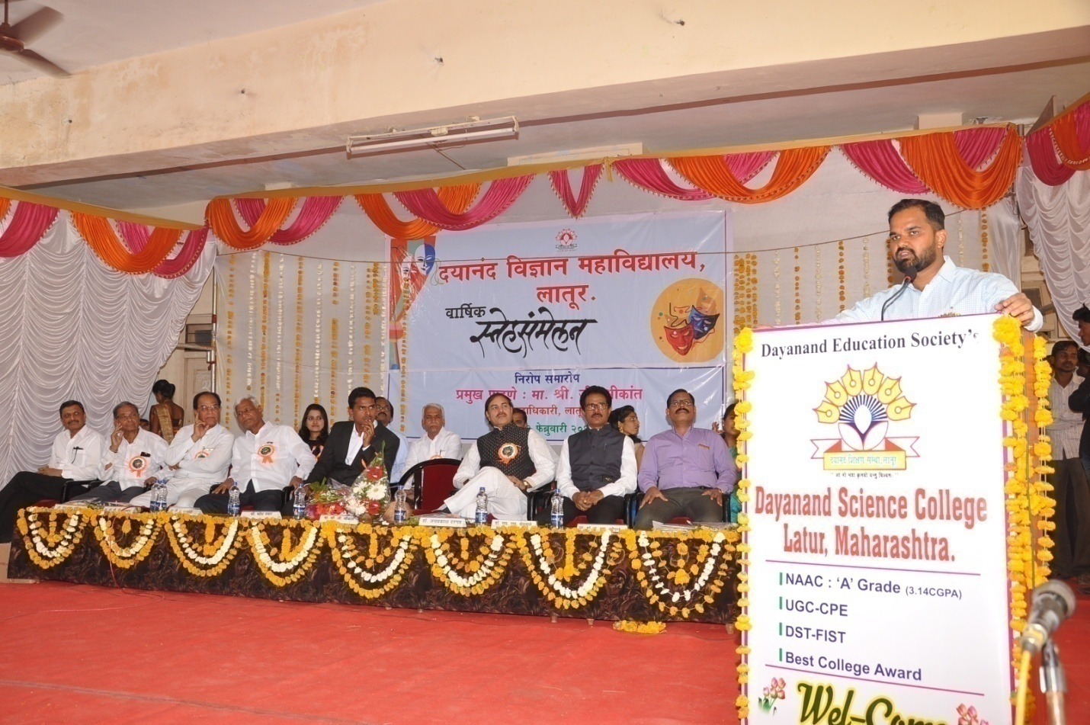
Hon.District Collector G.Shrikant Addressing to concluding ceremony programme
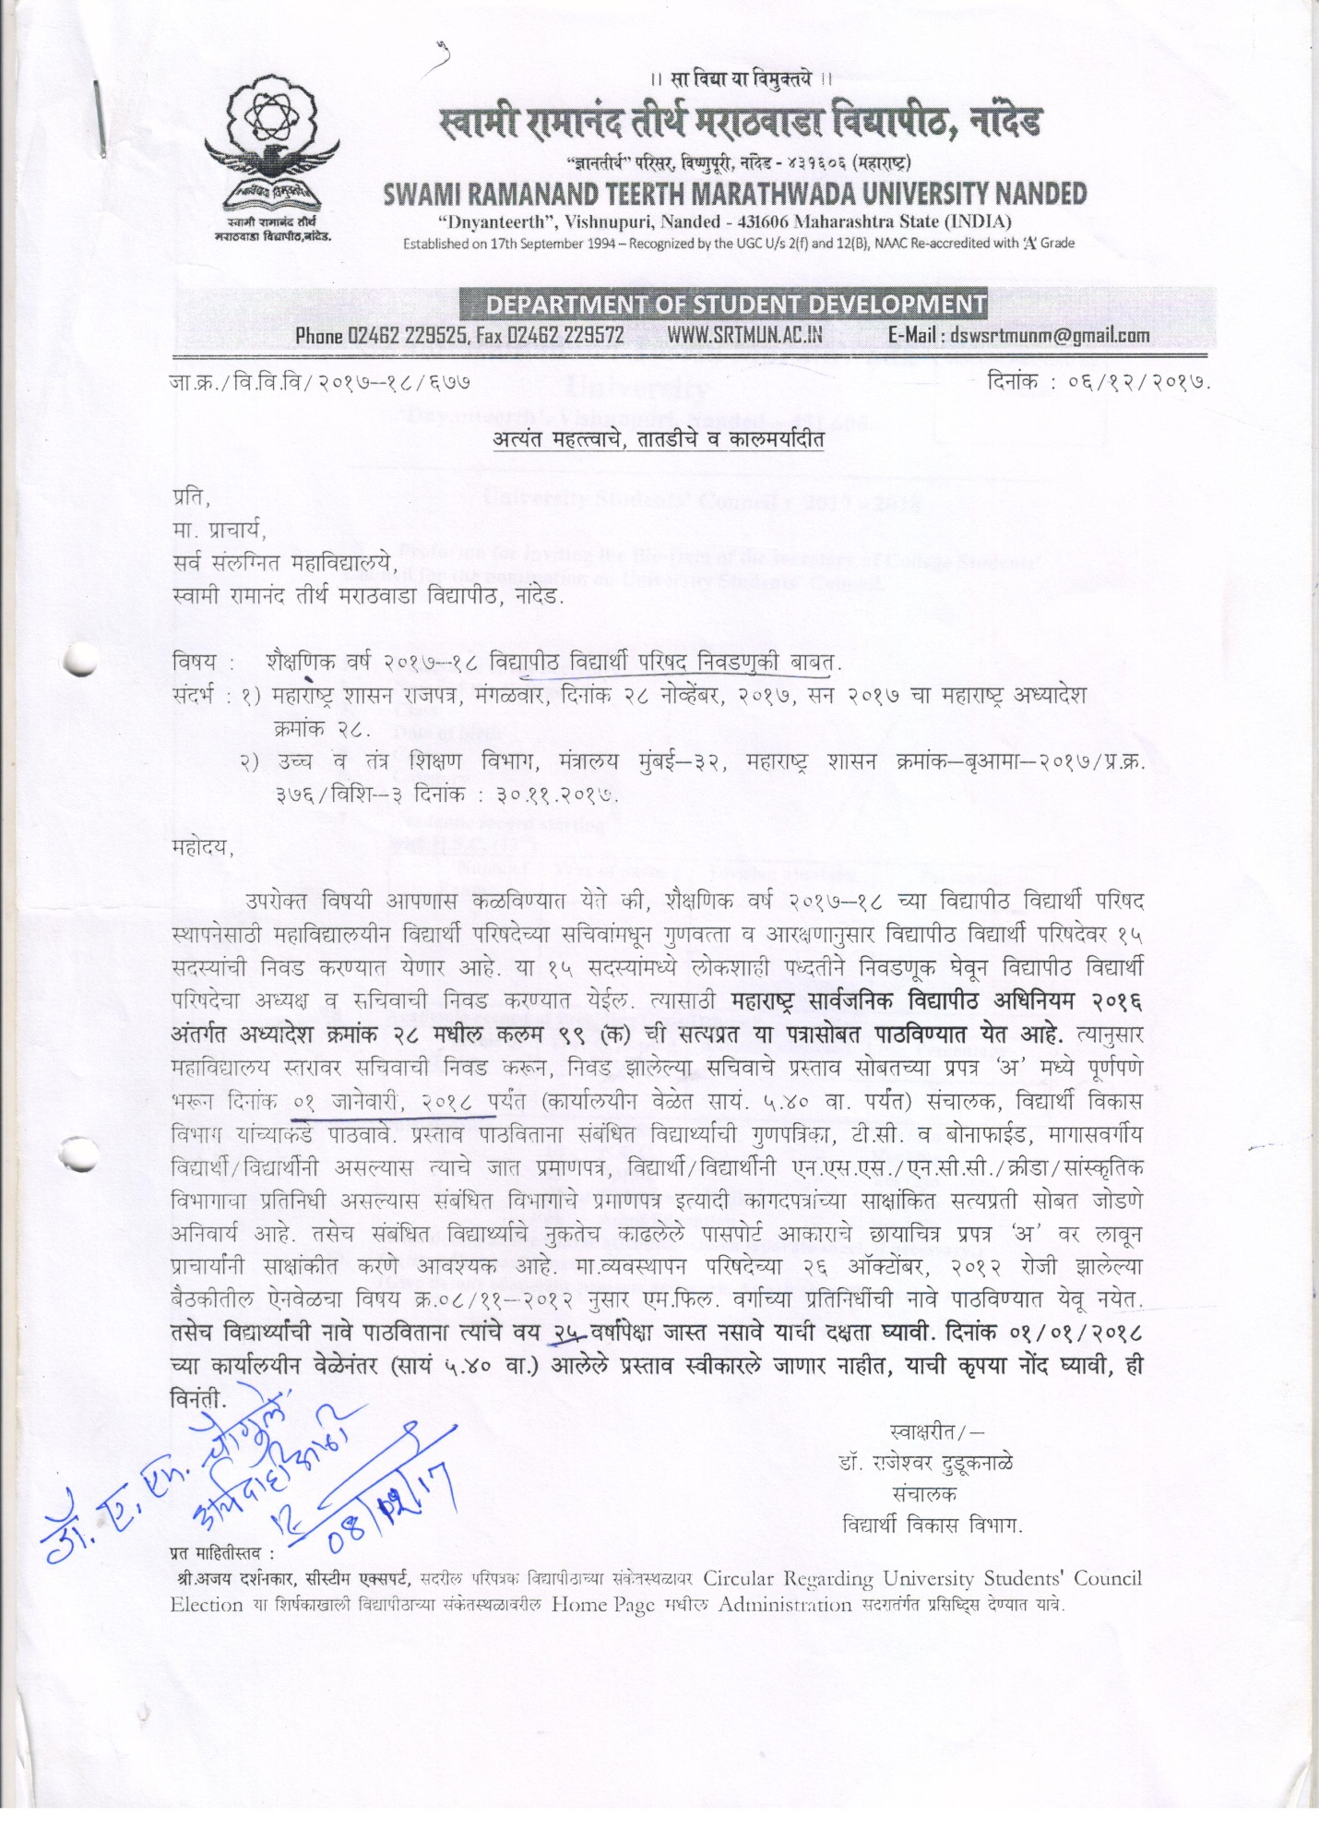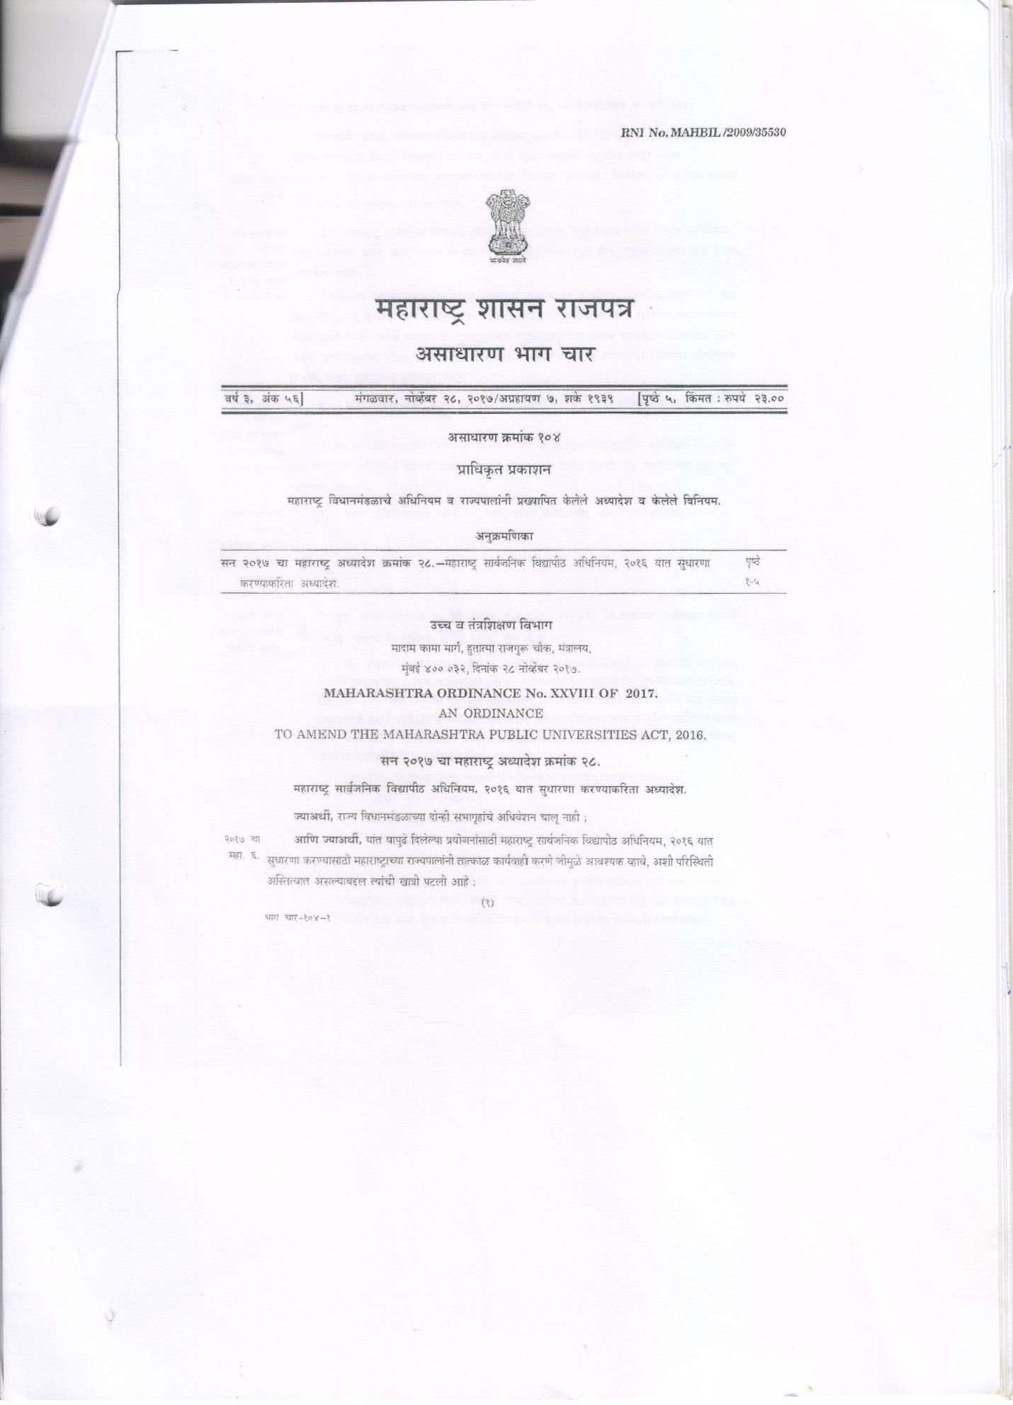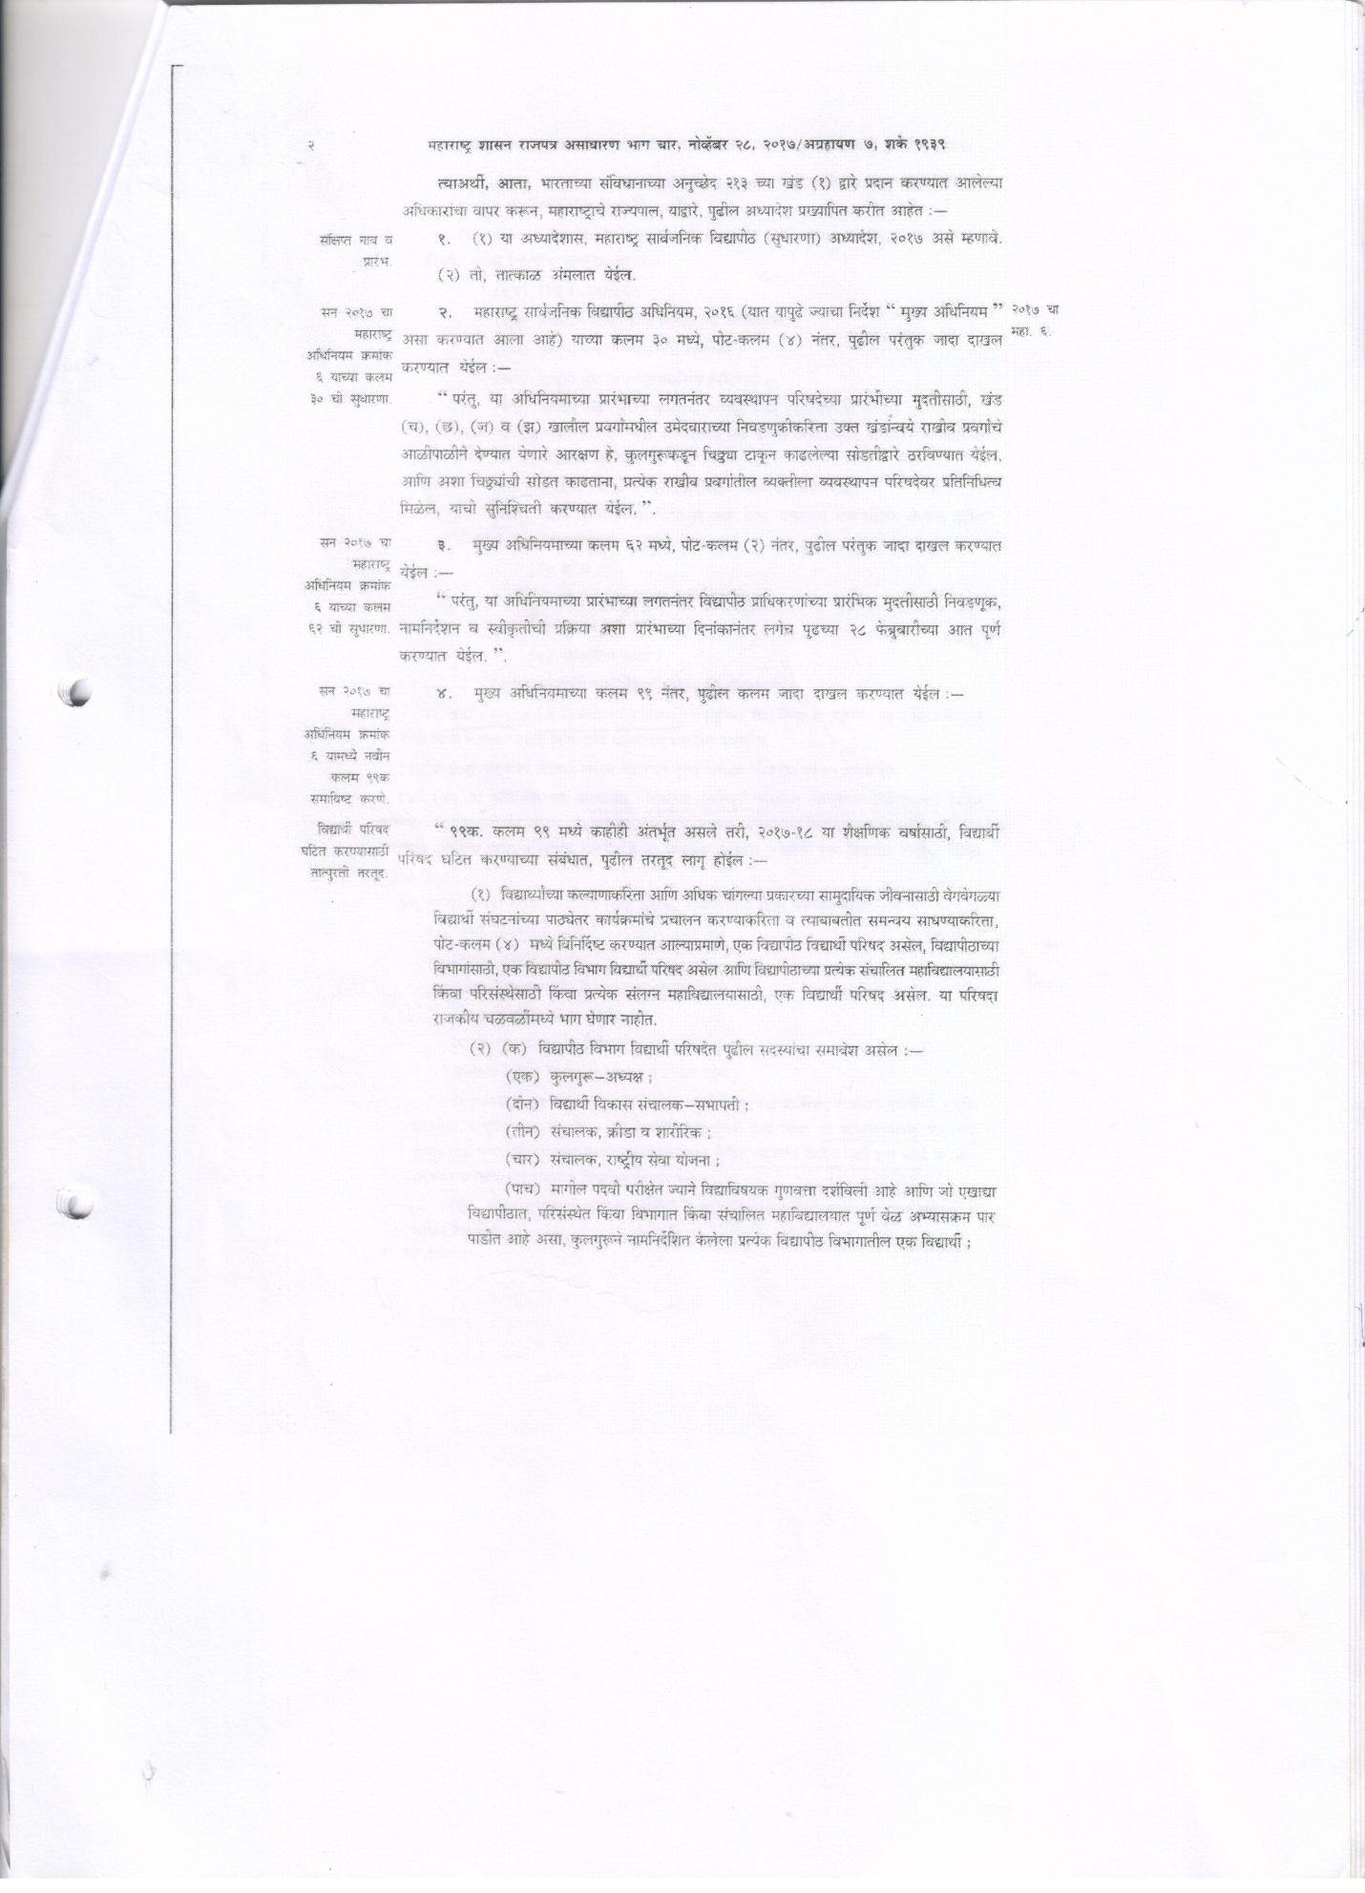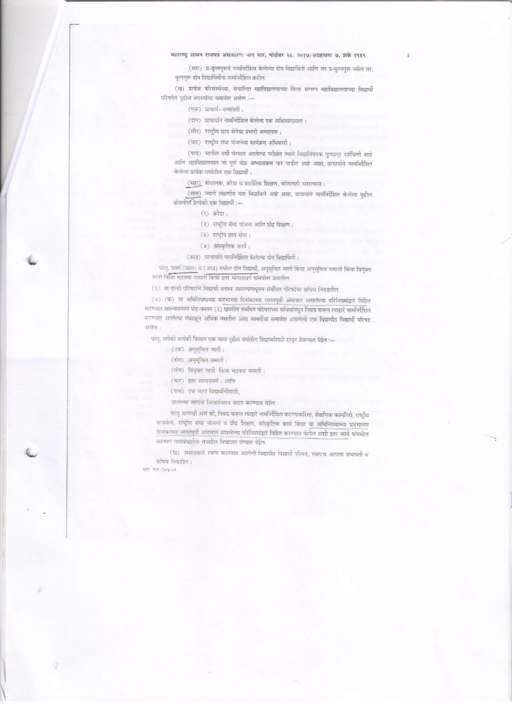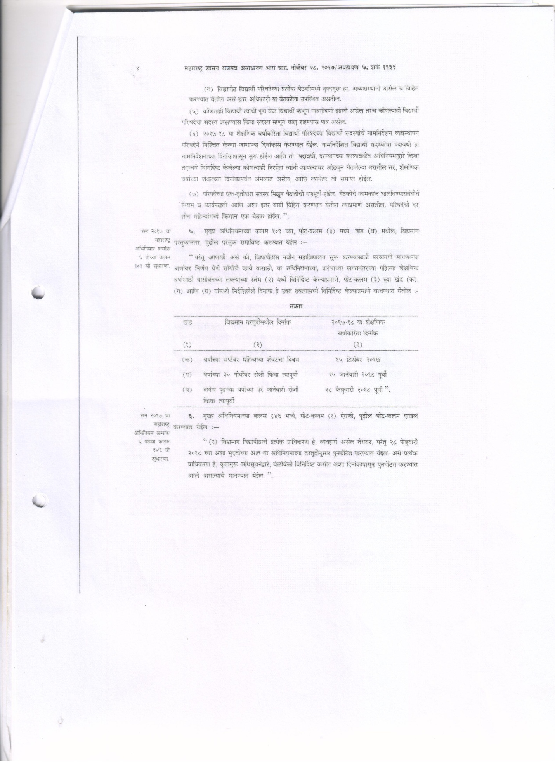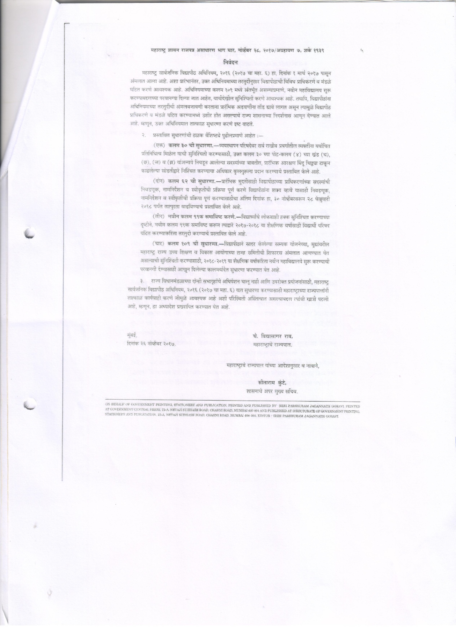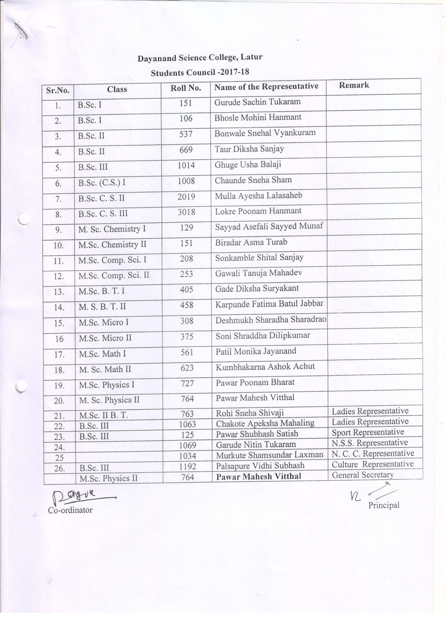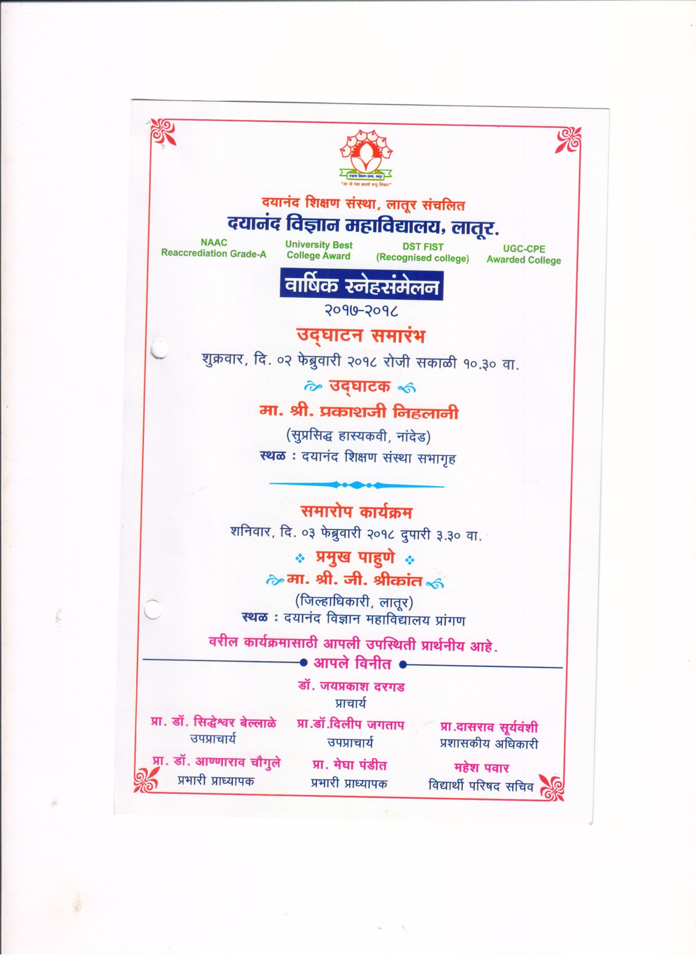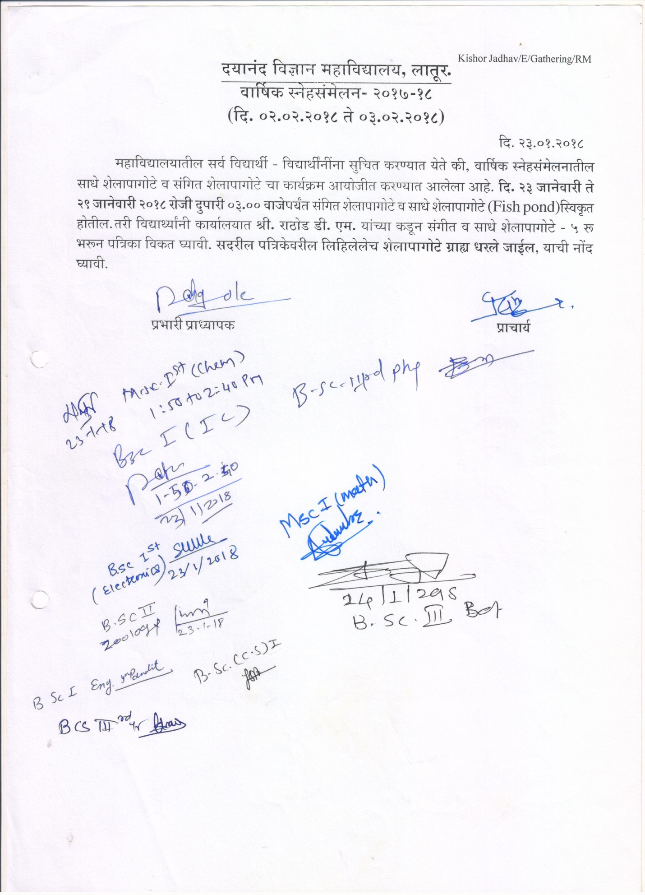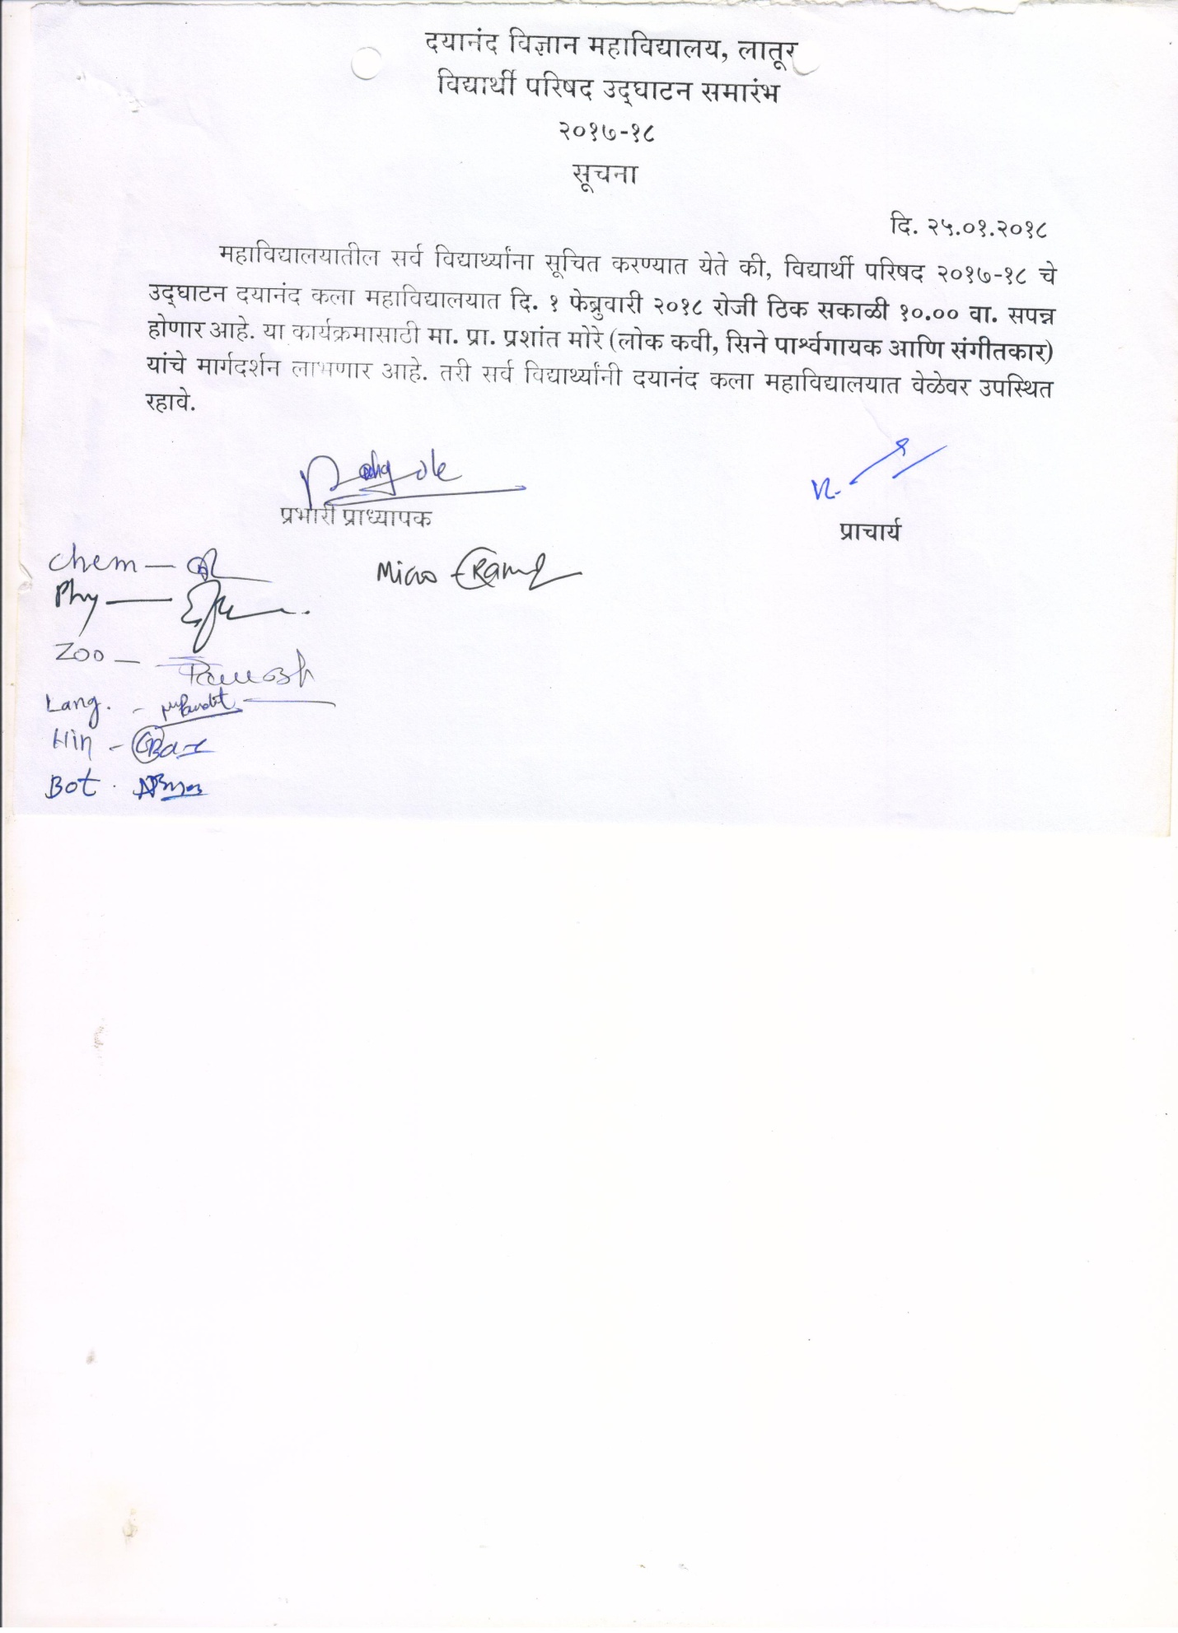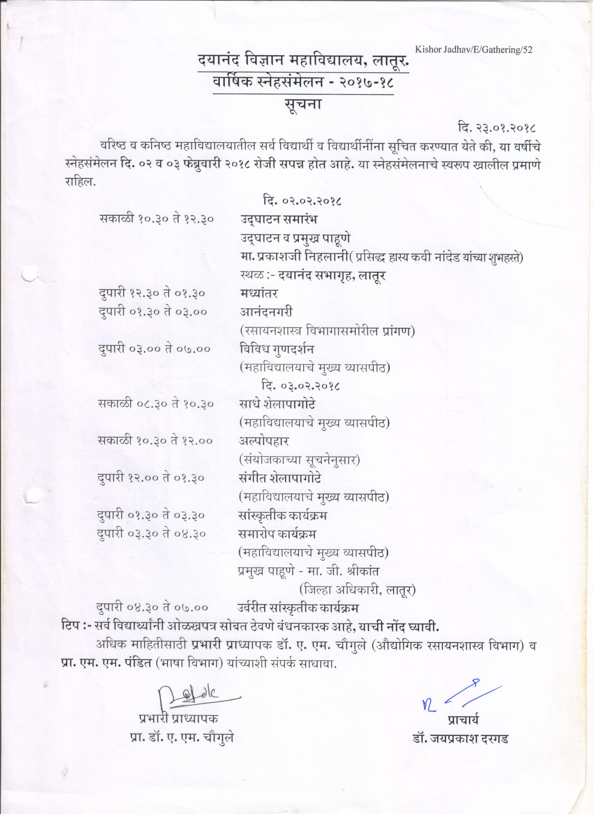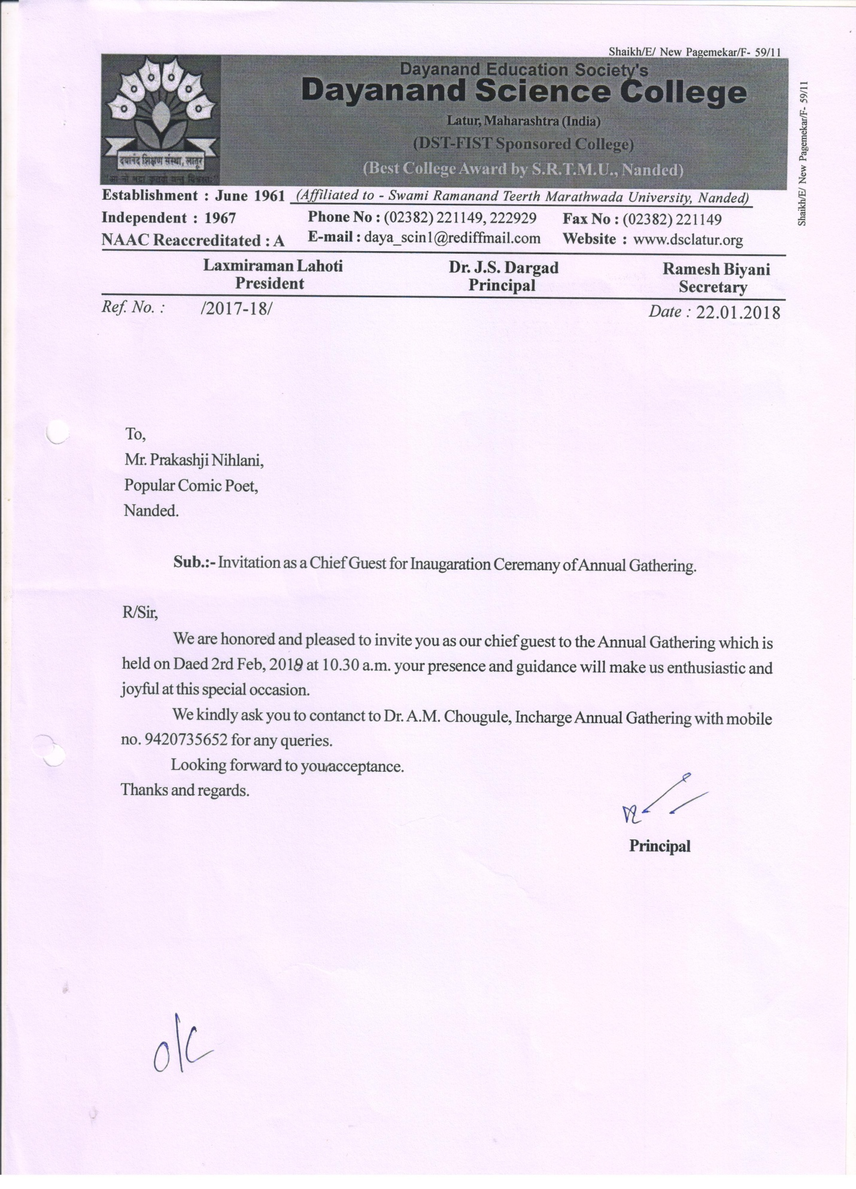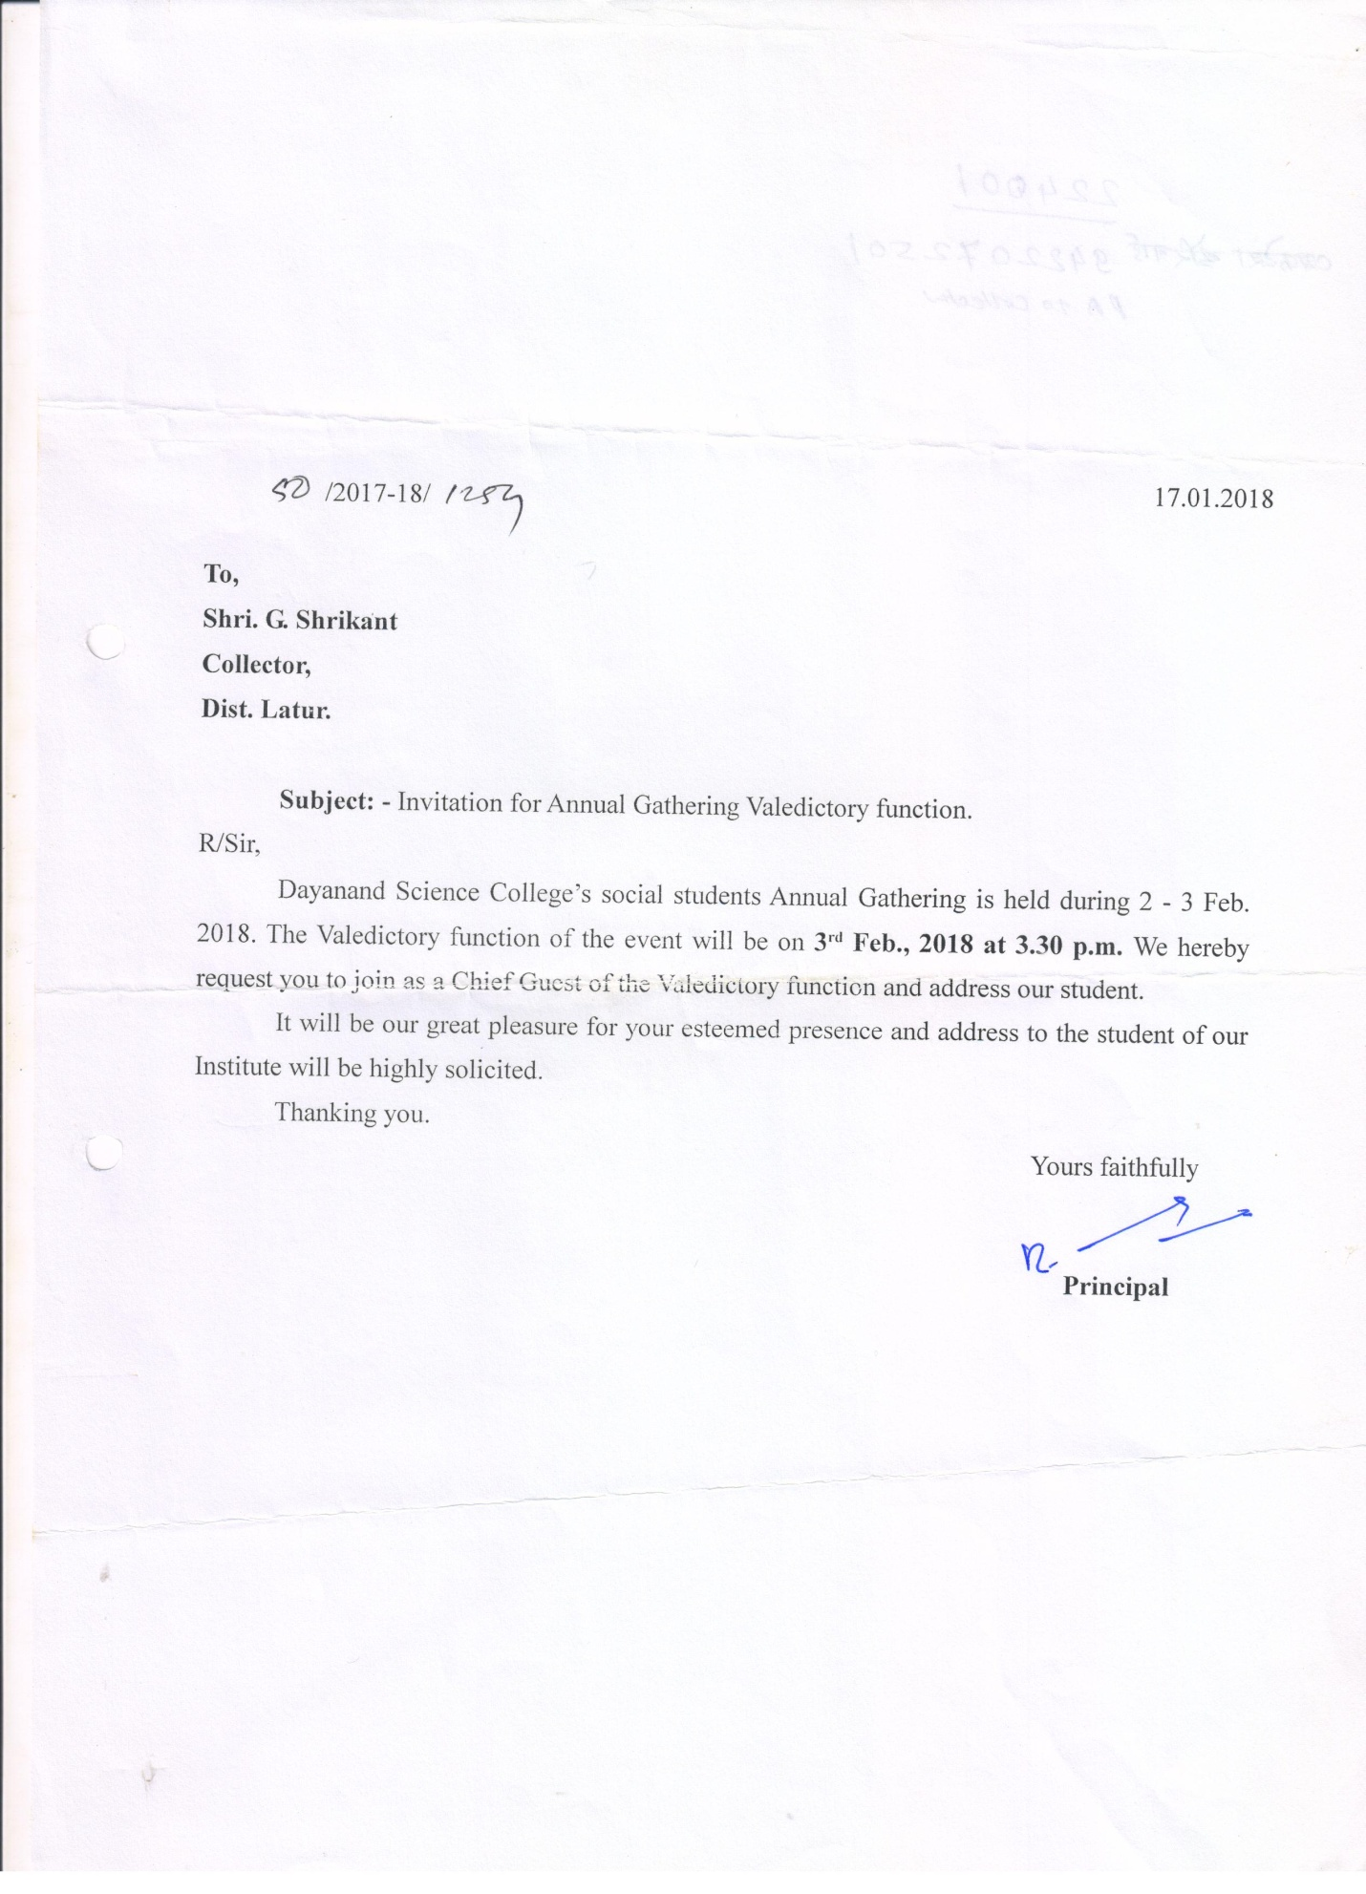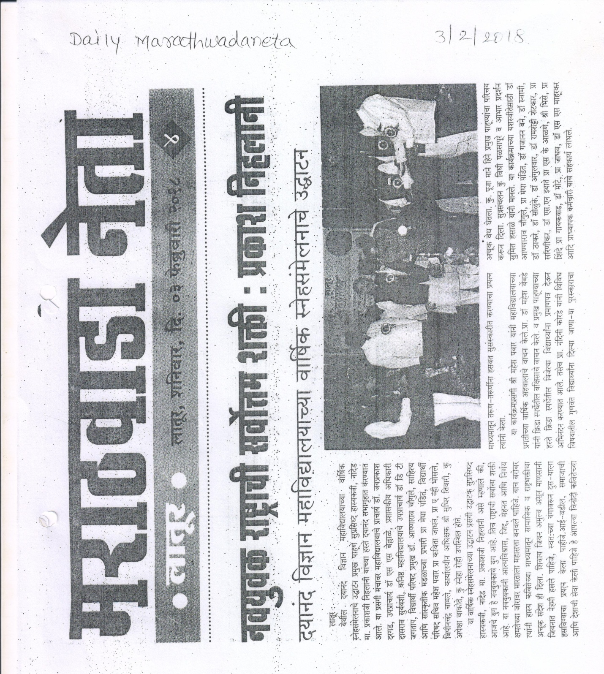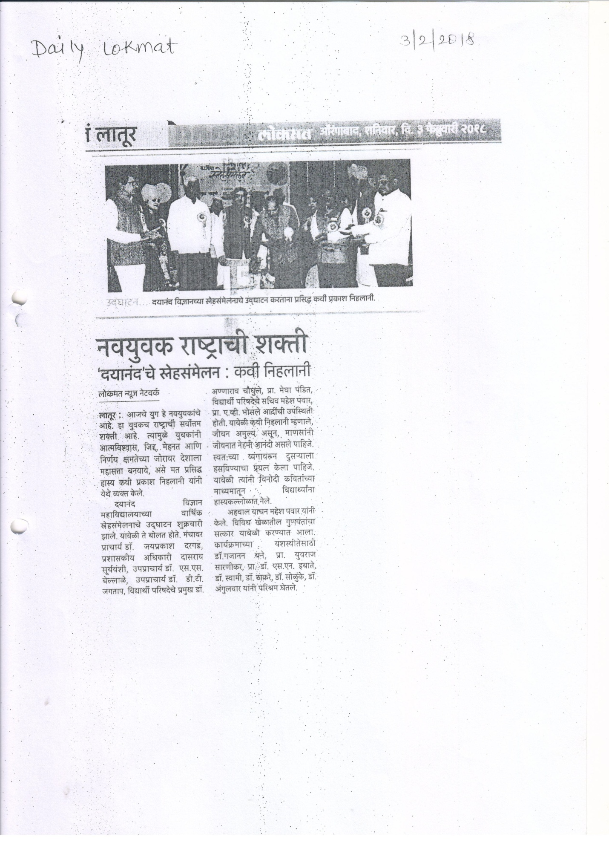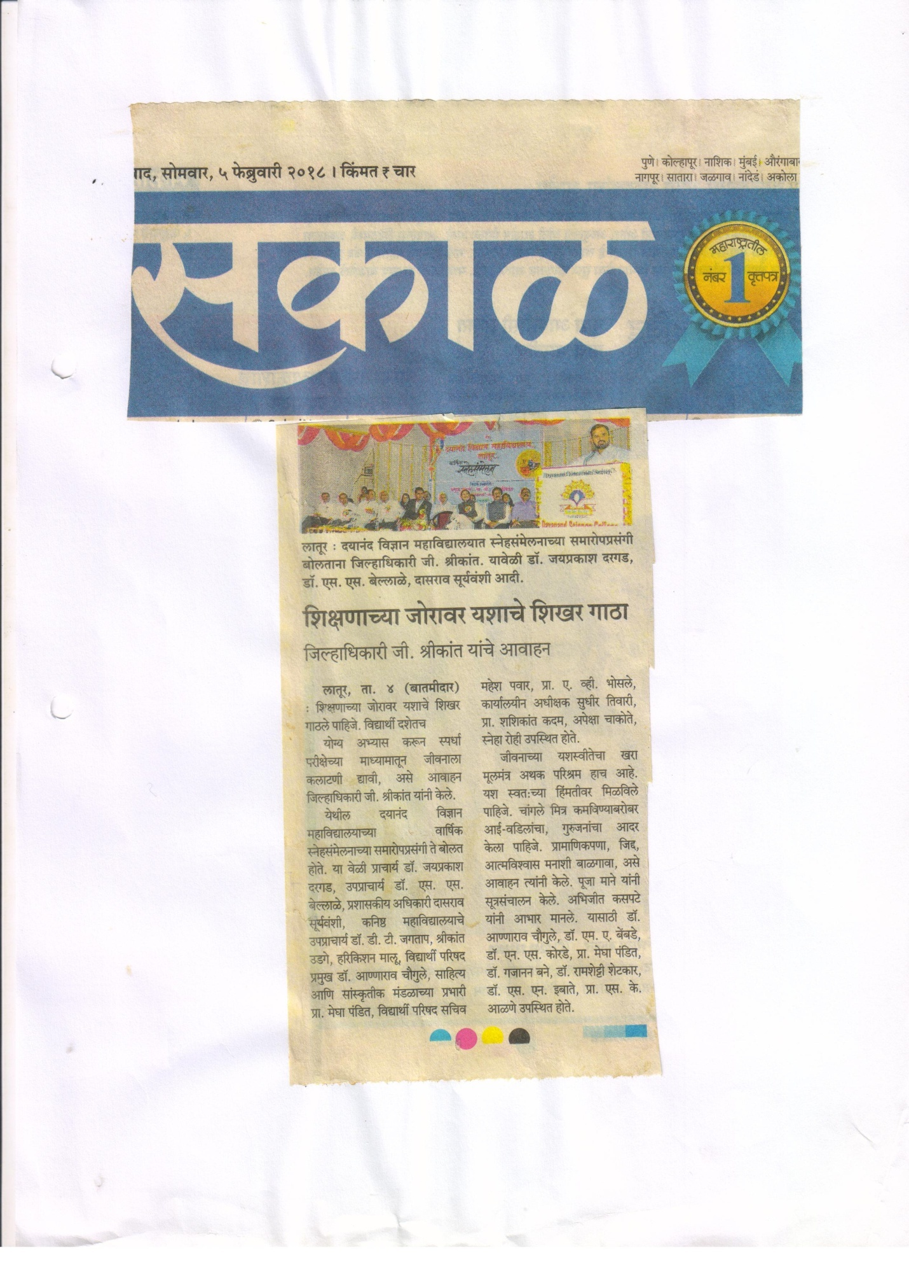

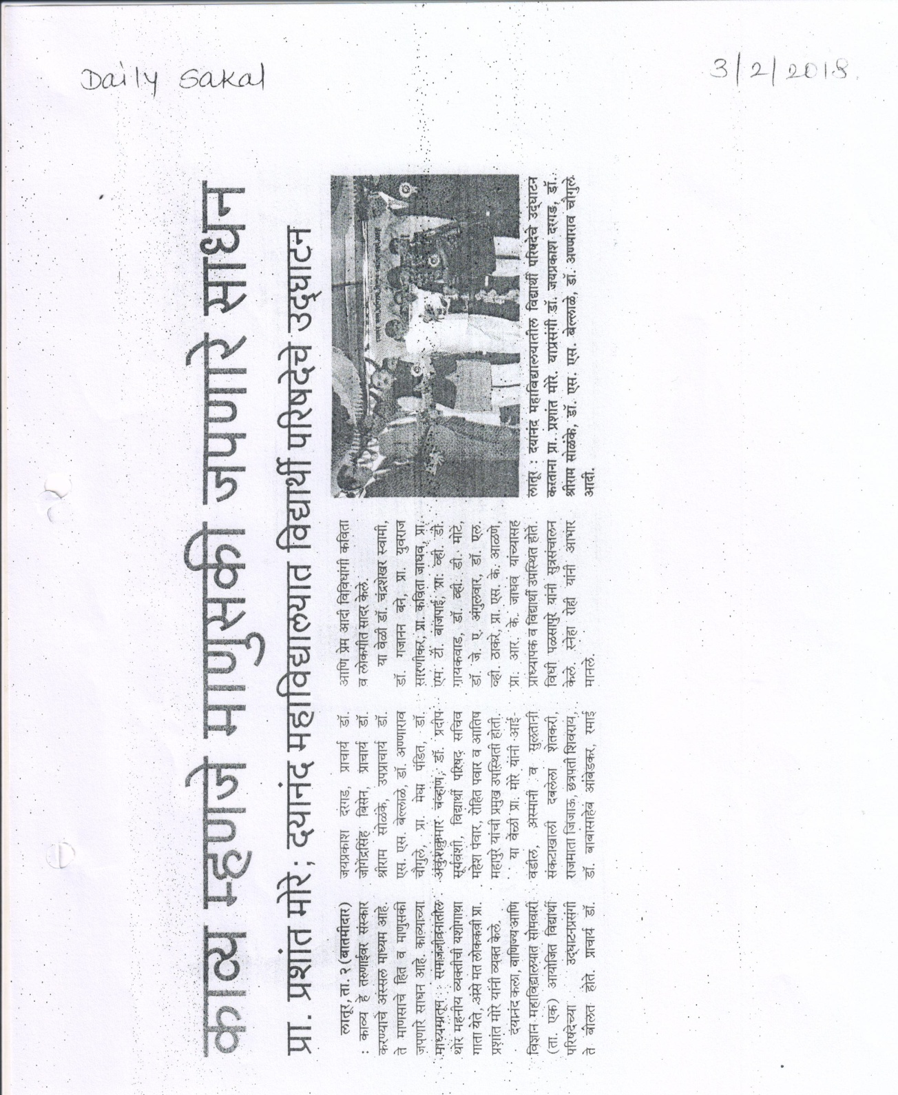
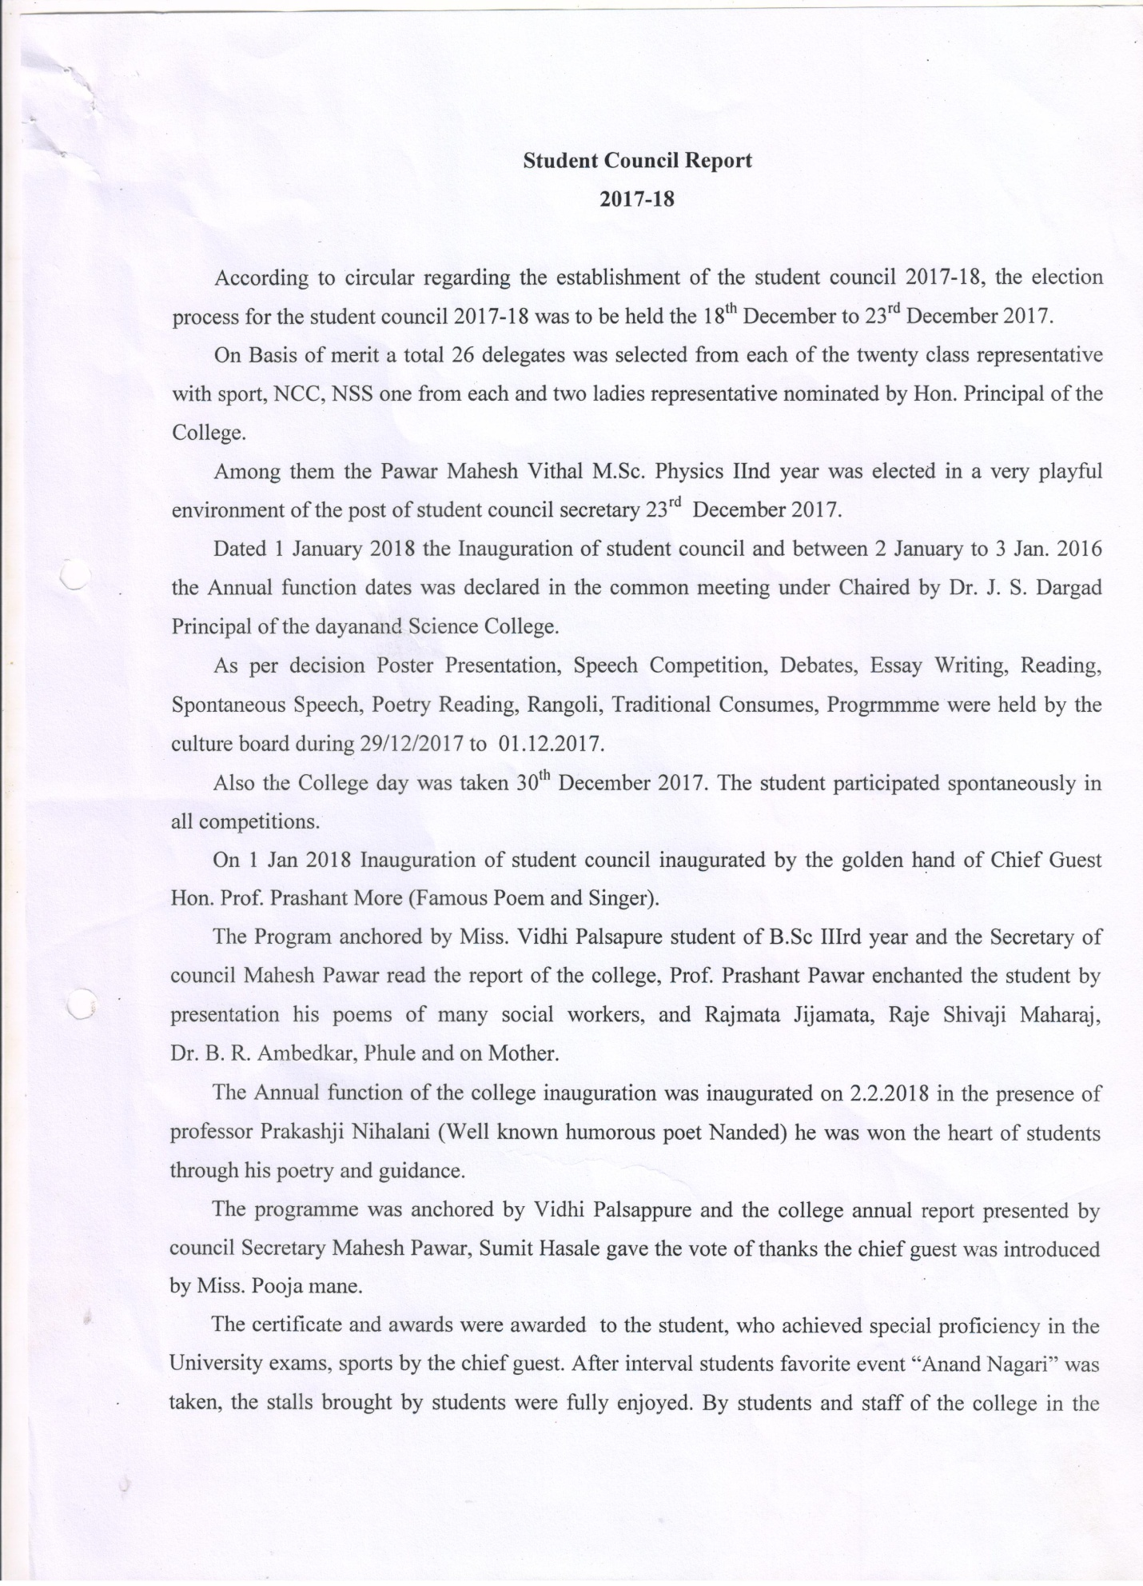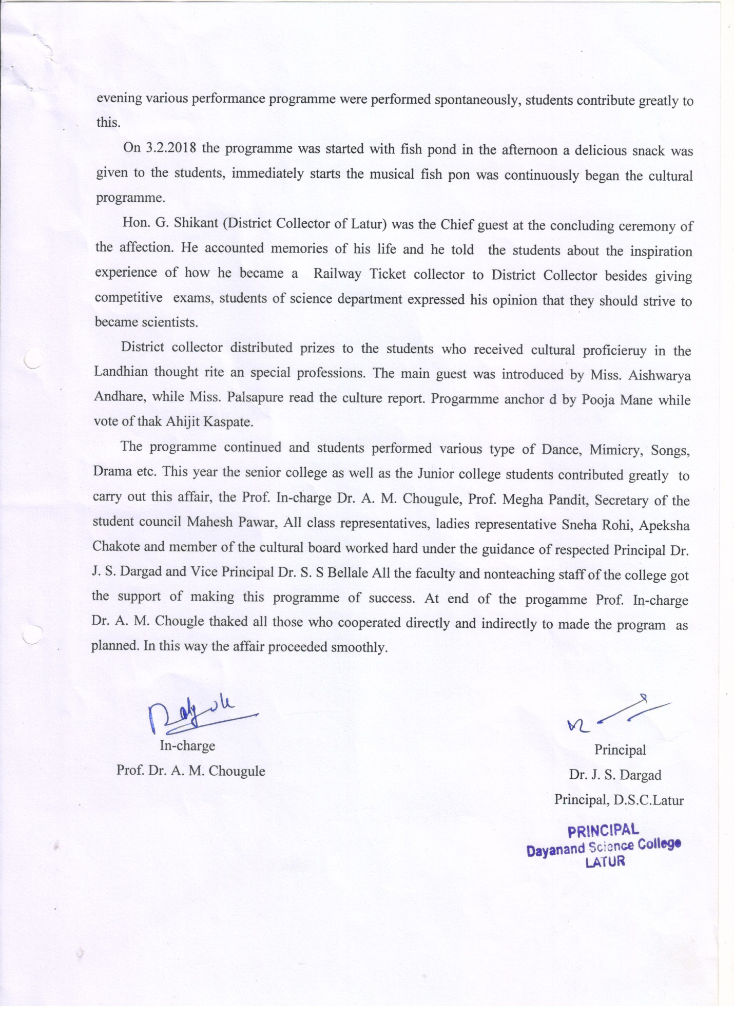Photo Gallery
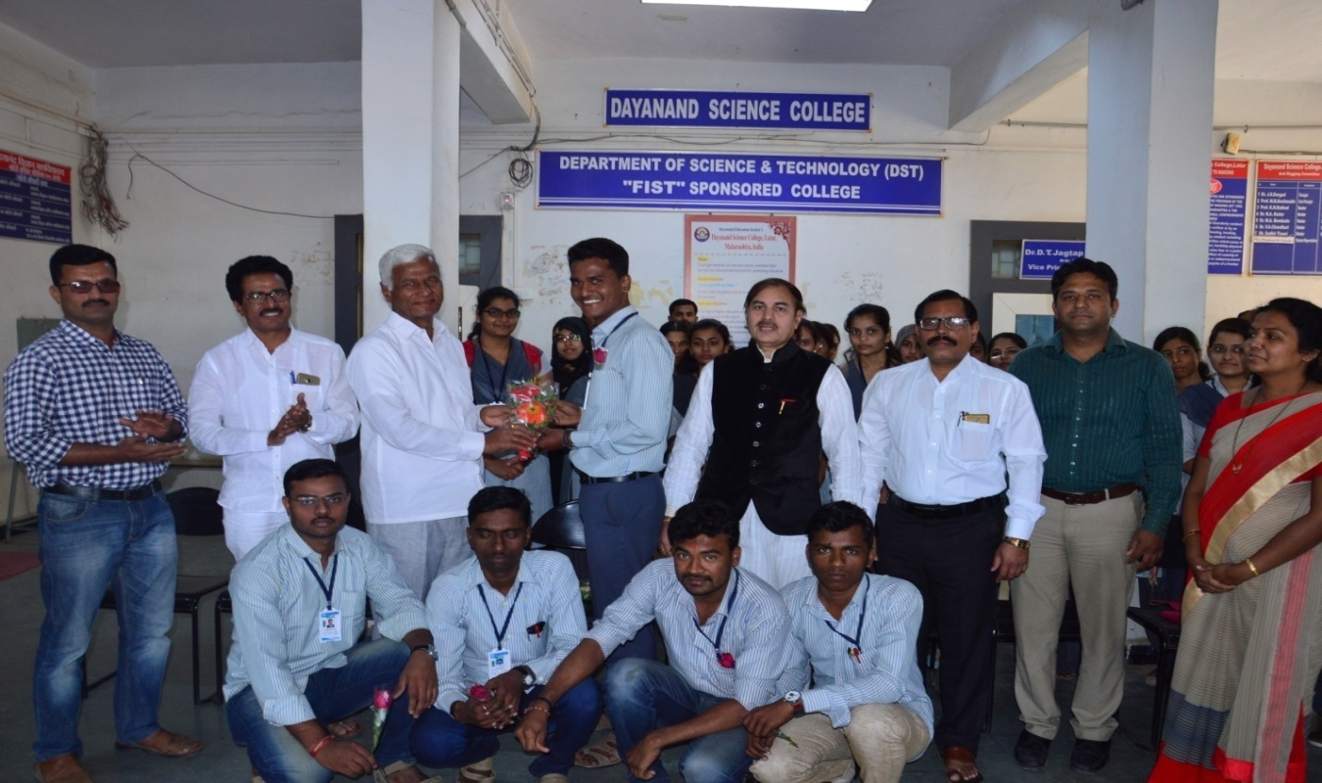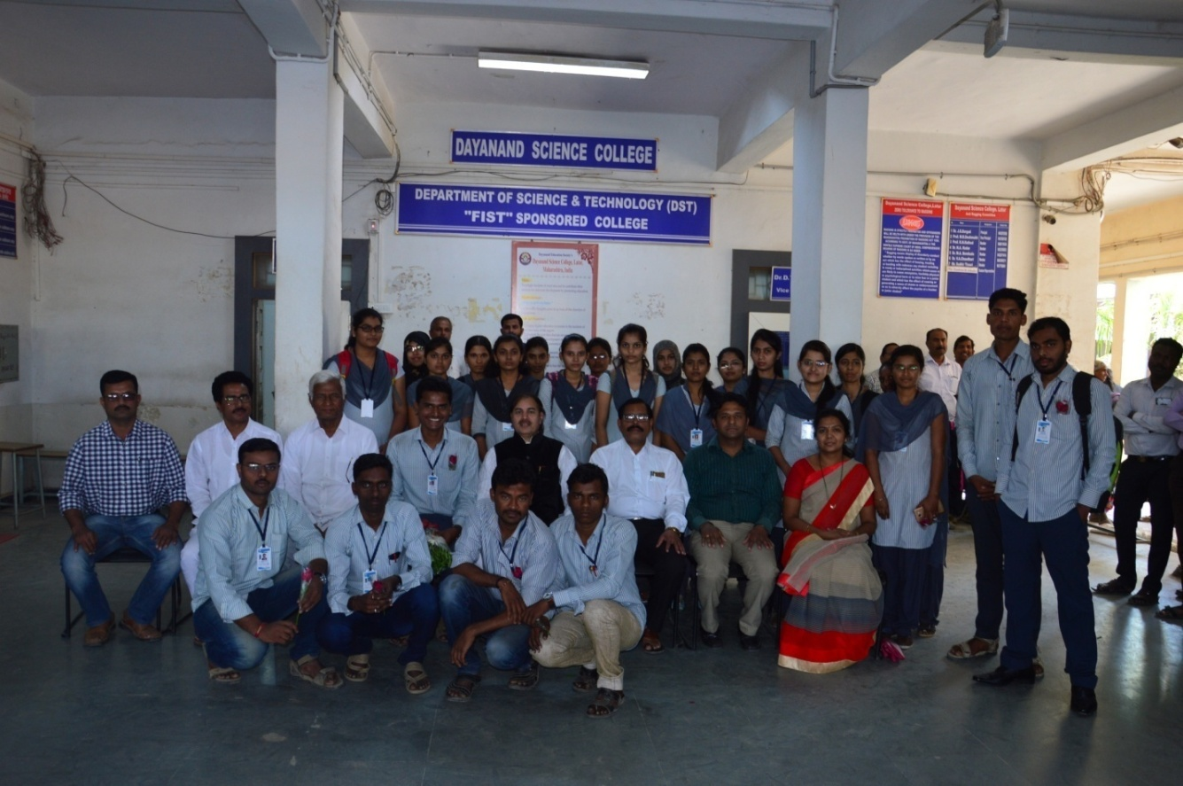
Newly elected student representative,council representative and student welfare committee with Hon. Principal Dr.J,S.Dargad

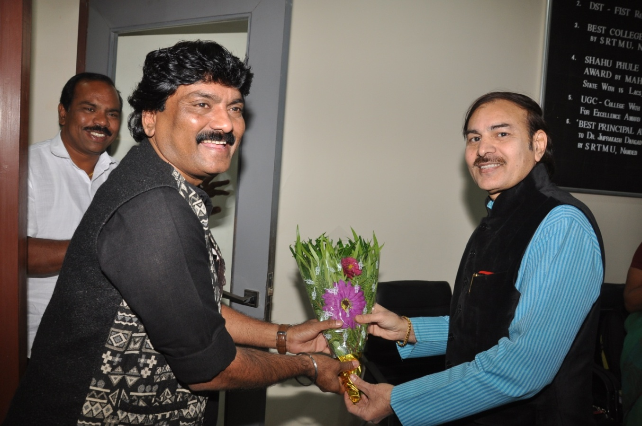
Hon. Principal Dr.J,S.Dargad Feliciated to Hon Prashant More when he entered into college premices

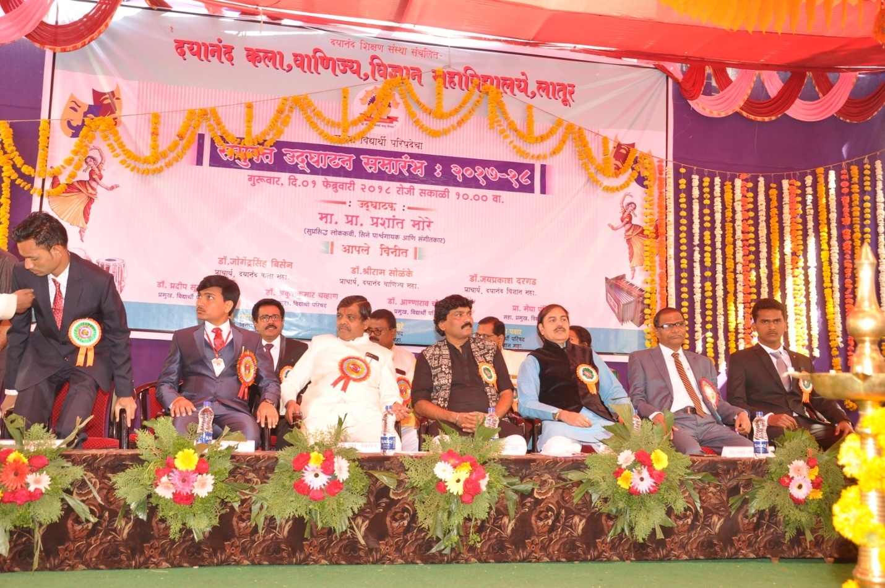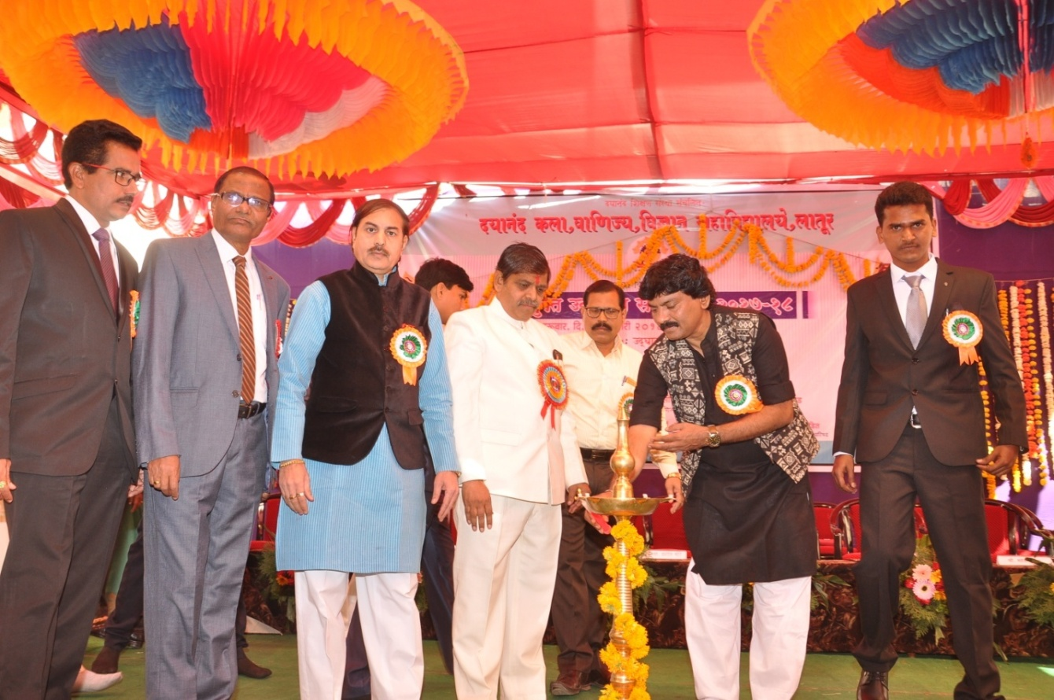
Hon. Prashant More lightning the candel of opening ceremony of student Council programme

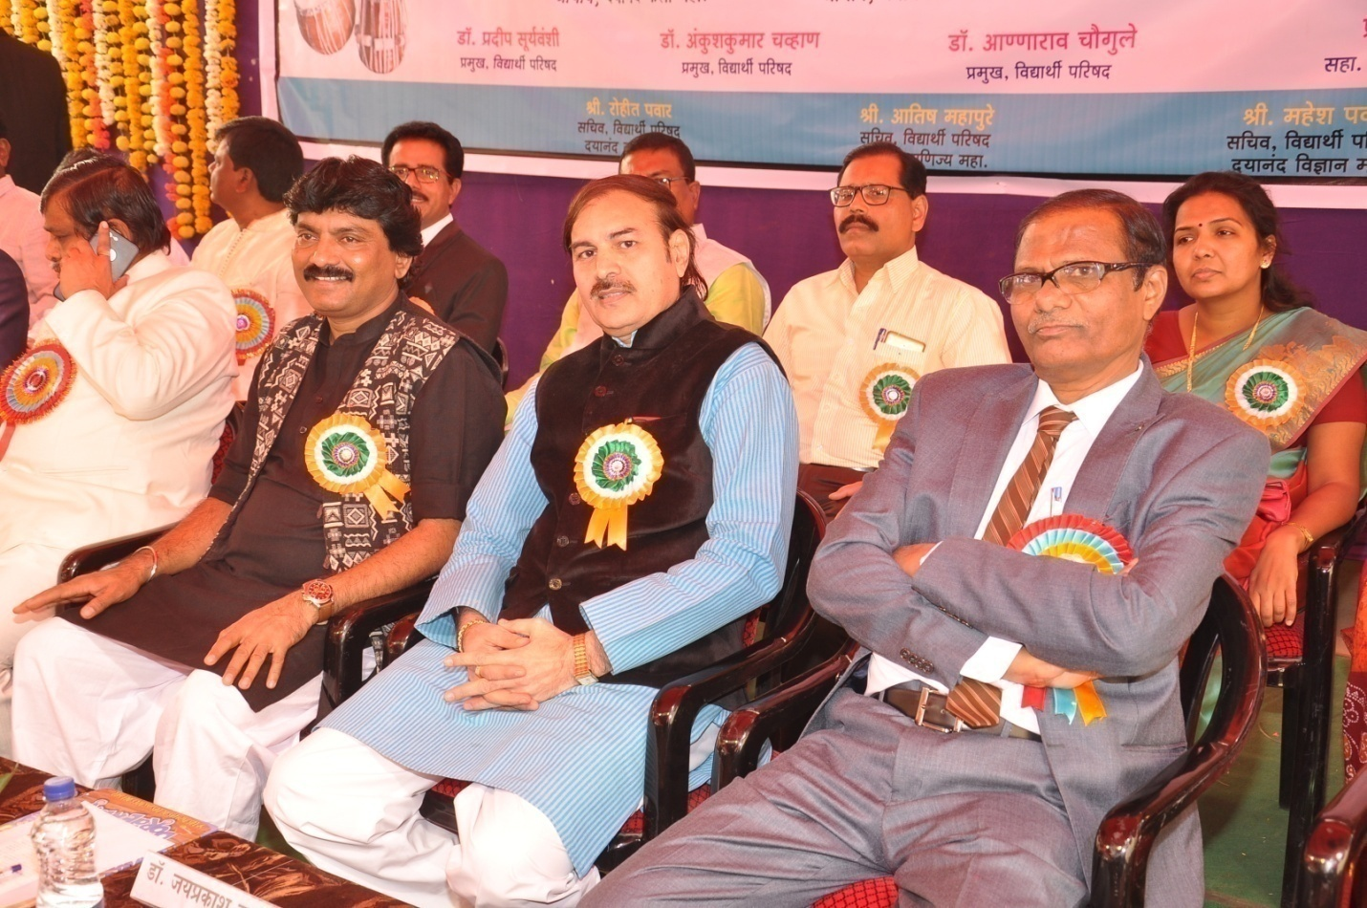 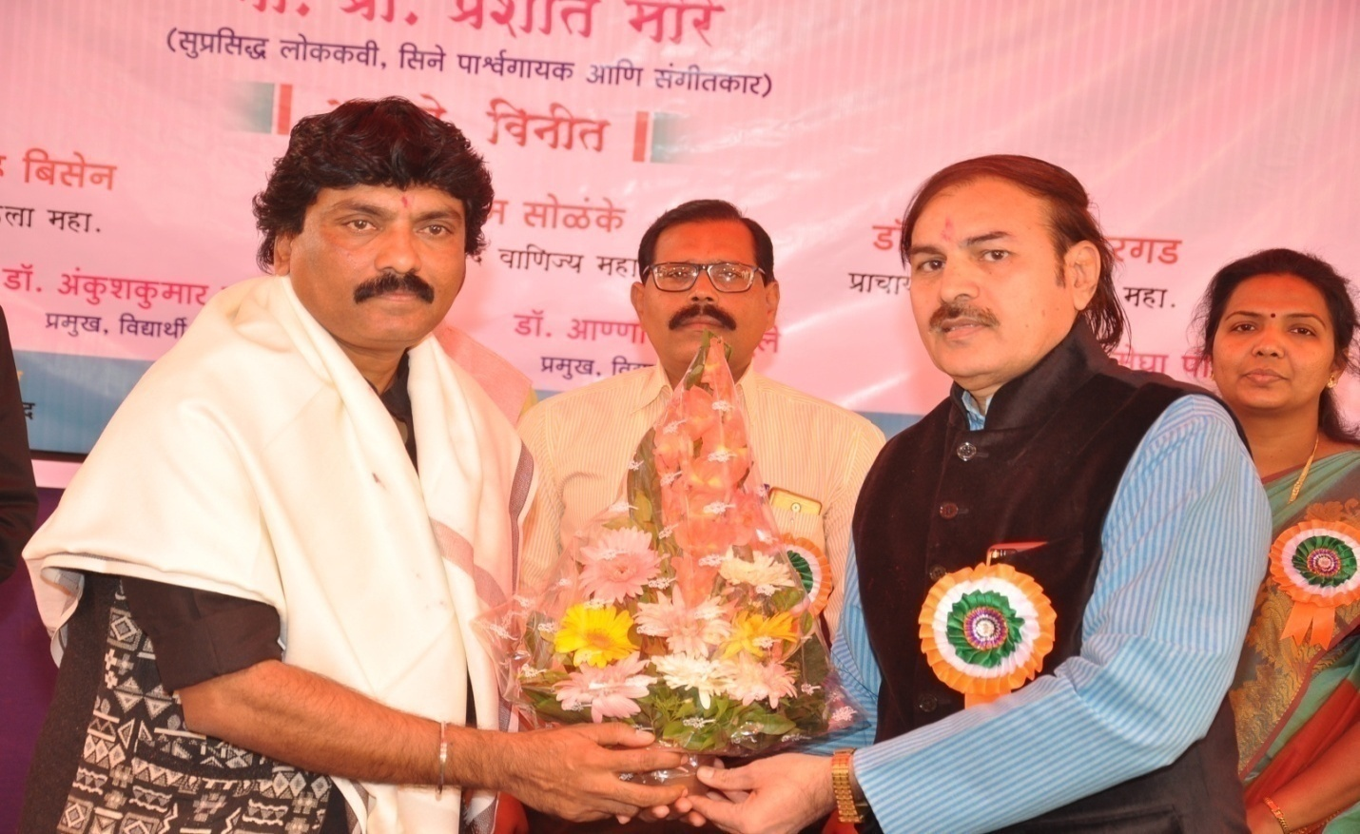 Hon. Principal Dr.J,S.Dargad Feliciated to Hon Prashant More

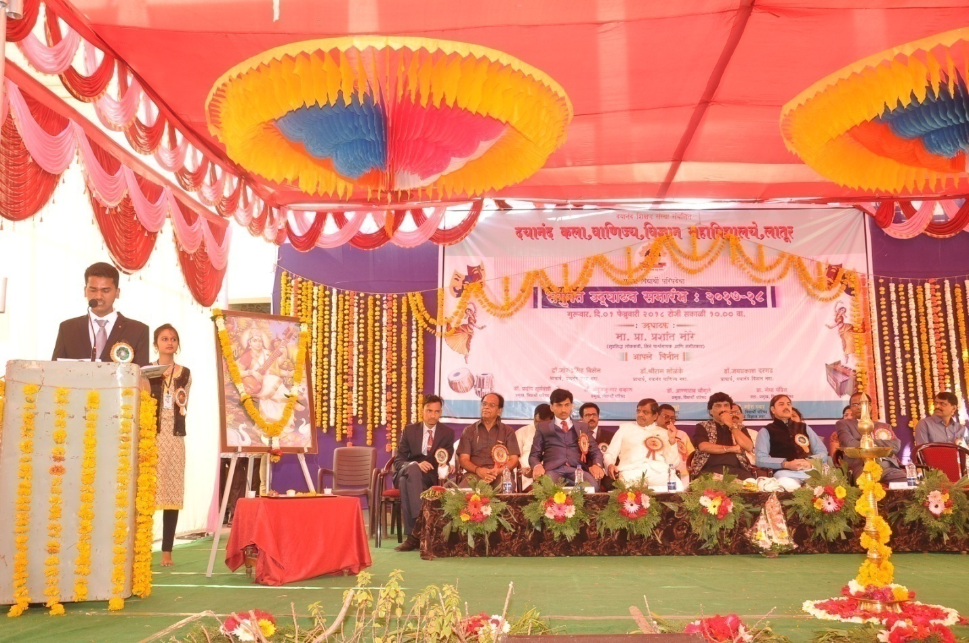 G.S Mahesh Pawar reading College achivement Report.
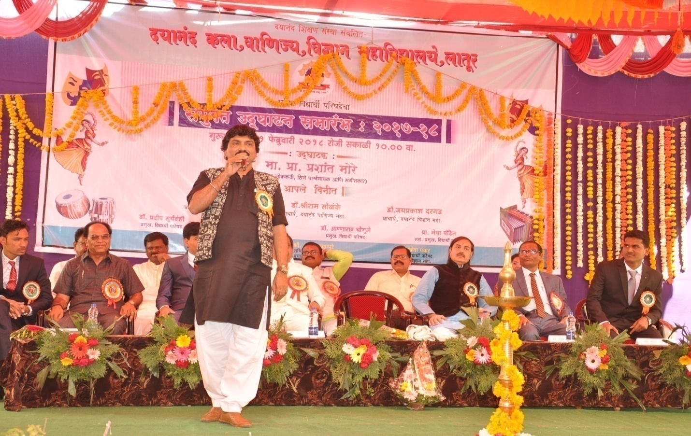
Presentation of Hon. Prashantji More

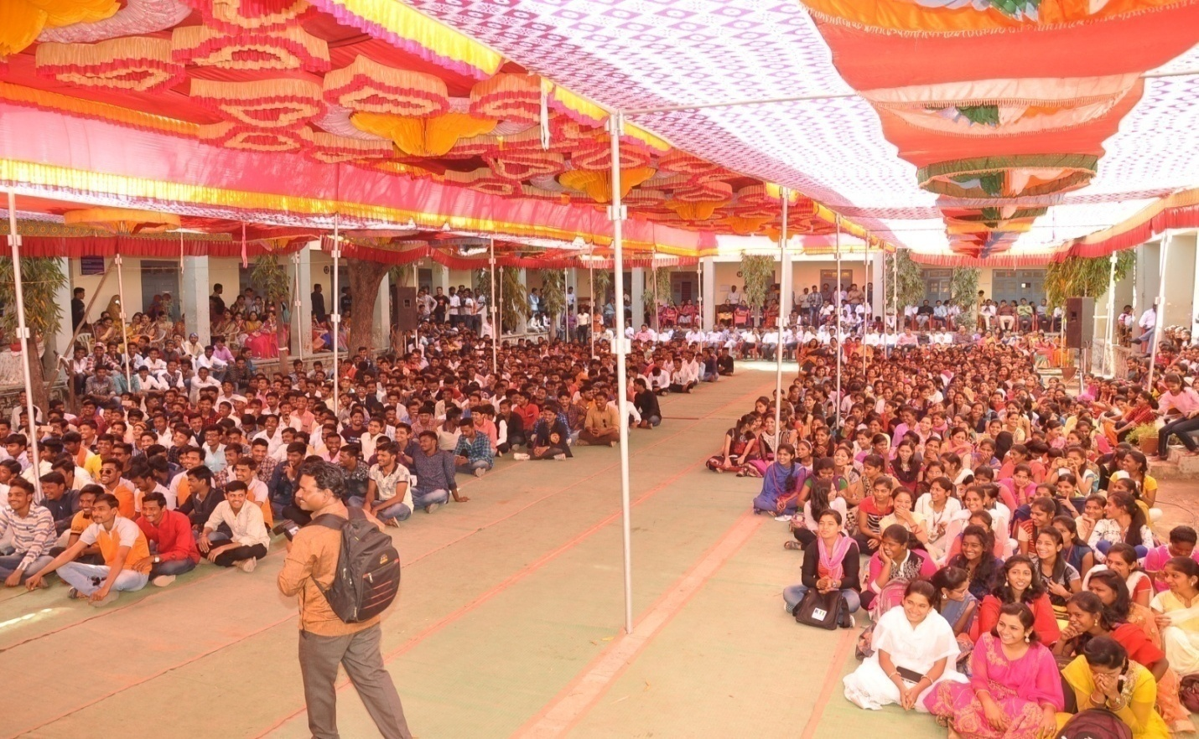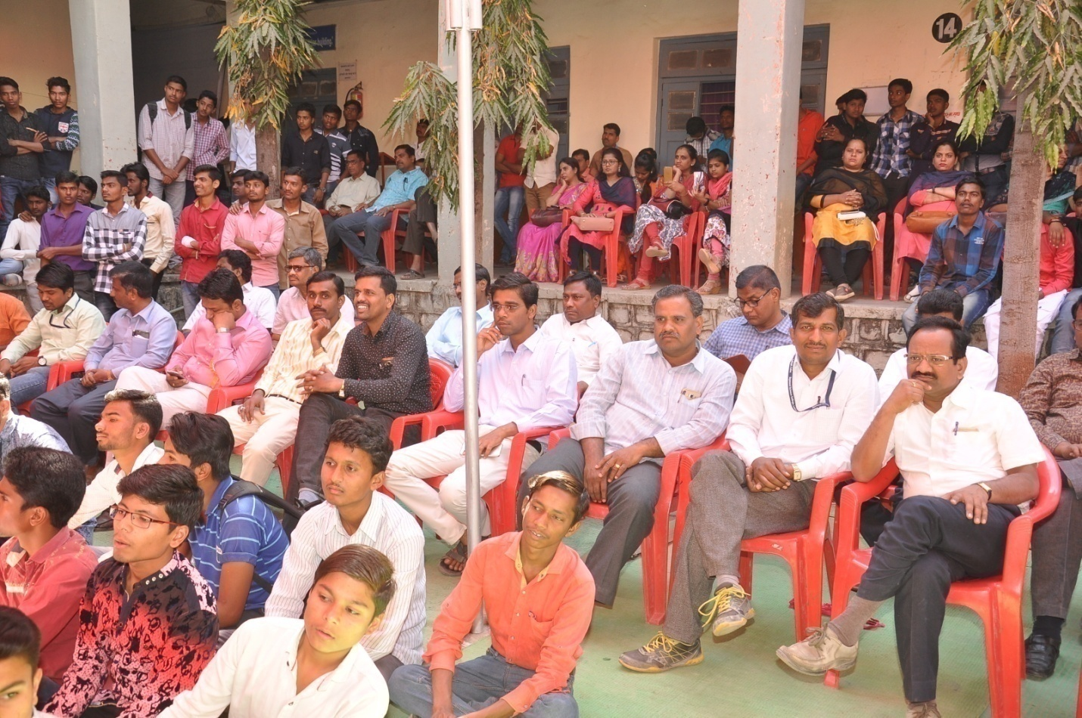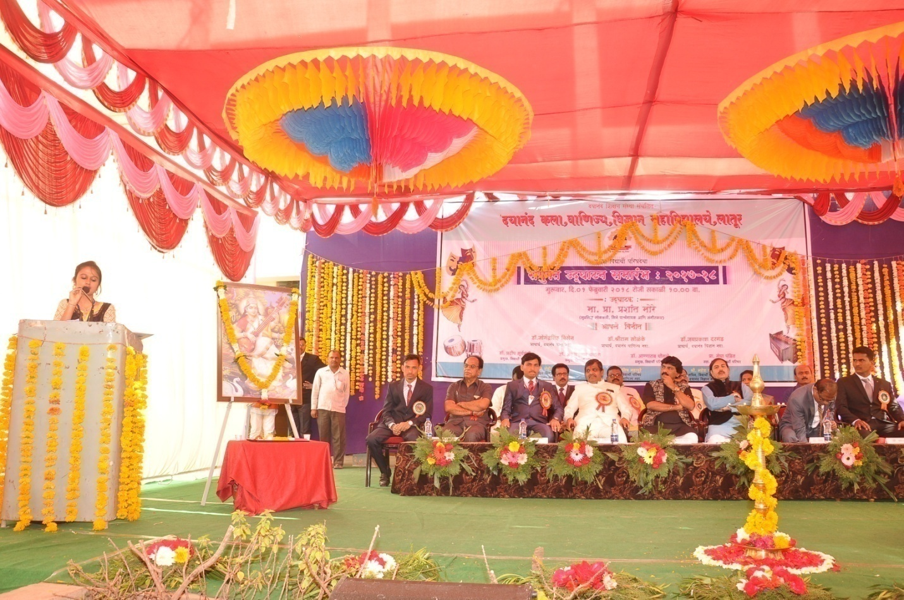

Photo Gallery Gathering Opening Ceremony

ZZ
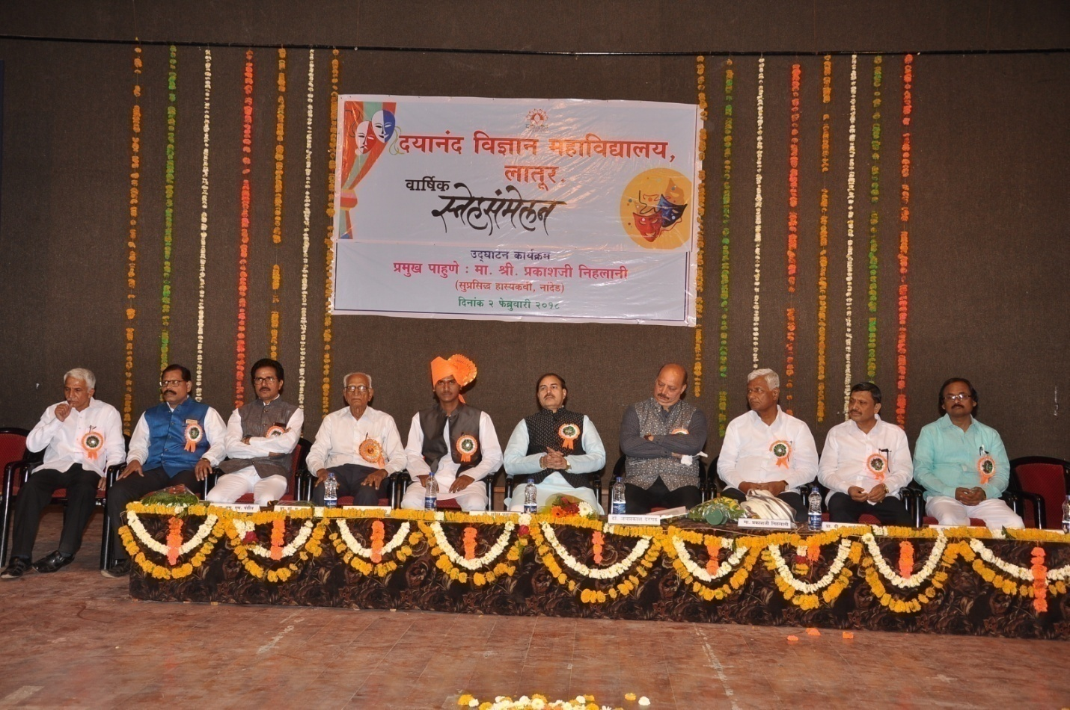 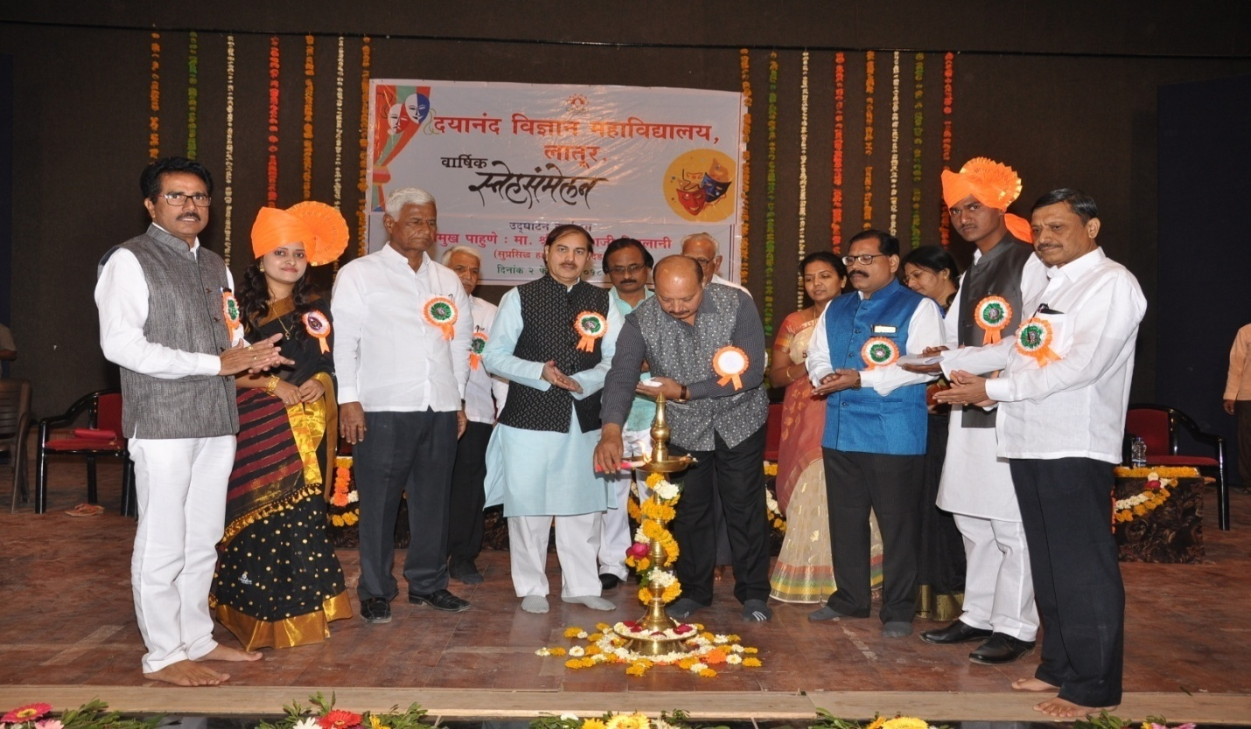 Opening ceremony of Annual function by Golden hand of Chief Guest Hon, Prkashji Nihlani
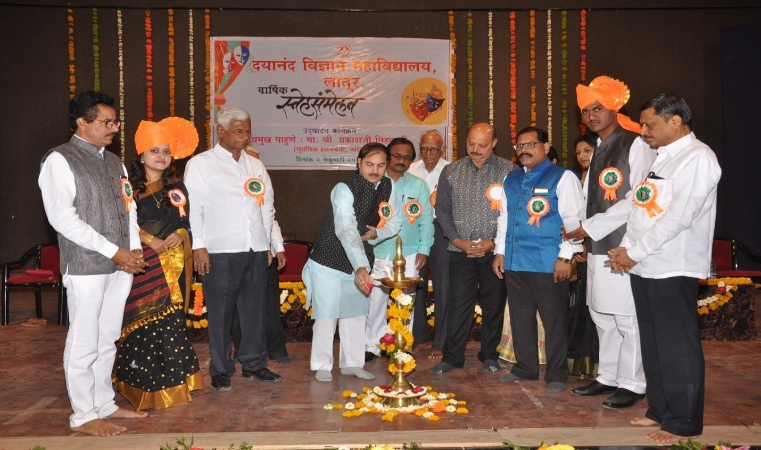 Opening ceremony Lightning lamp by Hon. Principal Dr.J S Dargad
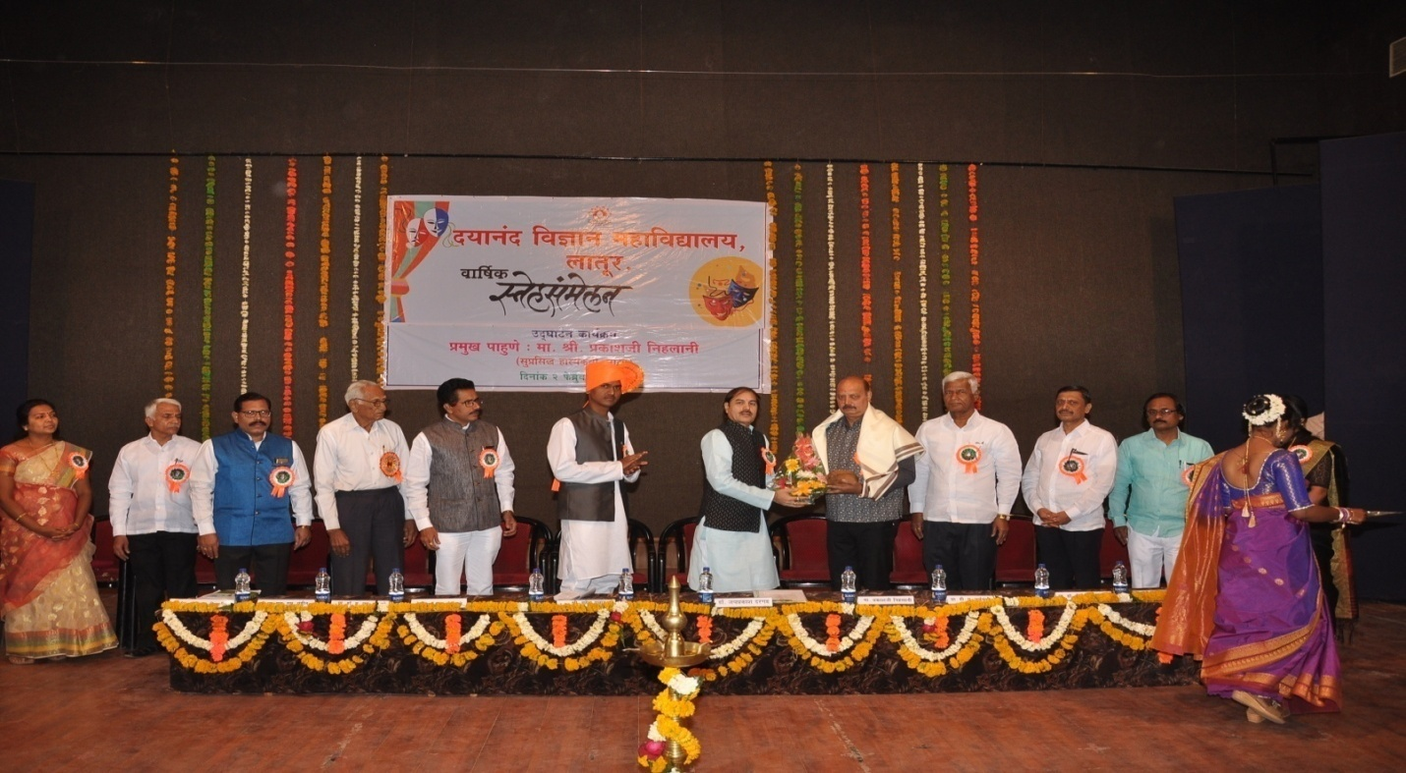
Felicitated to chief guest By Hon. Principal Dr.J S Dargad
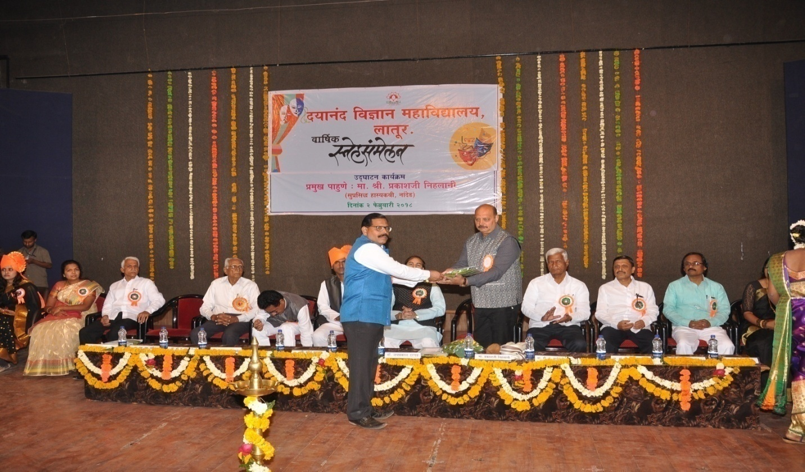FFFelicitated to chief guest By Sudent Council Incharge Dr.A.M Chougule
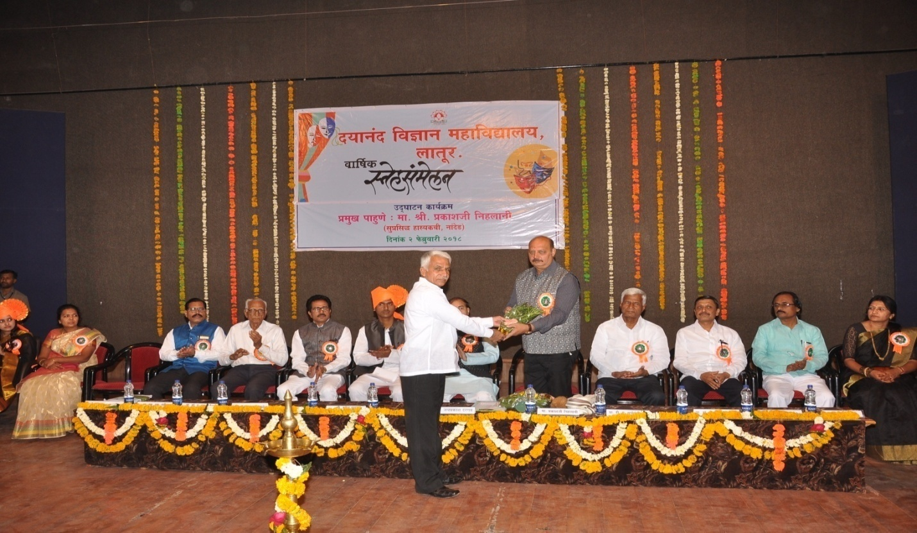 Felicitated to chief guest By Shri. Sudhir Tiwari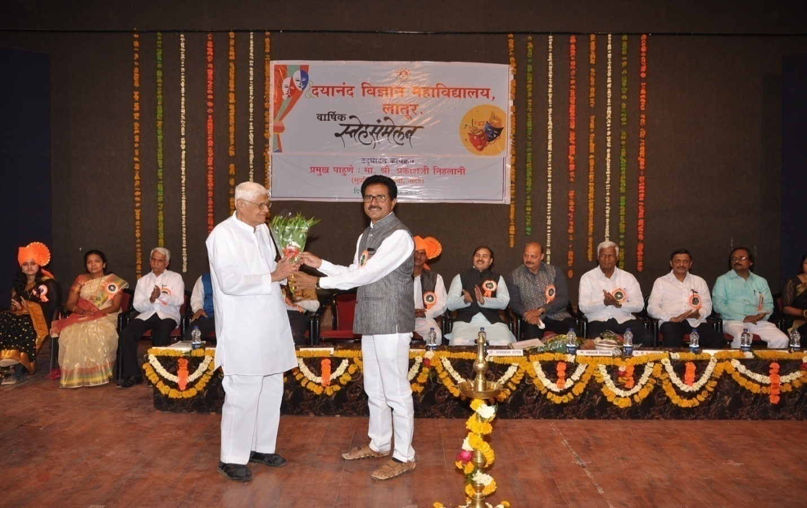

Felicitated to Meritorious 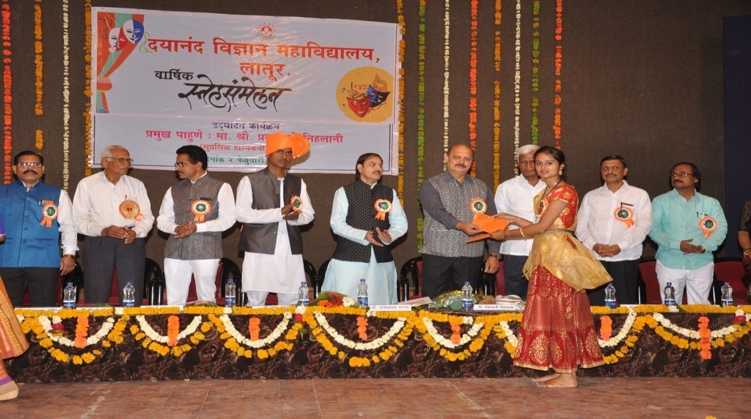
Felicitated to Meritorious Vidhi Palsapure
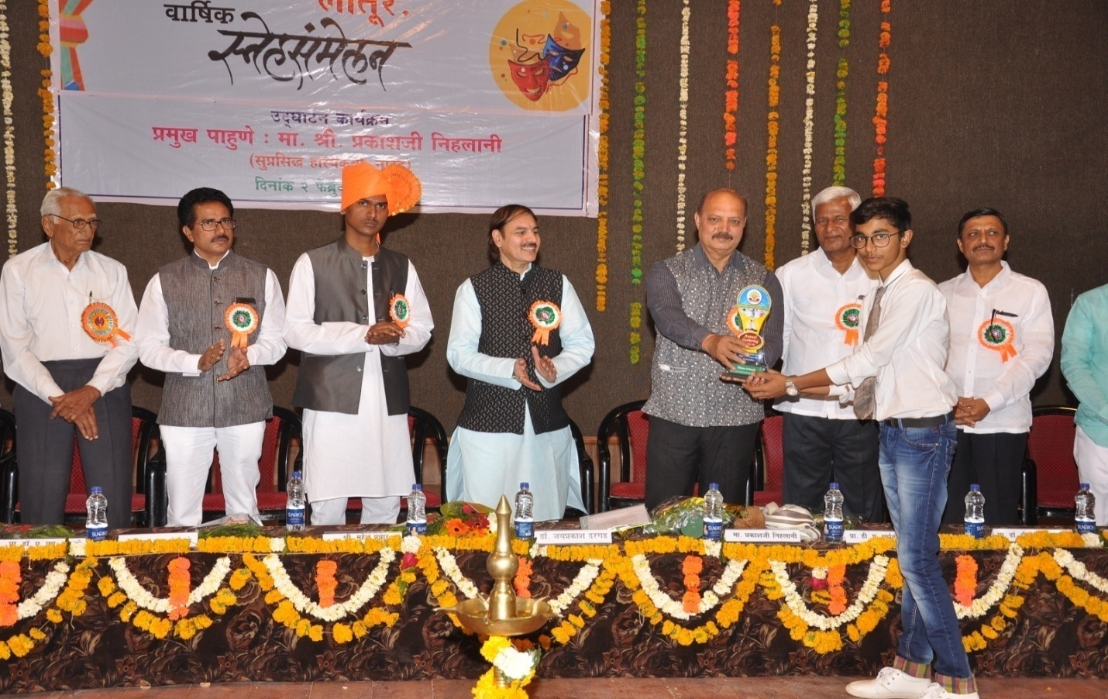 Felicitated to Meritorious 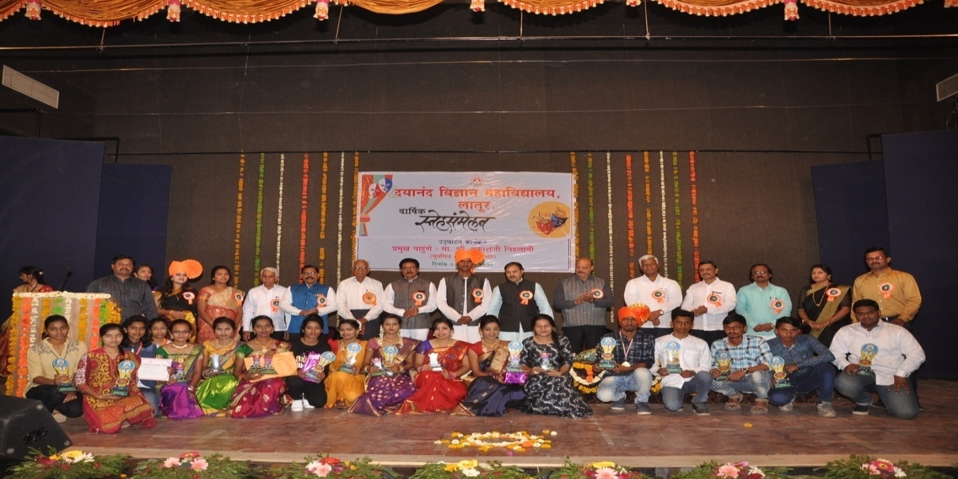
S Felicitated to Special Achivement Students of sports
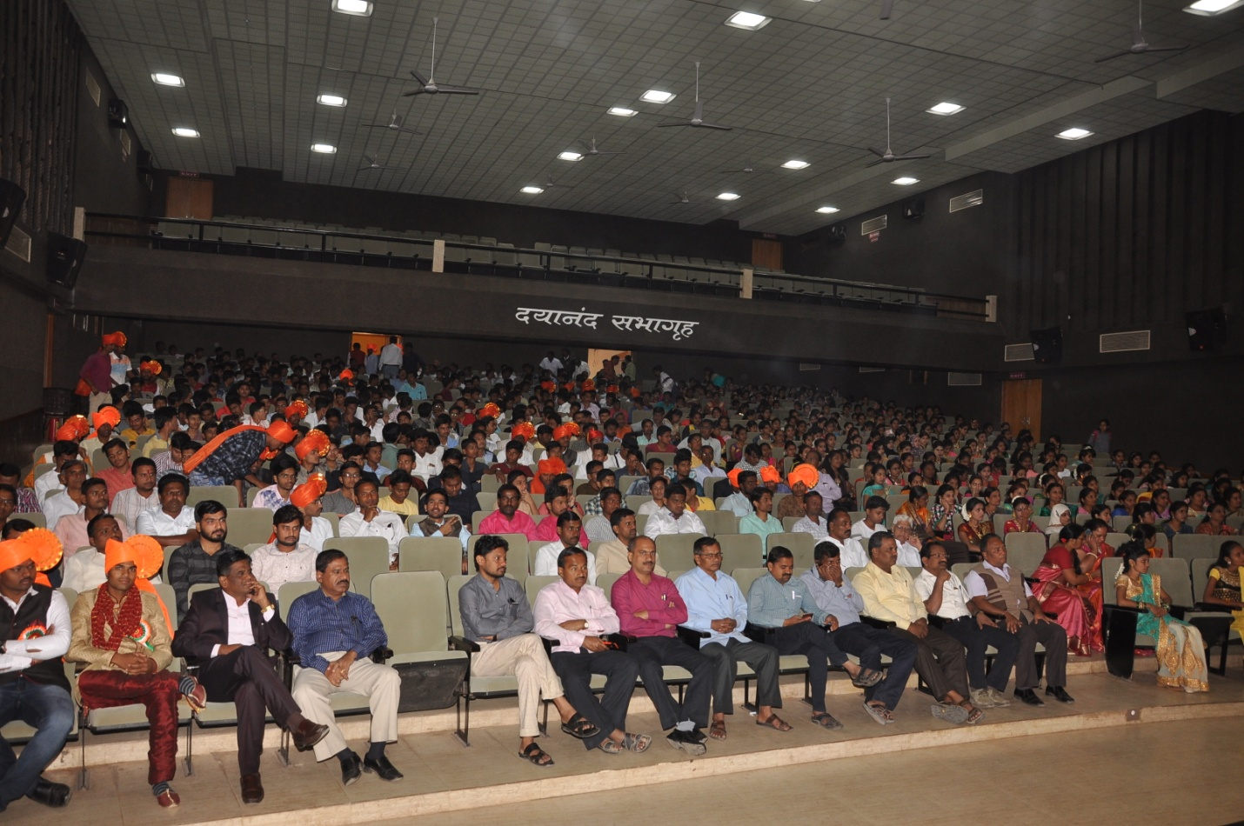
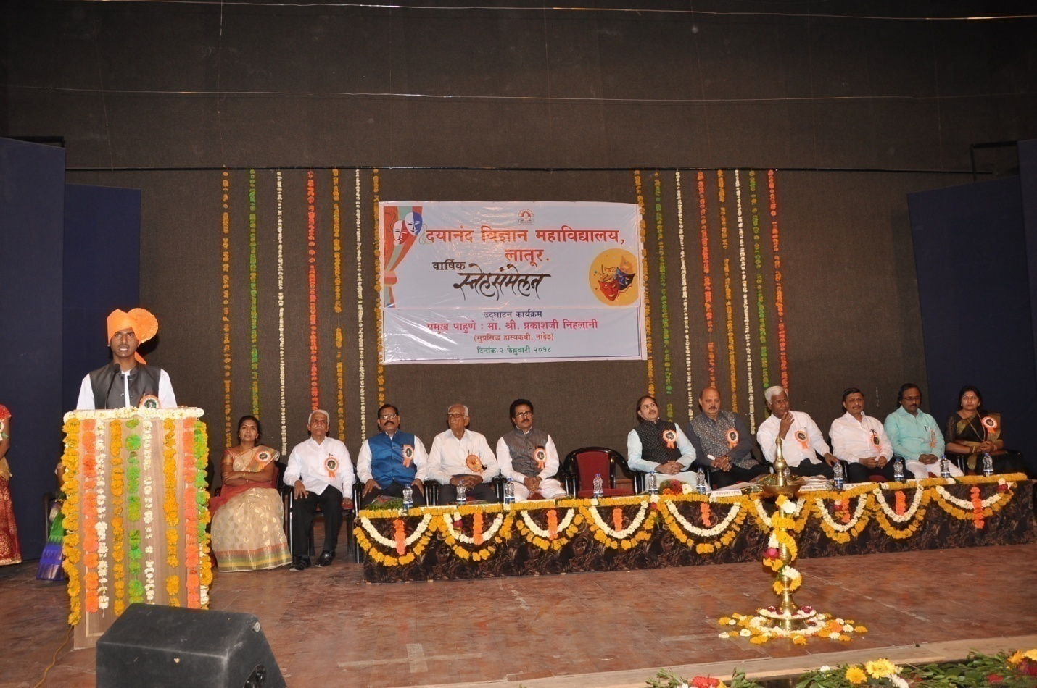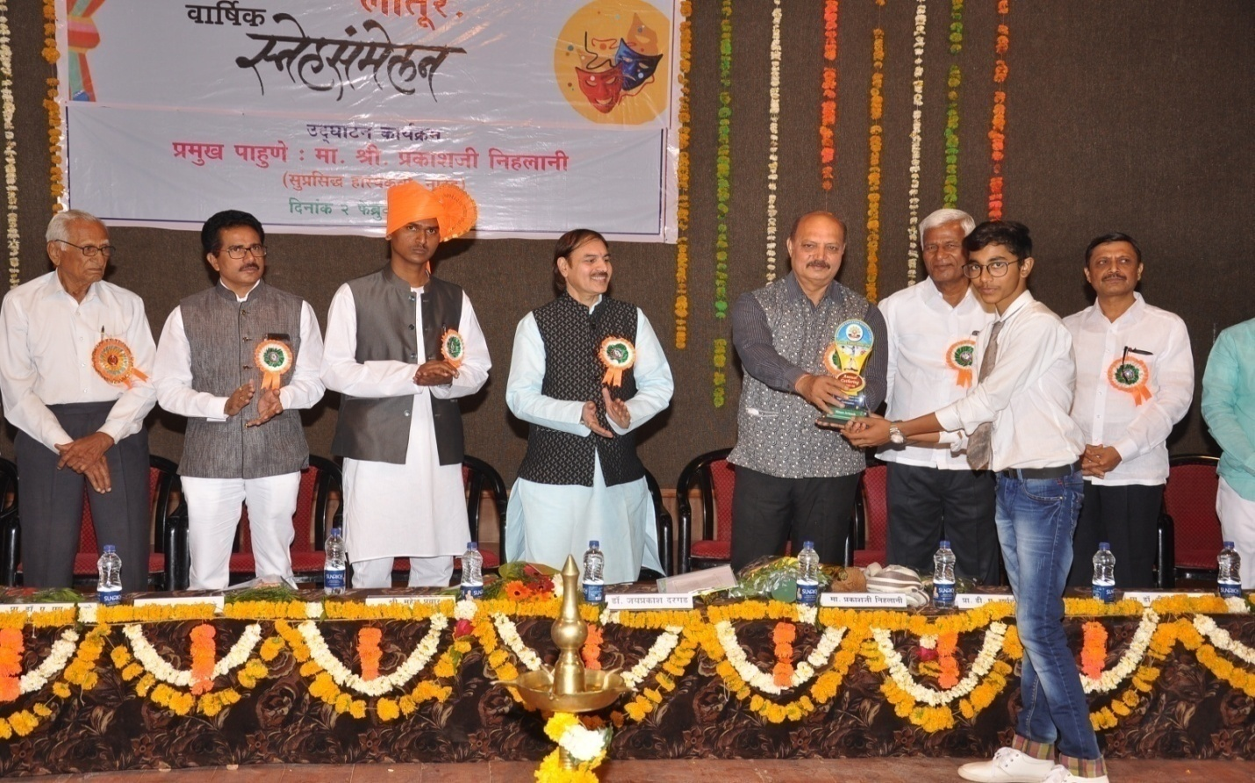Felicitated to Meritorious

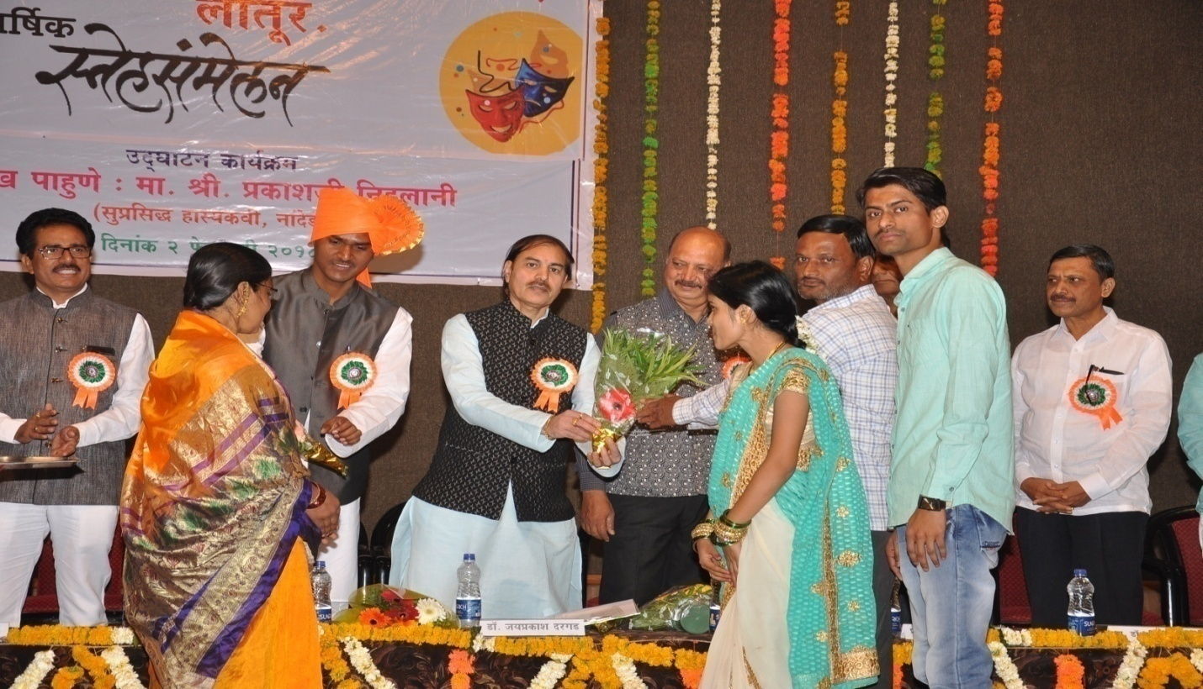Felicitated to Meritorious 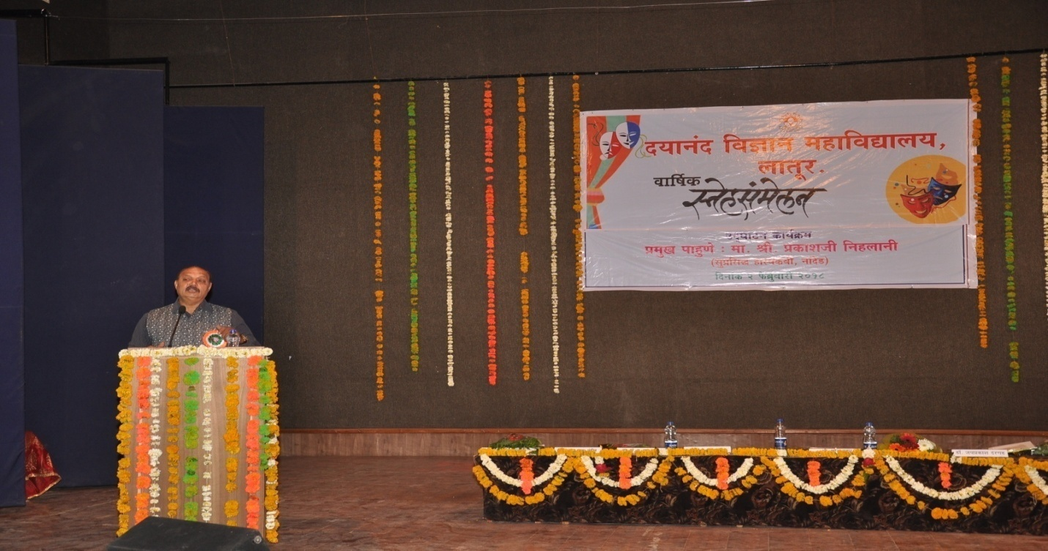

Presentation of Prakashji Nihlani
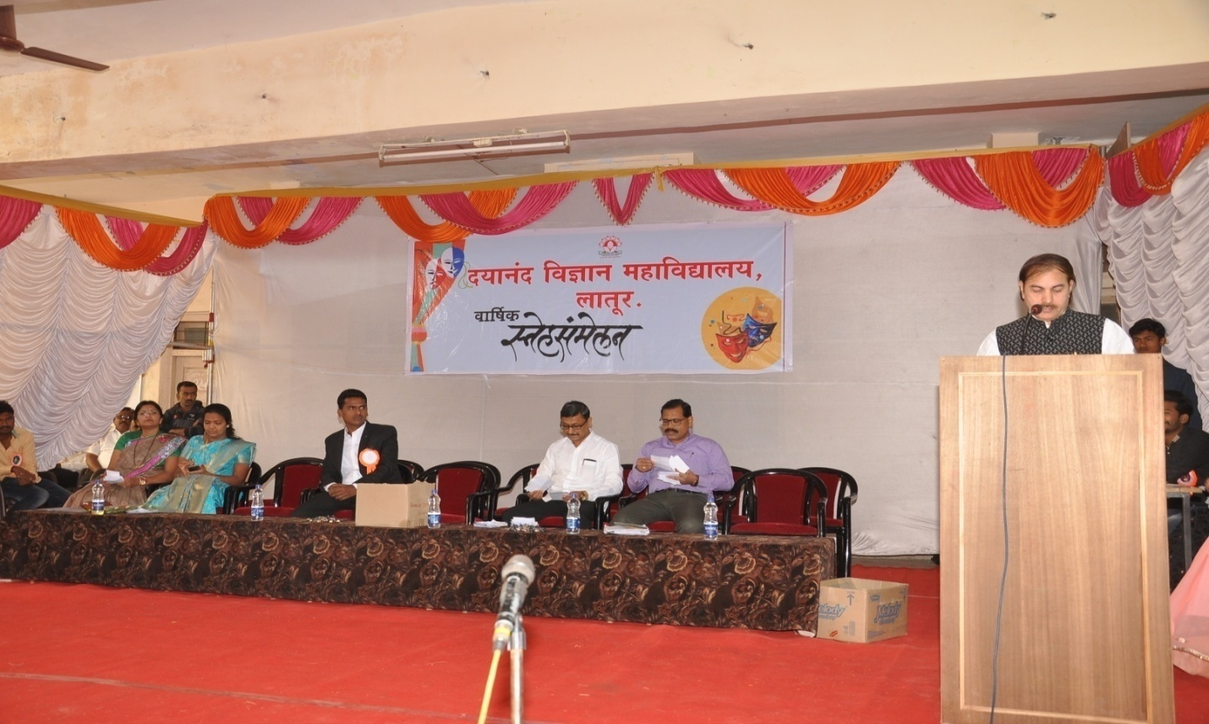

Events of Fishpond 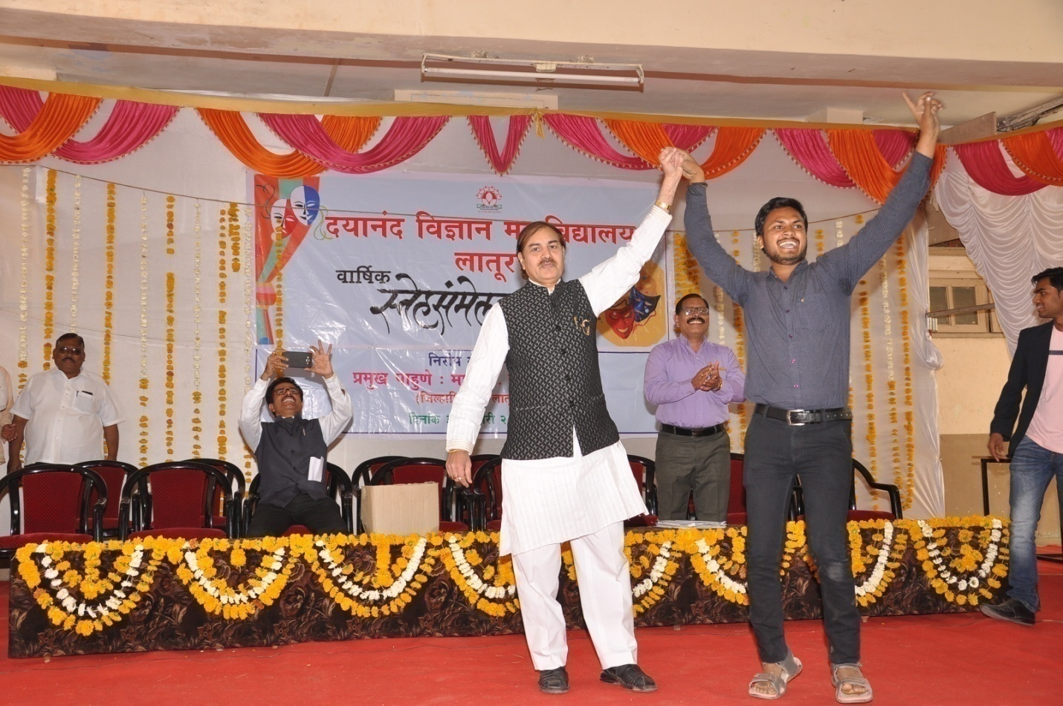 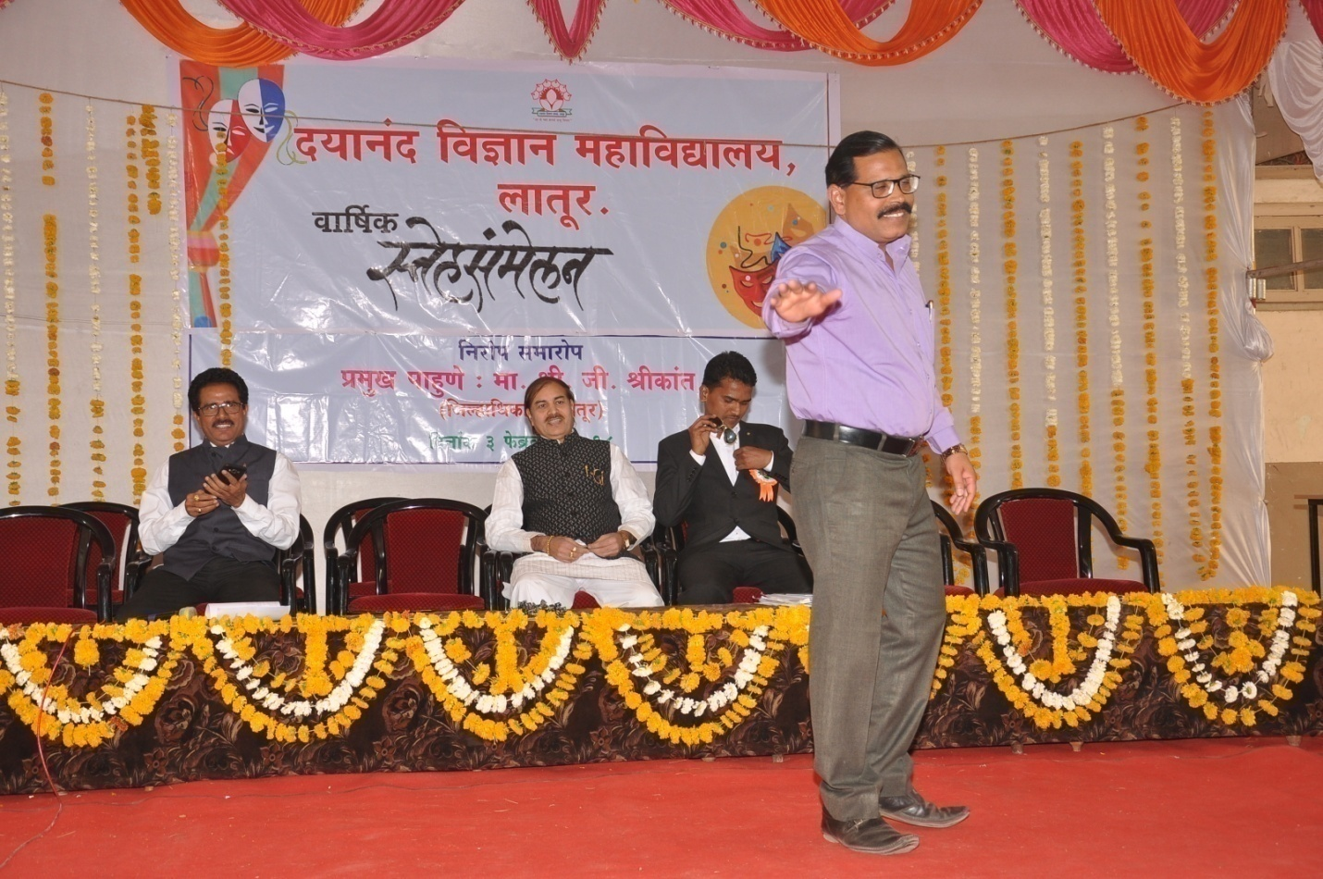 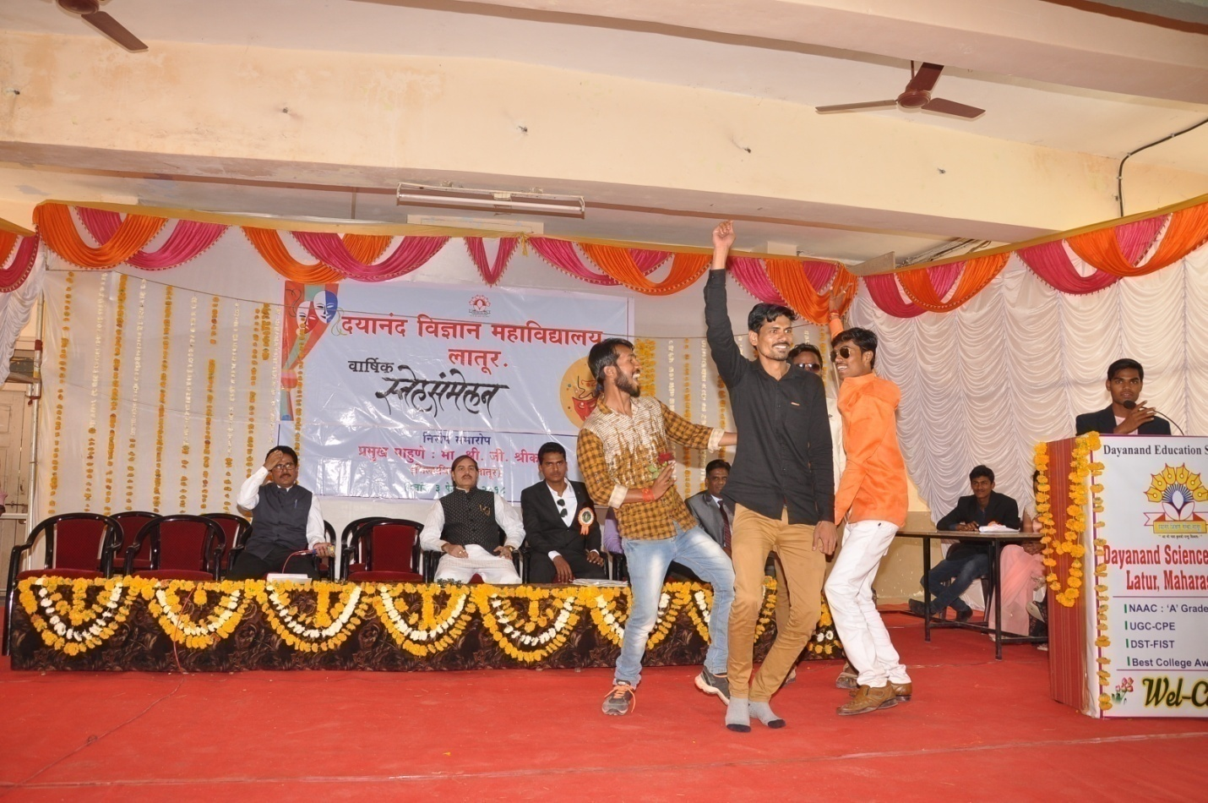 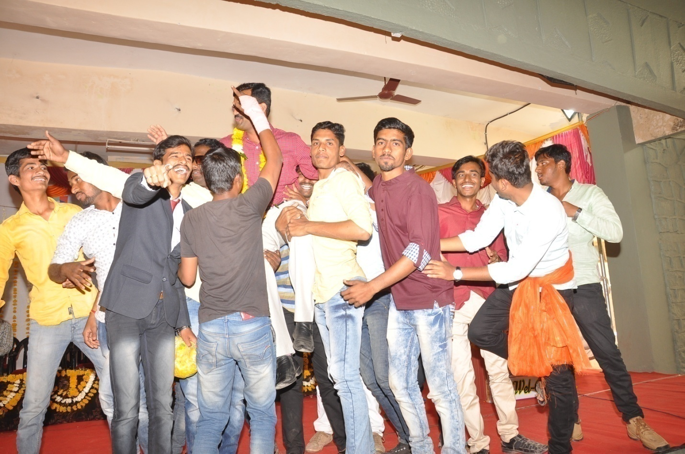 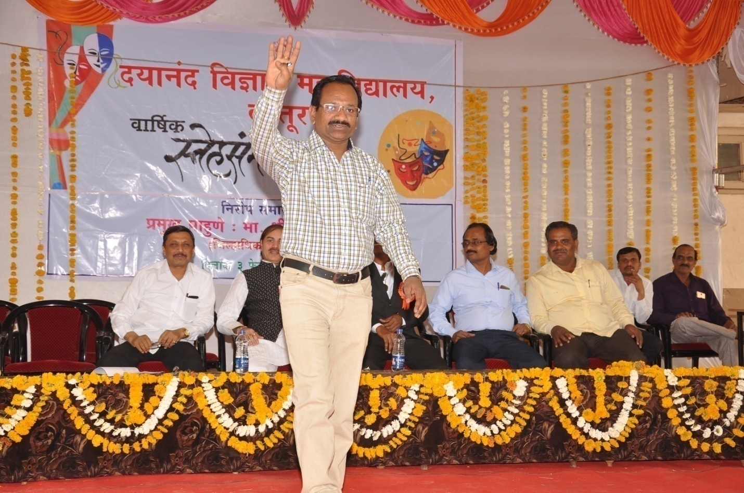 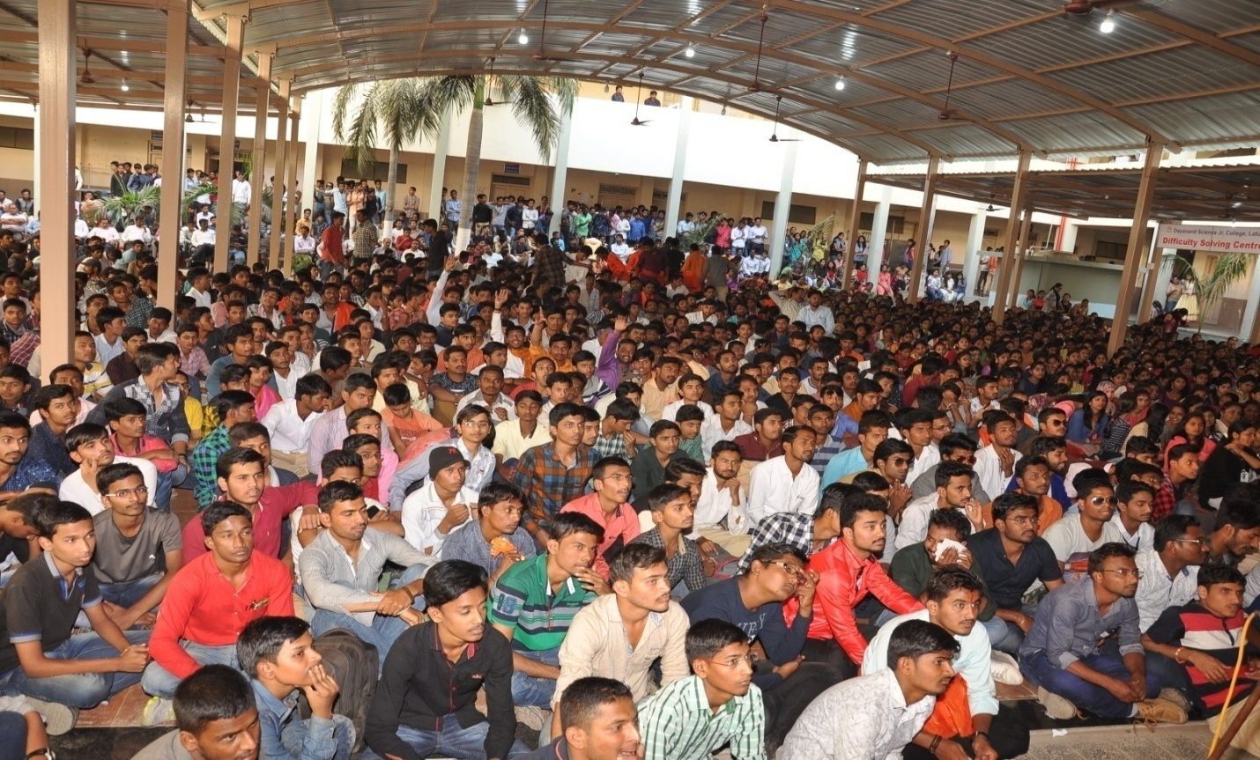
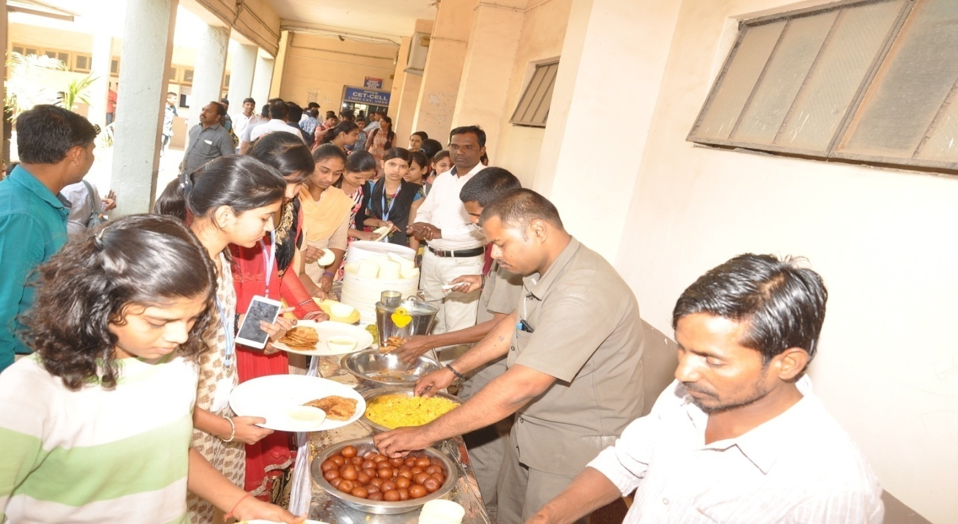

Events of Lunch

Photo Gallery Gathering Concluding Ceromony

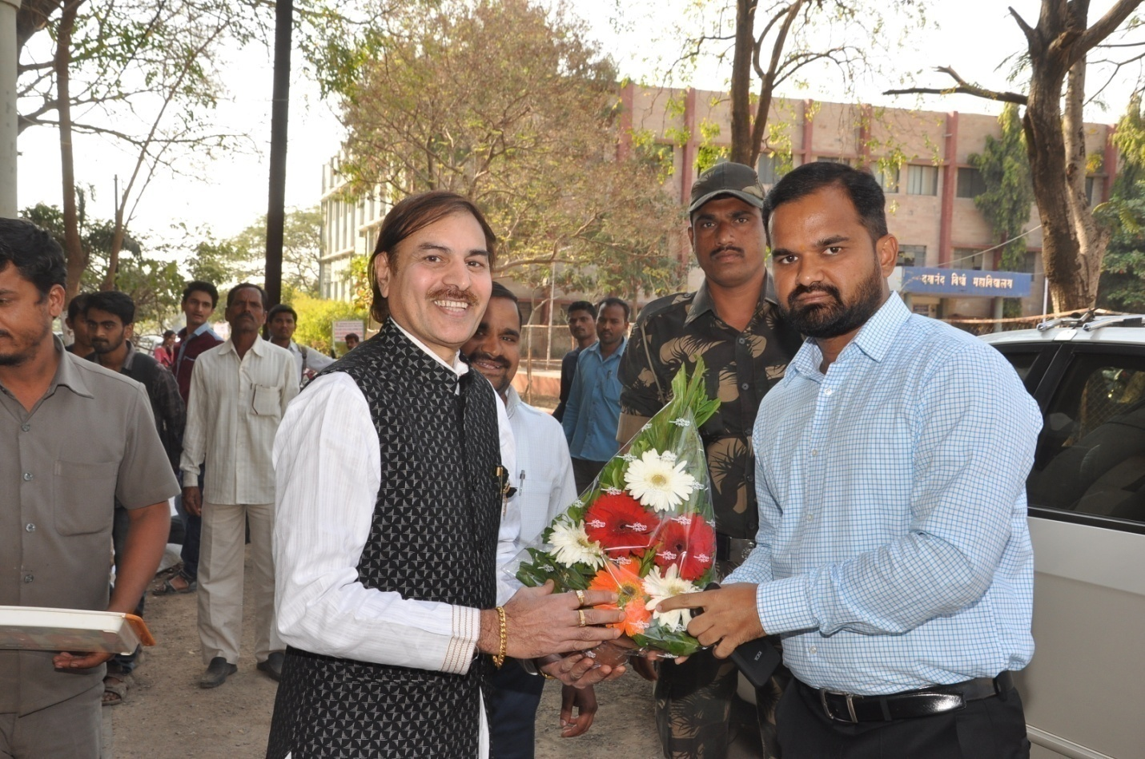
Felicitate to Hon. G. Shrikant(District Collector) by Dr. J. S Dargad at time of arrival
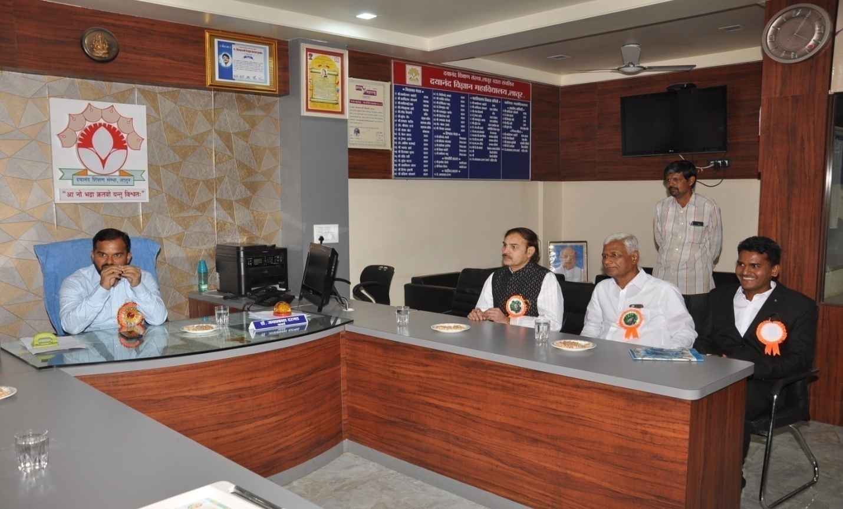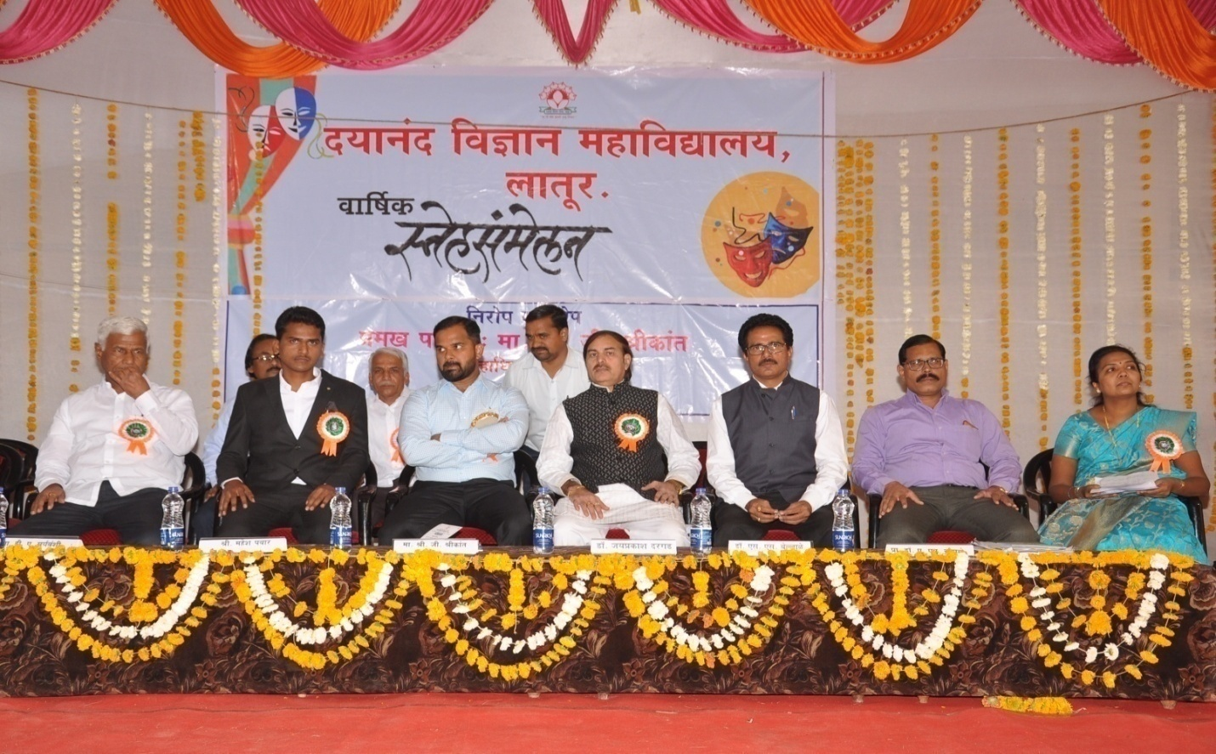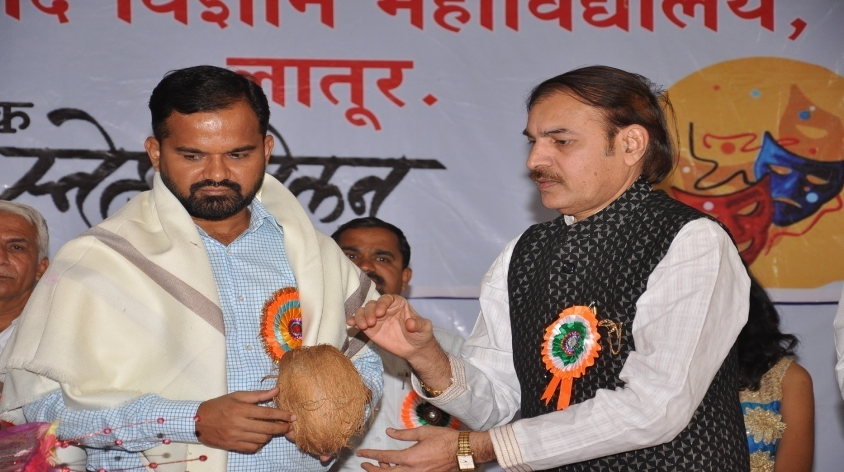 Felicitate to Hon. G. Shrikant(District Collector) by Dr. J. S Dargad at time of concluding ceremony
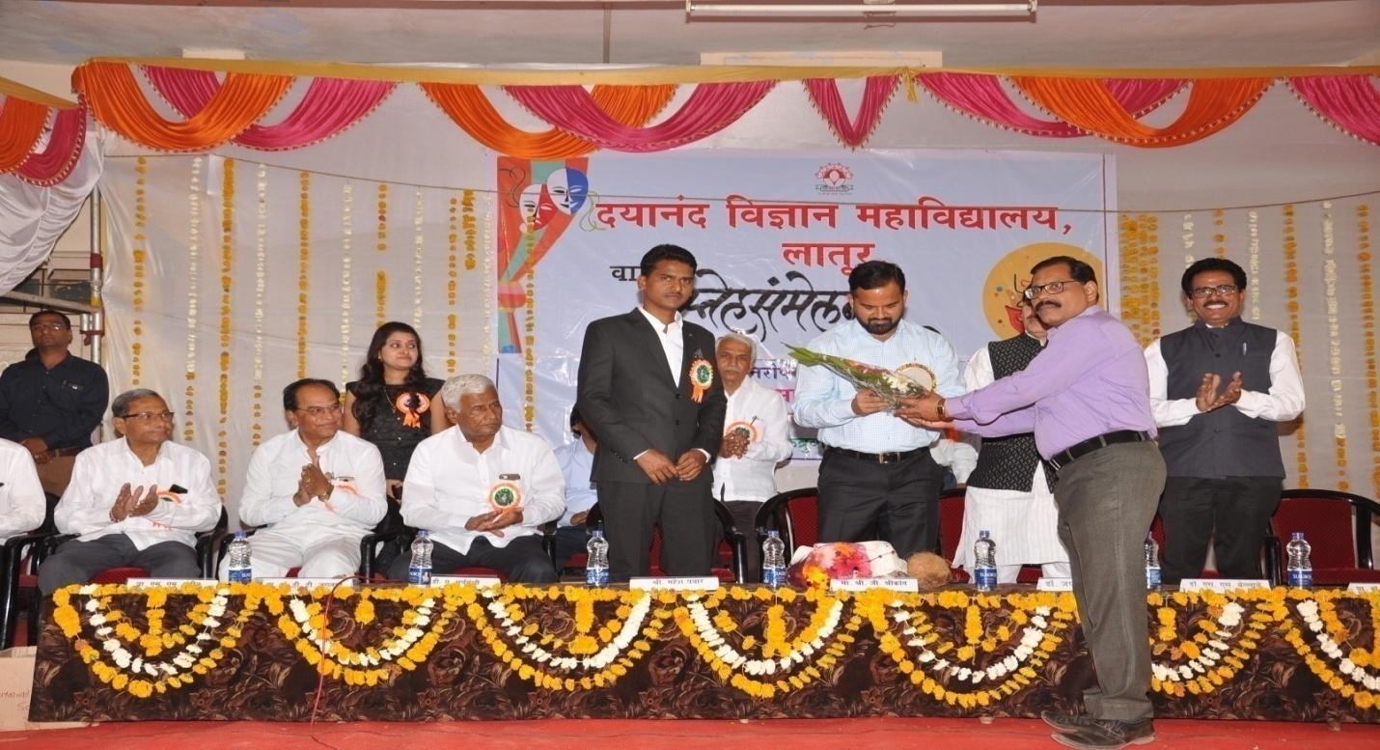
Felicitate to Hon. G. Shrikant(District Collector) by Dr. A.M Chougule c 