Dayanand Science College Latur
Student Council
2020-2021
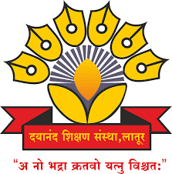

Dr.J.S.Dargad
Principal
Dayanand Science College Latur

Proffesor-In-Charge
Dr.A.M Chougule
Head
Dept.Of Industrial Chemistry

