Dayanand Science College Latur
Student Council
2019-2020
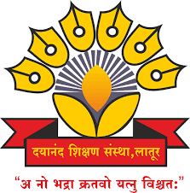

Dr.J.S.Dargad
Principal
Dayanand Science College Latur

Proffesor-In-Charge
Dr.A.M Chougule
Head
Dept.Of Industrial Chemistry

Student Welfare committee
2019-2020

Sr.No. | Name of Member | Designation
01 | Dr. A.M Chougule | Professor –In- Charge
02 | Prof M.M Pandit | Member
03 | Dr. M. A, Bembade | Member
04 | Dr, V, A Choudhari | Member
05 | Prof. R.K Jadhav | Member
06 | Dr. S.S Mahurkar | Member
07 | Prof .A.V.Bhosale(Jr) | Member
08 | - | Secretary student council

Activities (2019-2020)

Sr.No. | Name of Activities | Date | Chief Guest
01 | Organised Health cheke up programme | 31Jan.2020 | 1.Dr.Avinah Patil  (general Physician Latutr)  2.Dr.Sangita Bajaj  (Gynecologist)  3.Dr. Sarika Deshmukh  (Gynecologist)
02 | Organised one day work shop on Tubercoulasis and other deasises | 31 Jan. 2020 | 1.Dr.Avinah Patil  (general Physician Latutr)  2.Dr.Sangita Bajaj  (Gyconologist)  3.Shri Padurang Golmalu  (District Coordinator TB
03 | Annual Social Gathering | 14-15 Feb.2020 | Opening ceremony | Concluding ceremony
 |  |  | Hon. Sanjay Kalamkar  (Speakar and Story Writer) | Hon.Dr. J.SDargad  PrincipaI.  Dayanand Science College Latur

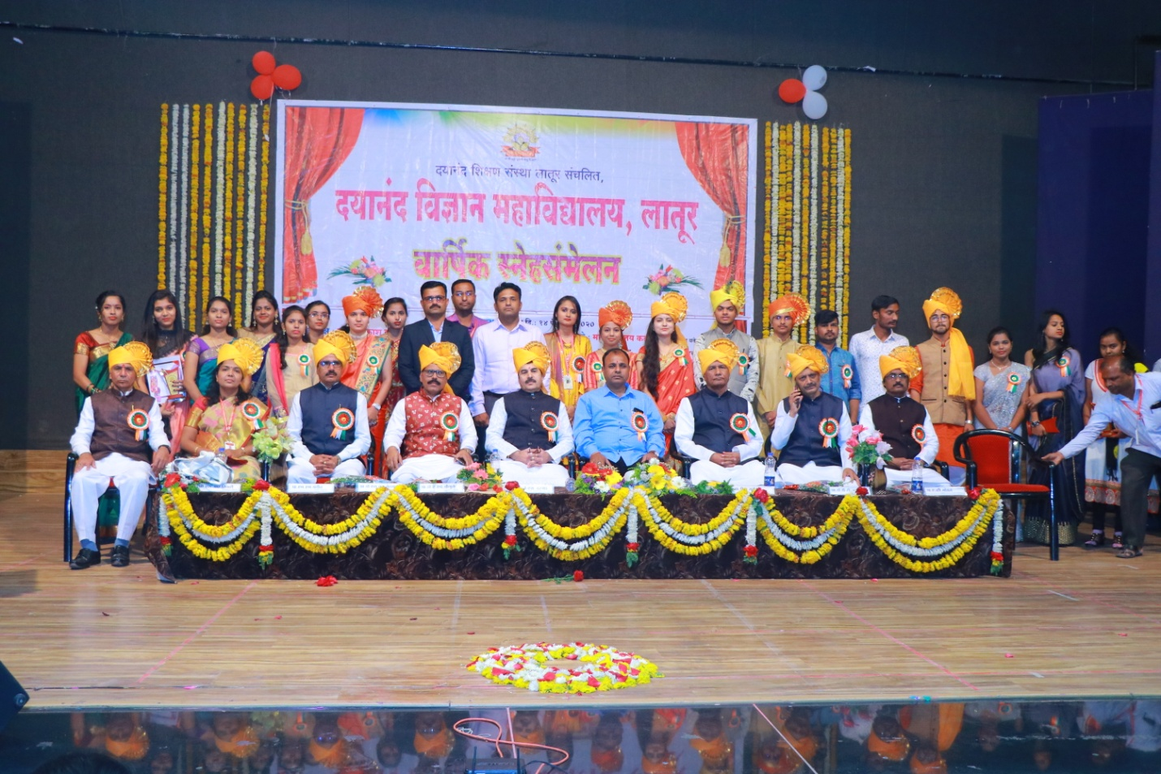
Student Representative and student welfare commitee with Chief guest Hon.Shri Sanjayji Kalamkar (Speaker and Story Writer) Along with Hon. Dr. J S Dargad, Dr. A M Chougule,Vice- Principle S S Bellale, Prof. Megha Pandit, Prof. Dasrao Suryawanshi , Dr. Avinash Bhosale and Shri. Sudhir Tiwari

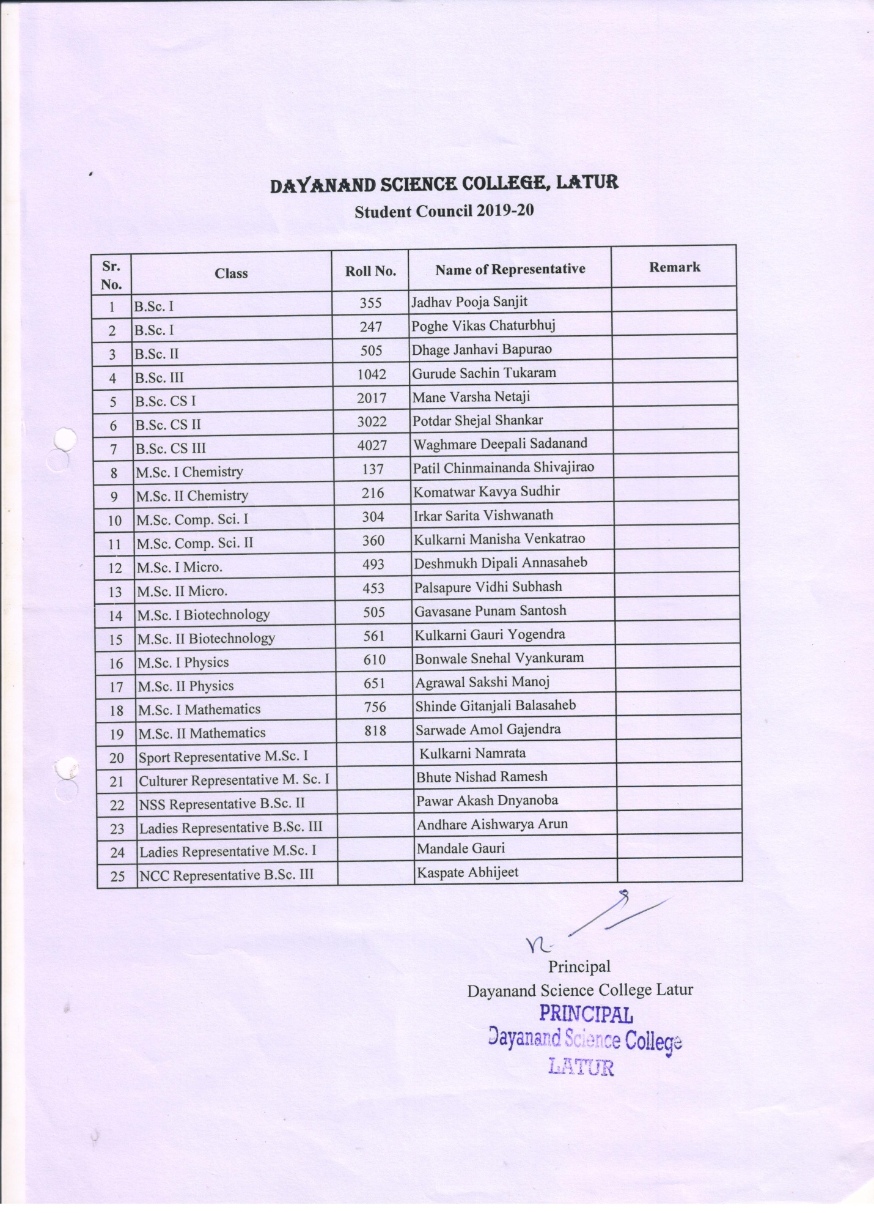
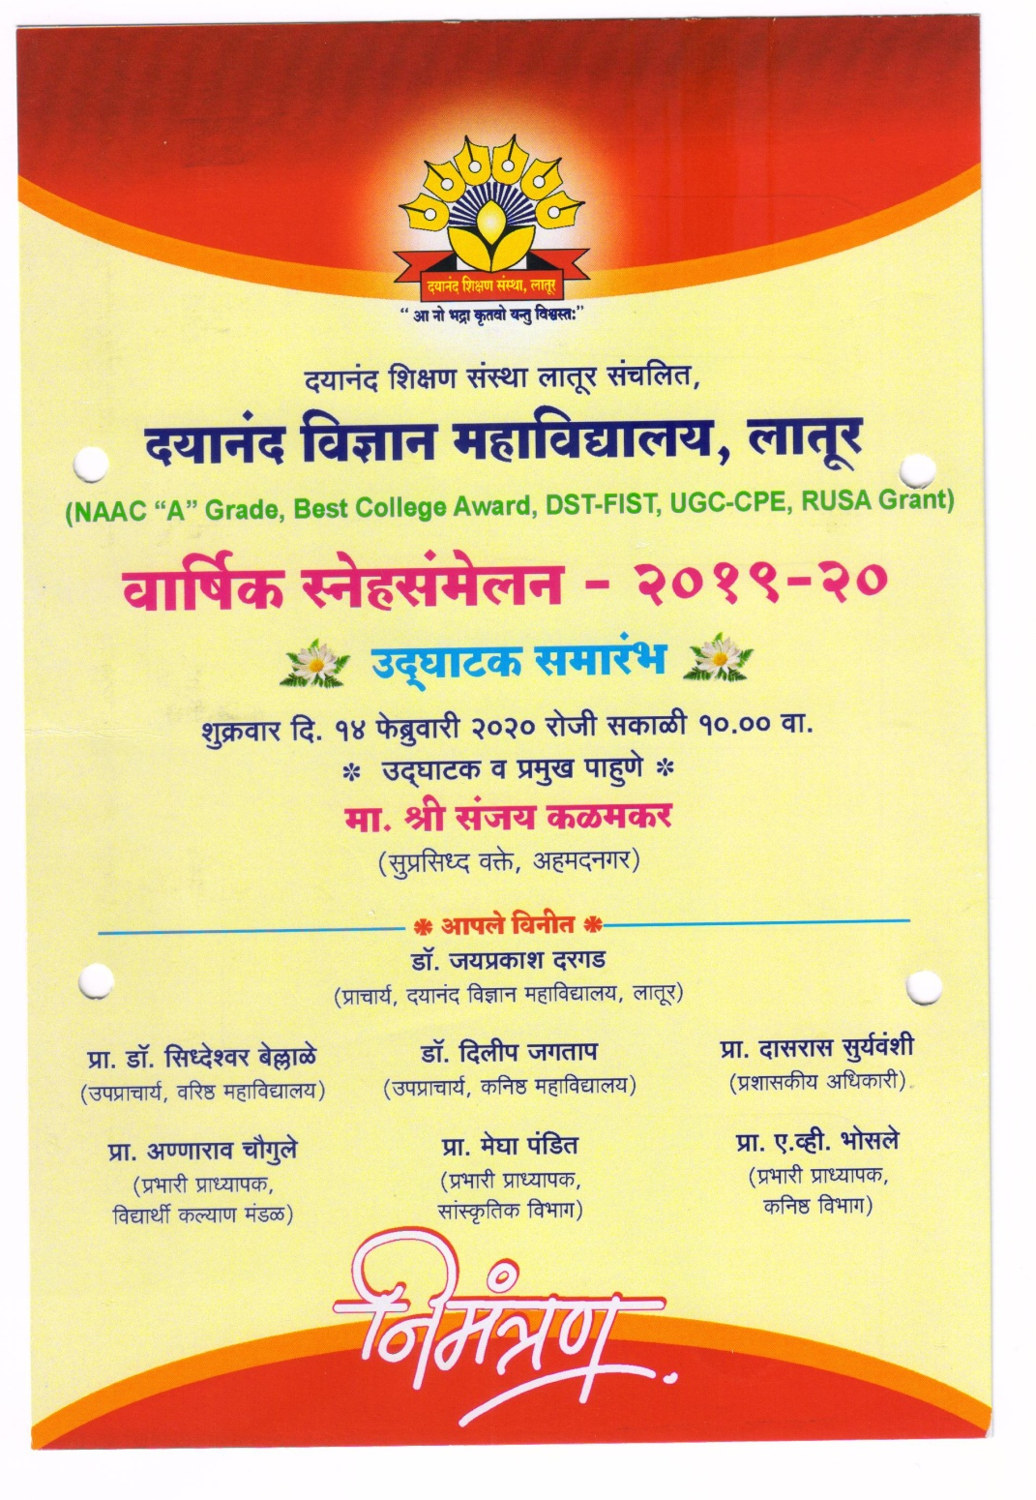

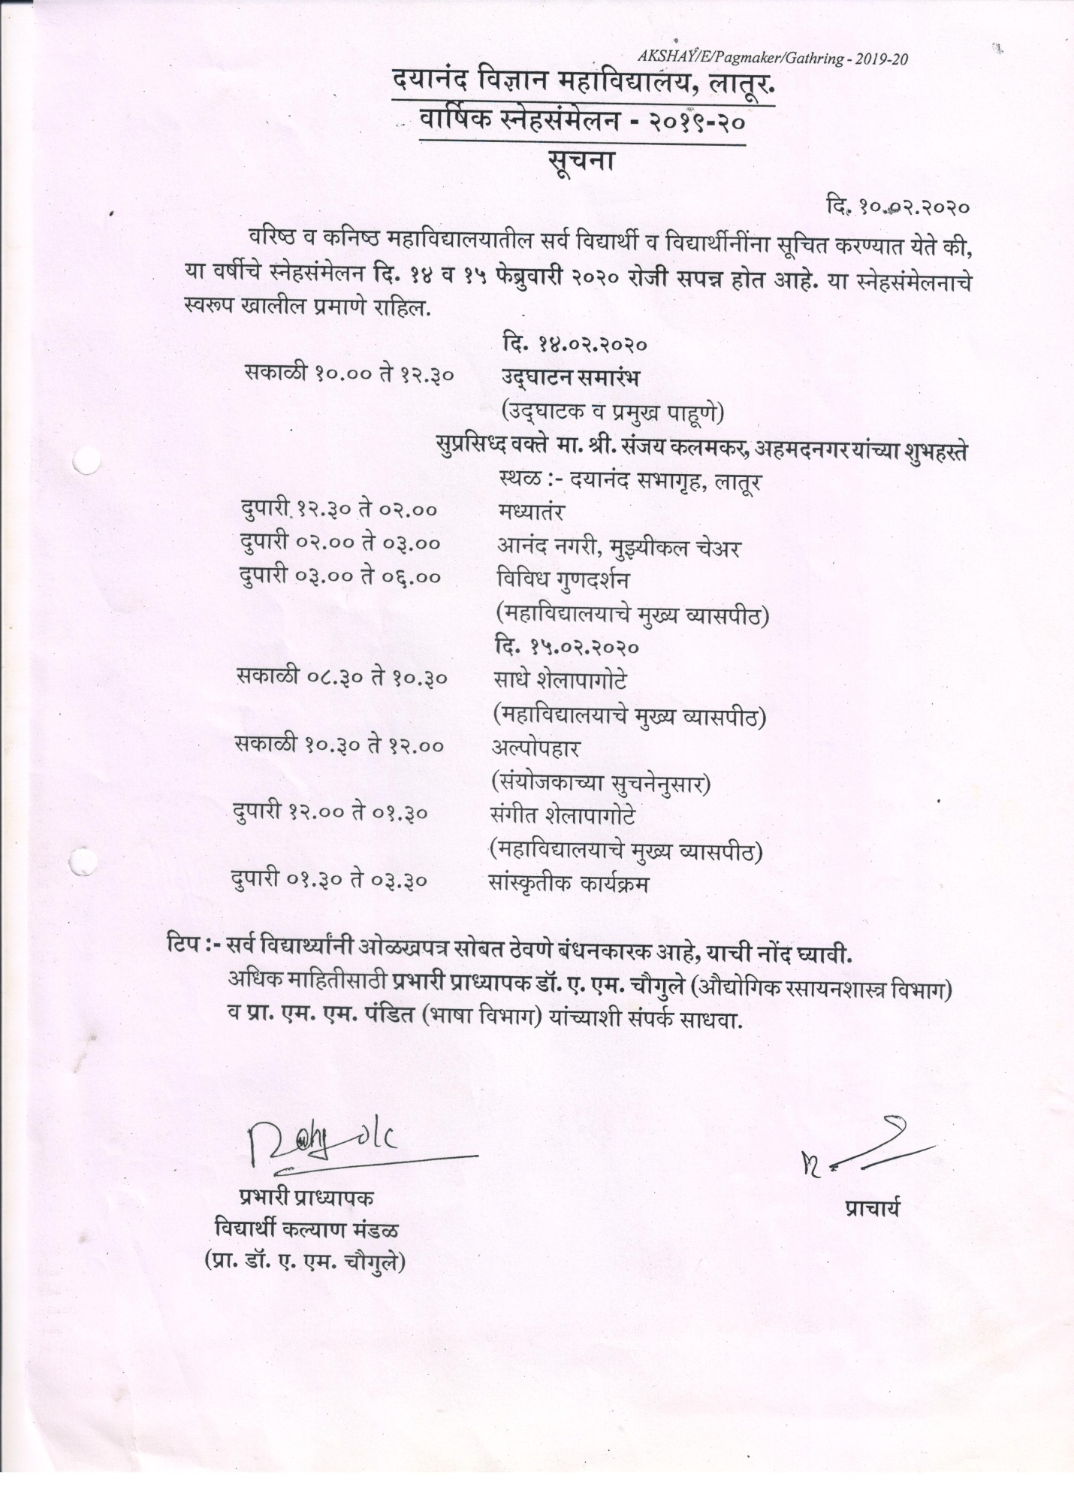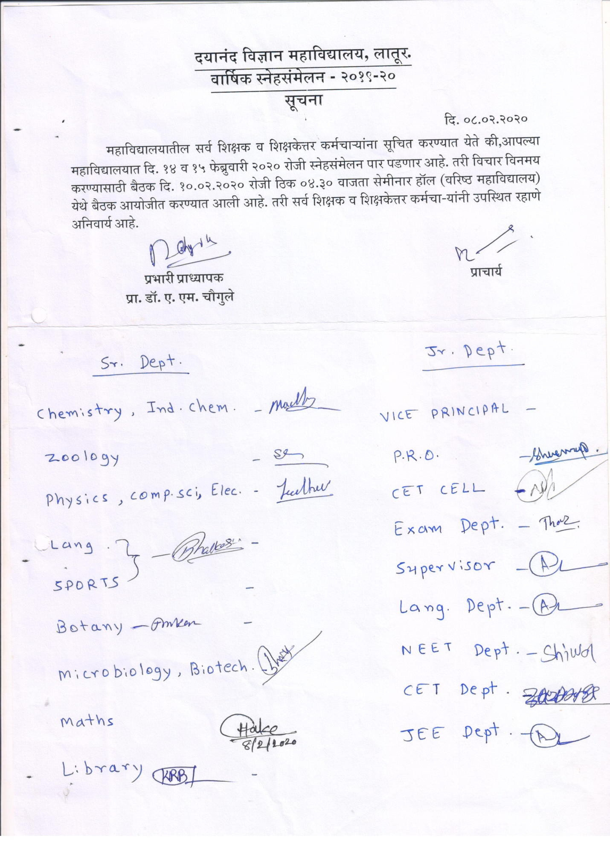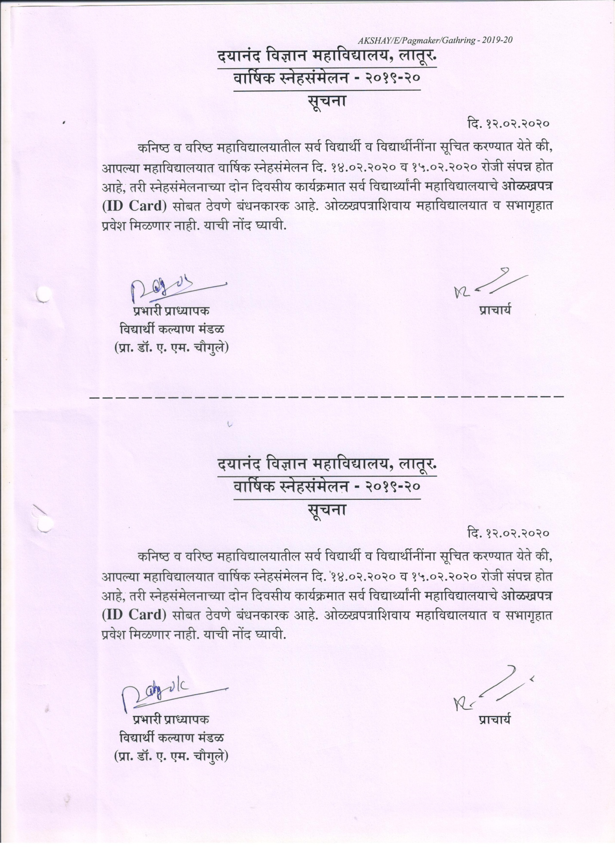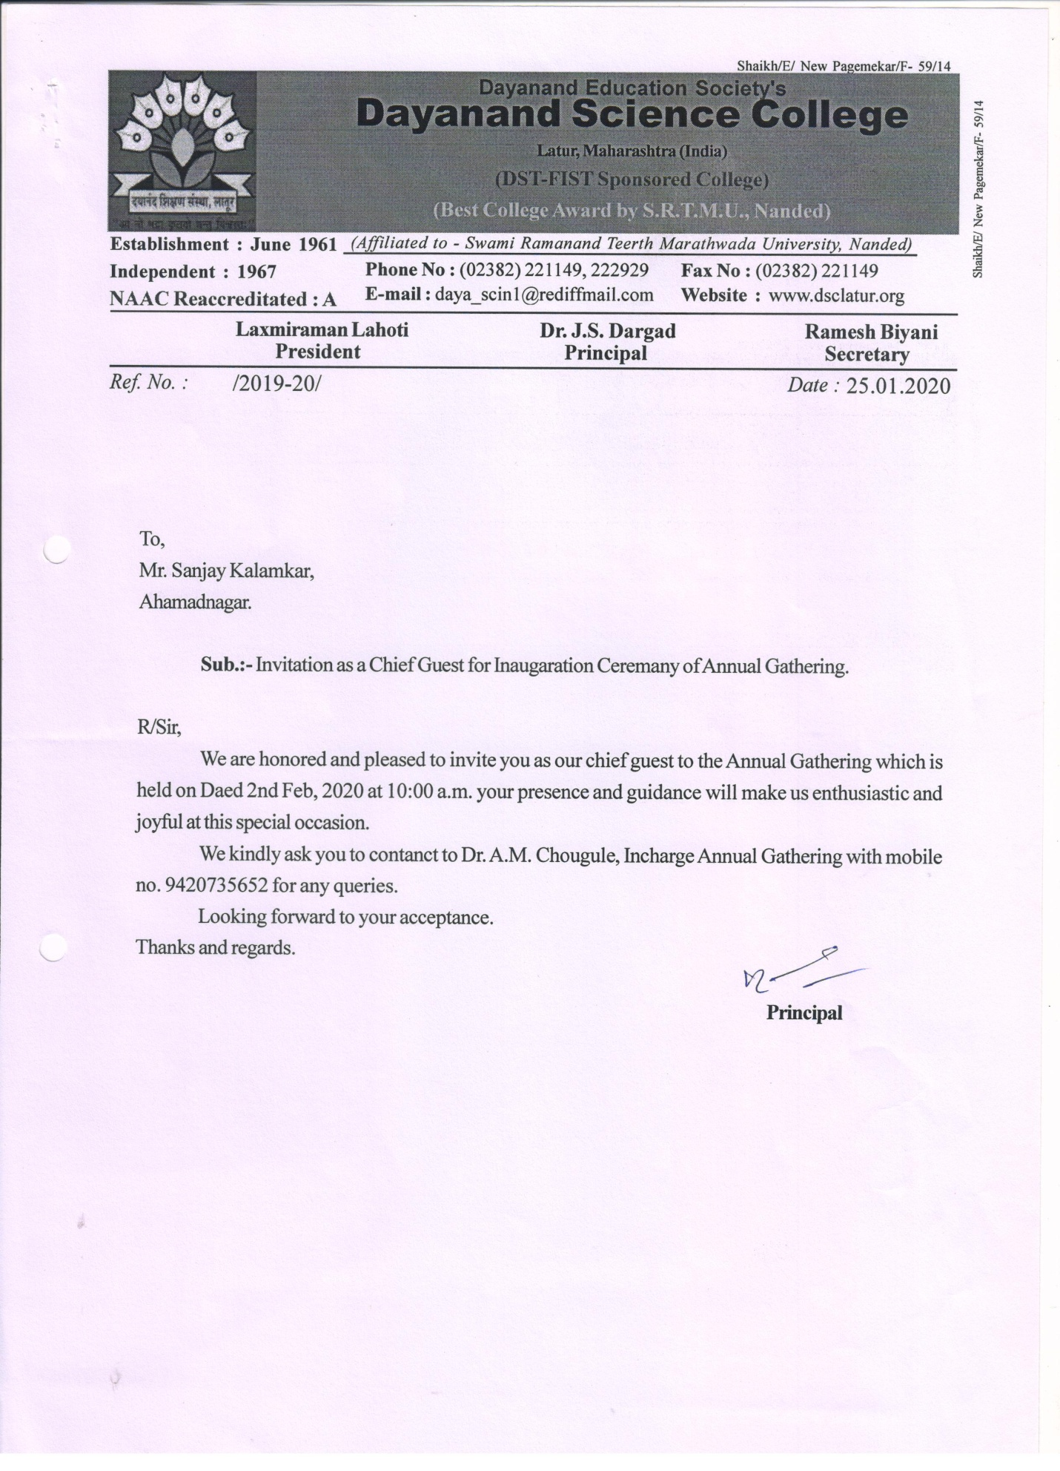
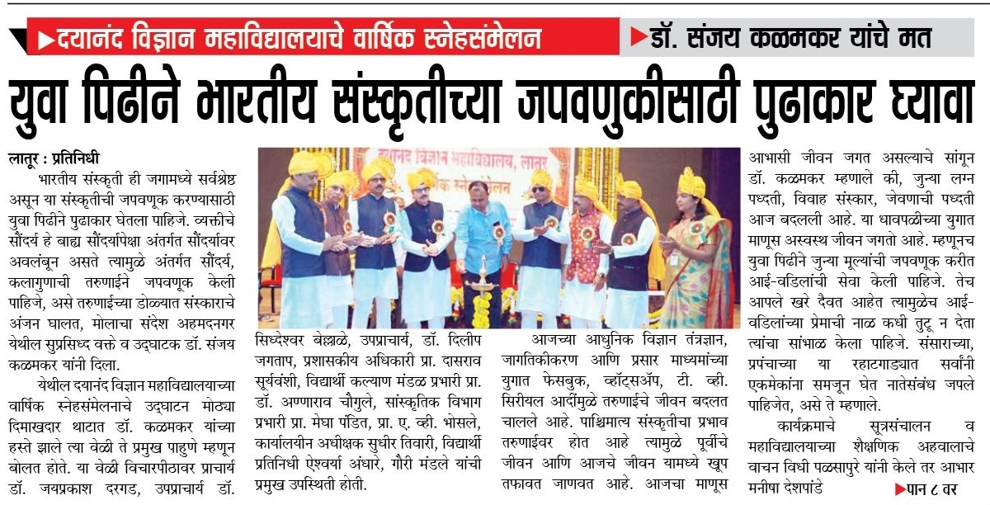

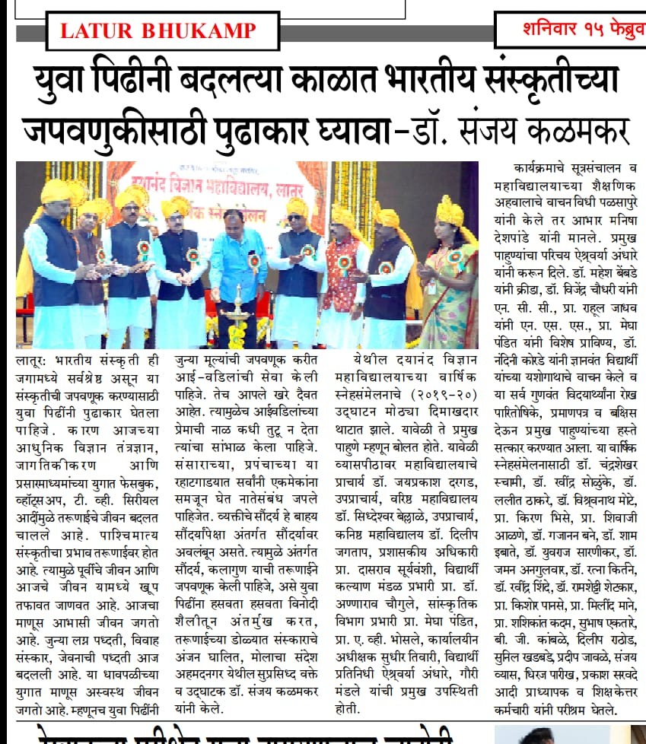
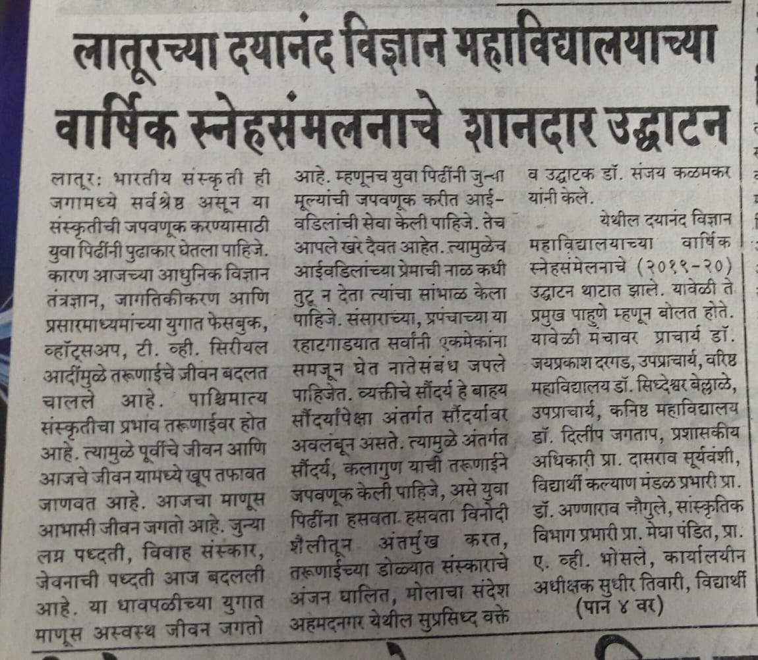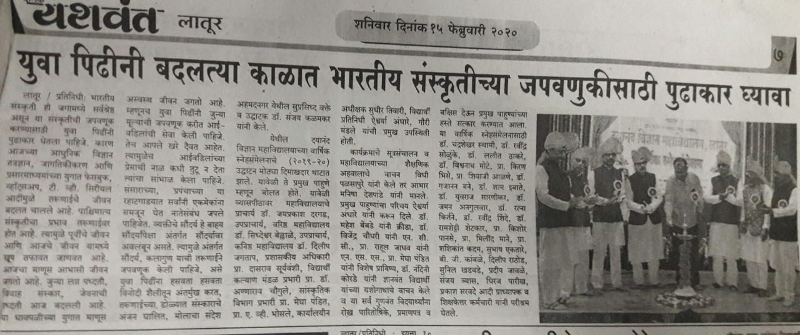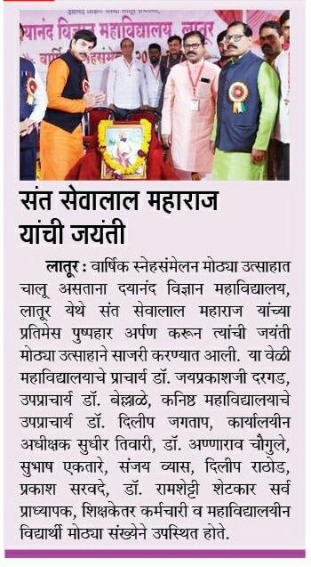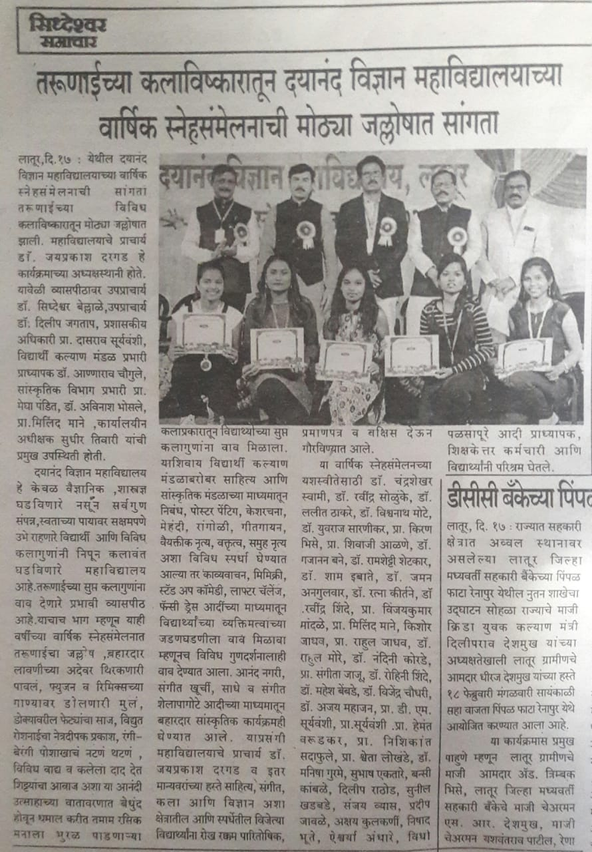
Student Council Report
2019-20
In the year 2019-20 student council establishment on dated 16 Dec. 2019 on basis of merit total Twenty-five delegates was selected, from which nineteen class representatives with sport, NCC, NSS, cultural one from each and two ladies representative nominated by Hon. Principal of the college.
Programme and meetings
There are four meetings conducted for student council on different issues of students in presence of Hon. Principal in the principal office.
Organized Health checkup programme and one day work shop on awareness of Tuberculosis and other Diseases under UGC-CPE scheme for all college student on dated 31-01-2020 under chairman ship of Dr. J. S. Dargad Principal Dayanand Science College Latur and chief guest was shri Pandurang Golmalu ( Distric co-ordinator T.B. control center Latur ) and shri Akash Godke president Mahatma fule NGO all college student participated in this programme and taken the benefit of the work shop and also Health checkup camp.
Annual Gathering
On dated 23-01-2020 organized the meeting regarding confirmation on the date for celebration on Annual gathering and cultural programme. In this meeting Chairperson Hon. Dr. J. S. Dargad sir finally suggested that on 13-02-2020 organized the all sports & cultural events compitations for students and 14-15 Feb.2020 celebrate the events for Annual function .
All events are organized by students council and cultural association as per schedule on 13-02-2020 competition activities of cultural and sports events was taken, student participated spontaneously in all competitions like solo and group dance, rangoli, spontaneous speech, musical chair,cricket,badminton,chess etc.
On 14-02-2020 Annual function of the college inauguration was inaugurated by Hon. Shri Sanjay Kalamkar wel known speaker and story writer he was won the heart of student through his guidance & katha kathan programme.The programme
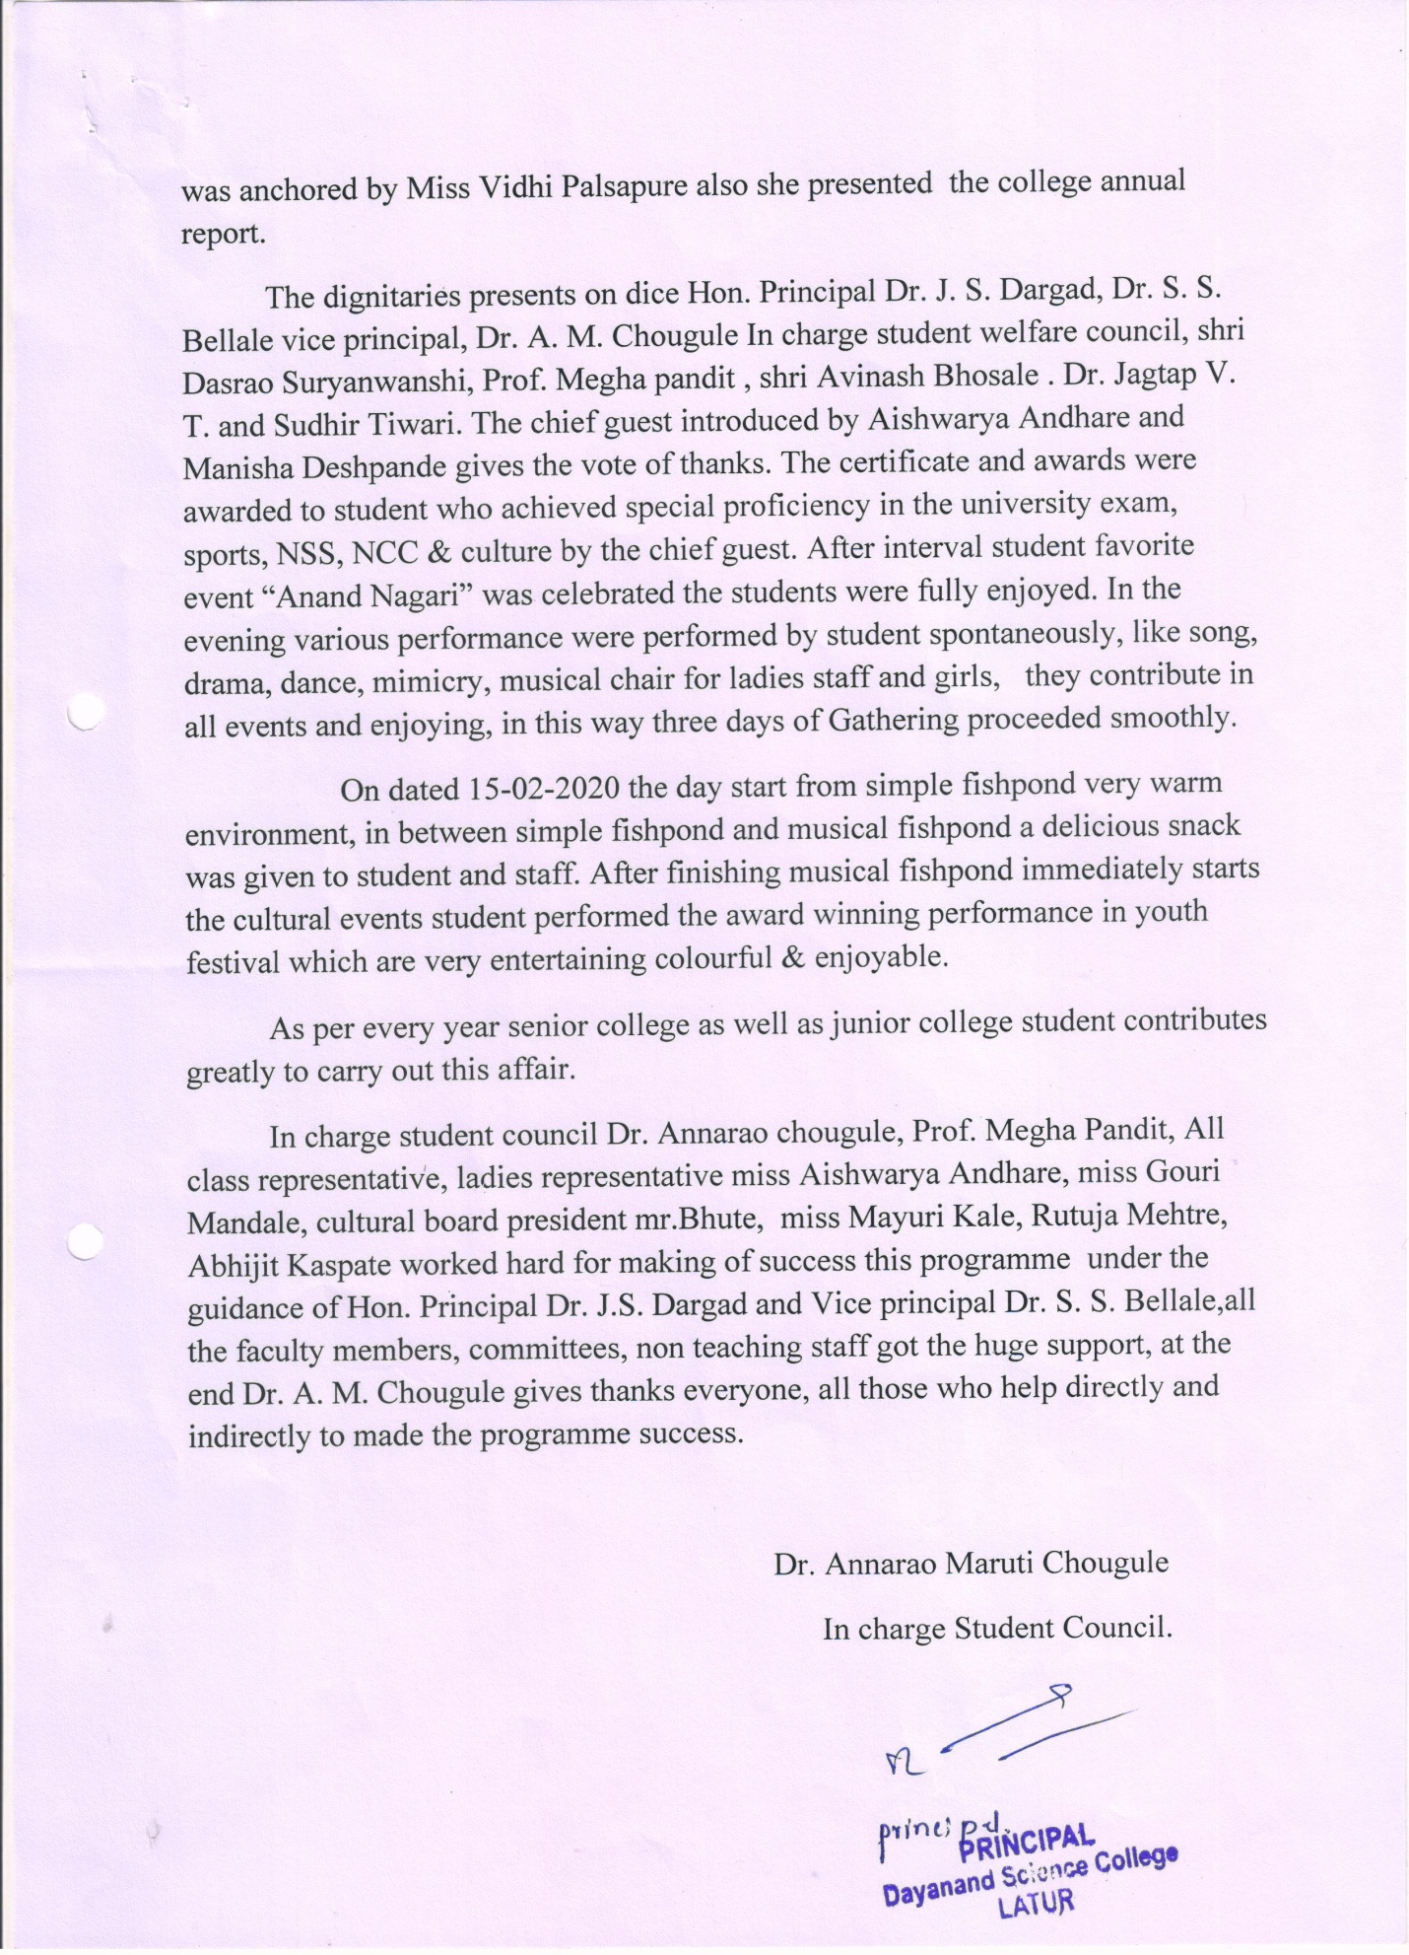
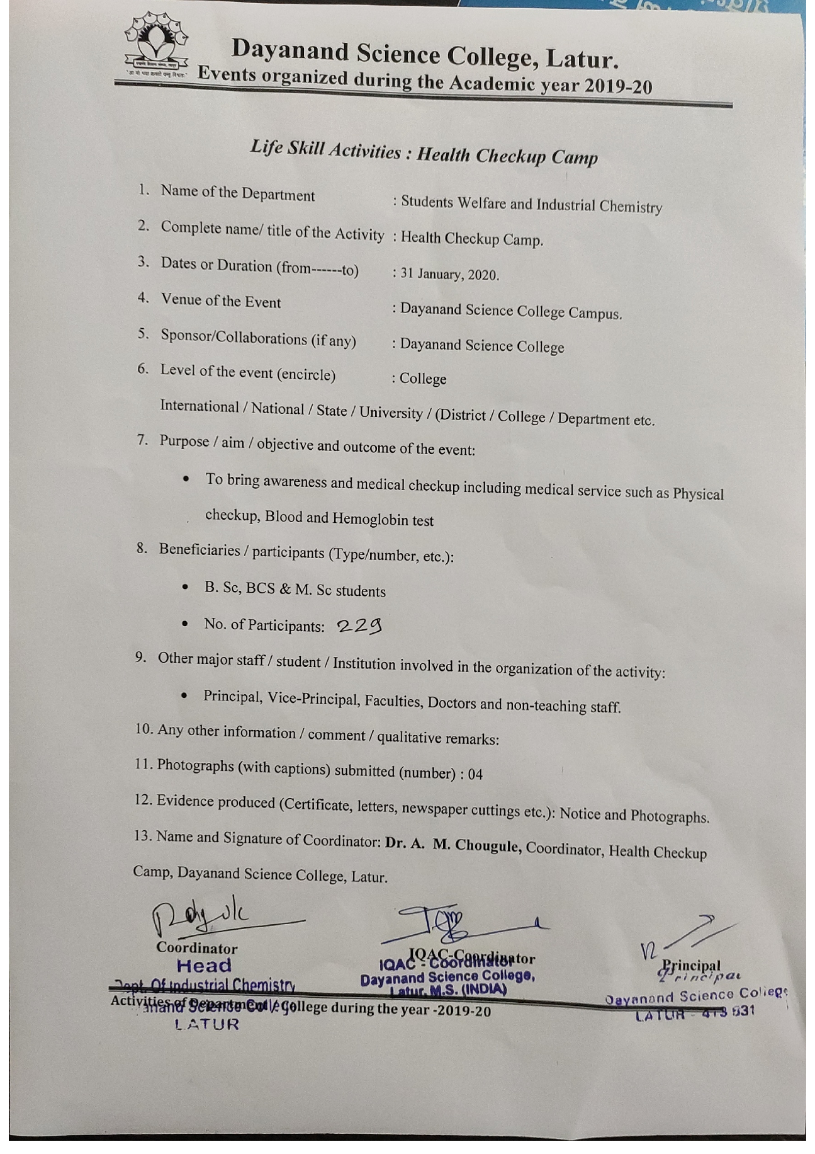Photo Gallery Gathering Opening Ceremony
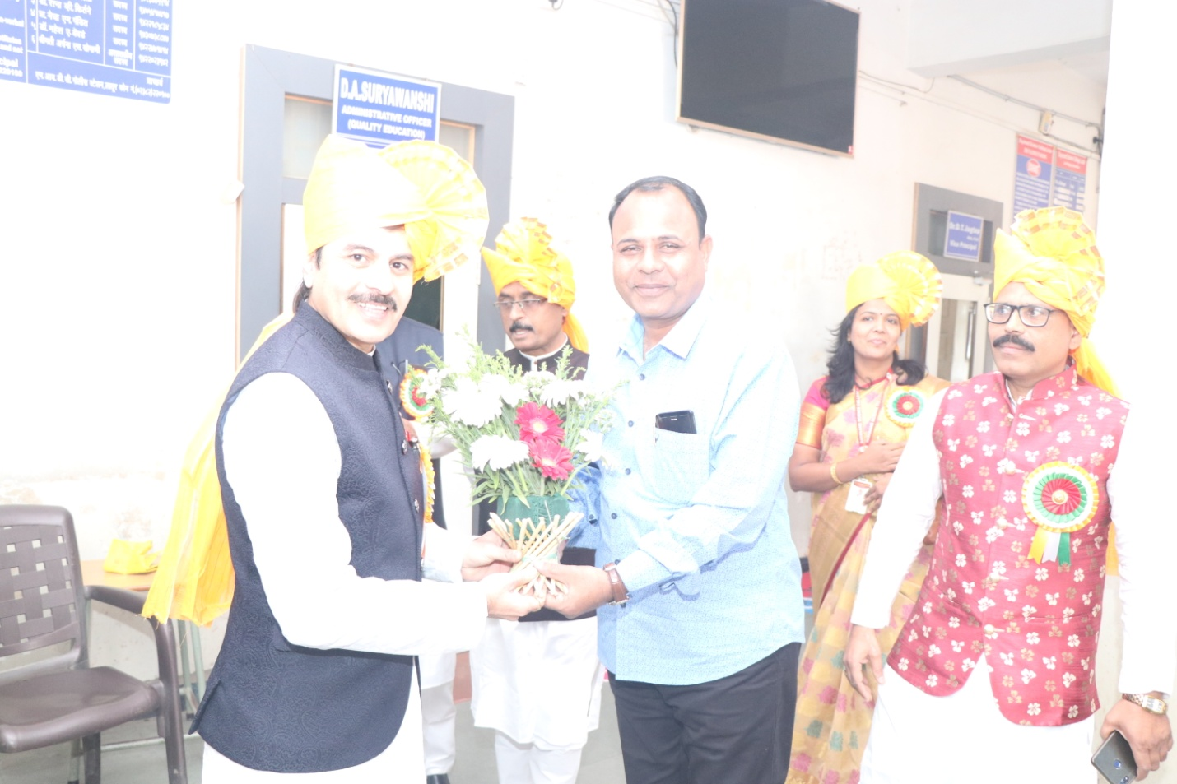
Hon. Principle Dr. J S Dargad Falicitate to Hon. Chief Guest Sanjayji Kalamkar at His Arrival

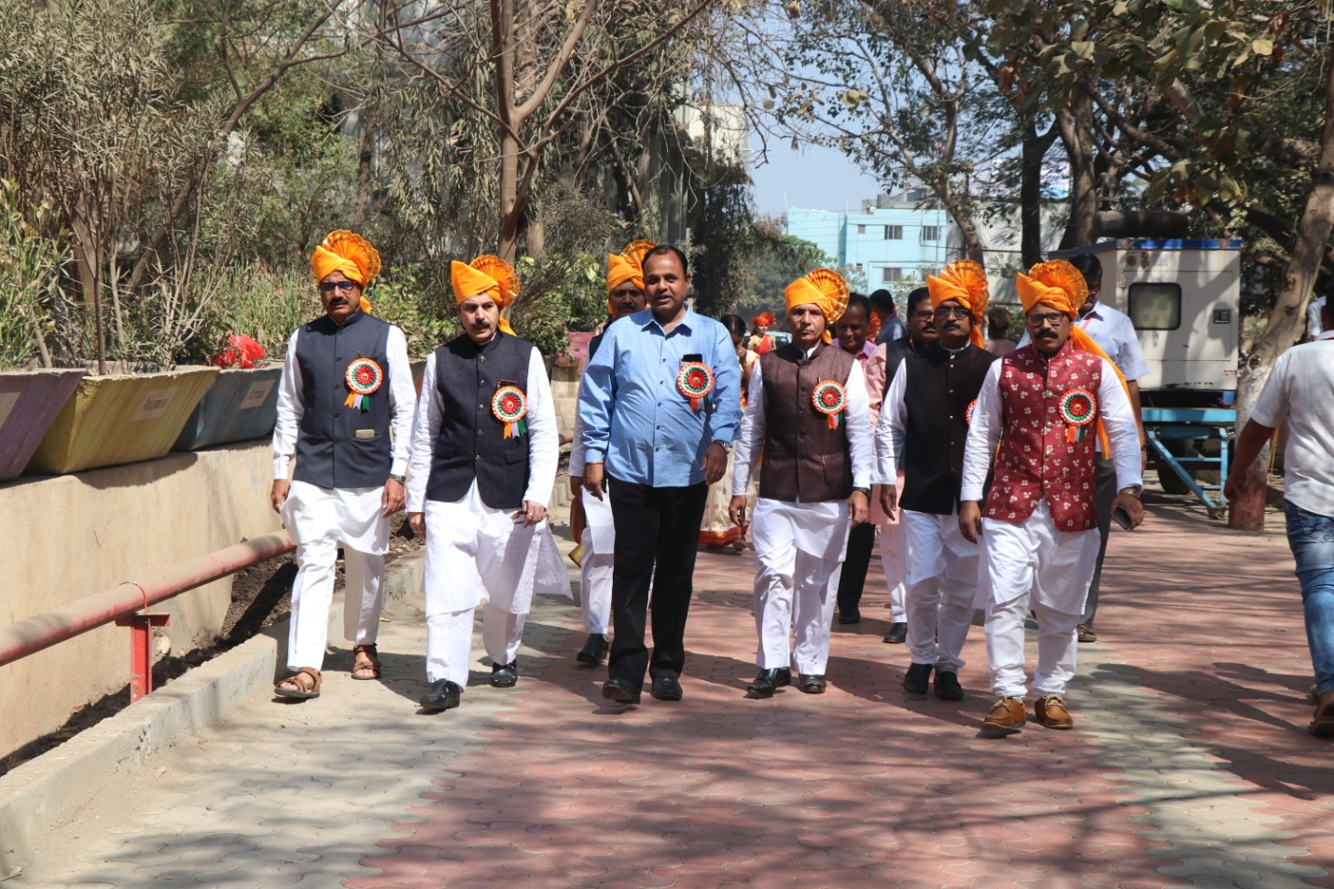

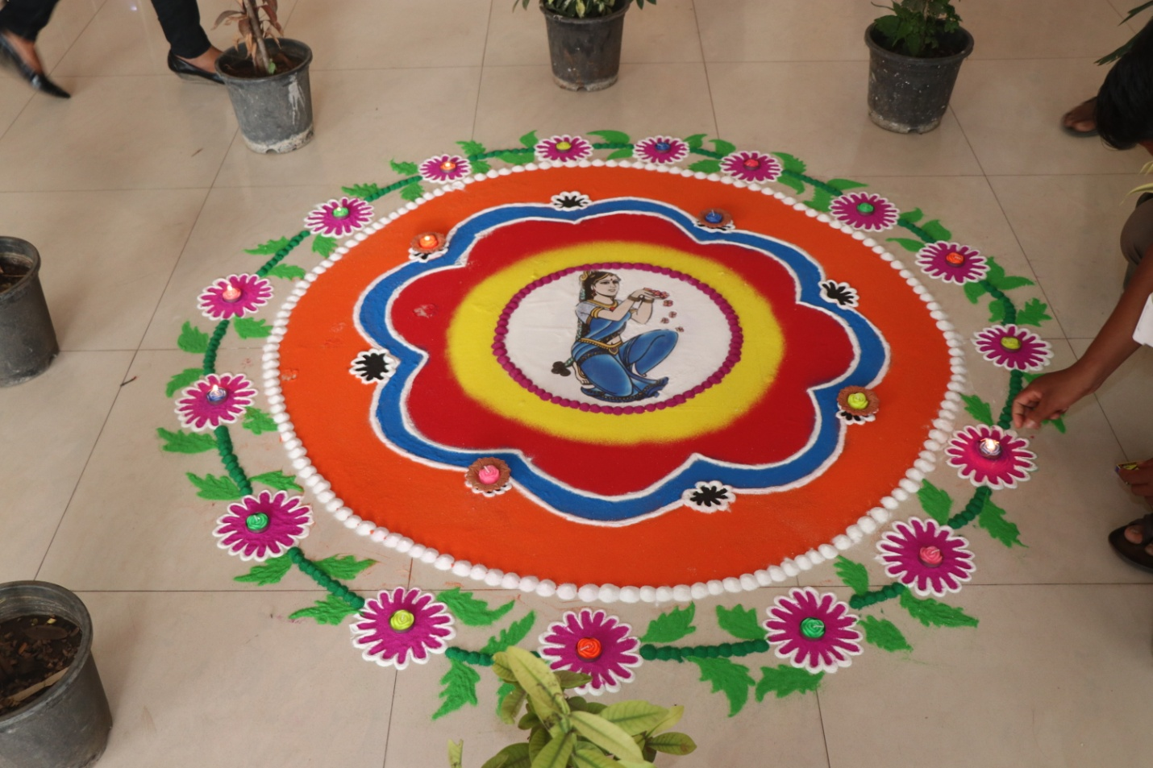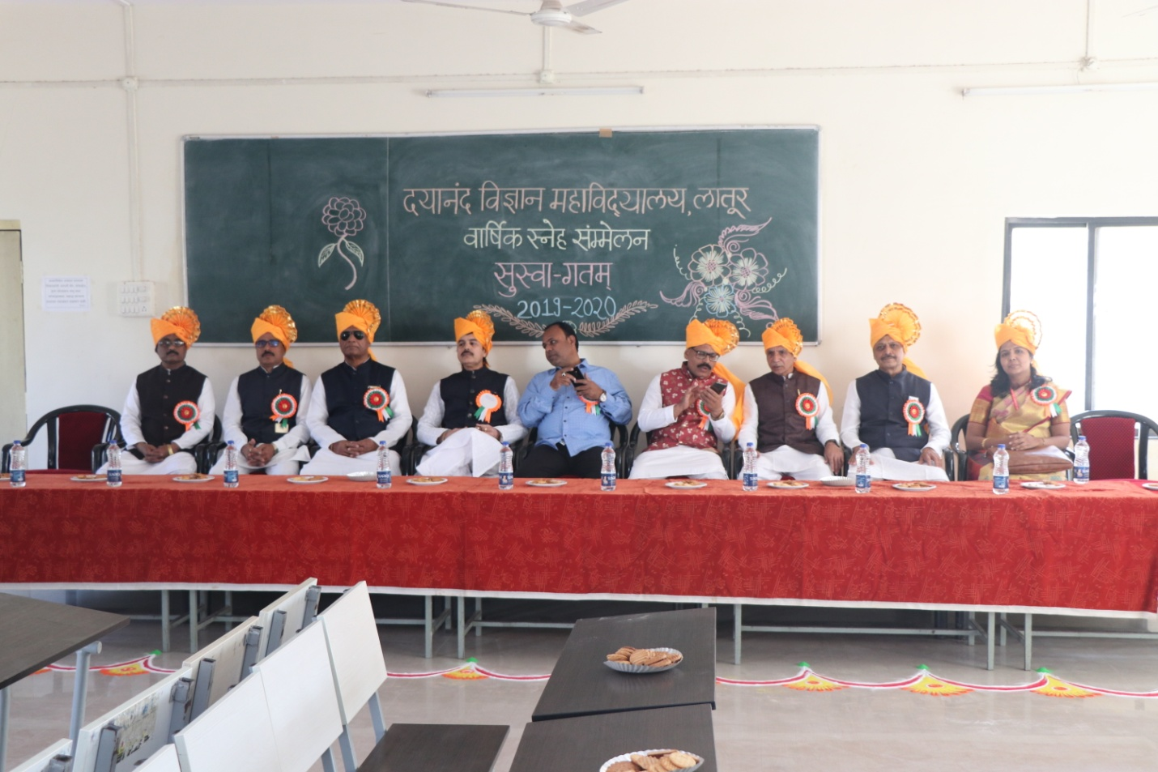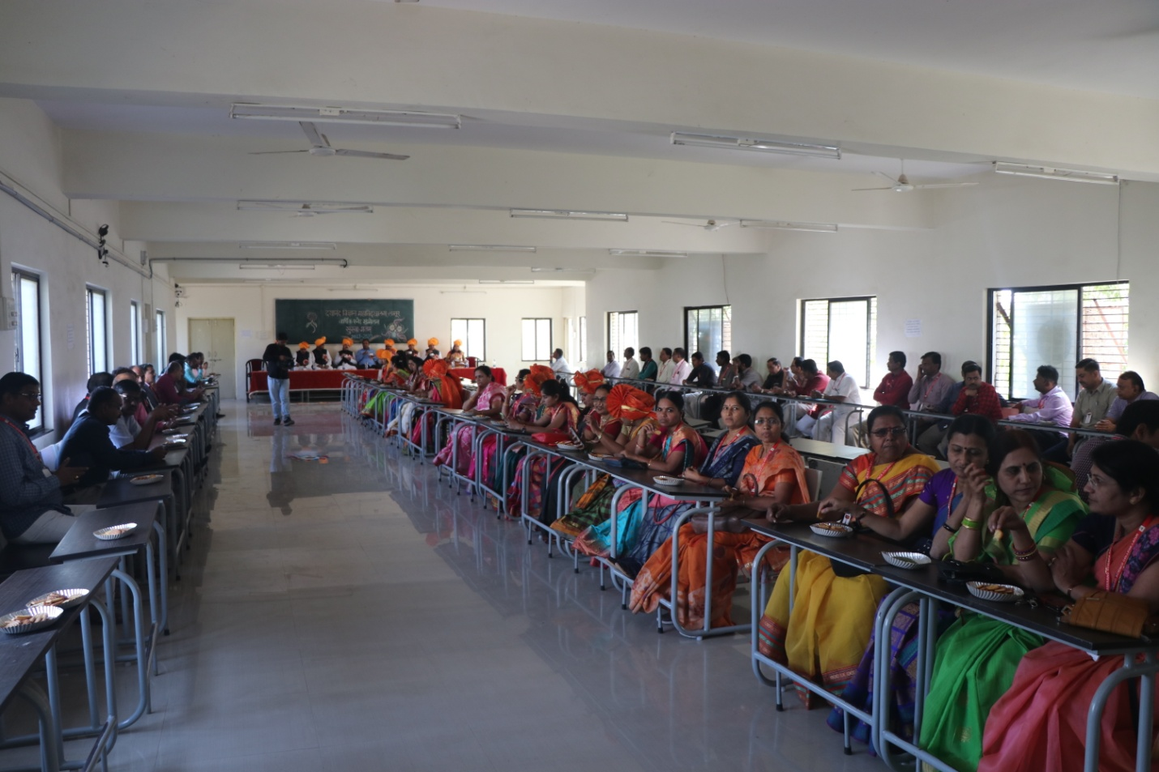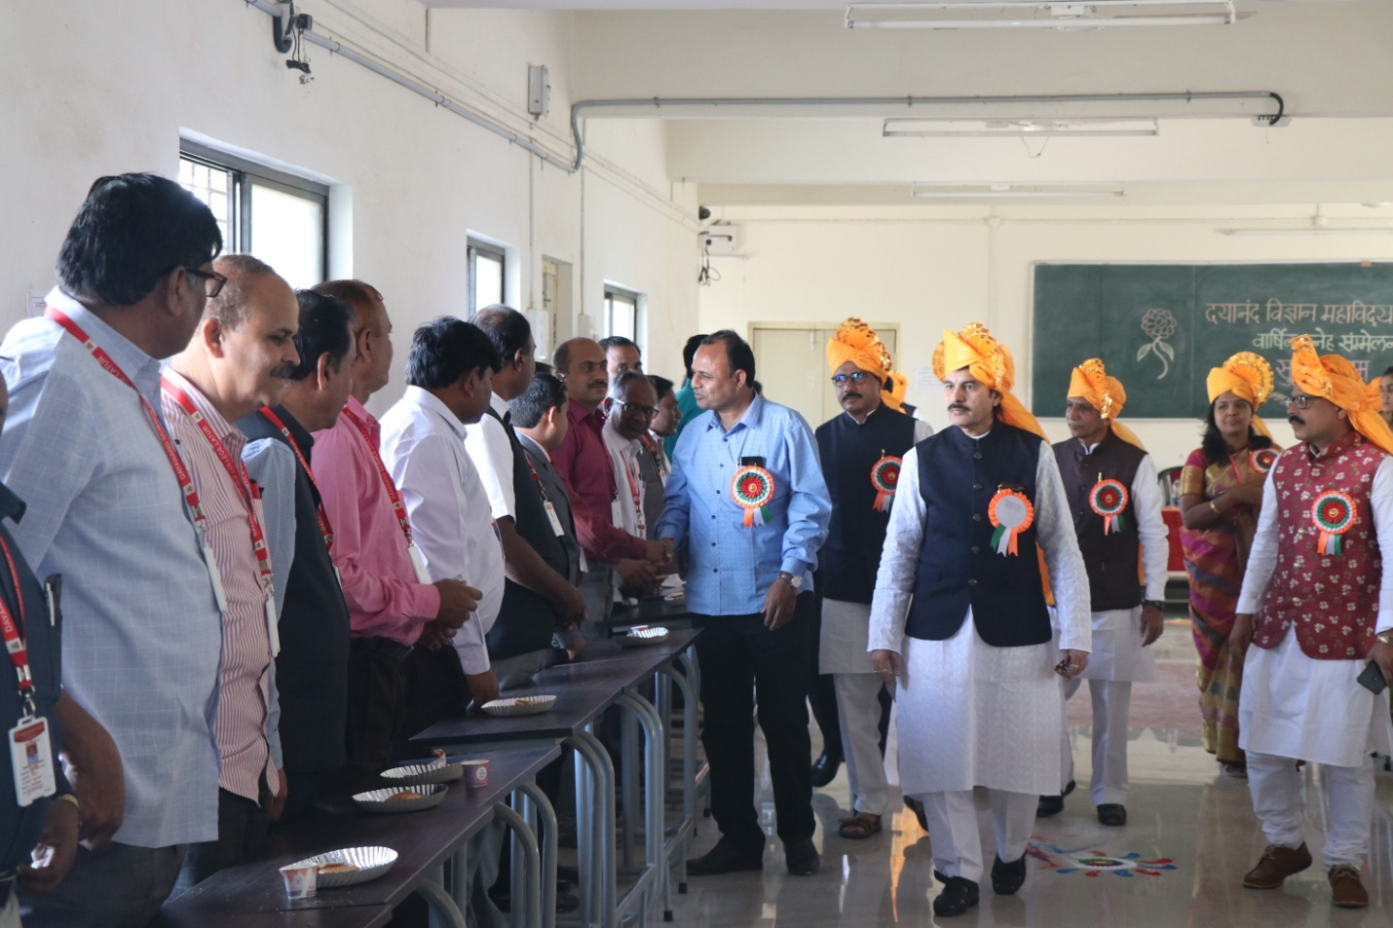
Introduction With Staff

Photogallery Of Opening Ceremony of Annual Function ggg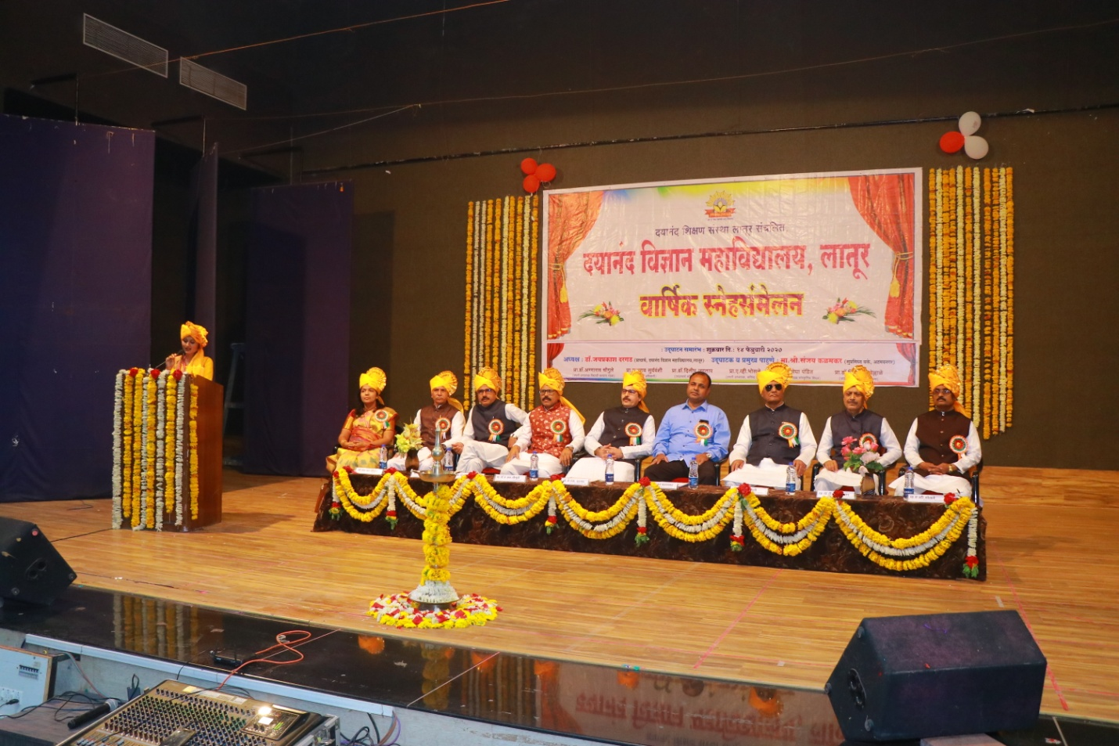 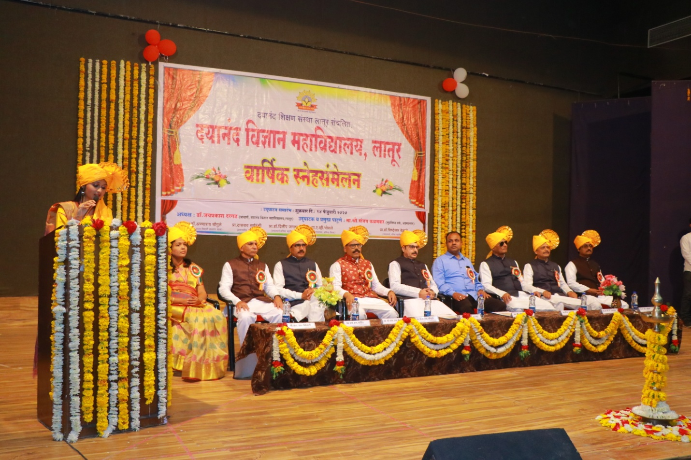 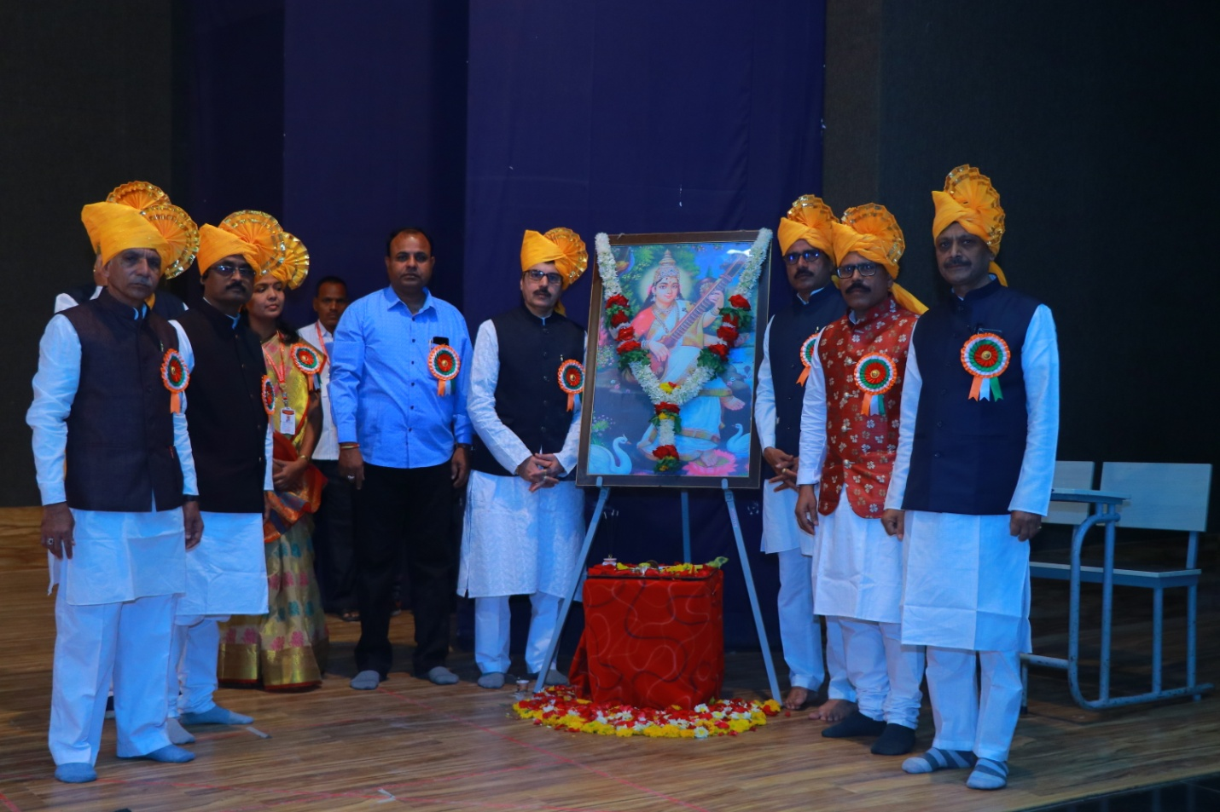 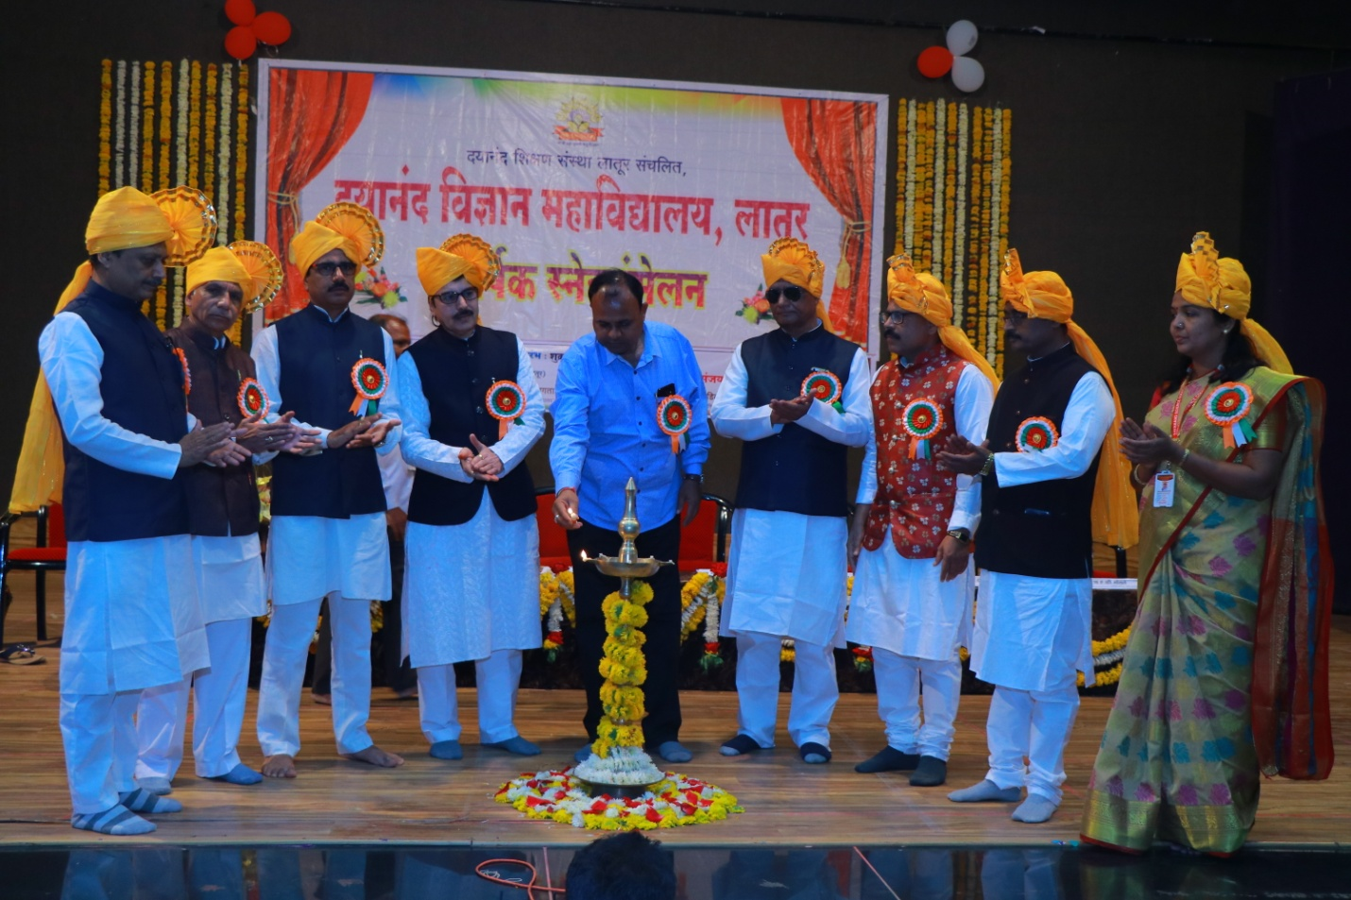 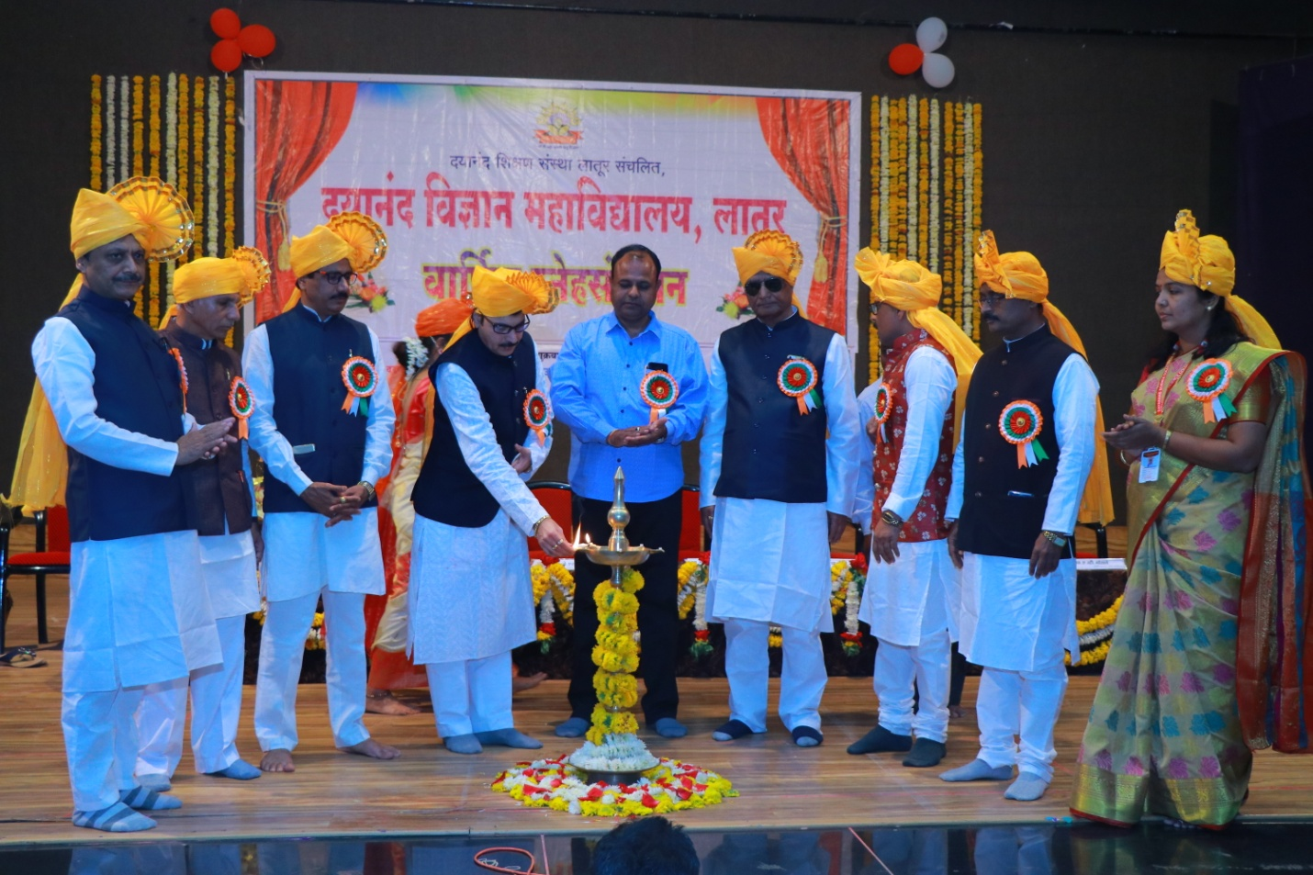 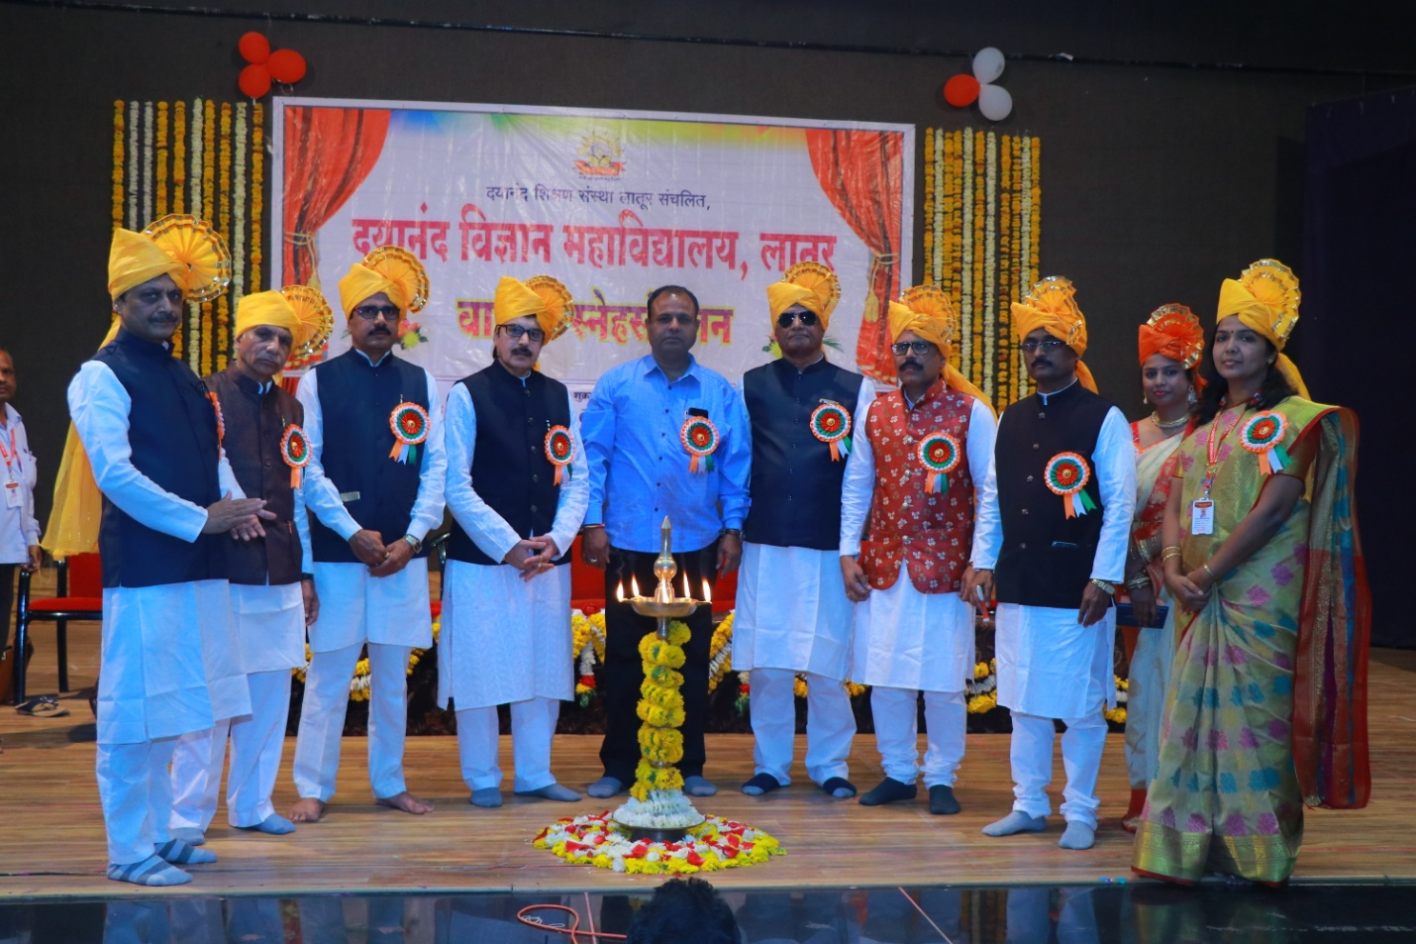 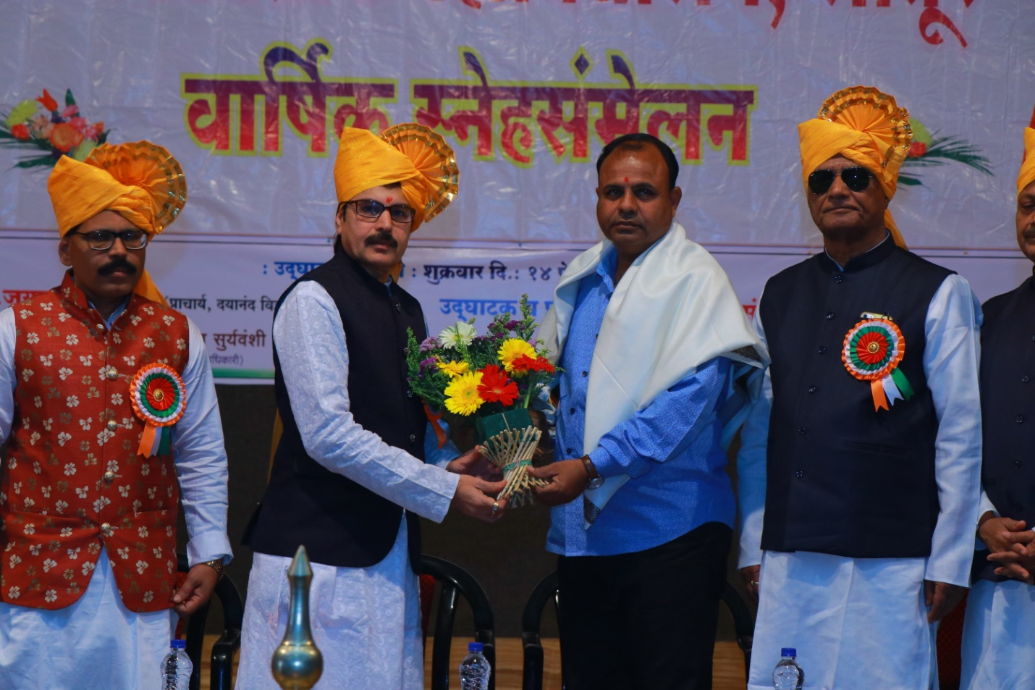 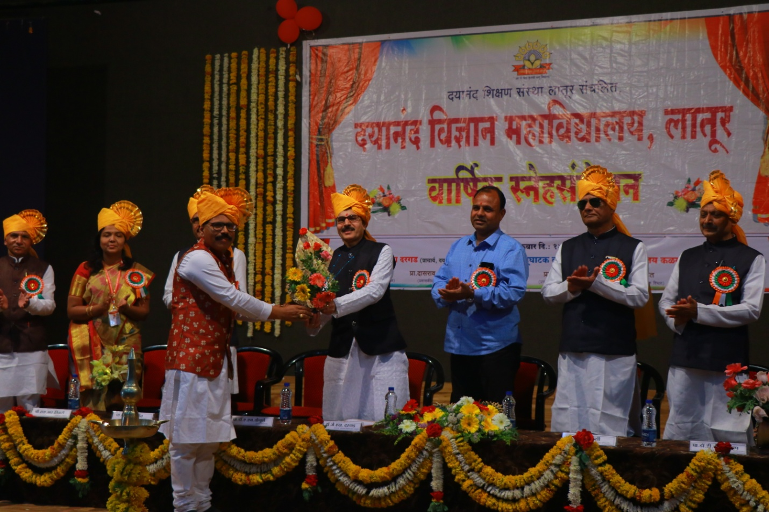 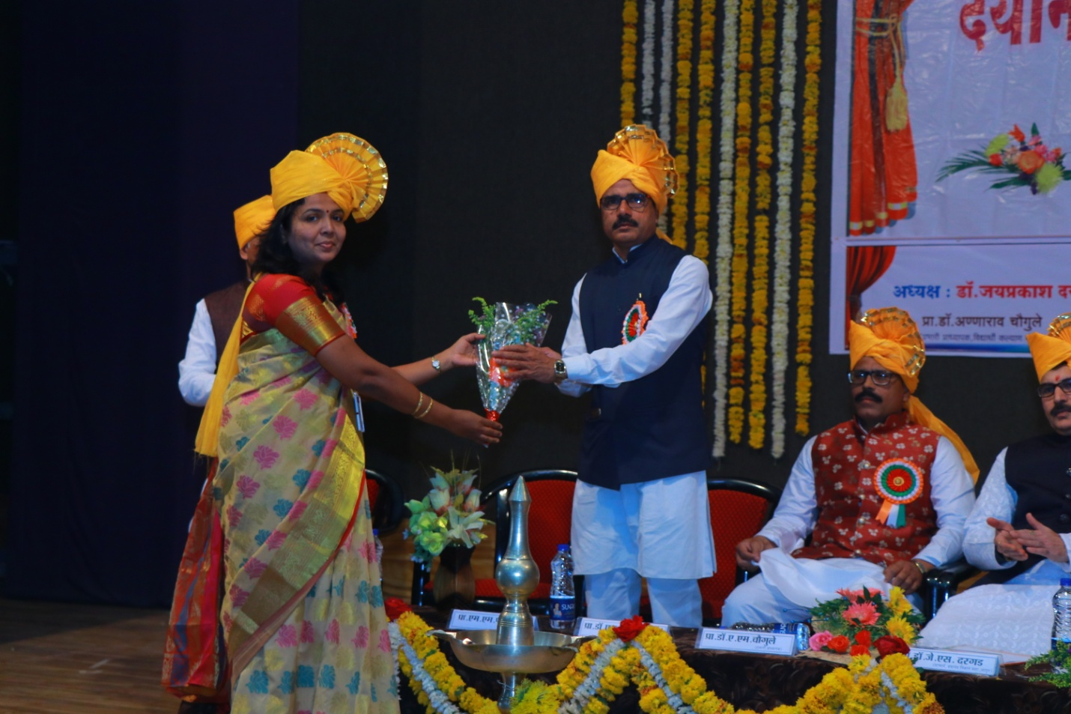 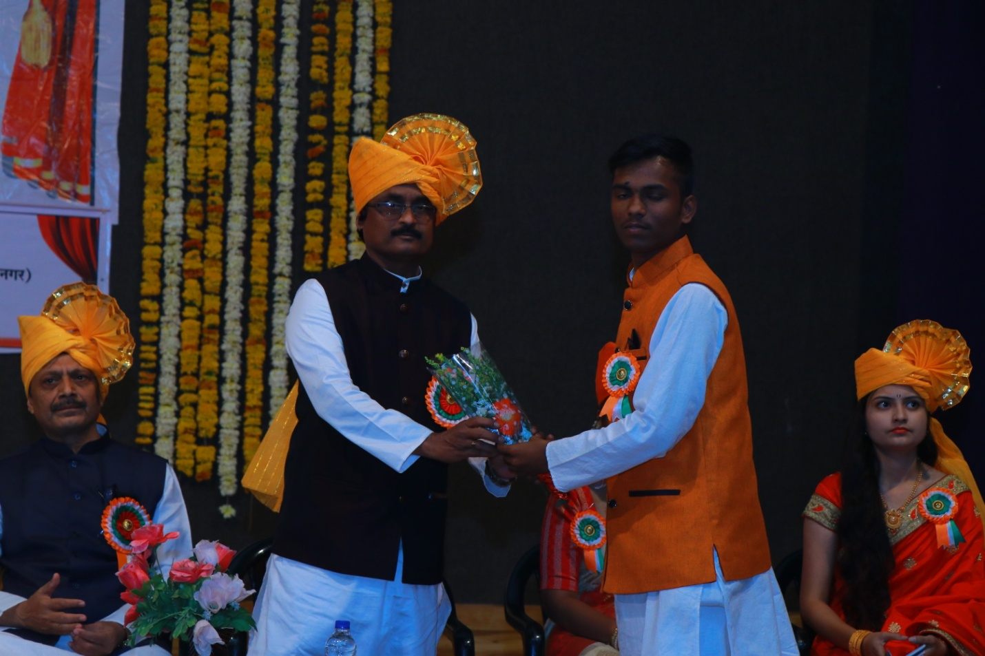 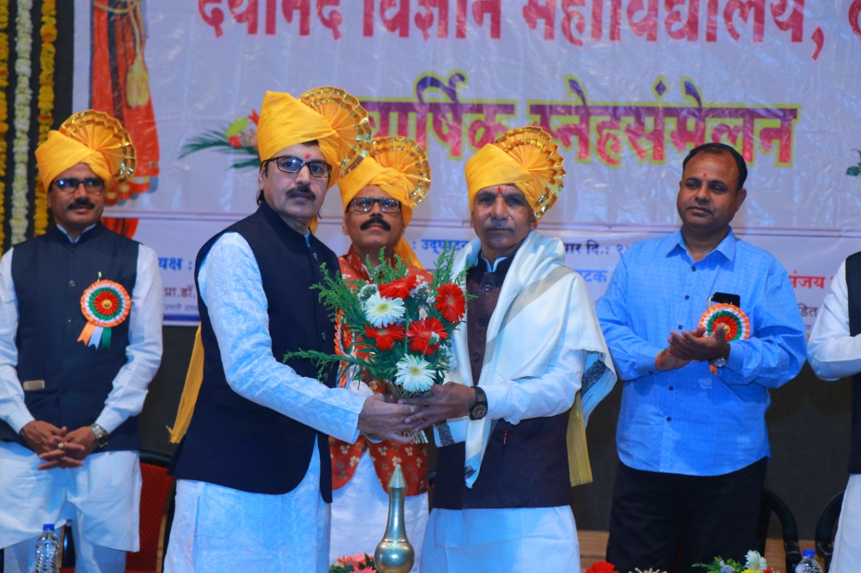 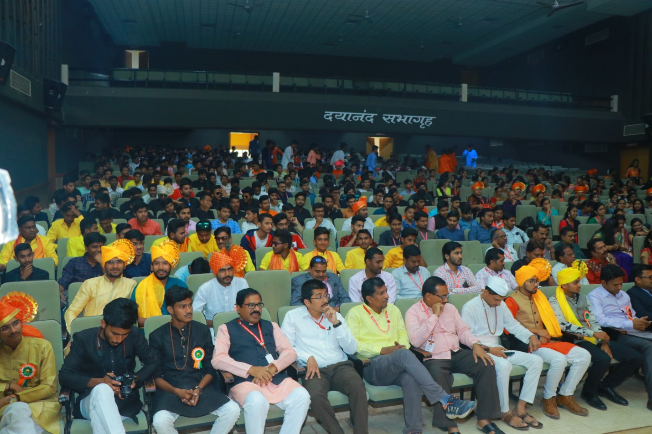 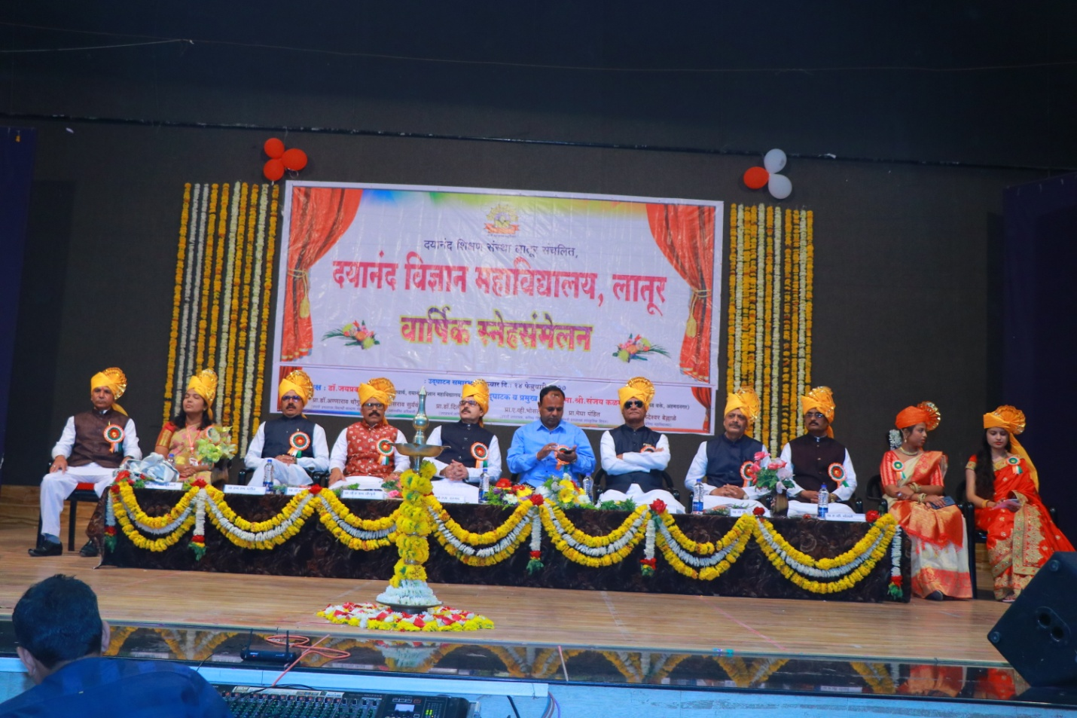 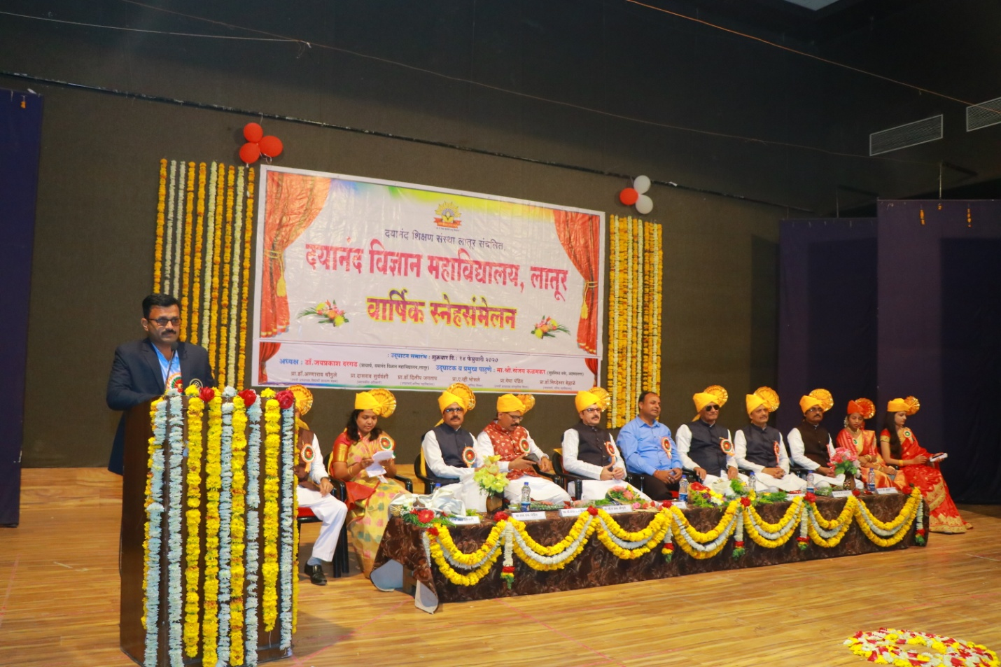 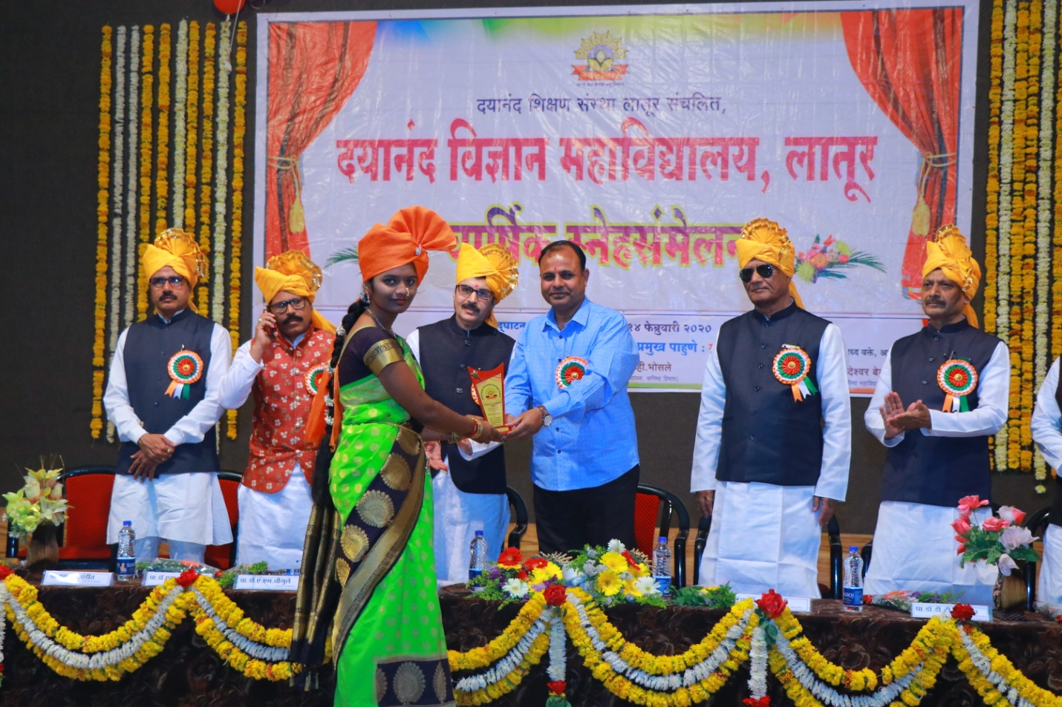 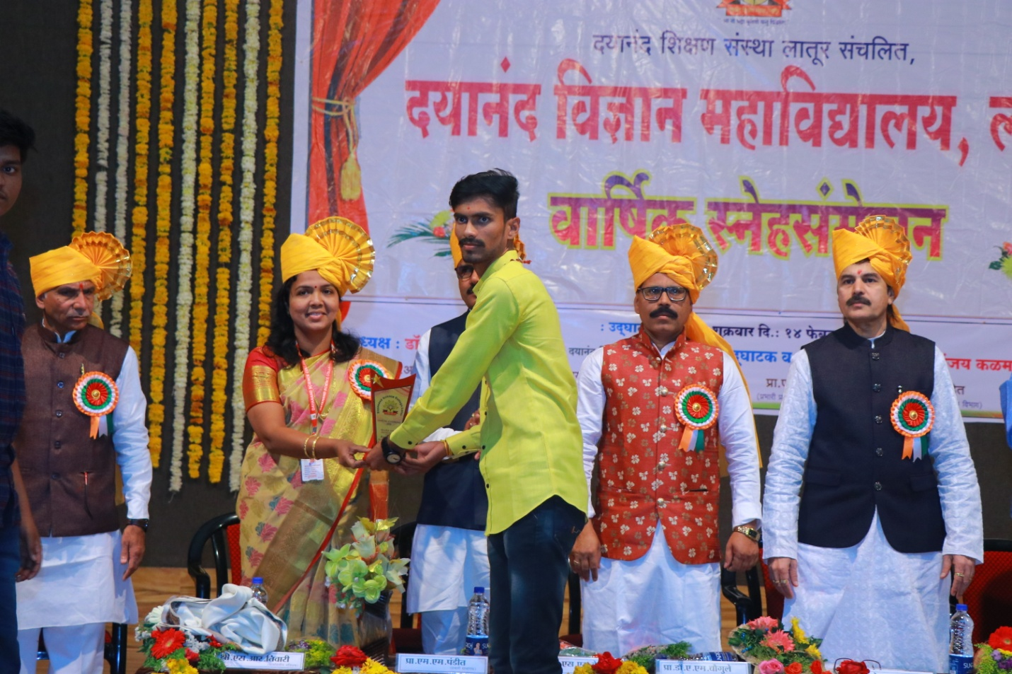 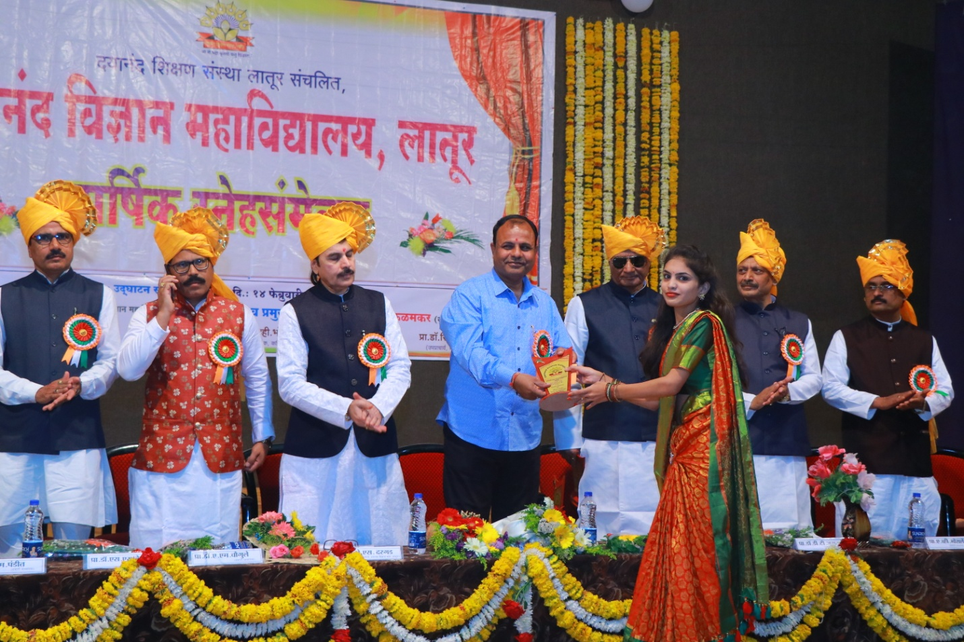 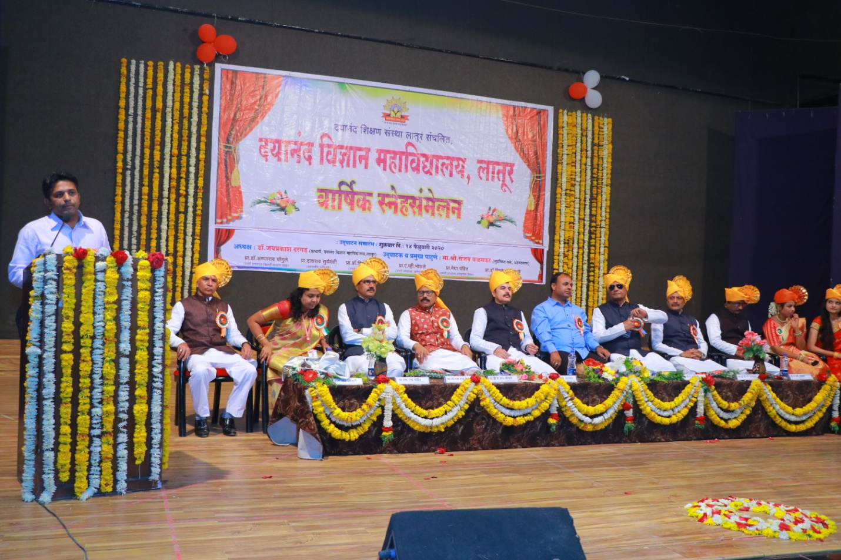 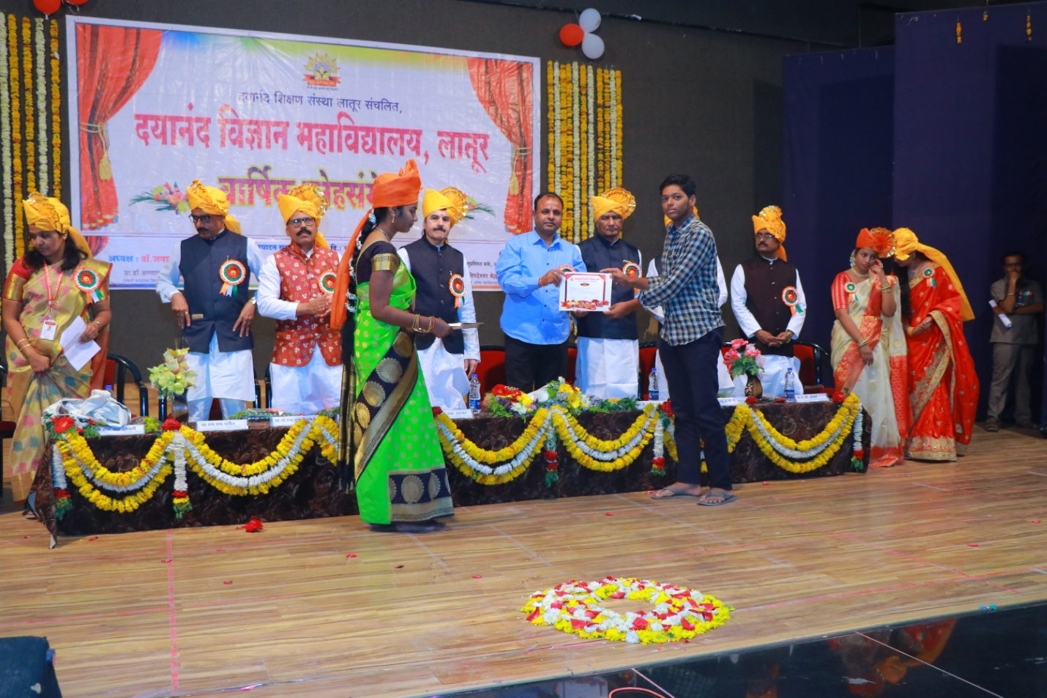 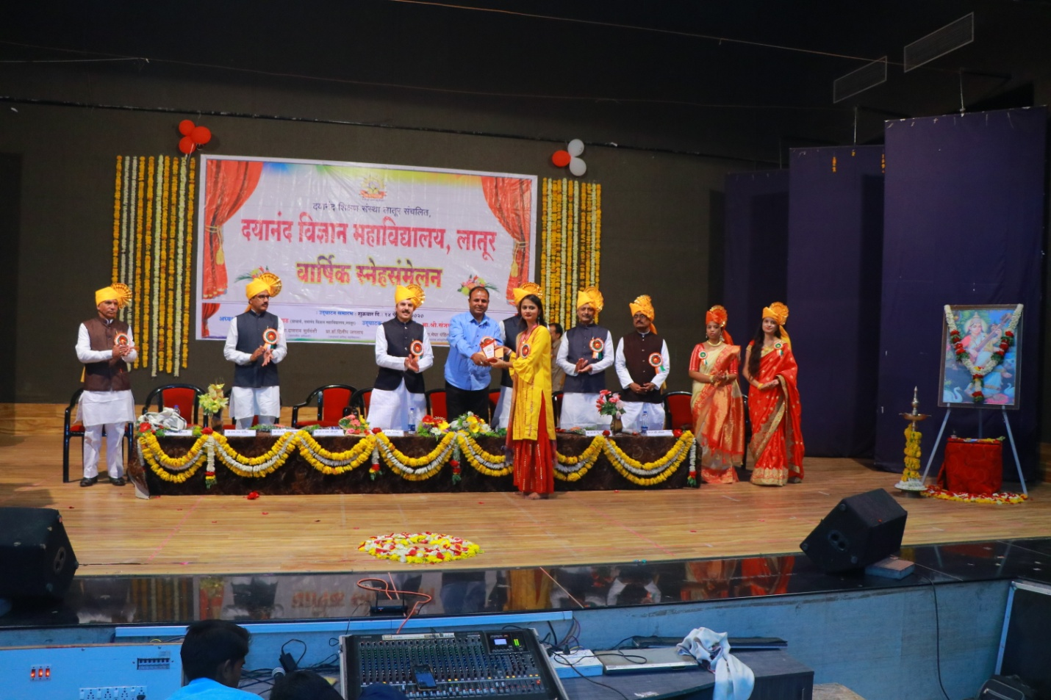 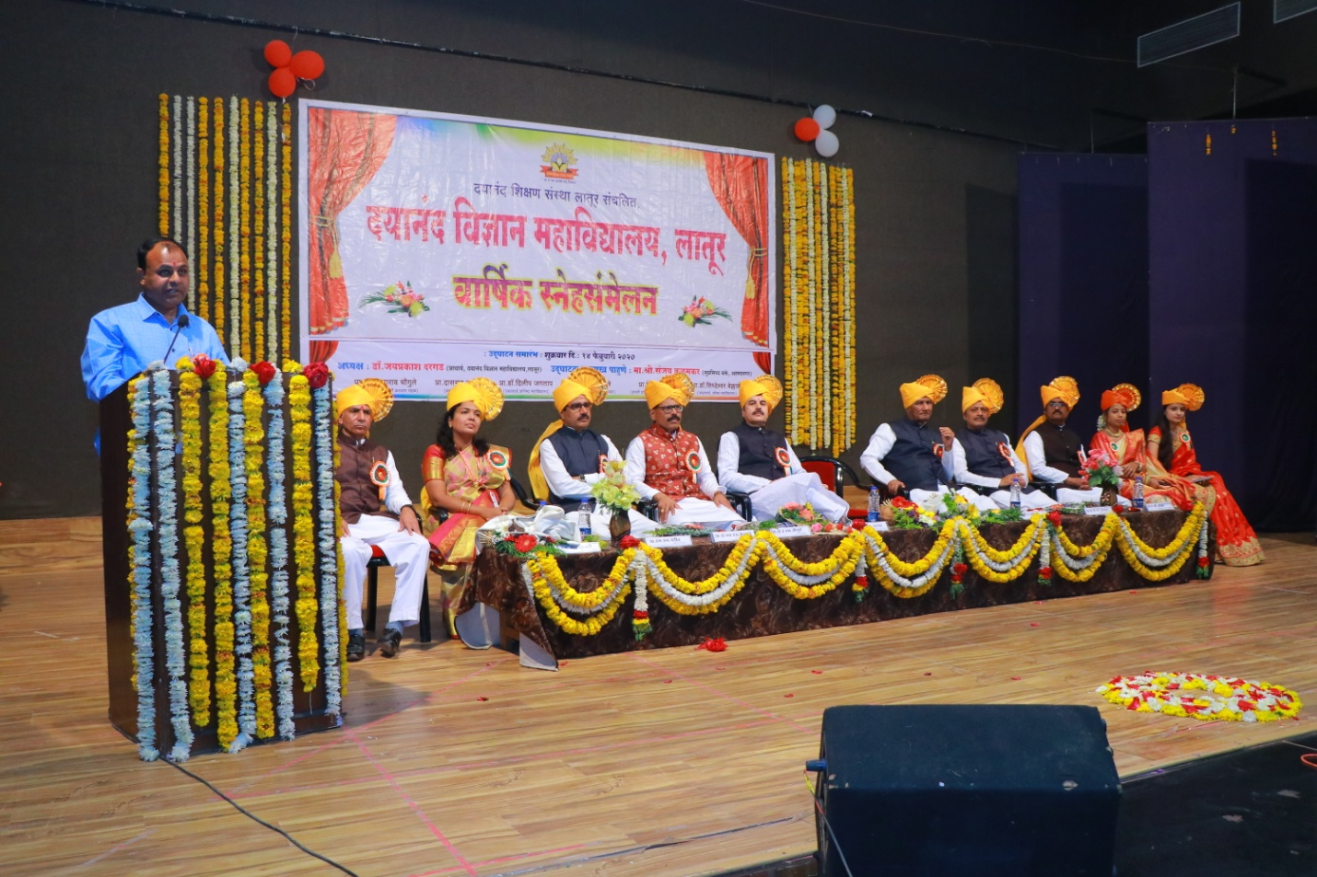 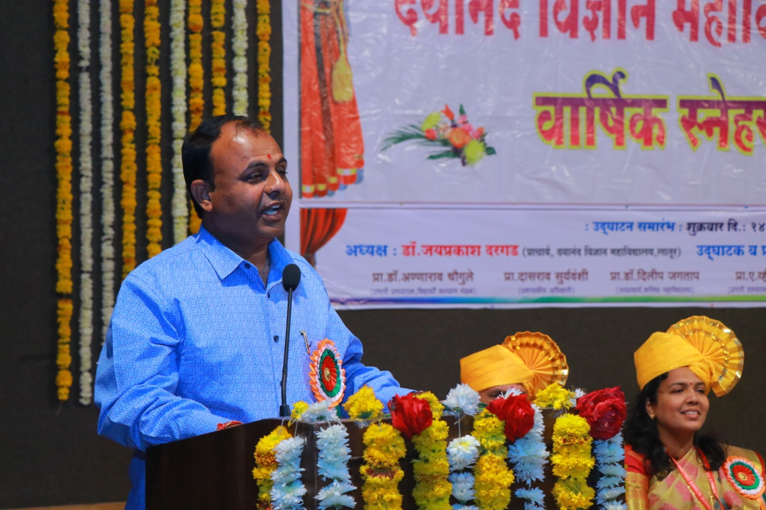 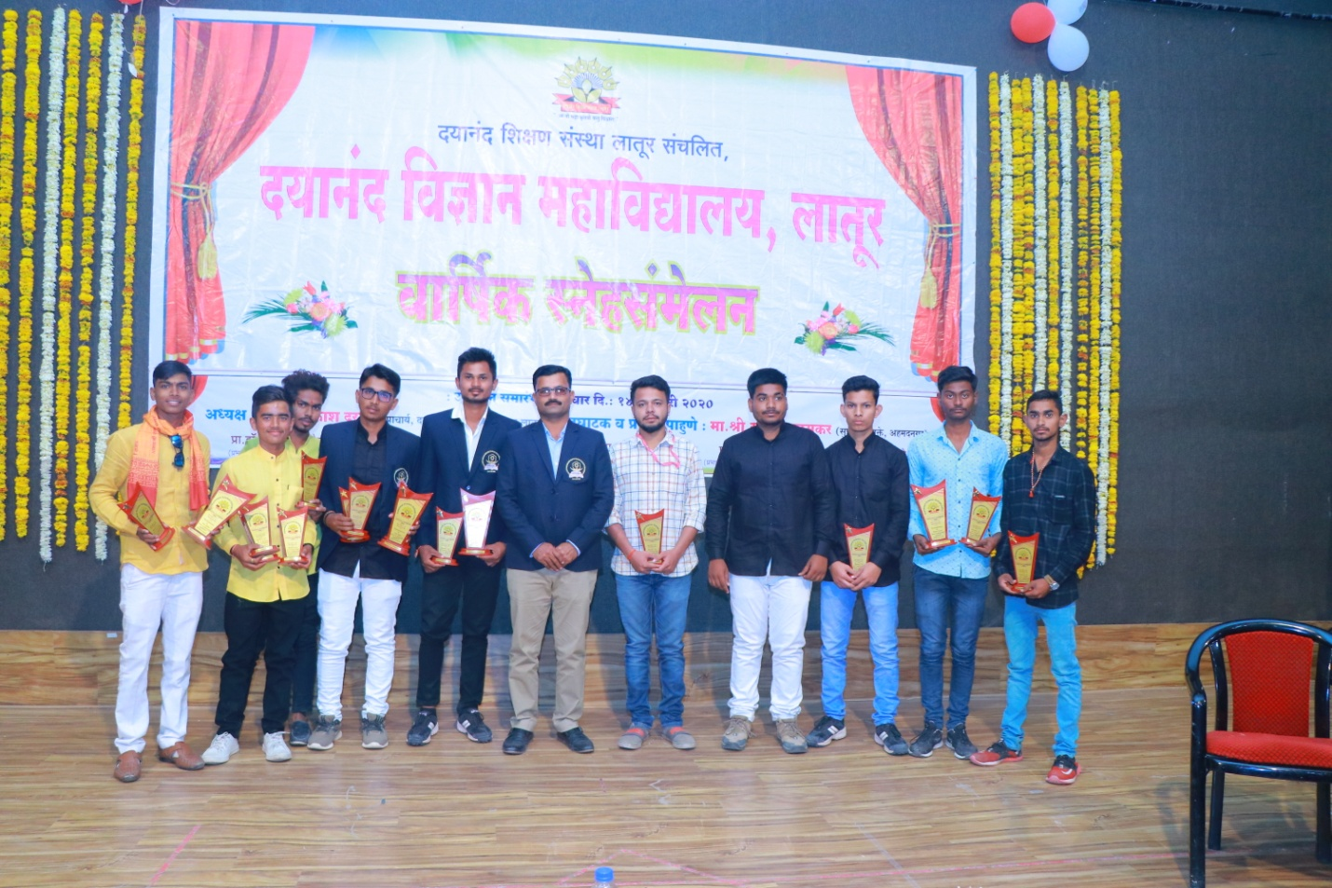 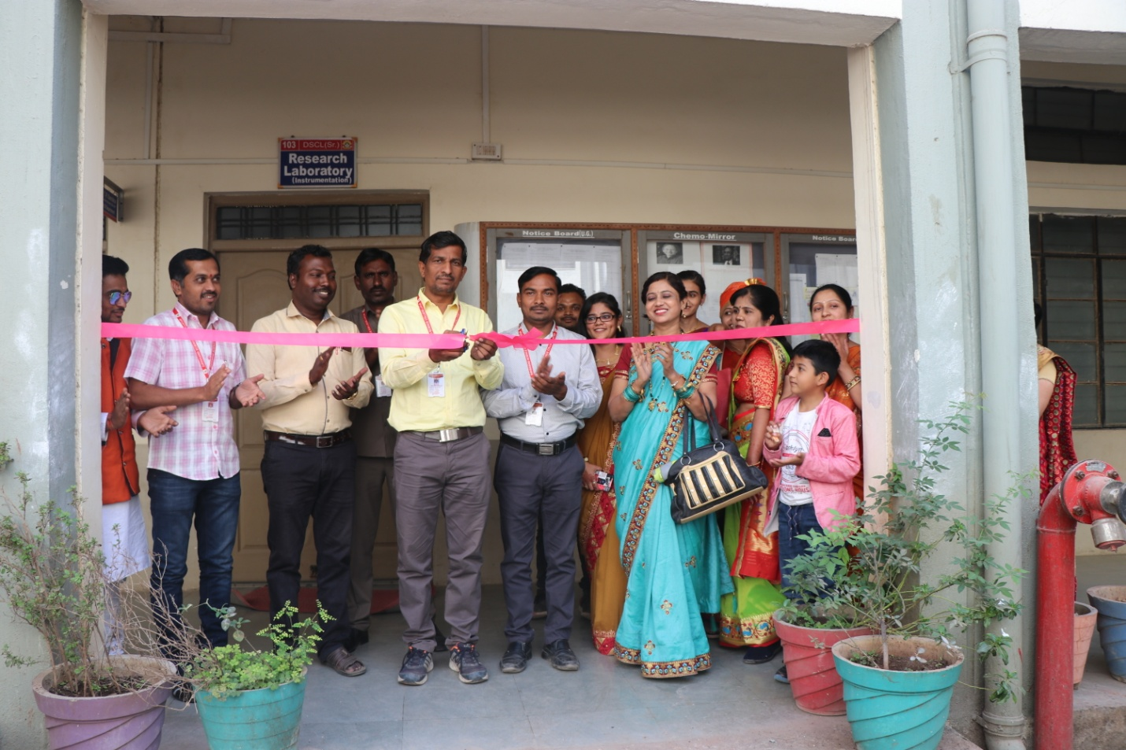 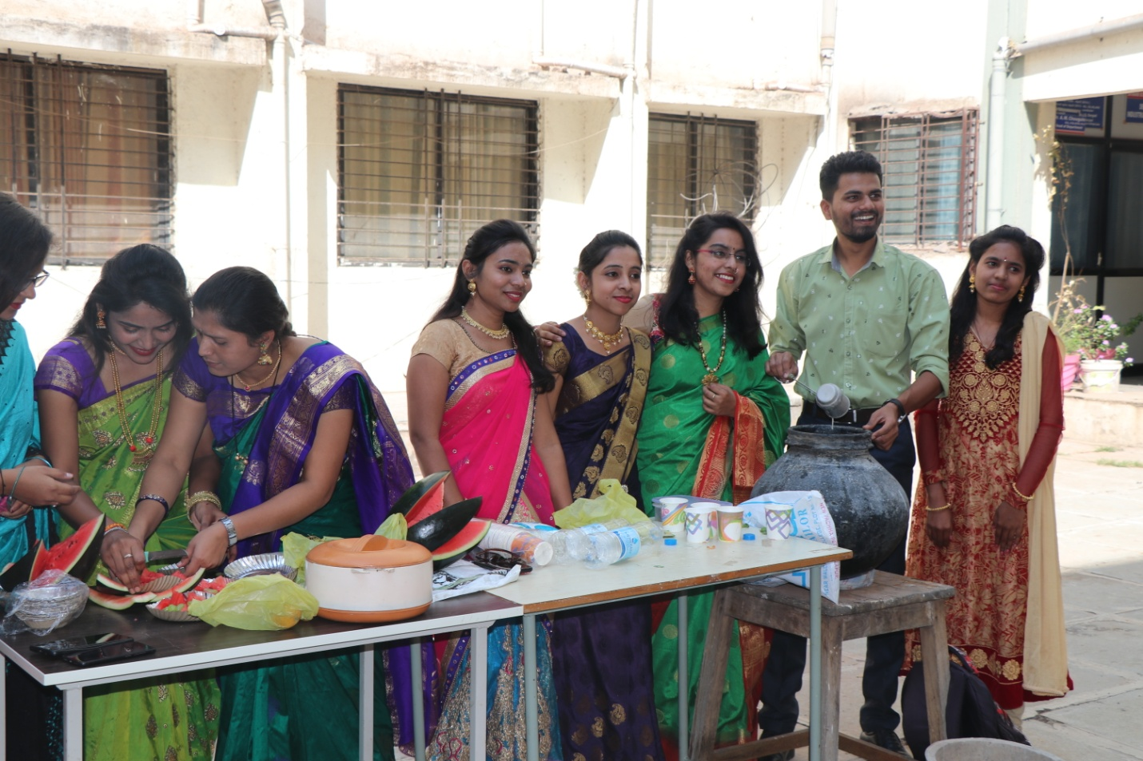

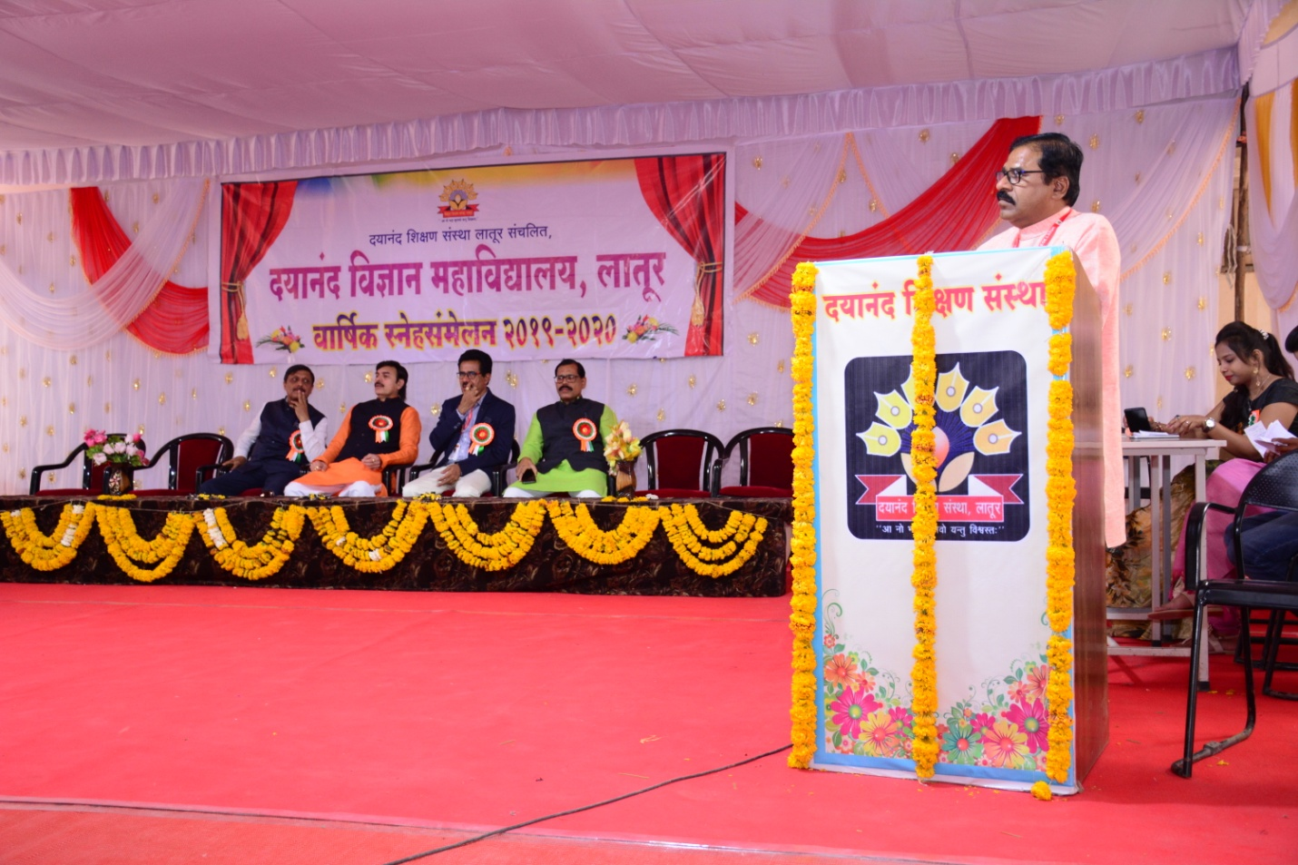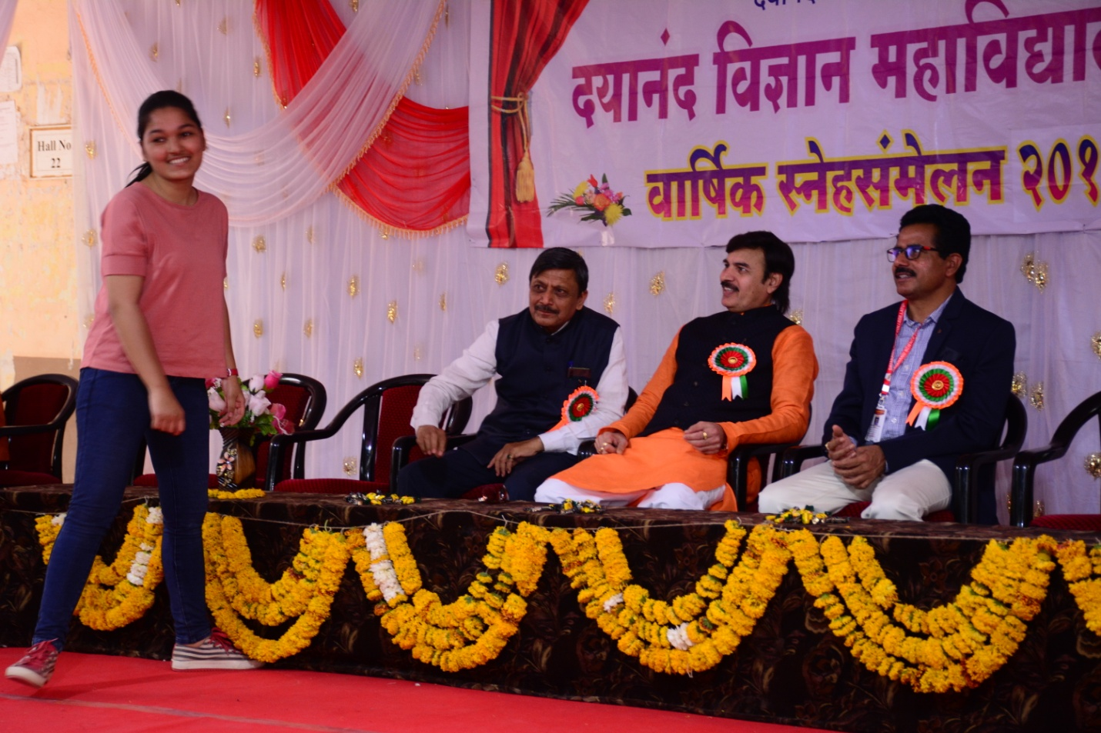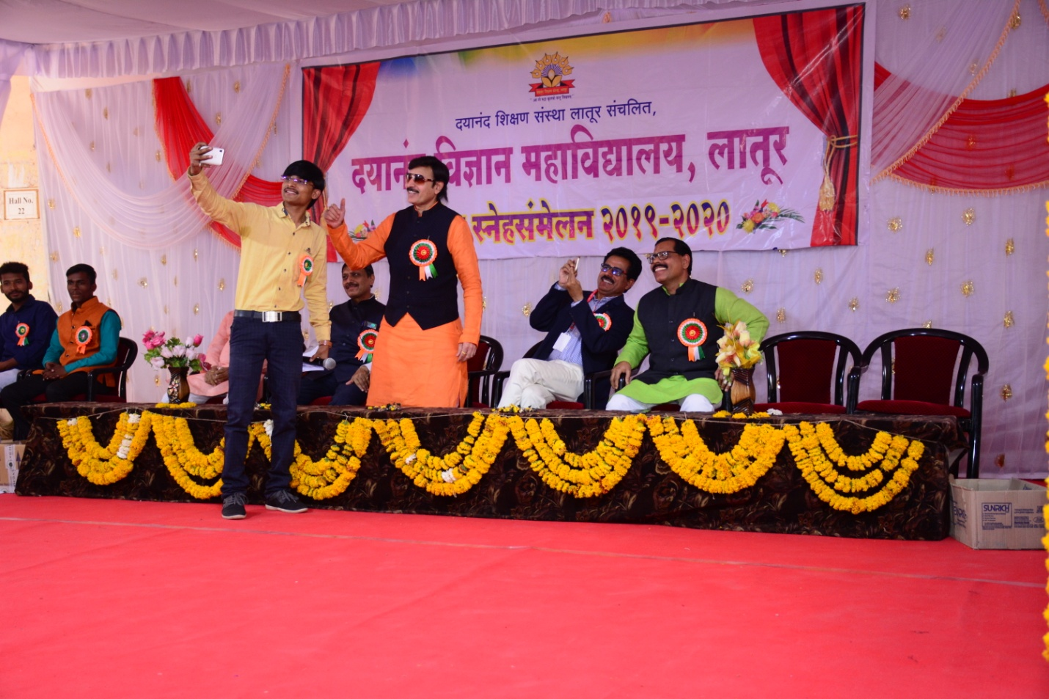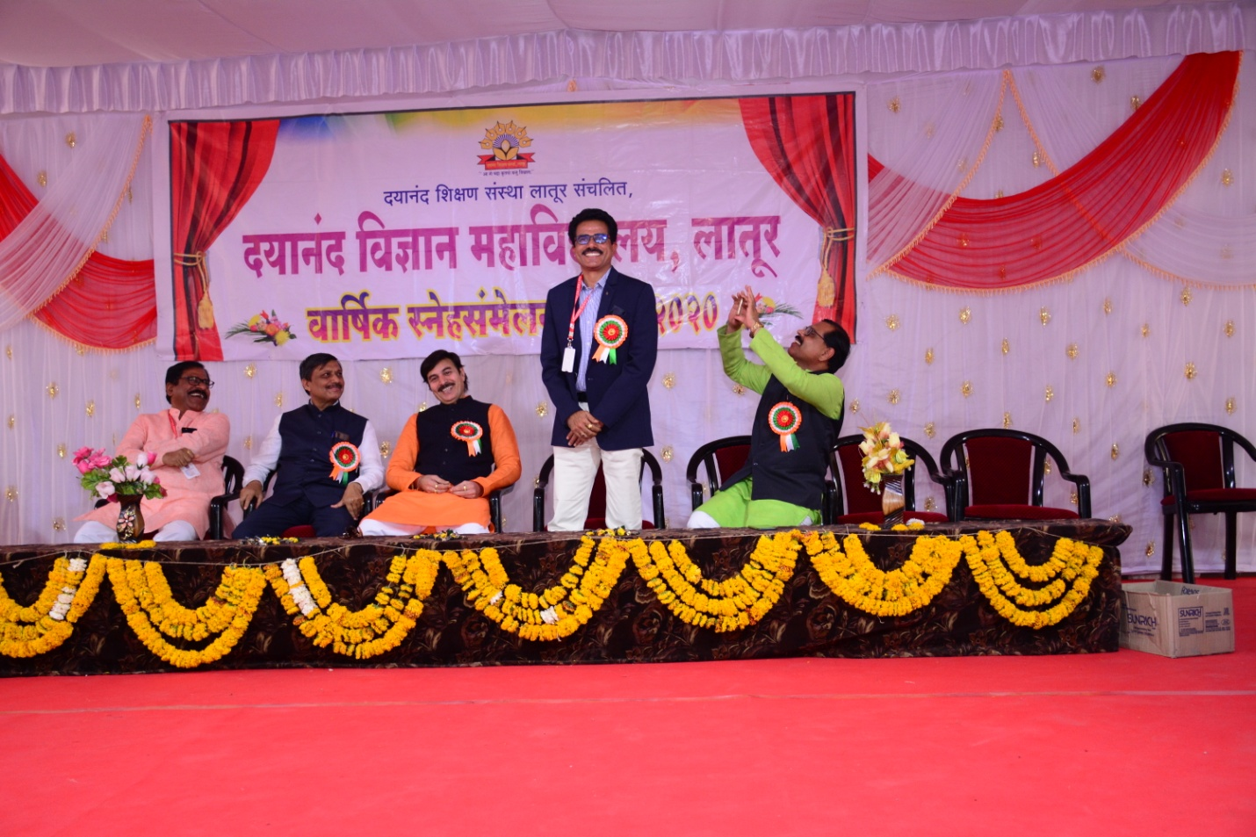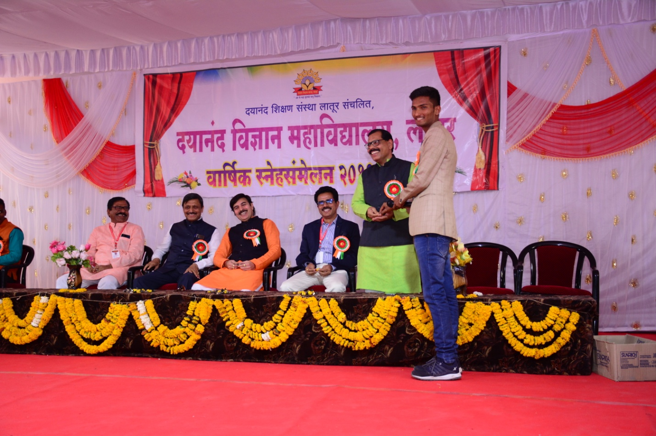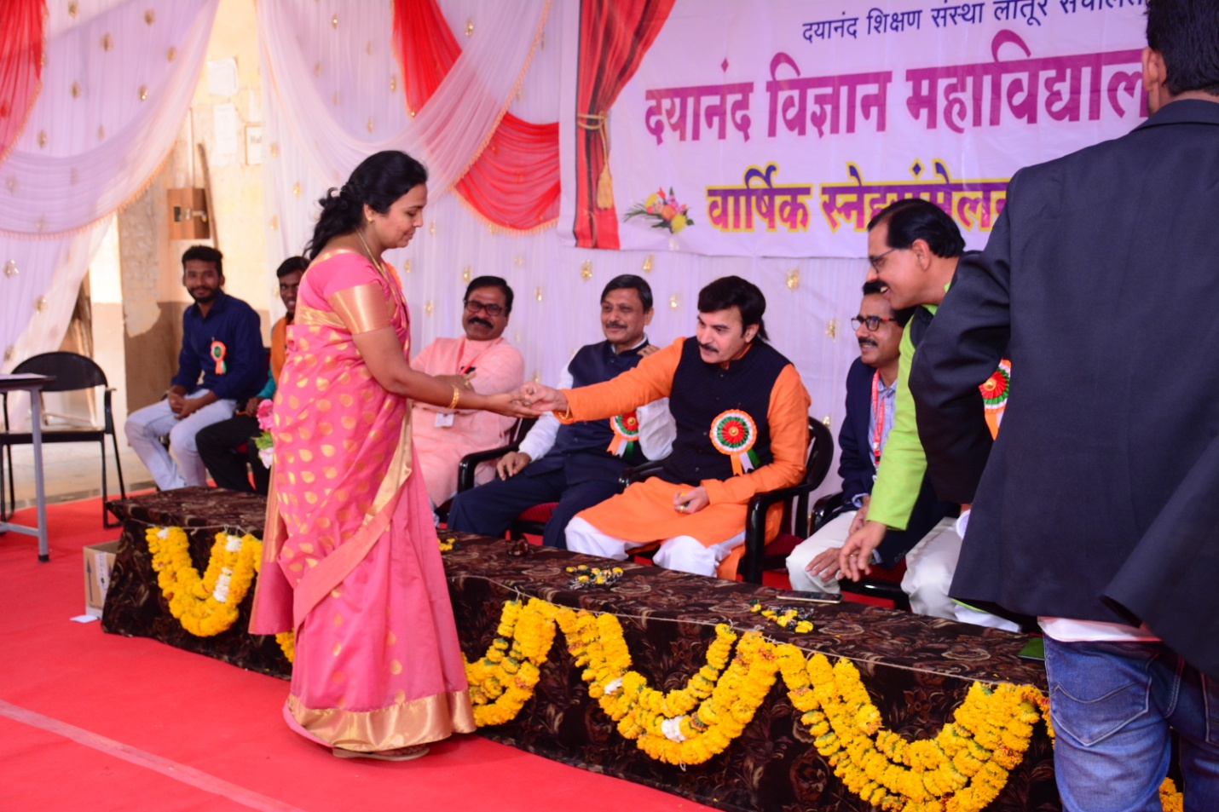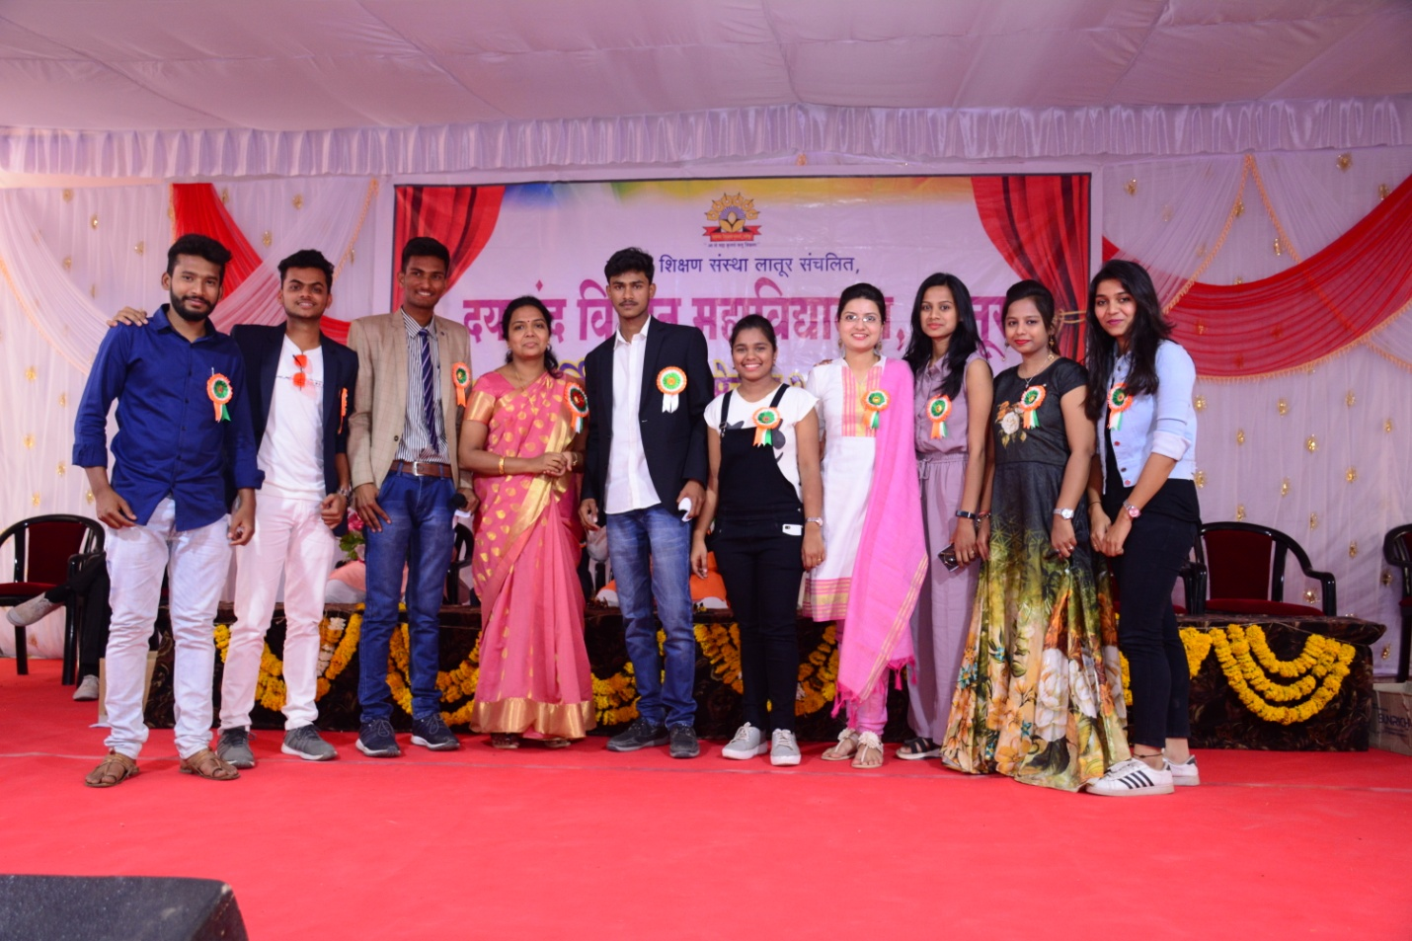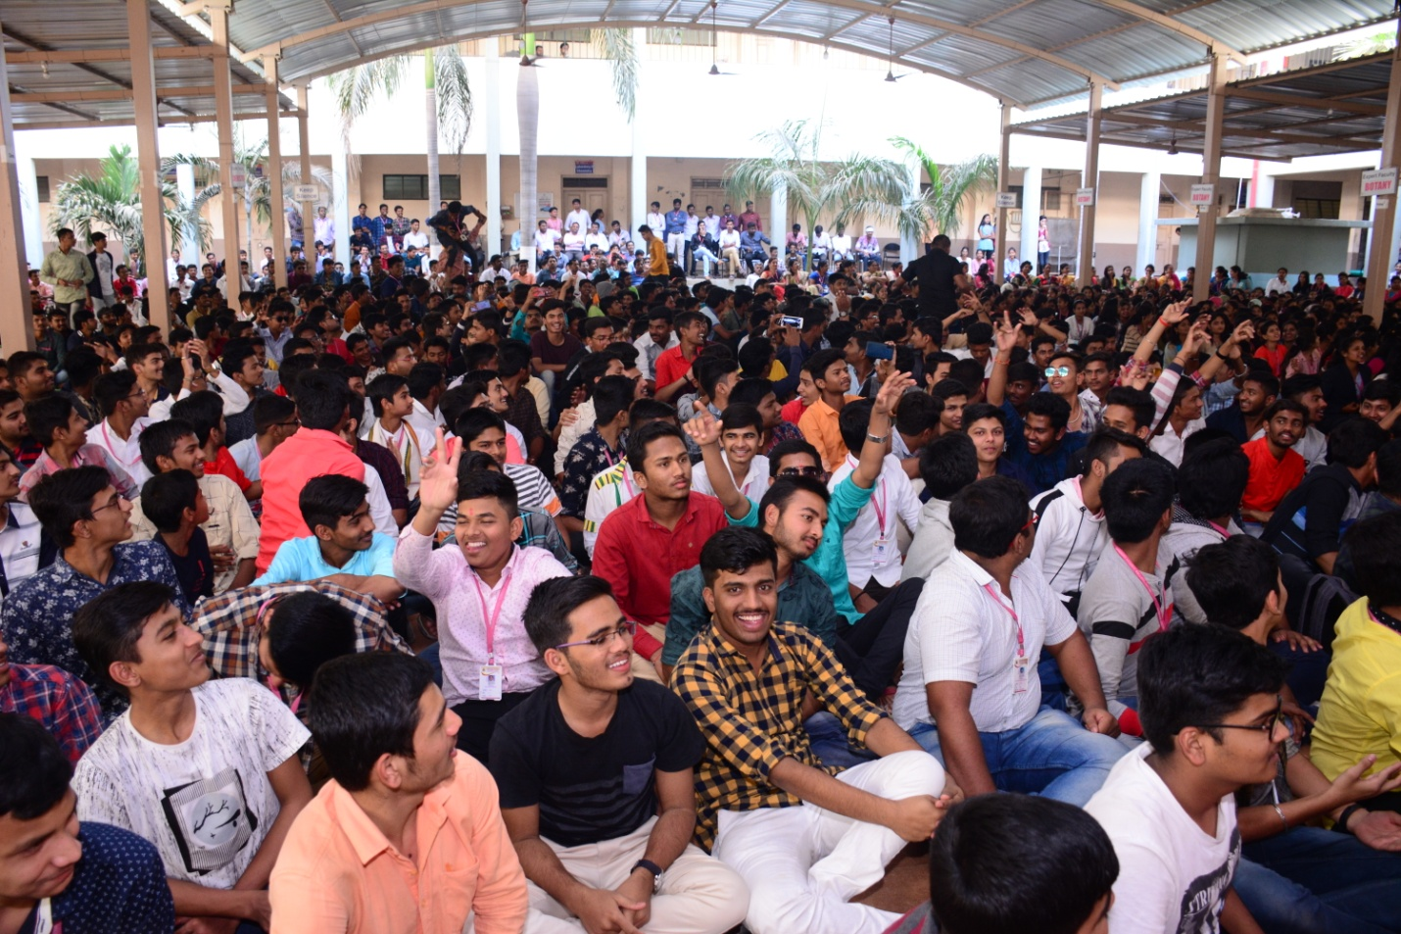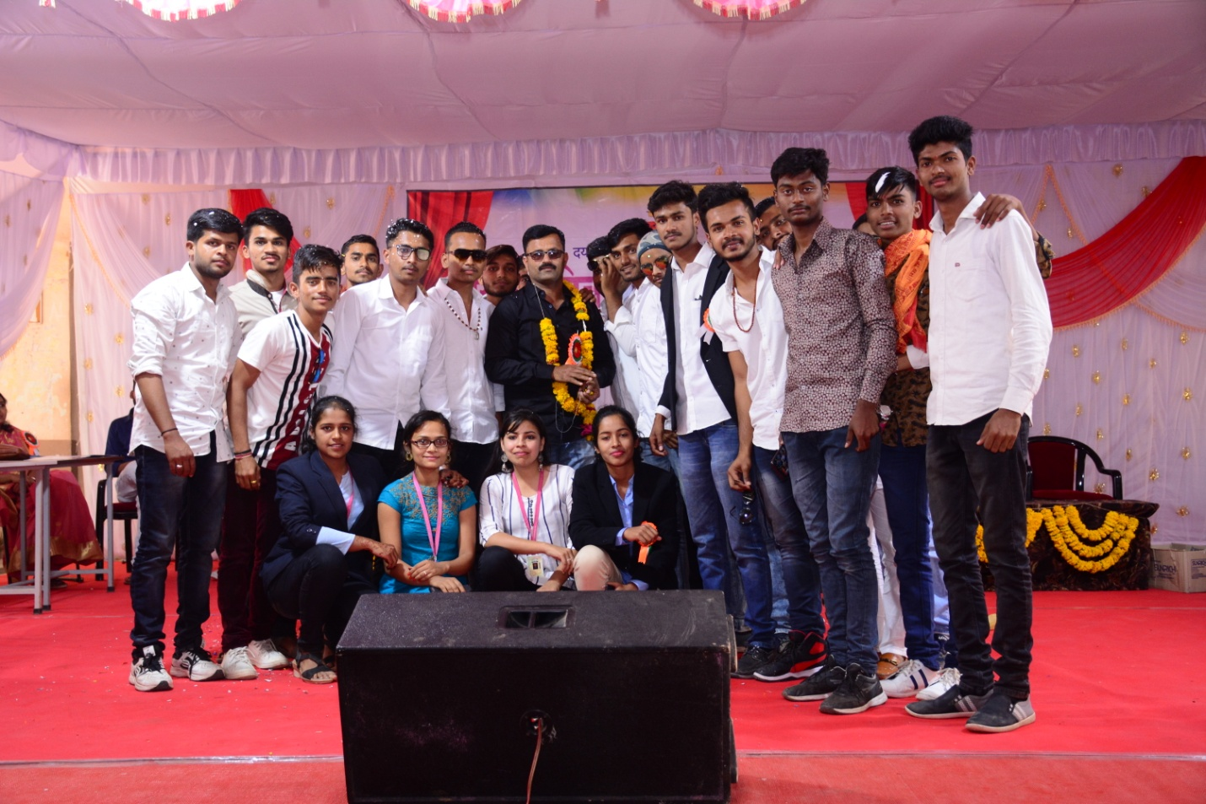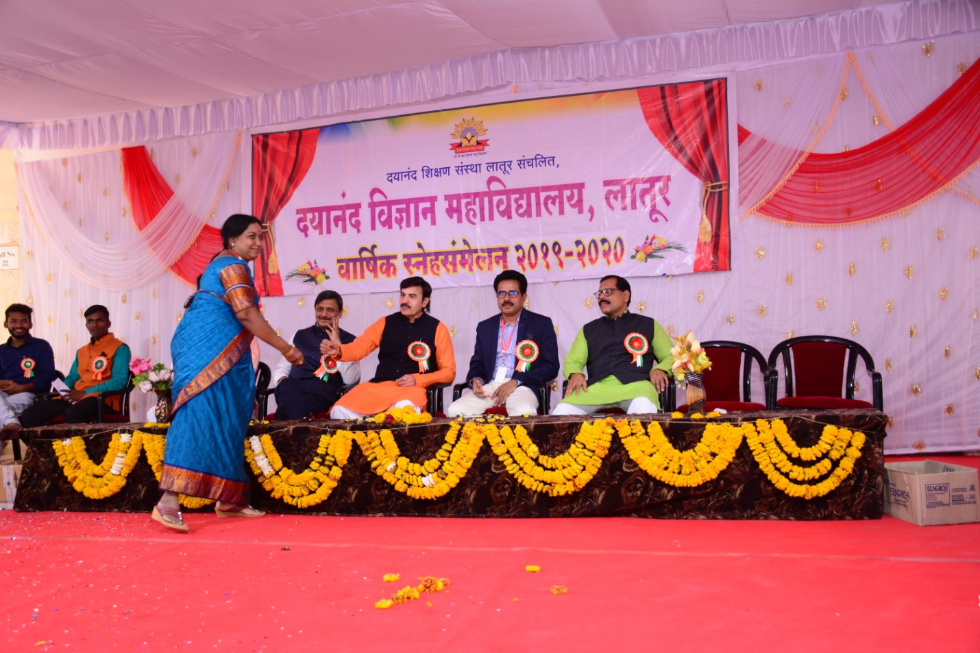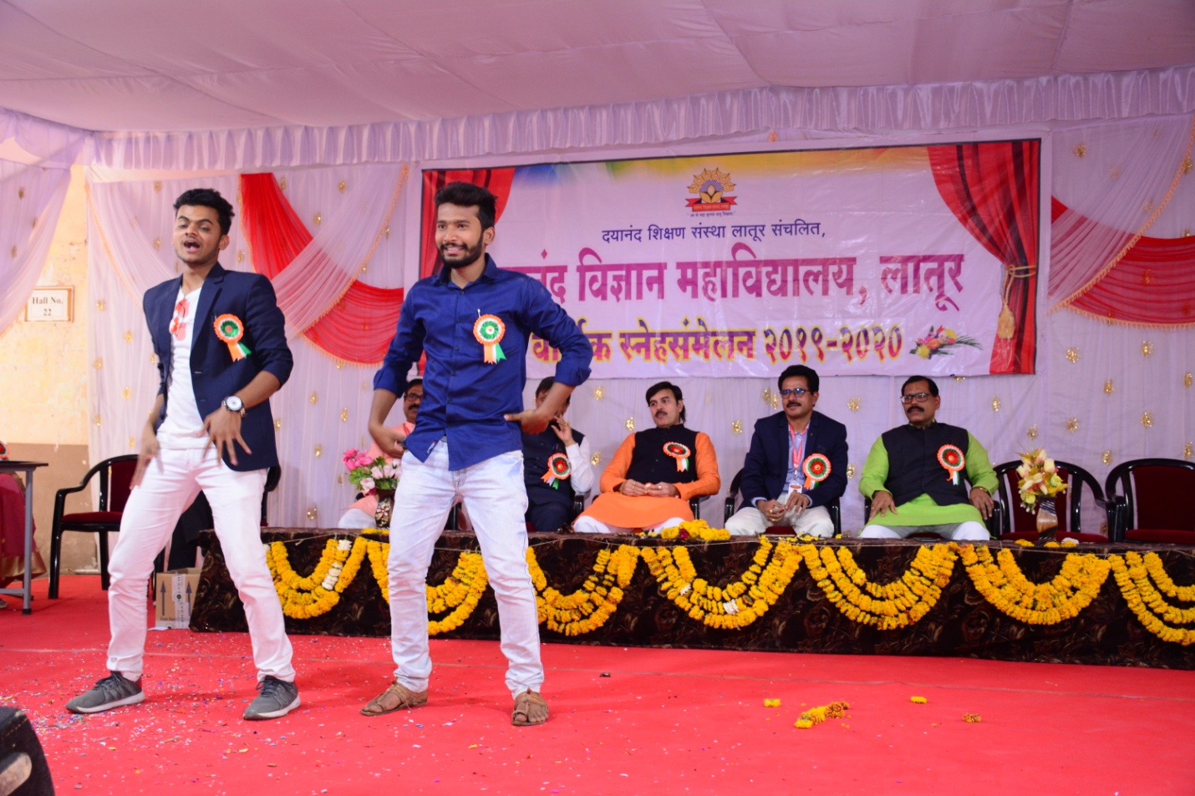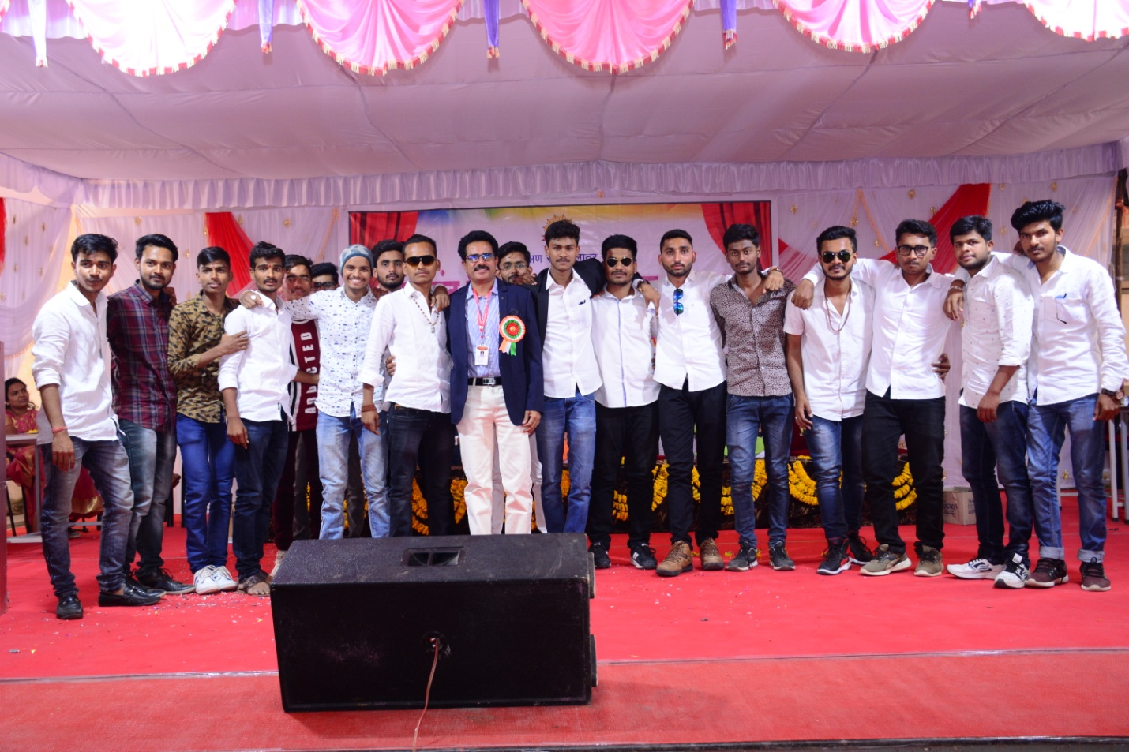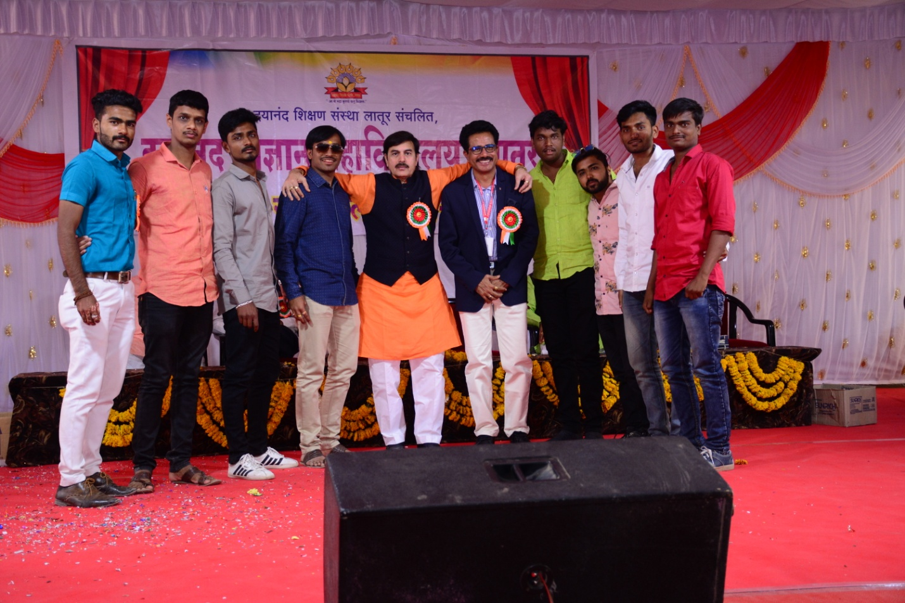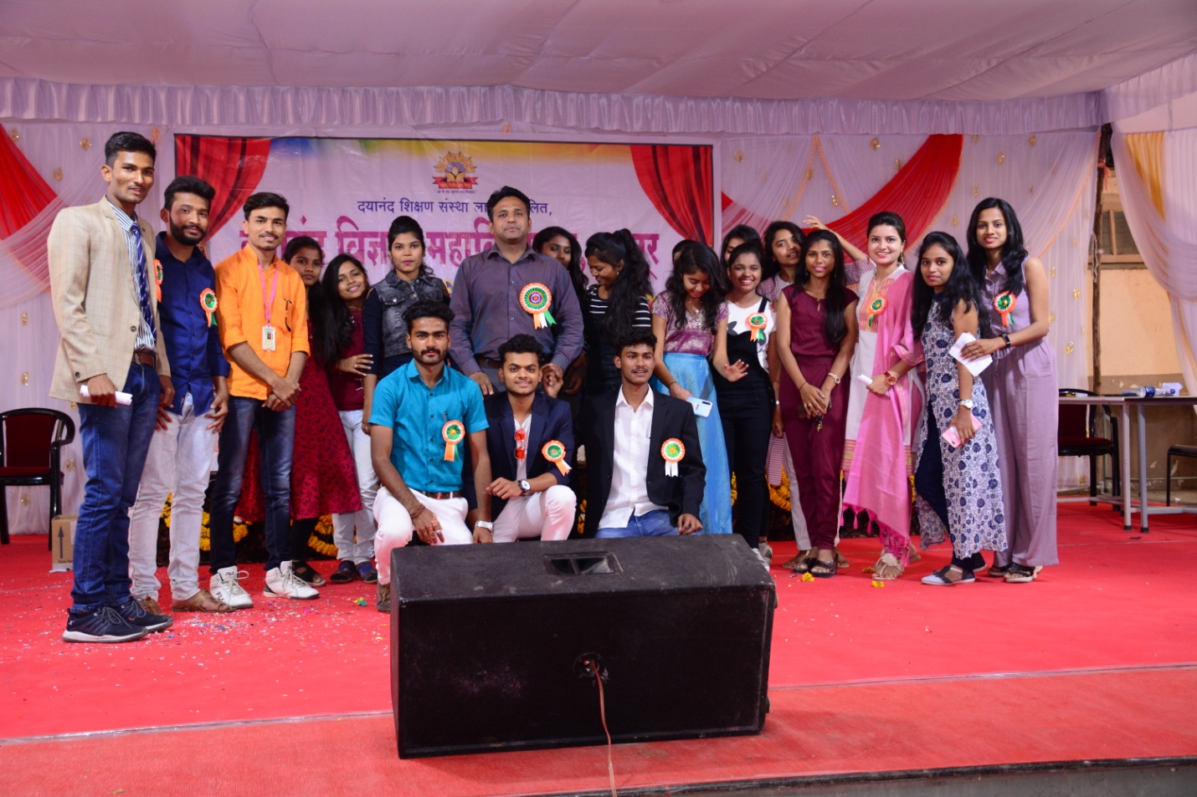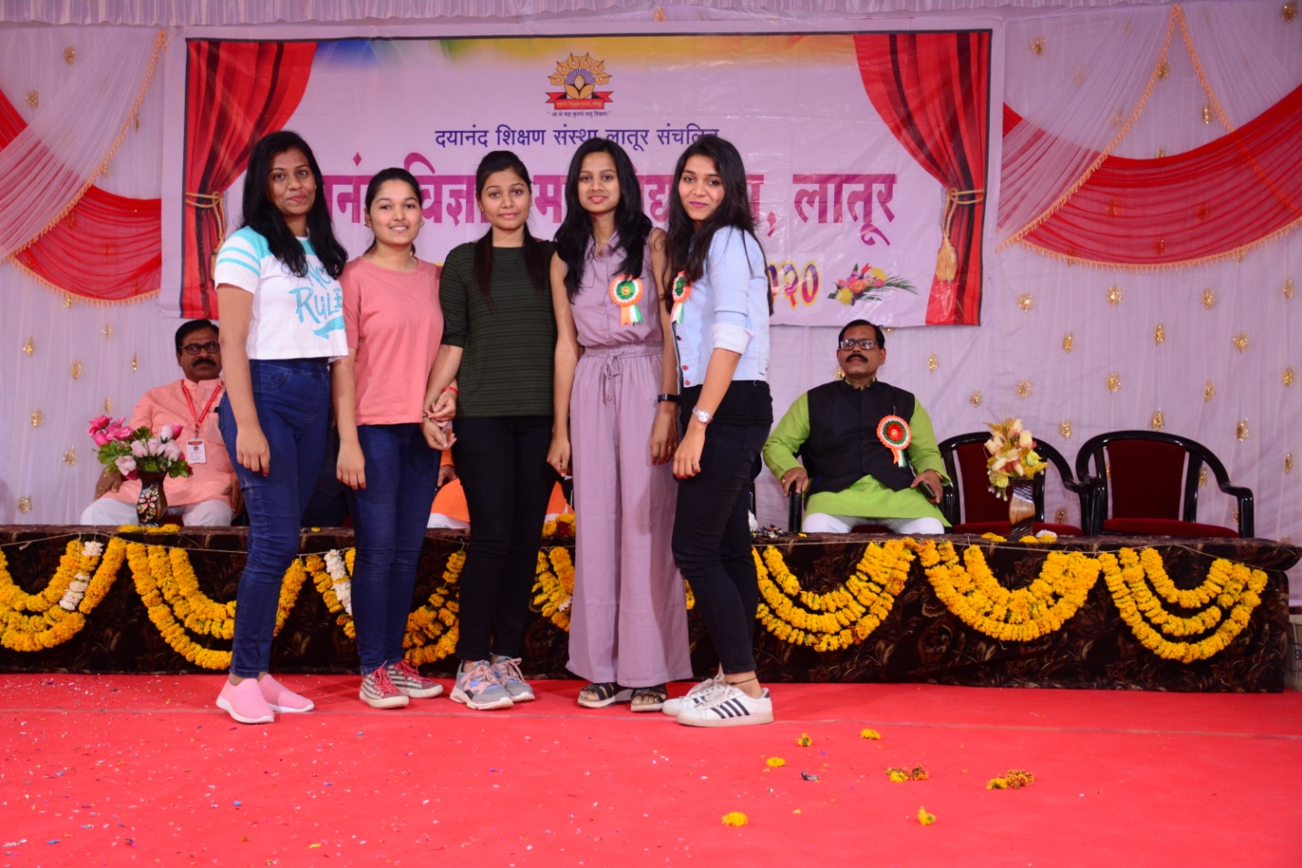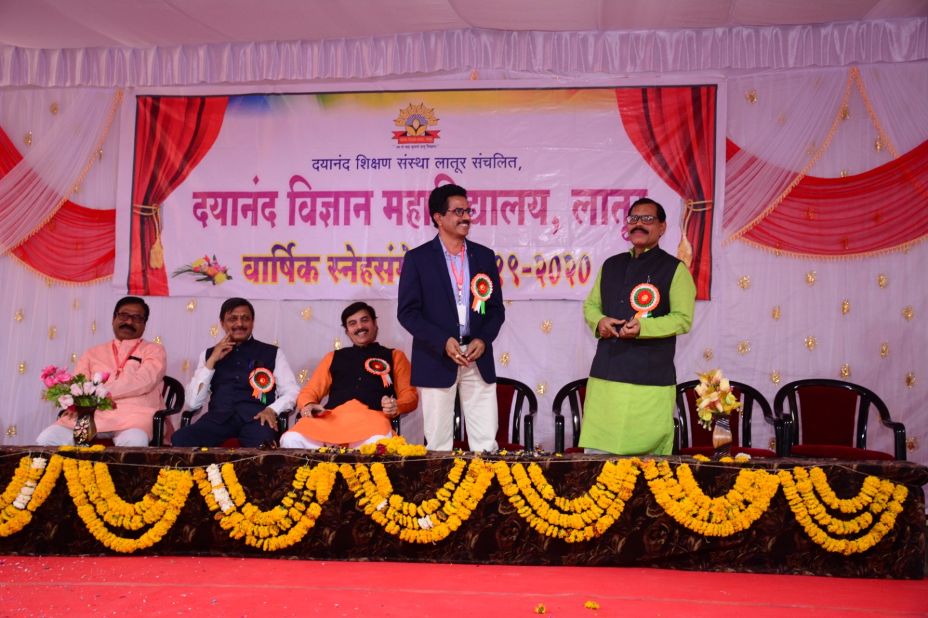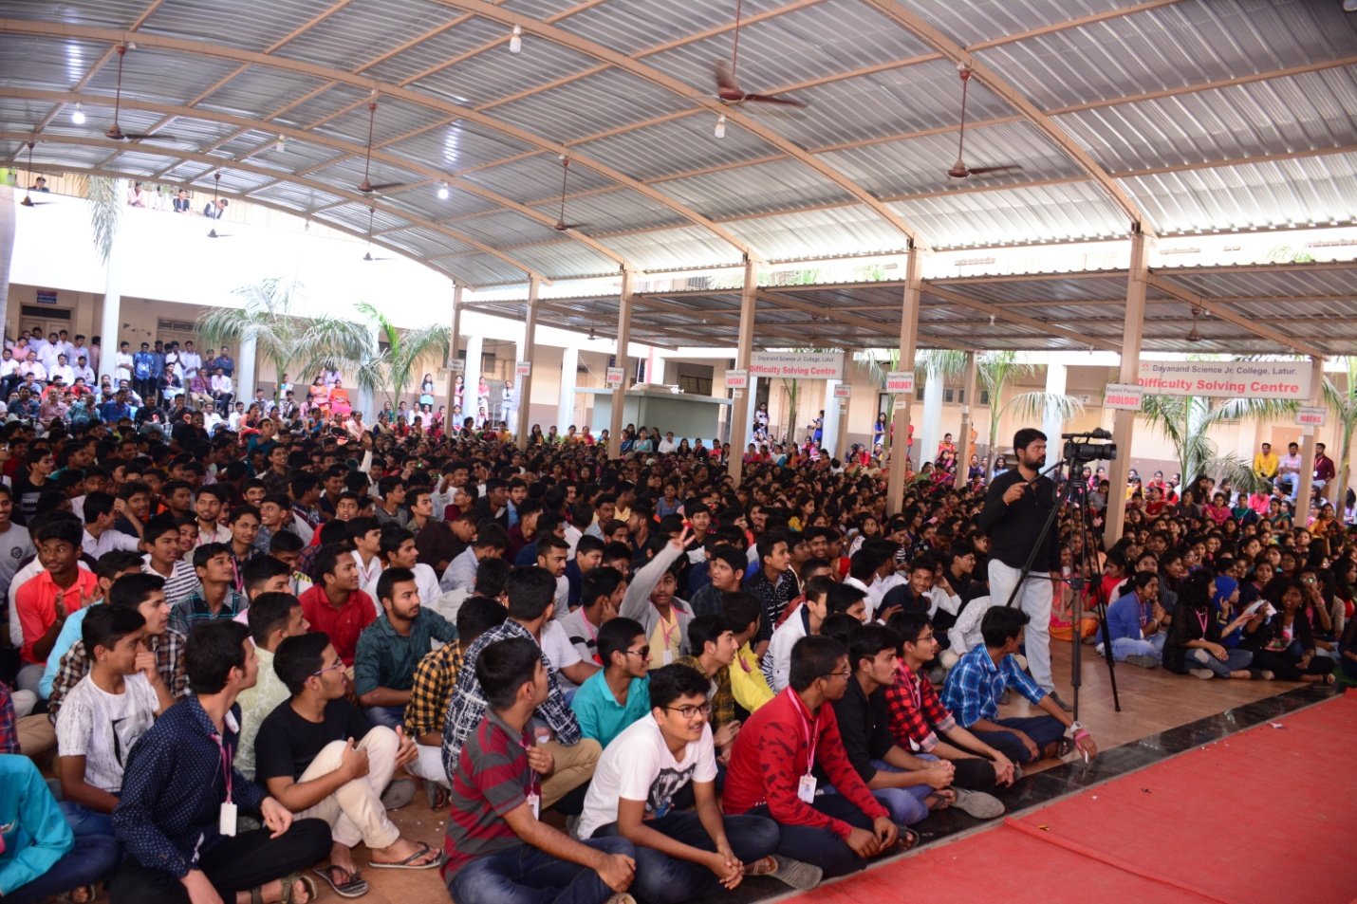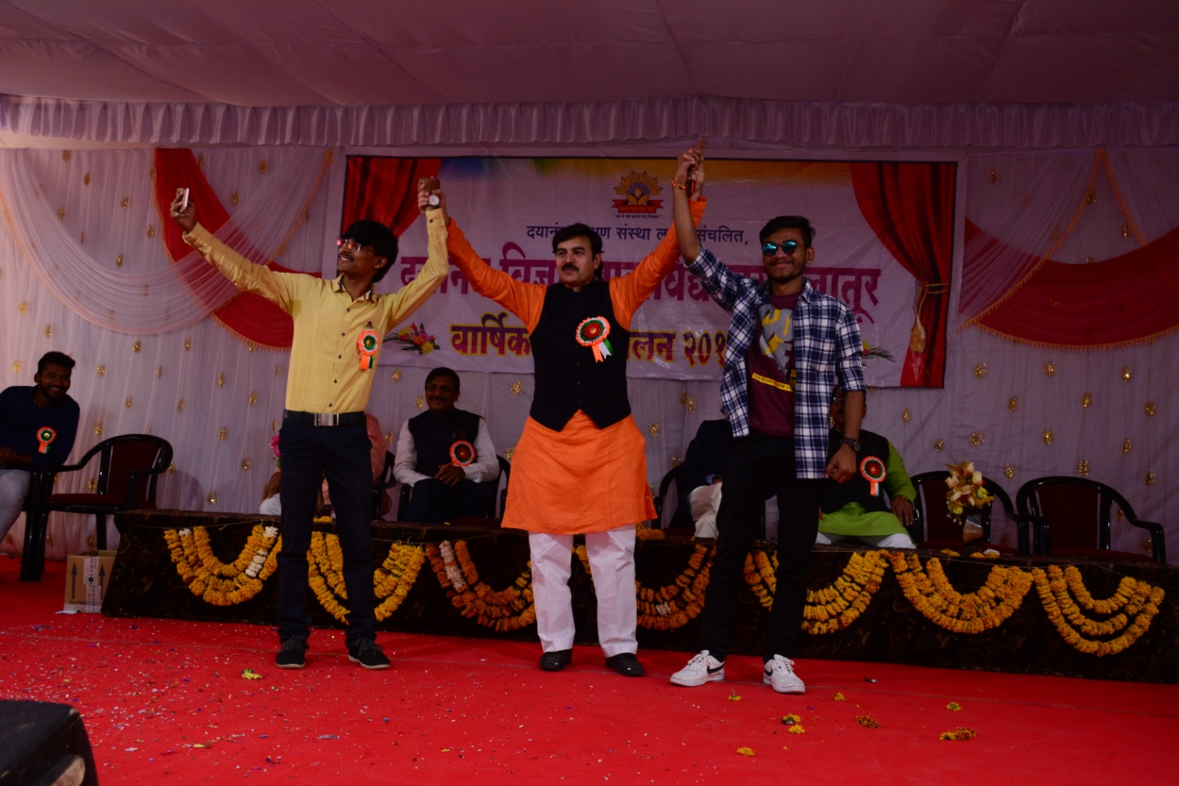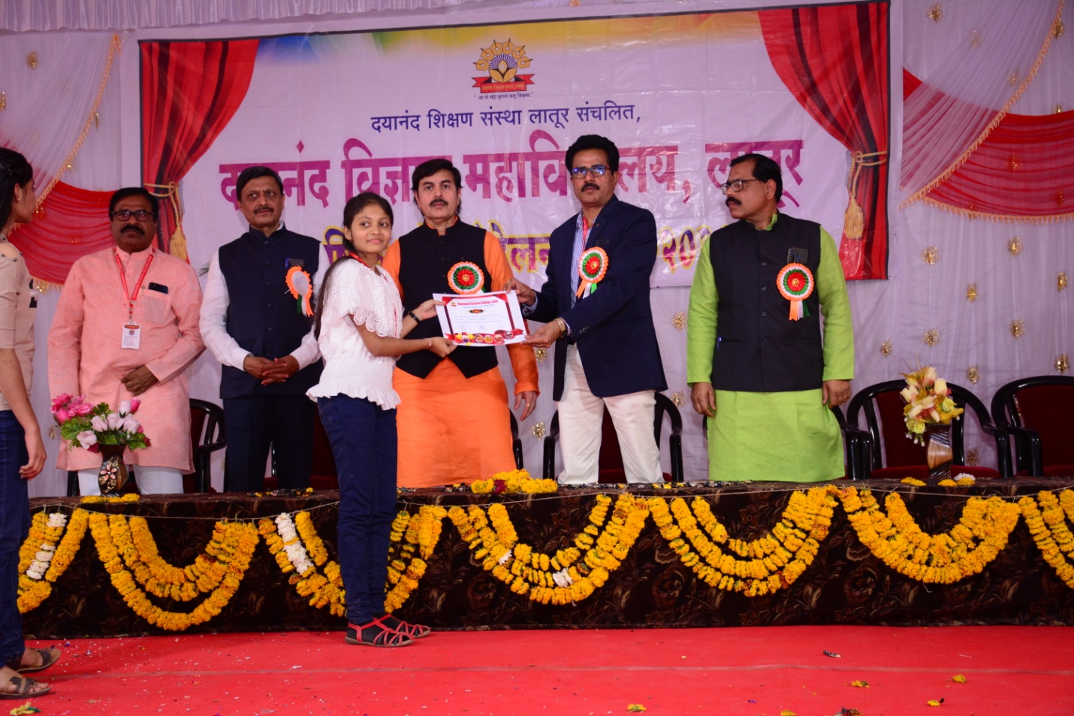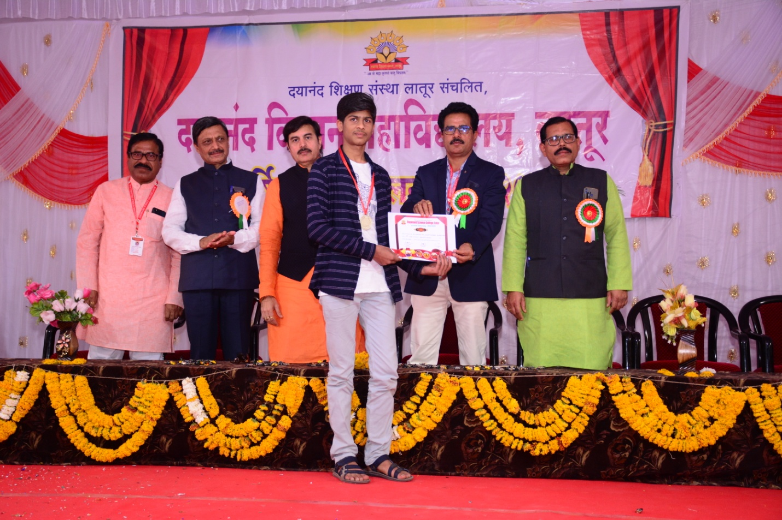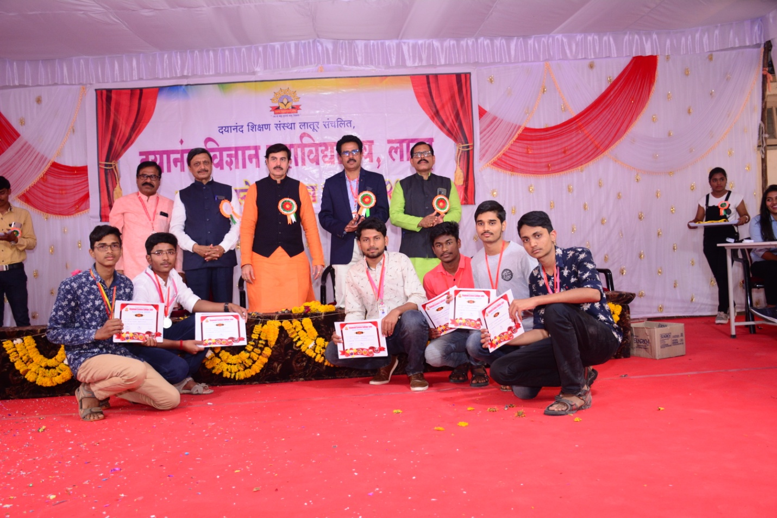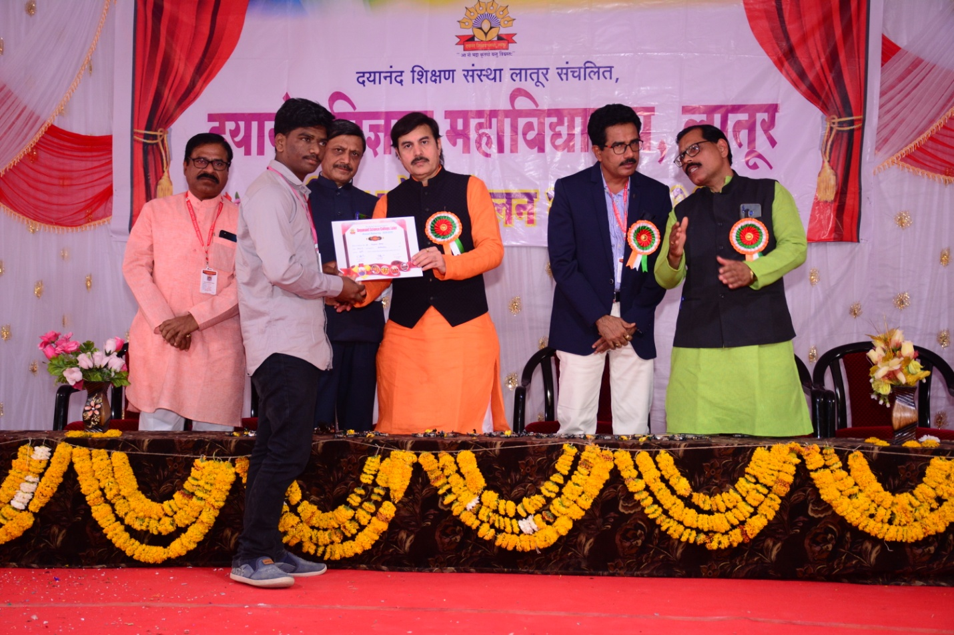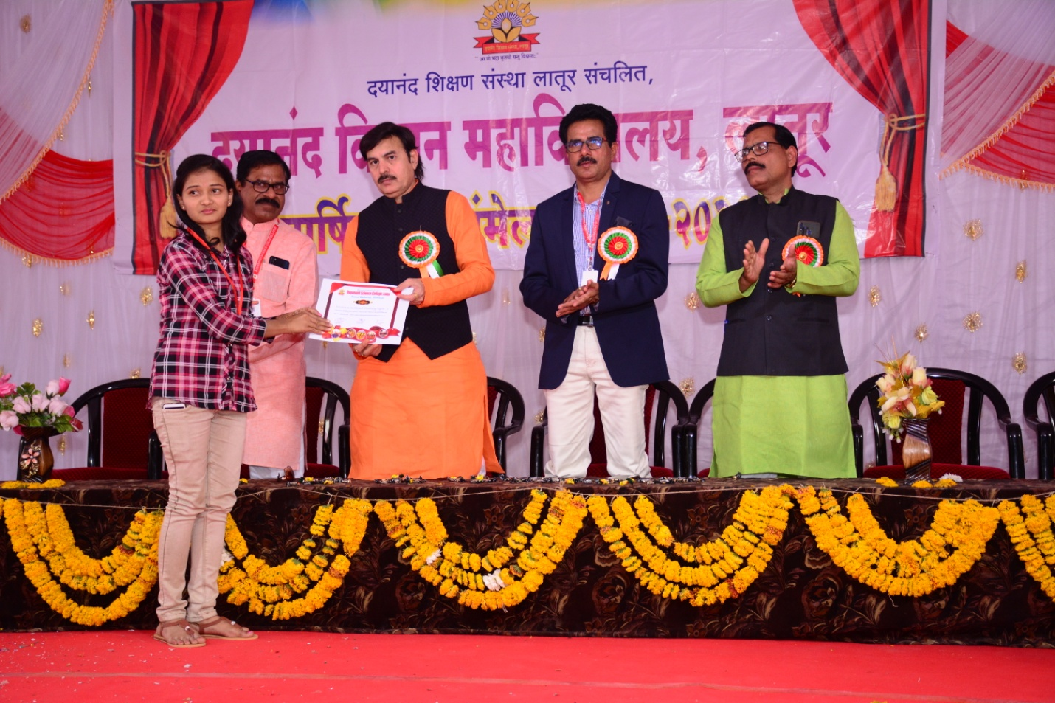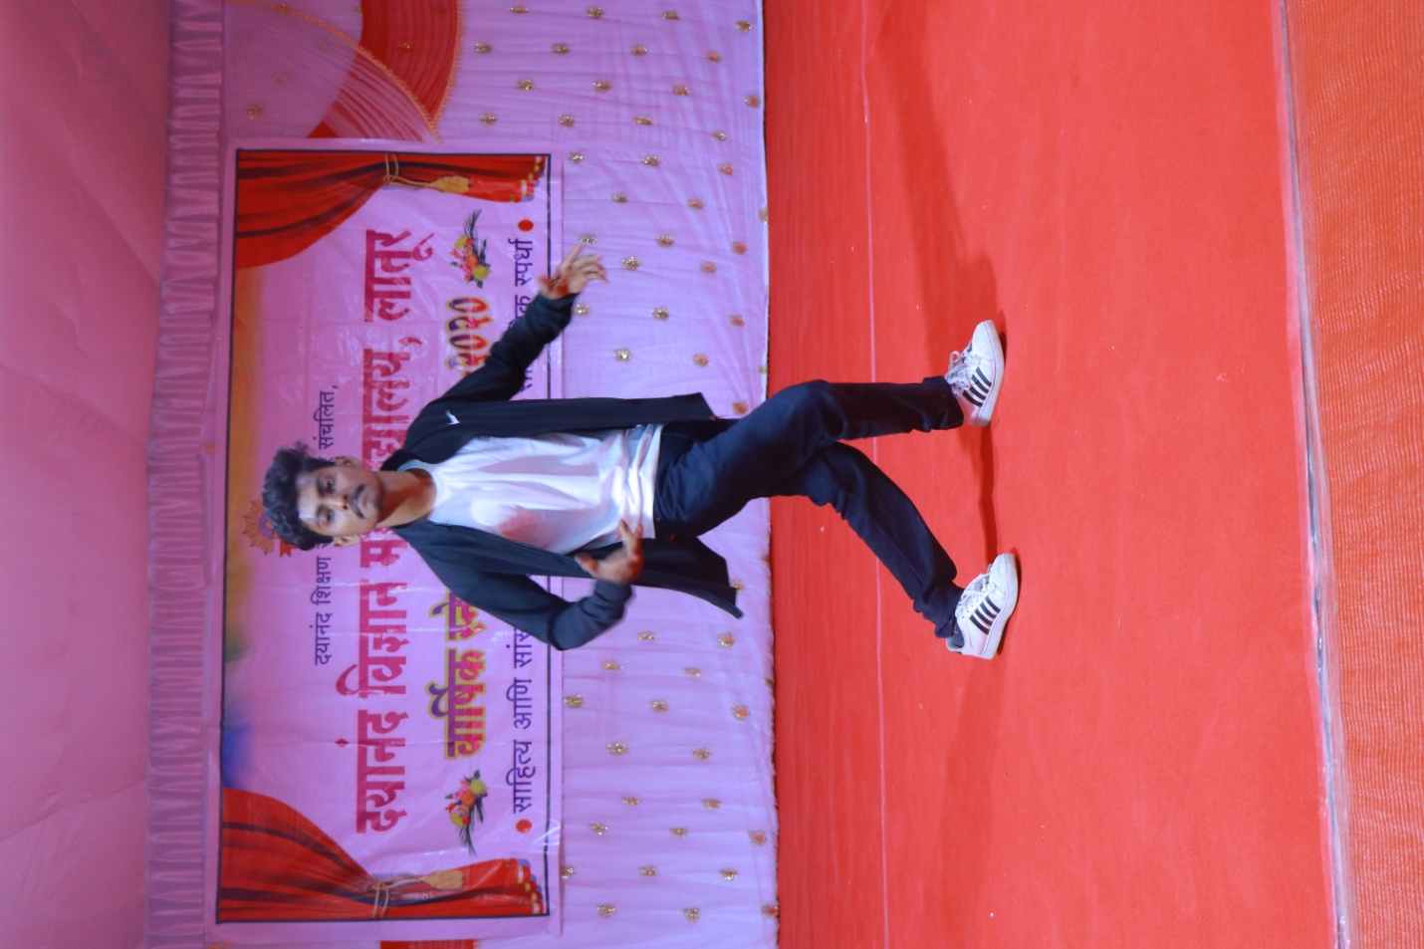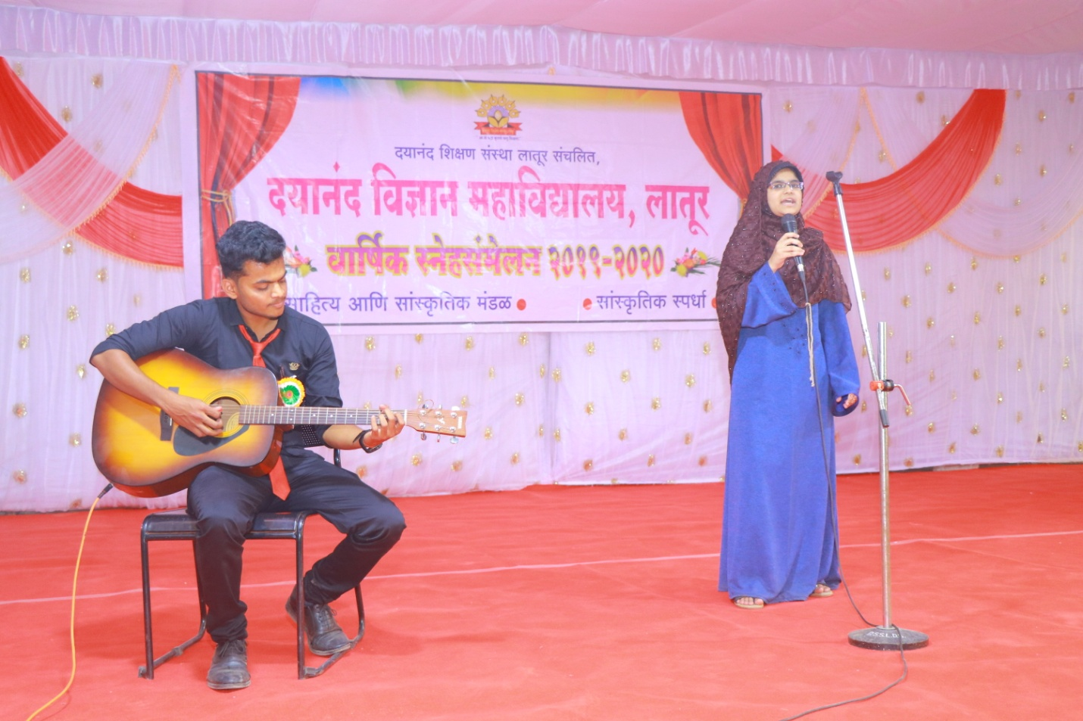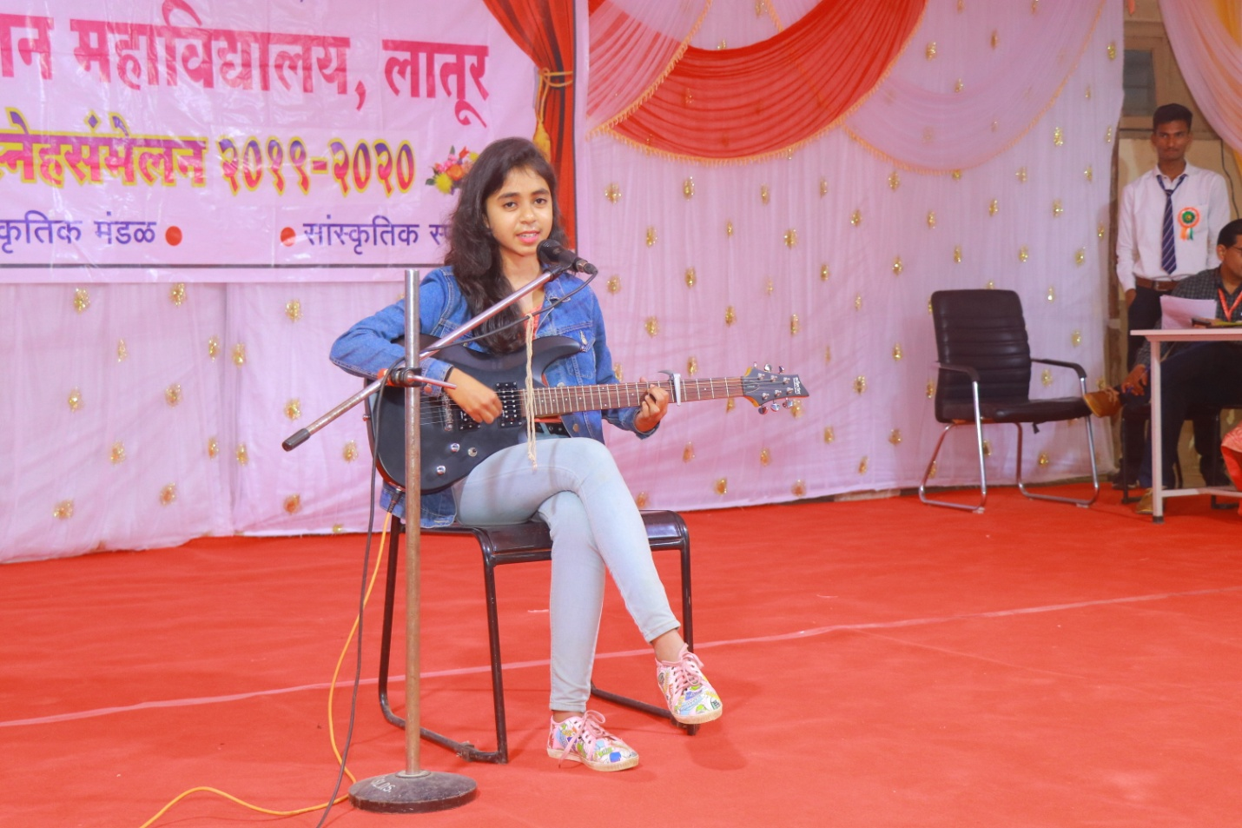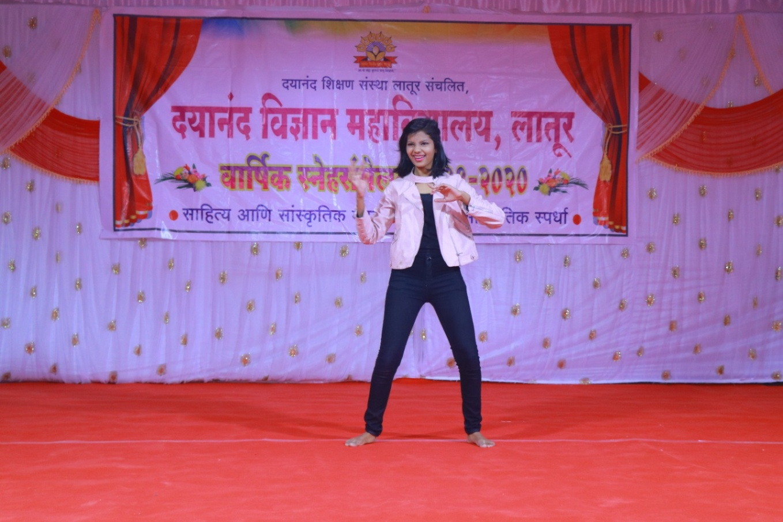

Photo Gallary Health Check up Camp
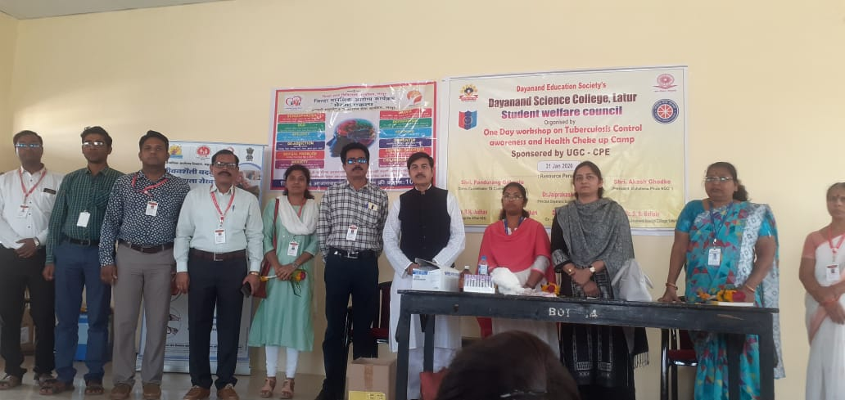
Principal Dr. J. S. Dargad sir, Vice-Principal Dr. S. S. Bellale sir, Co-ordinator of Yuvati kalyan mandal2019-20 Miss. S. D. Lokhande, N.S.S and N.C.C co-ordinators, Dr. Sarita Shende and Dr. Sarika Deshmukh For girls Health Checup Camp.
