Dayanand Science College Latur
Student Council
2015-2016
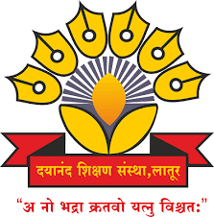

Dr.J.S.Dargad
Principal
Dayanand Science College Latur

Proffesor-In-Charge
Prof.K.R Rathod
Head
Dept.Of Physics

Student welfare committee
Committee (2015-2016)

Sr.No. | Name of Member | Designation
01 | Prof K. N. Rathod | Professor –In- Charge
02 | Prof M.M. Pandit | Member
03 | Dr. M. A. Bembade | Member
04 | Prof, G.H.Bane | Member
05 | Dr. V.A. Choudhari | Member
06 | Dr. V.D. Mote | Member
 | Ghodke Prashant Hanumant | Secretary 0f student council

Activities from 2015 – 2021.
Activities (2015-2016)

Sr.No. | Name of Activities | Date | Chief Guest
01 | Student Council Opening Ceremony function | 10 Oct 2015 | Hon.Sandip Gaikwad  (Comedy Emperor, Marathi Movies and Reality Show)
02 | Organised Health check up programme | 25-27 Feb. 2016 | Dr.Avinah Patil  (general Physician Latur)
03 | Annual Social Gathering | 30-31 January 2016. | Opening ceremony | Concluding ceremony
 |  |  | 1.Hon.Bharat Satpute,  2.H0n.Yogiraj Mane  (famous speakers and poet) | Hon,Dr. J.S Dargad  PrincipaI  Dayanand Science College Latur
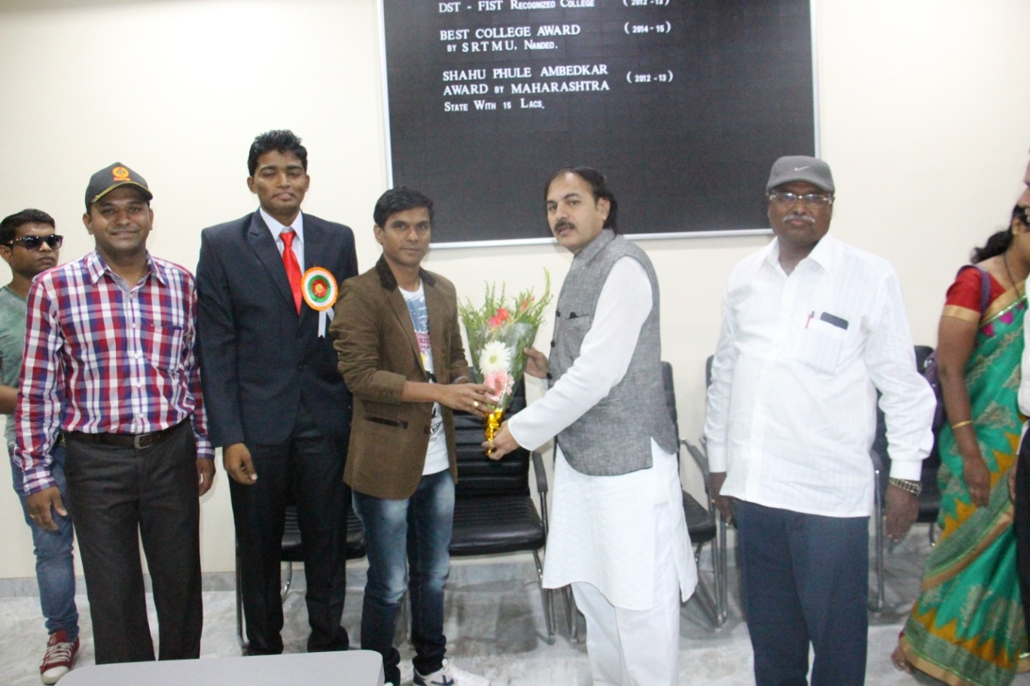
Hon.Principal .Dr.J.S.Dargad Felicited to Chief Guest of Student council opening ceremony Hon.Sandip Gaikwad along with proffcer incharge K.N Rathod student council secratory Avinash Ghodke
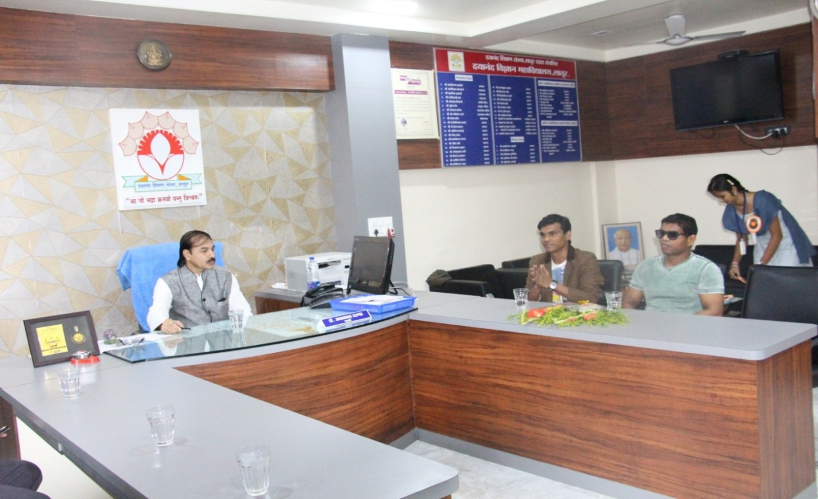Hon.Principal Dr.J.S.Dargad discussing with Hon.Sandip Gaikwad Chief Guest of Student council before opening ceremony of student council
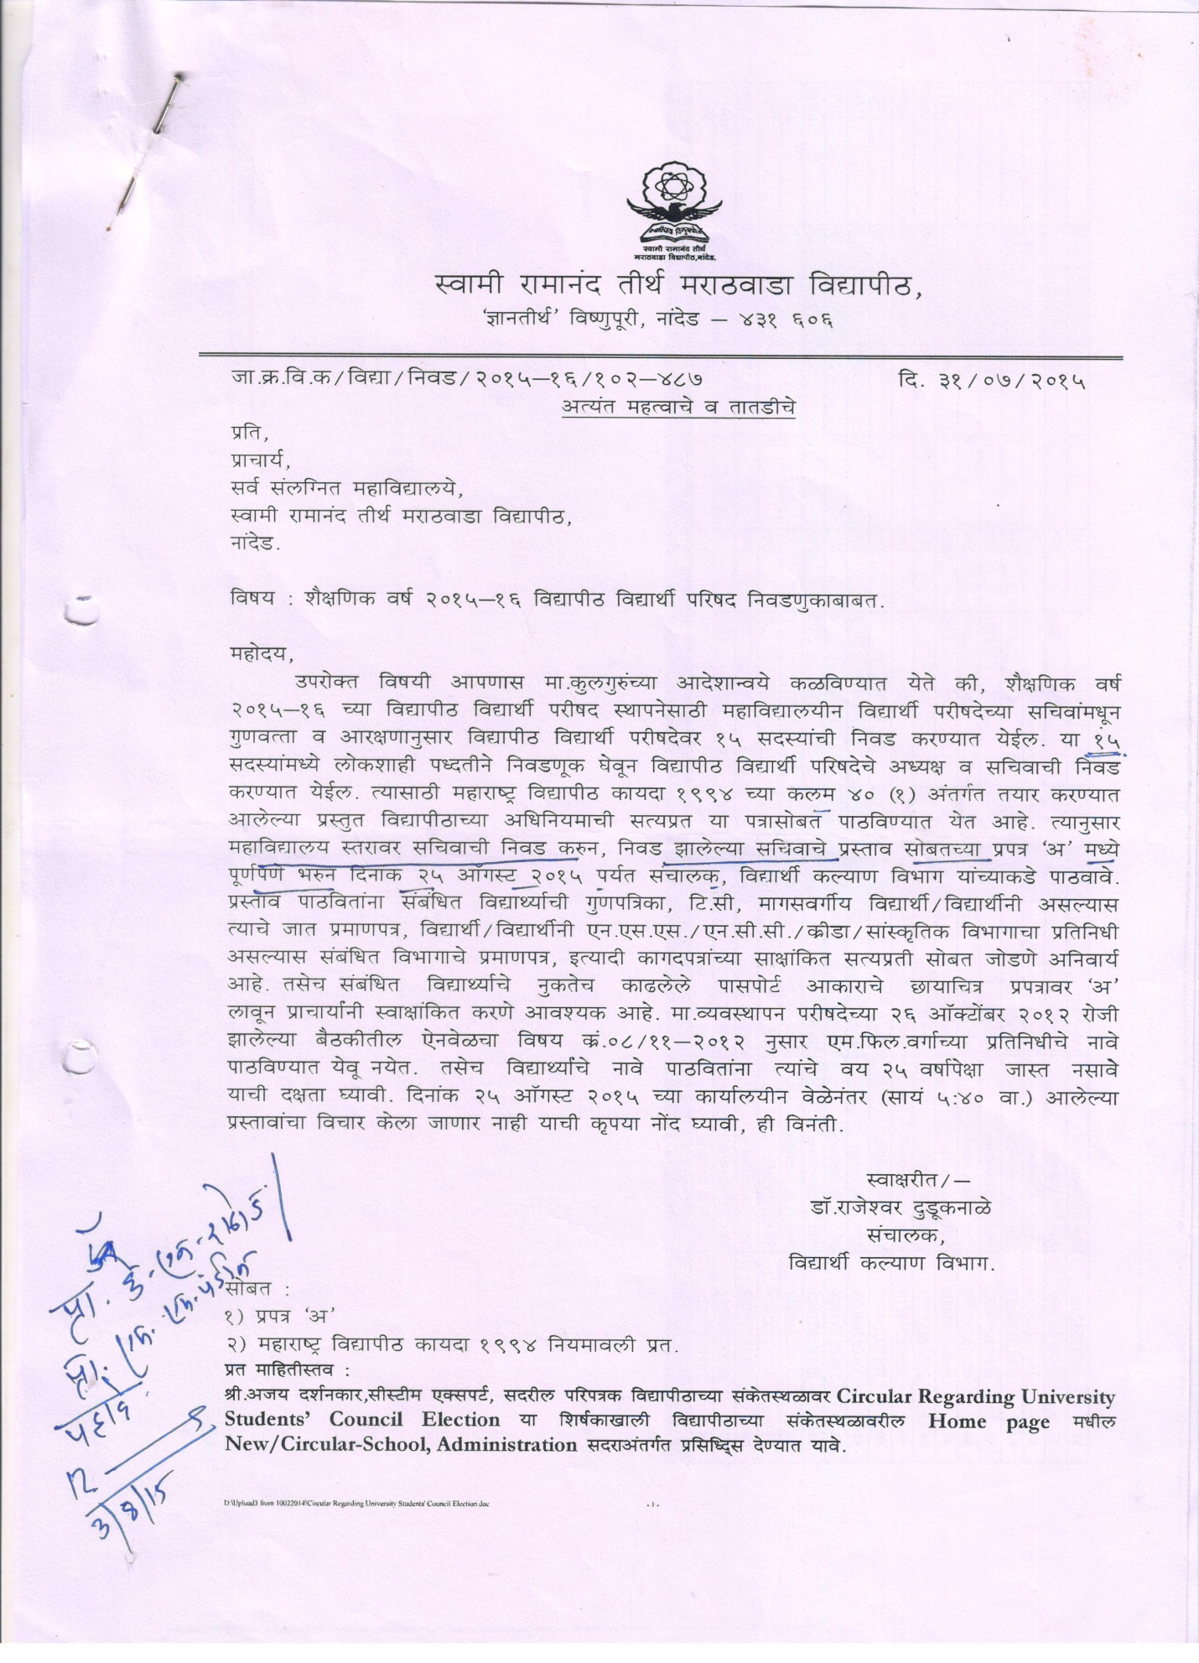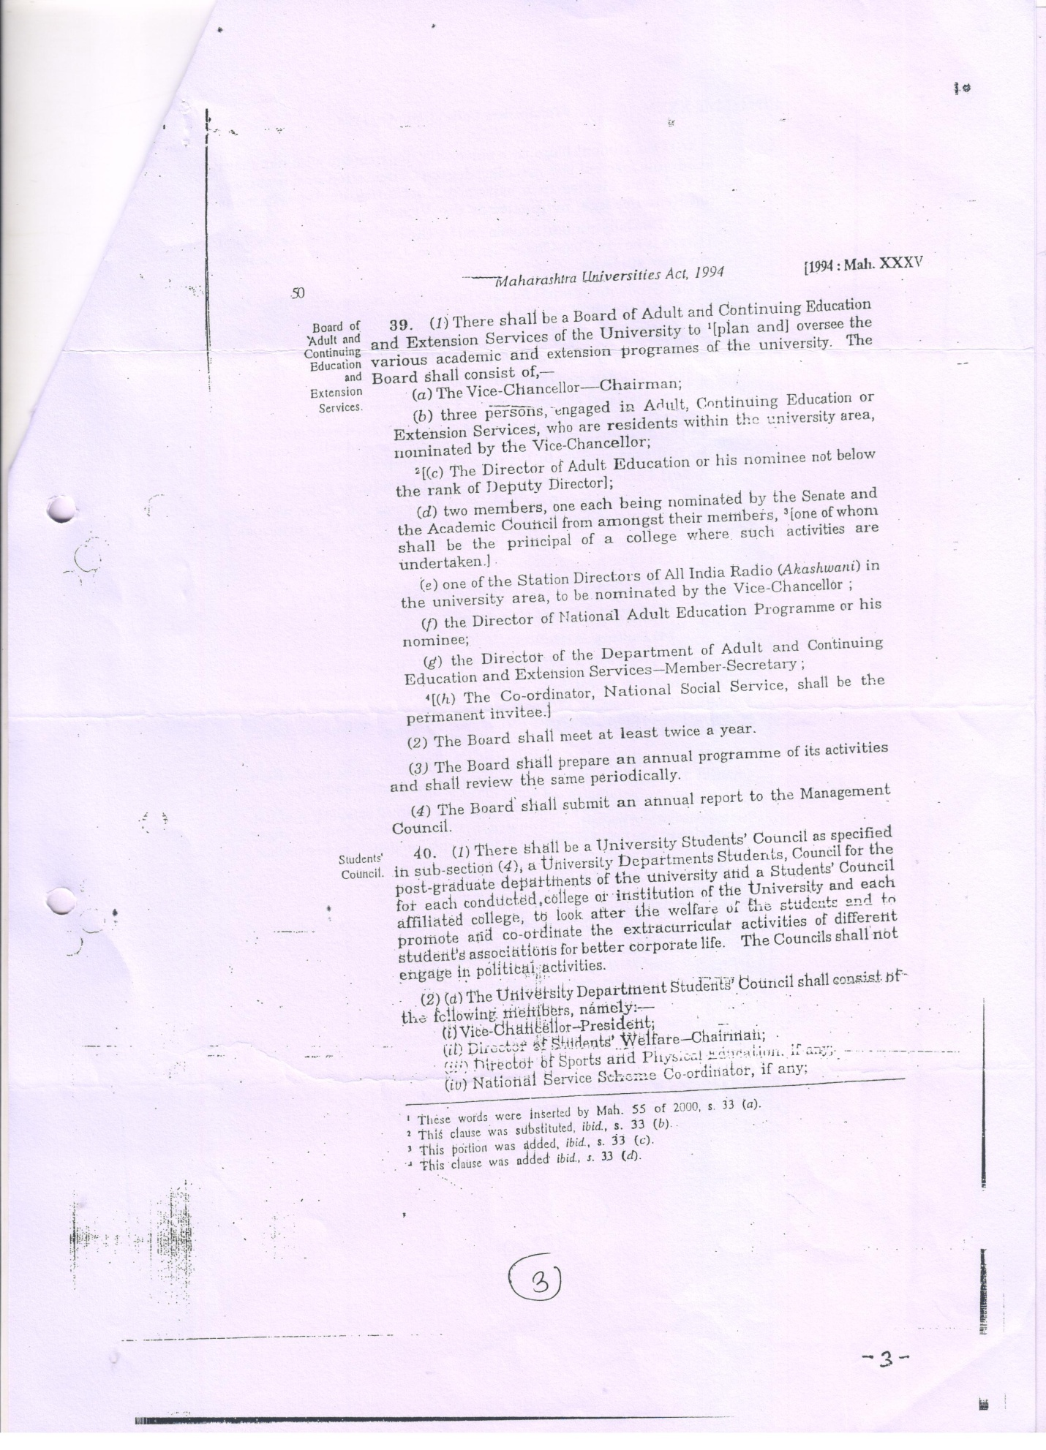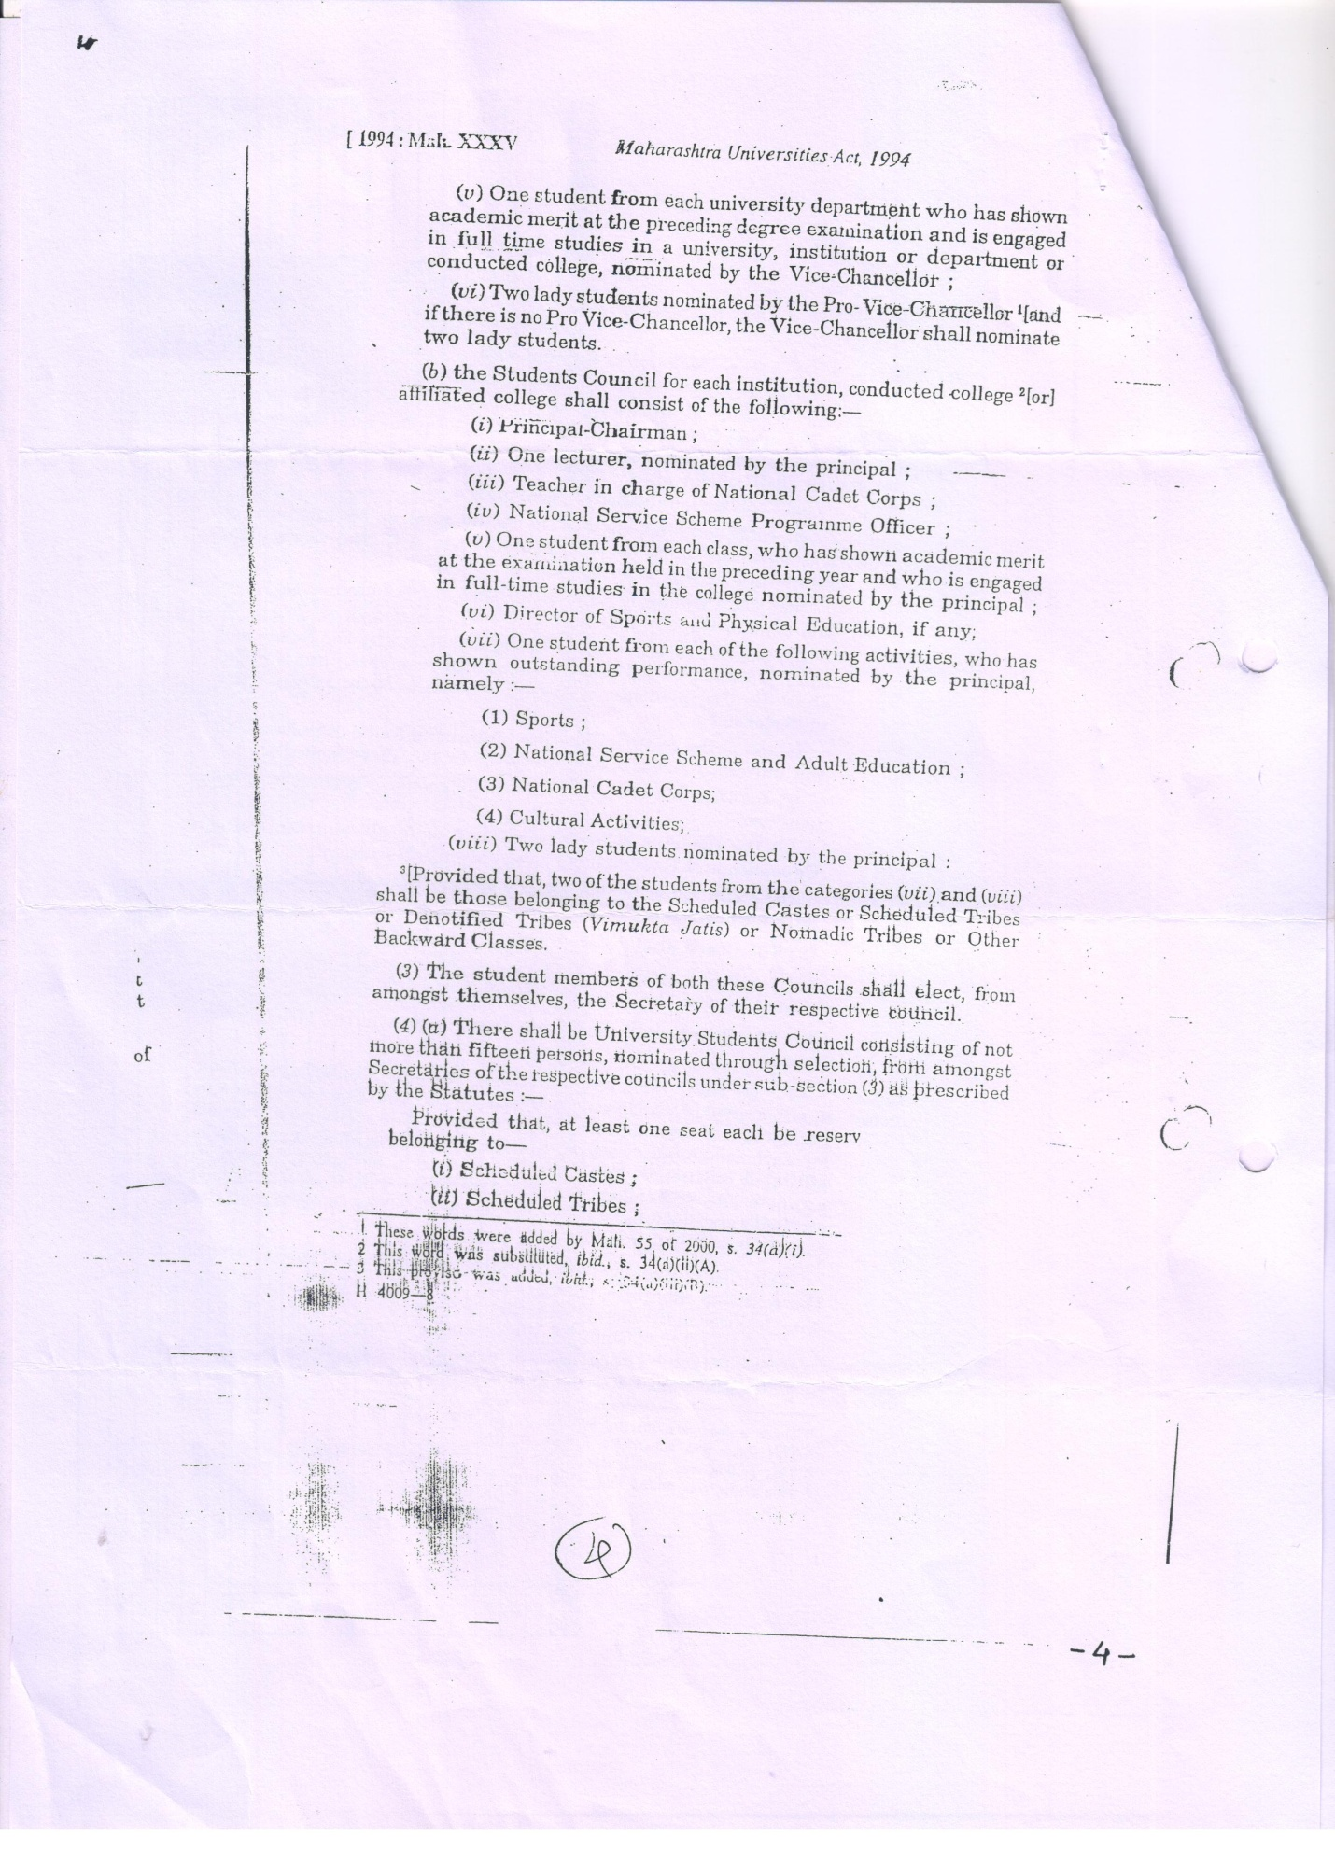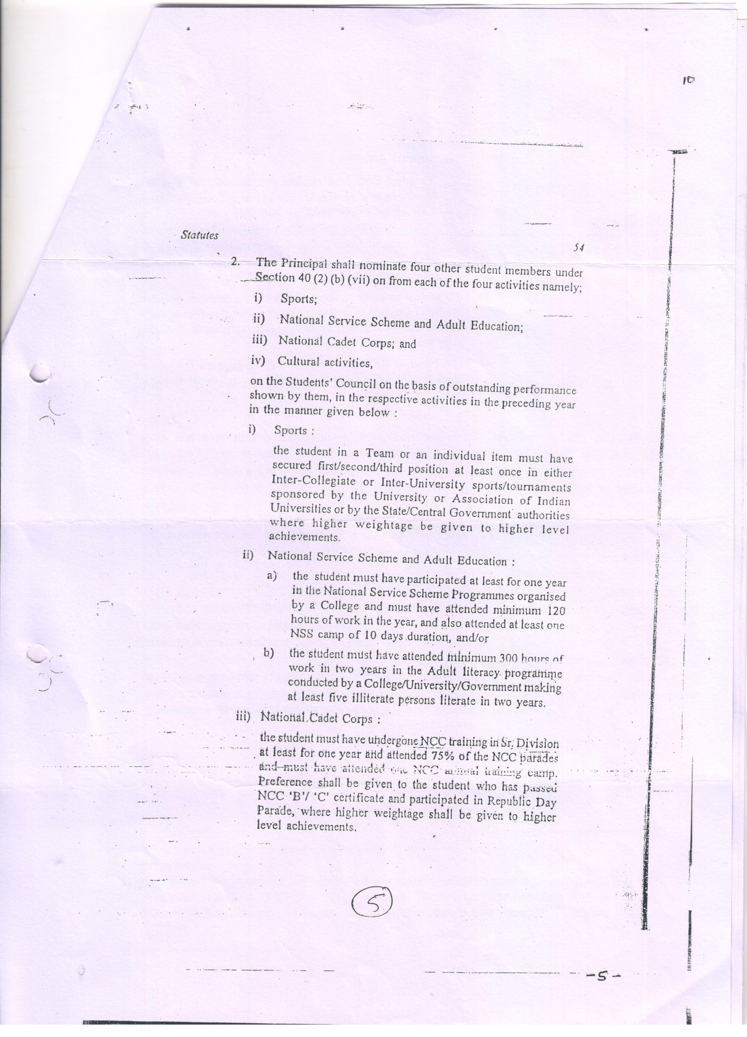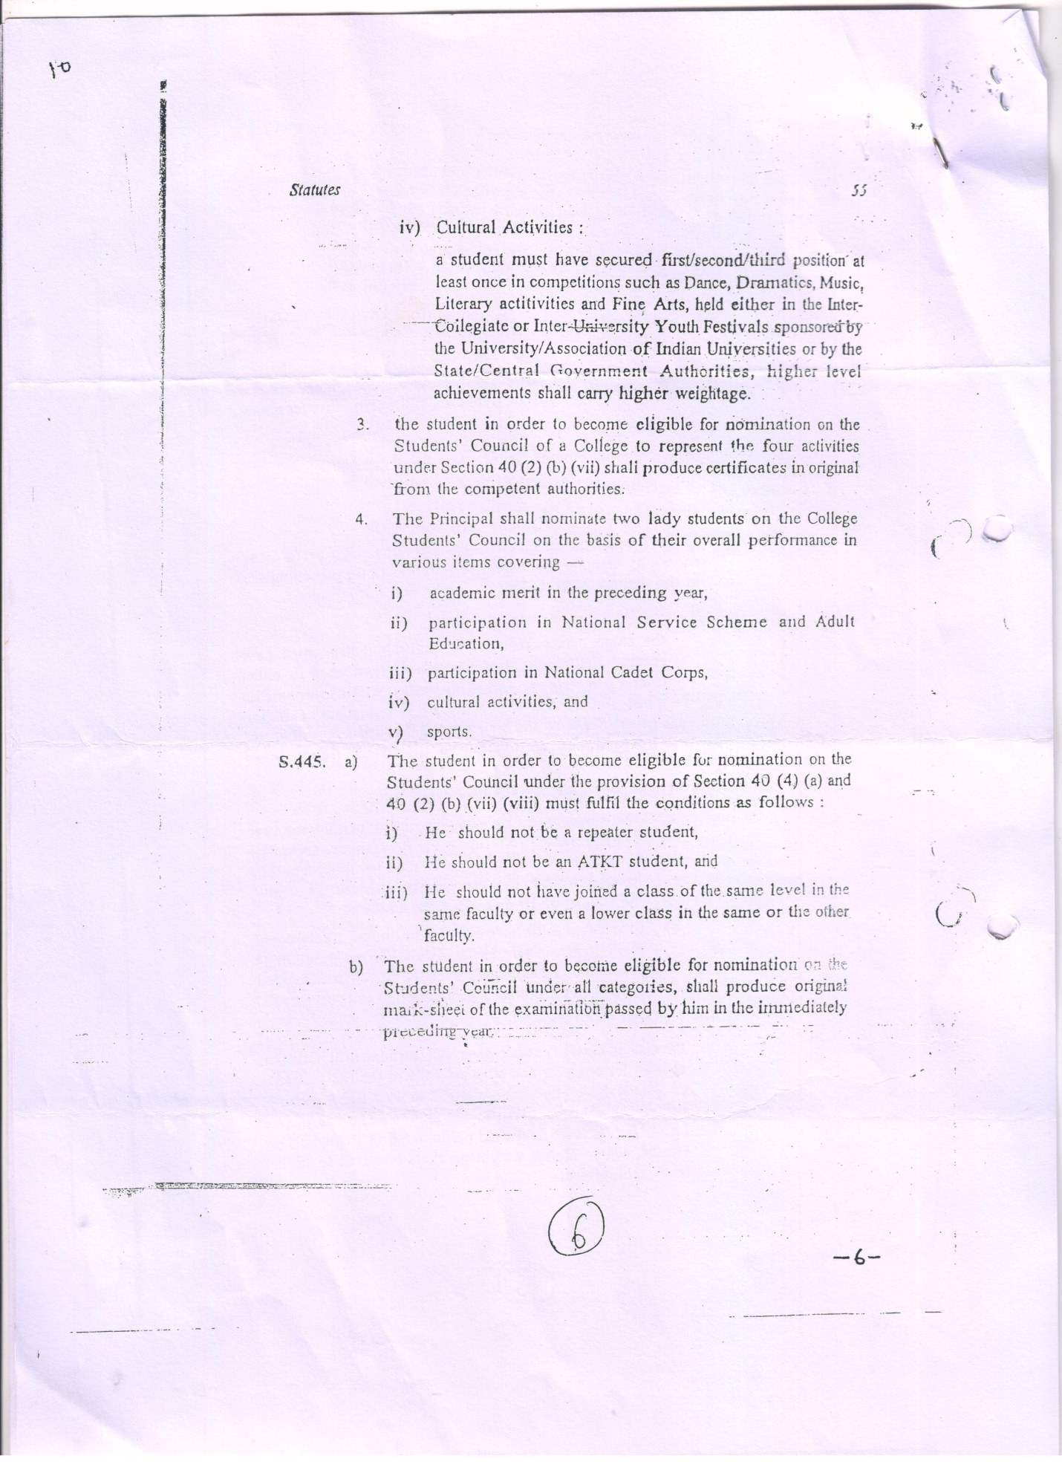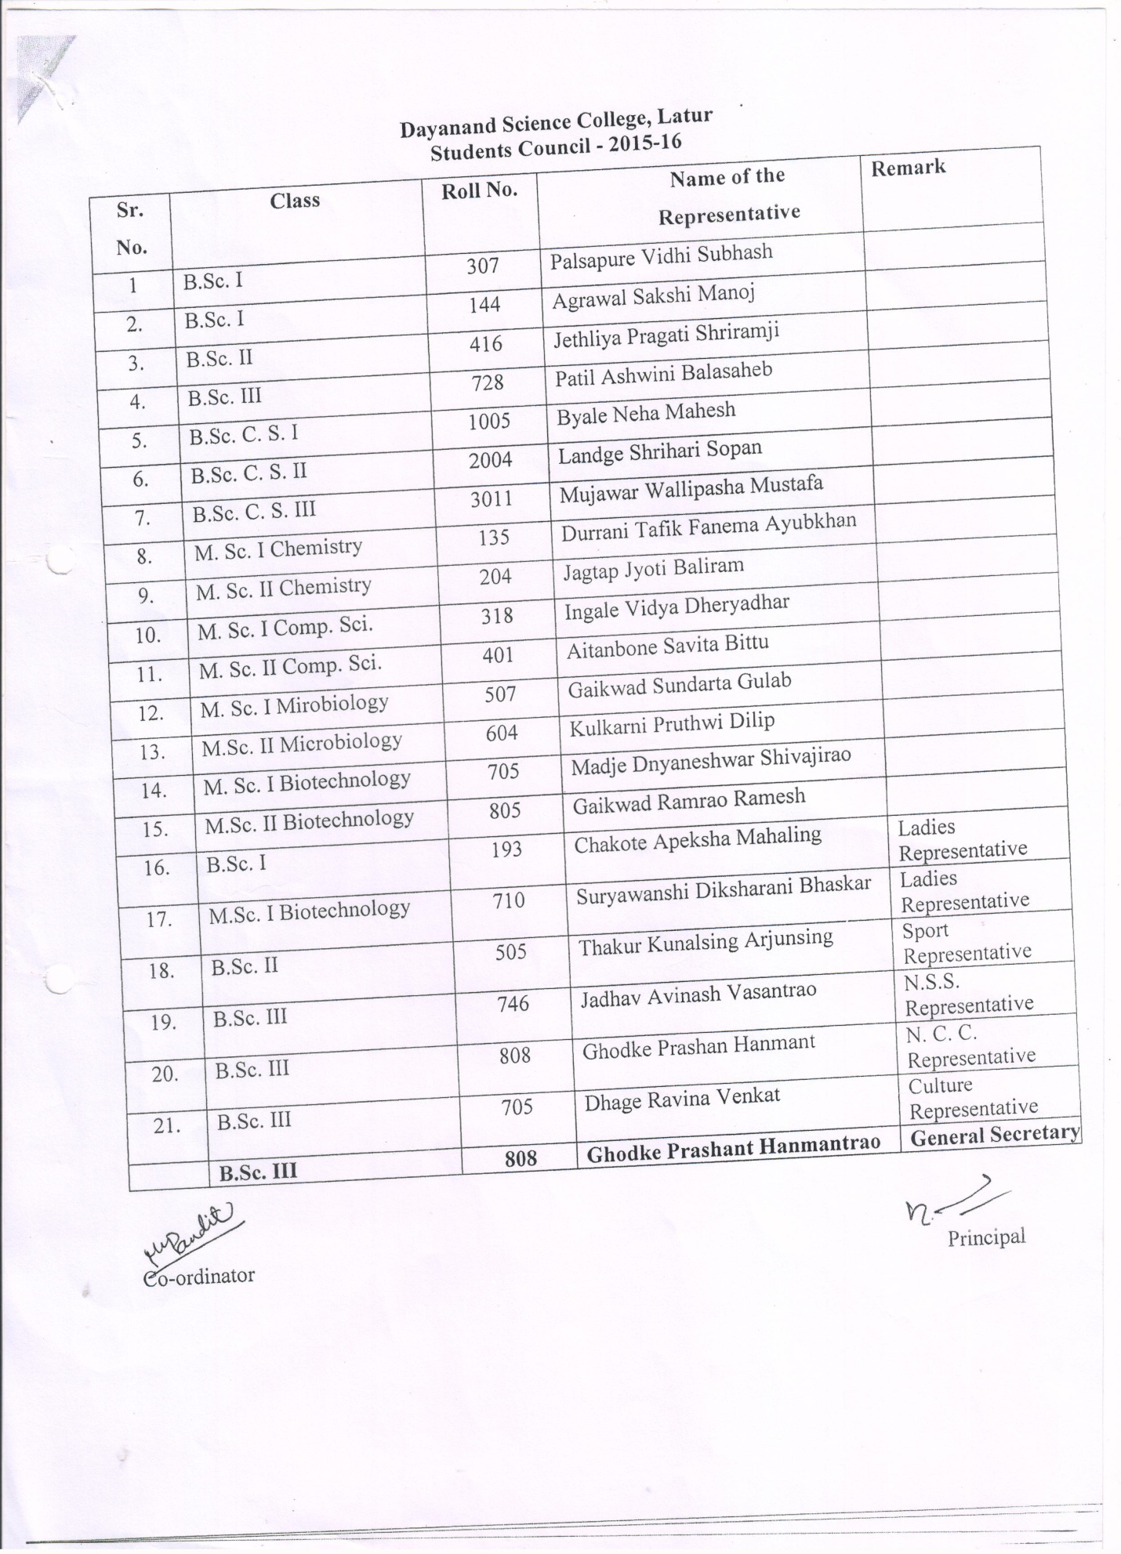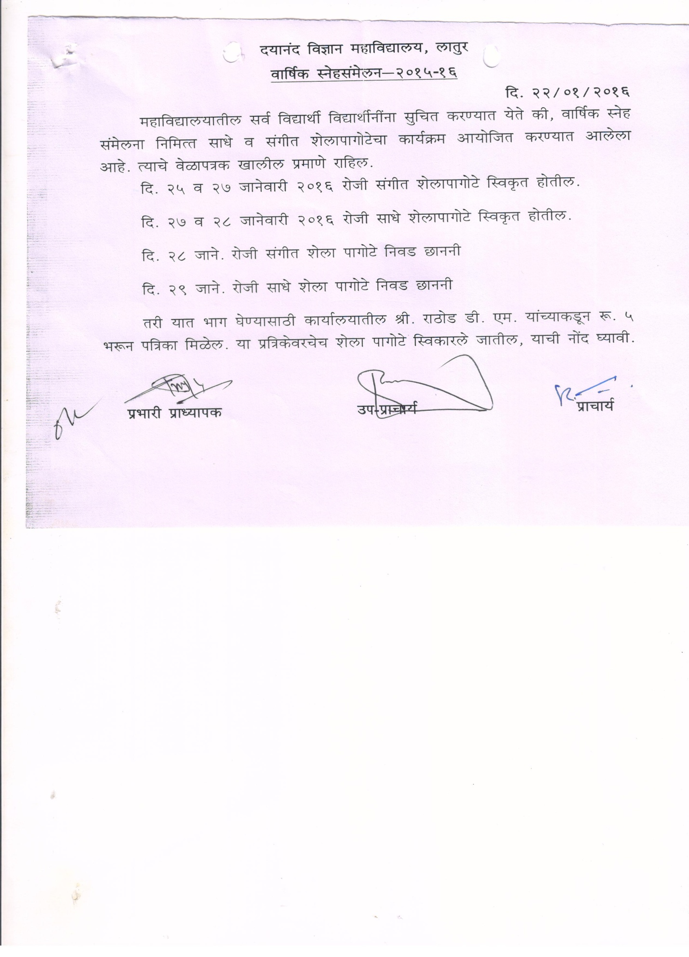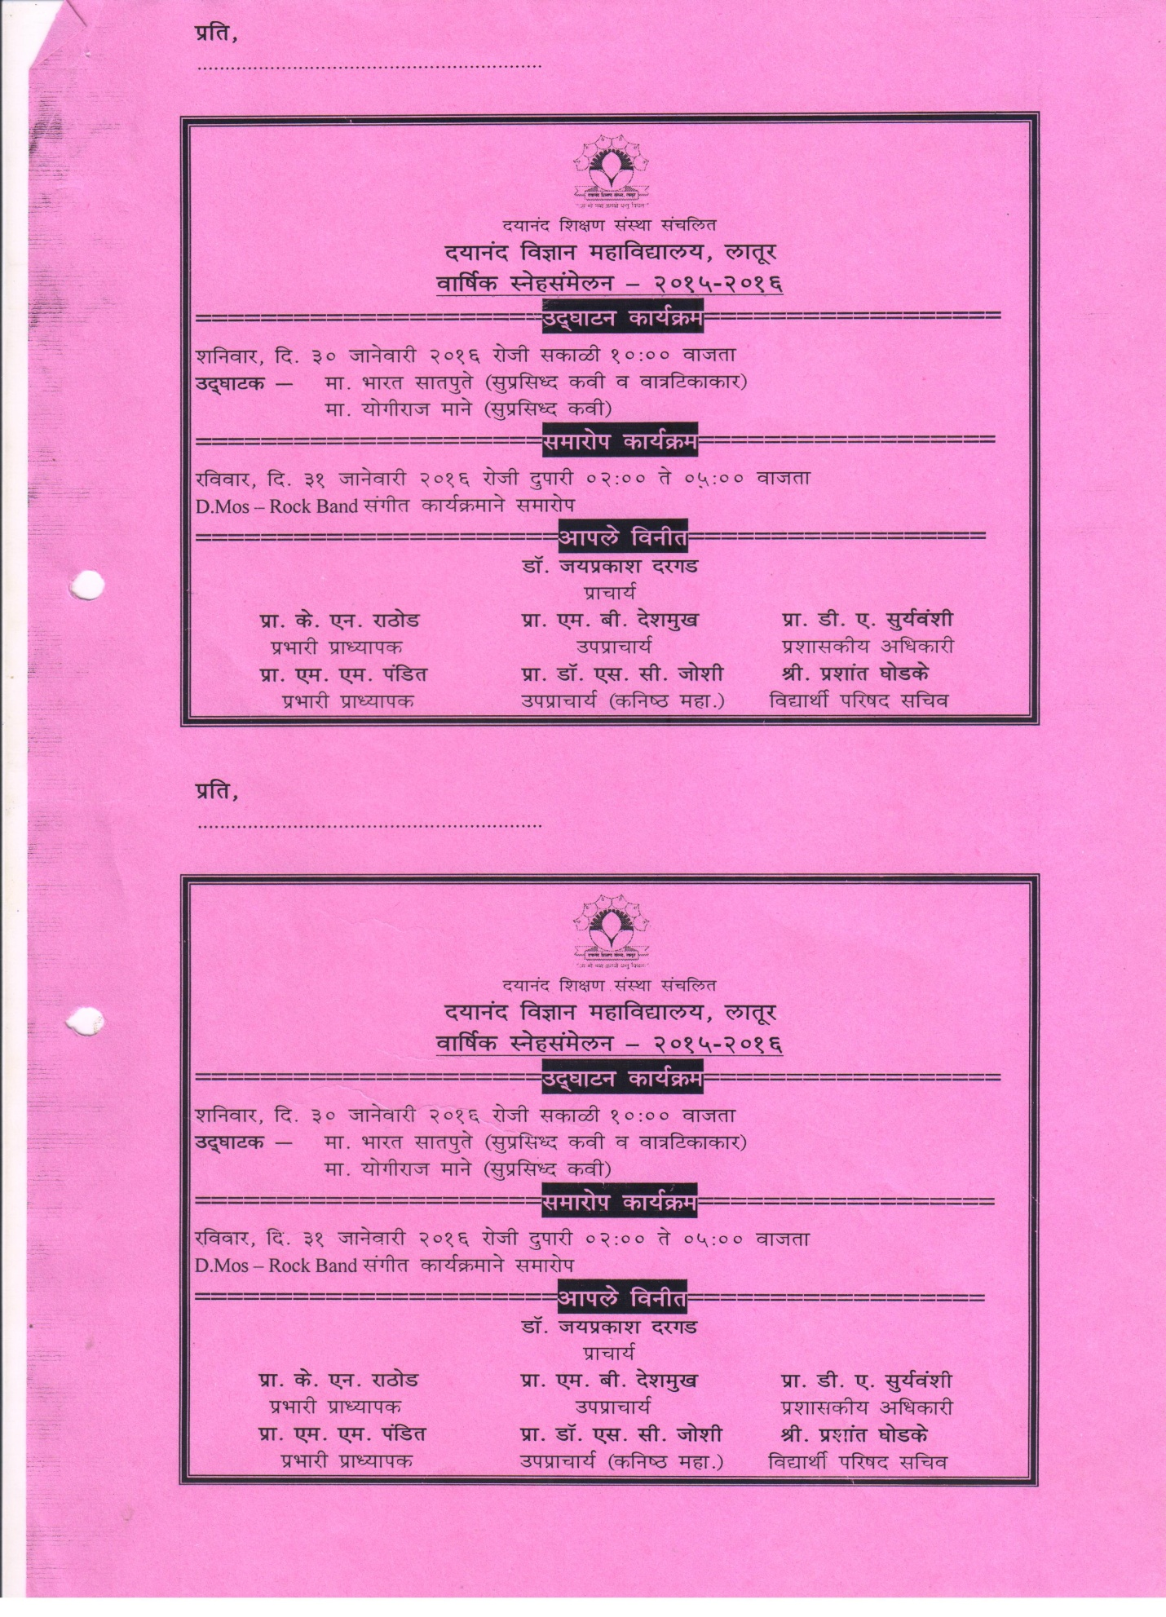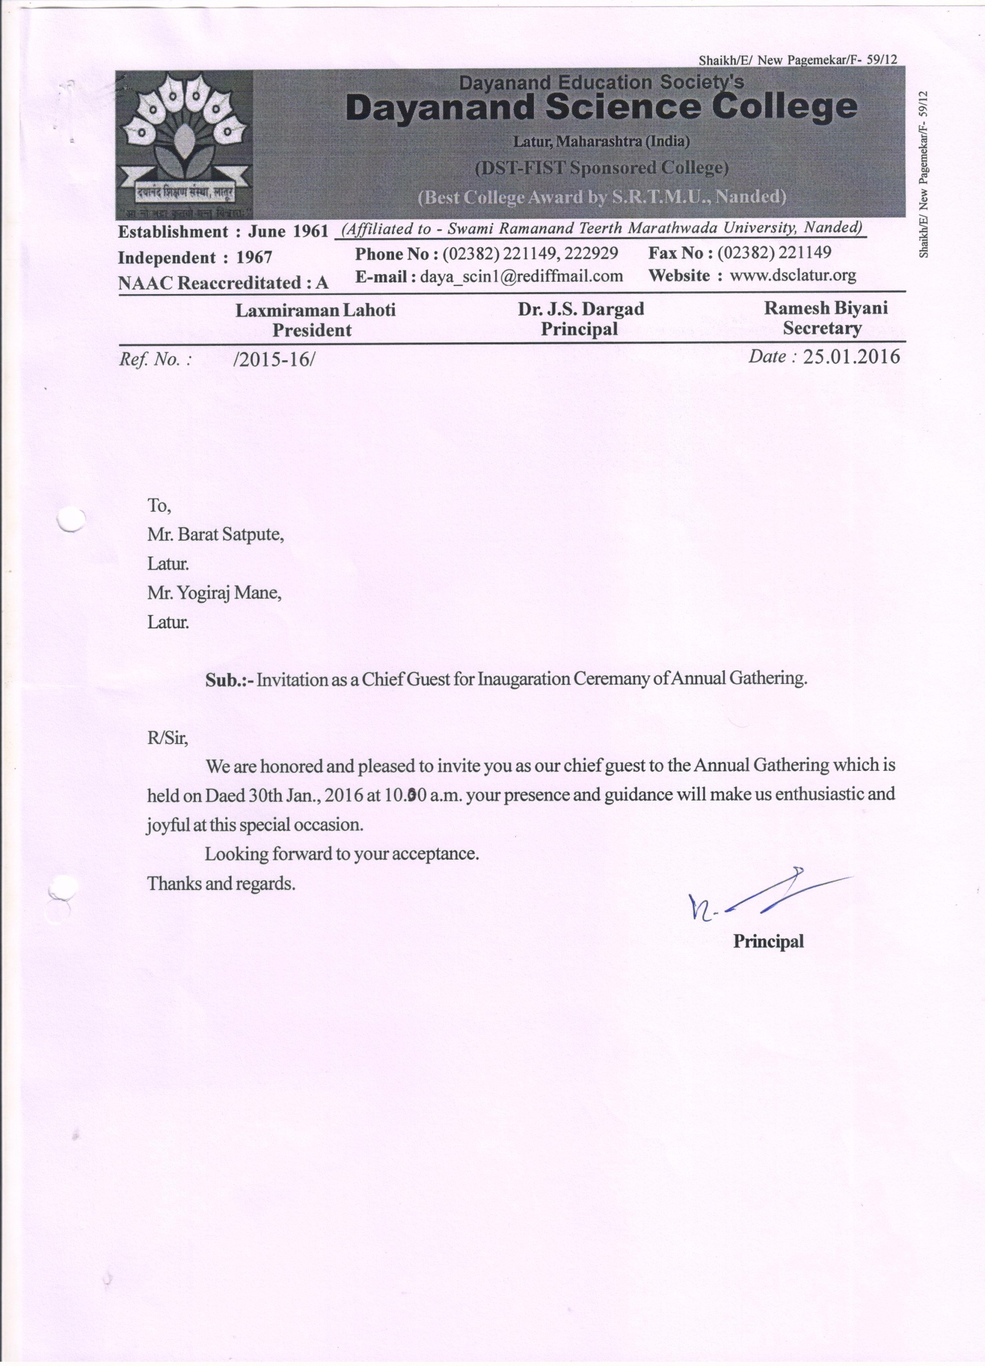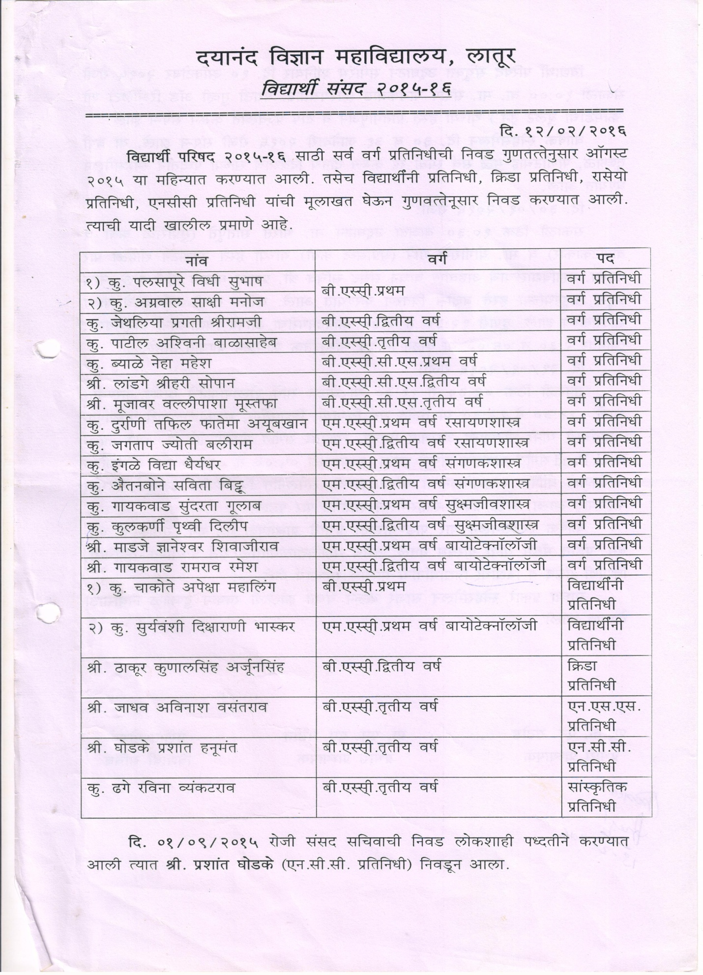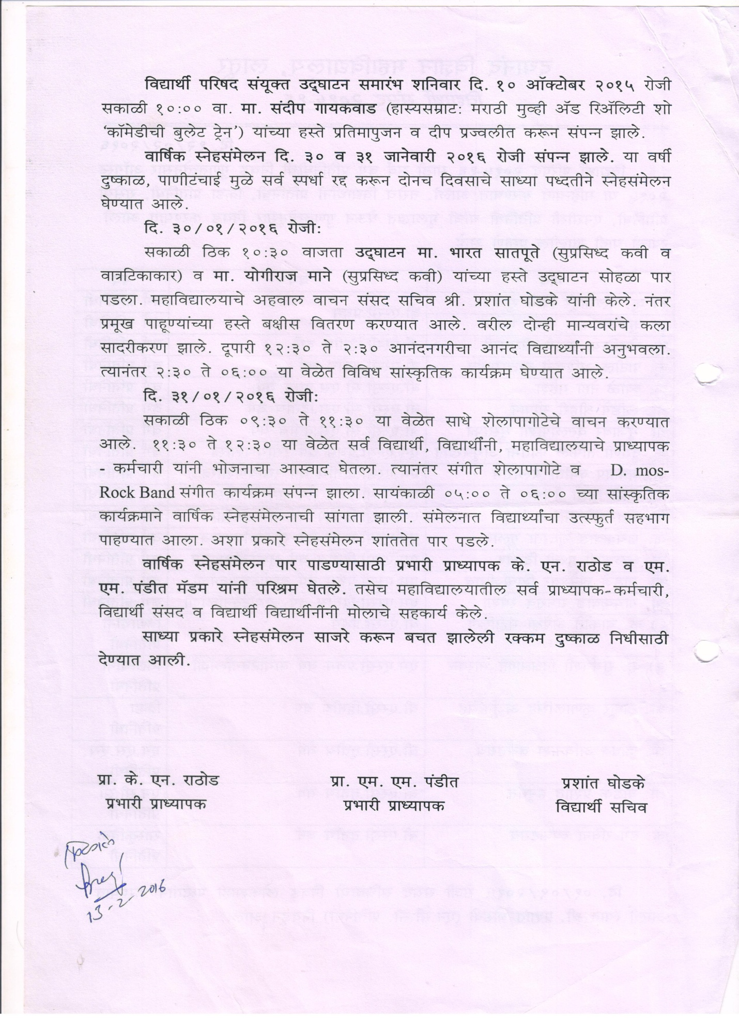
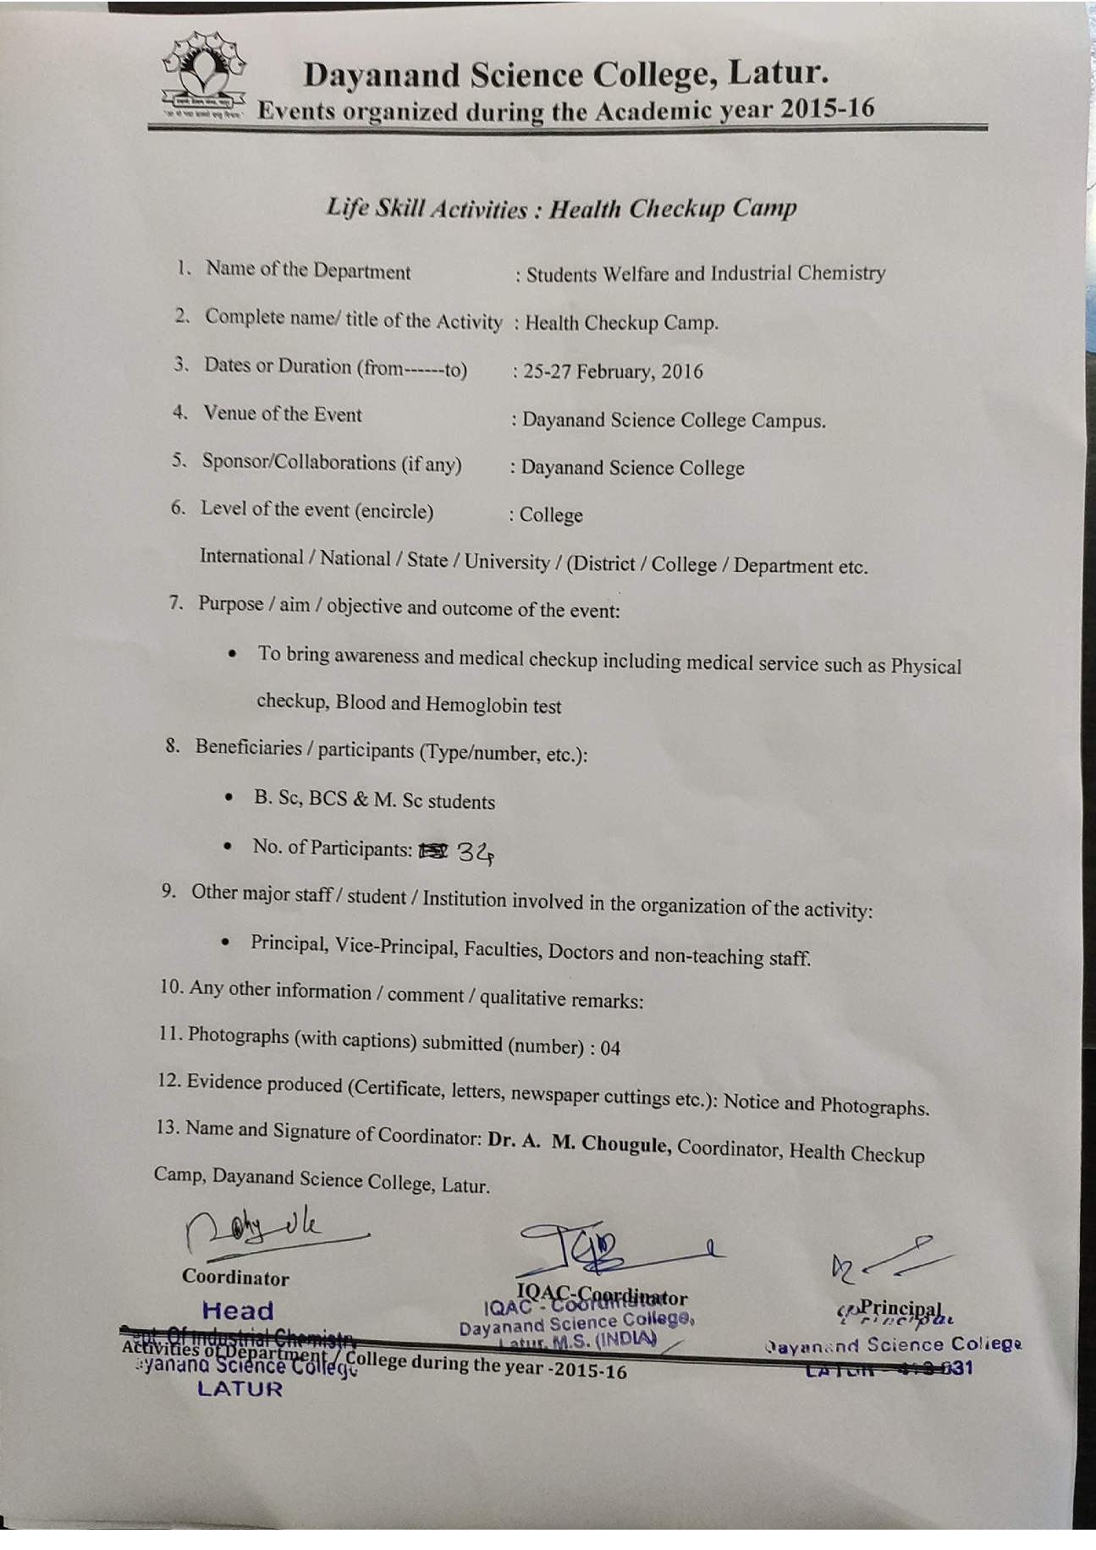Photo Gallery
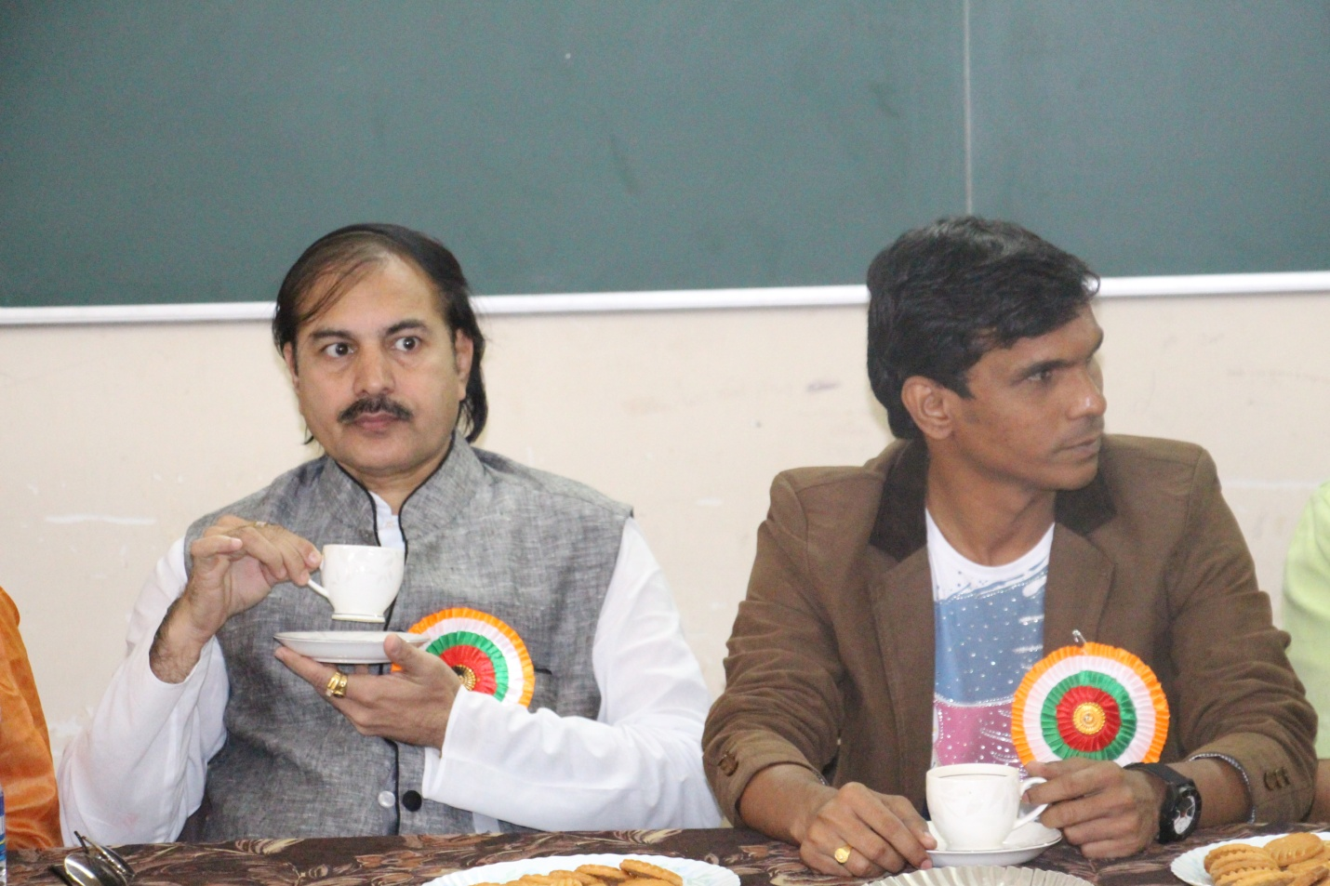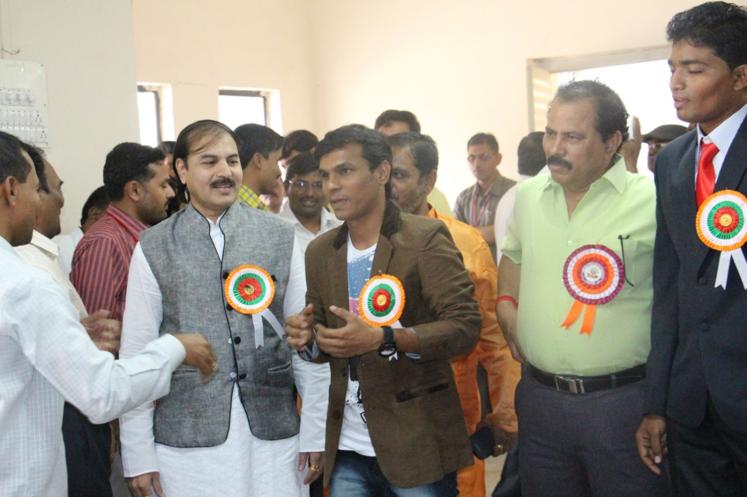
Hon.Chief Guest Sandip Gaikwad along with Hon. Dr J.S Dargad in staff introduction programme
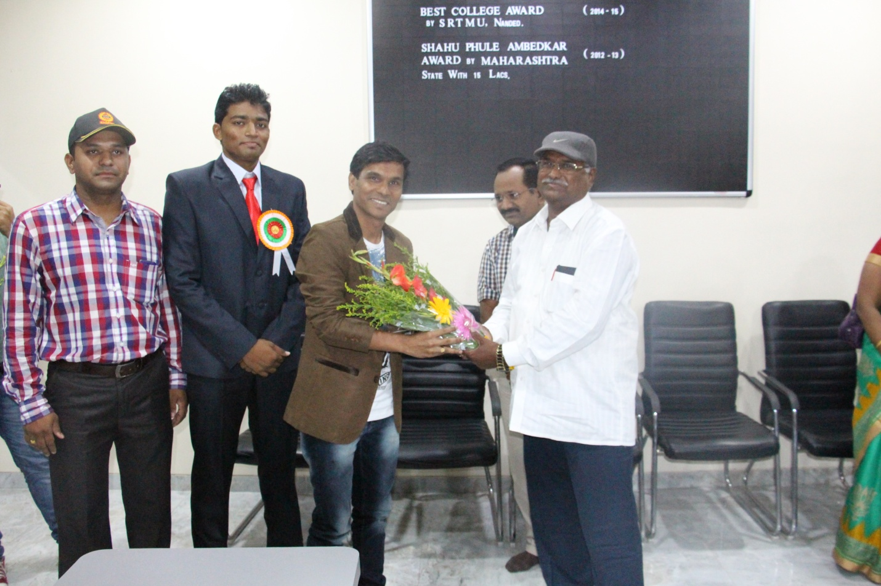
Hon.Chief Guest Sandip Gaikwad Felicitated by professor incharge K.R Rathod

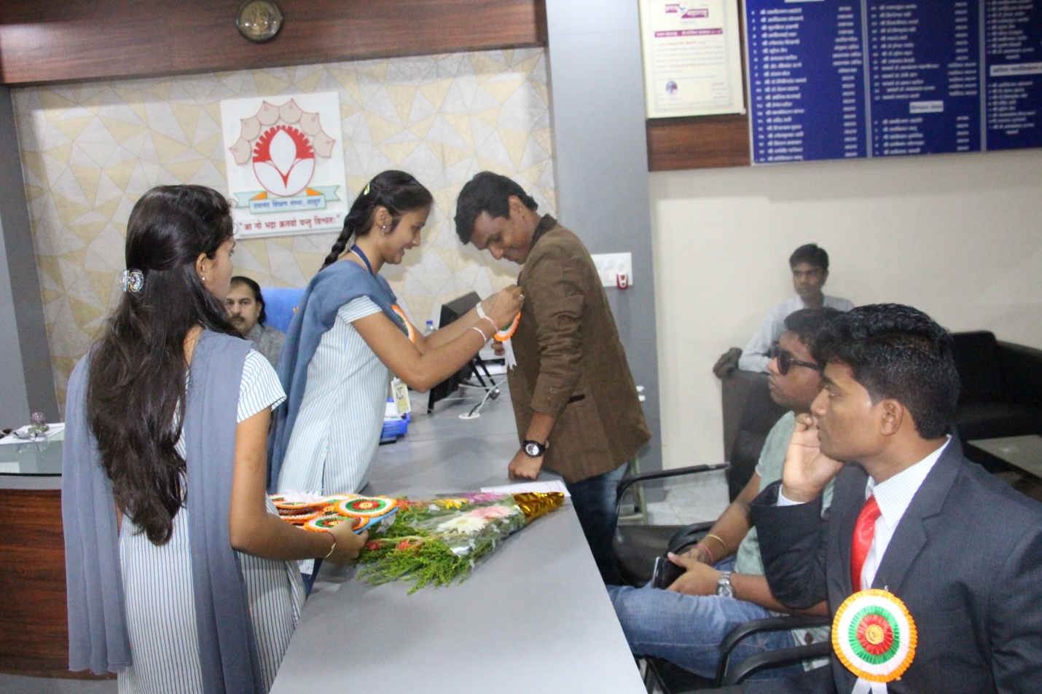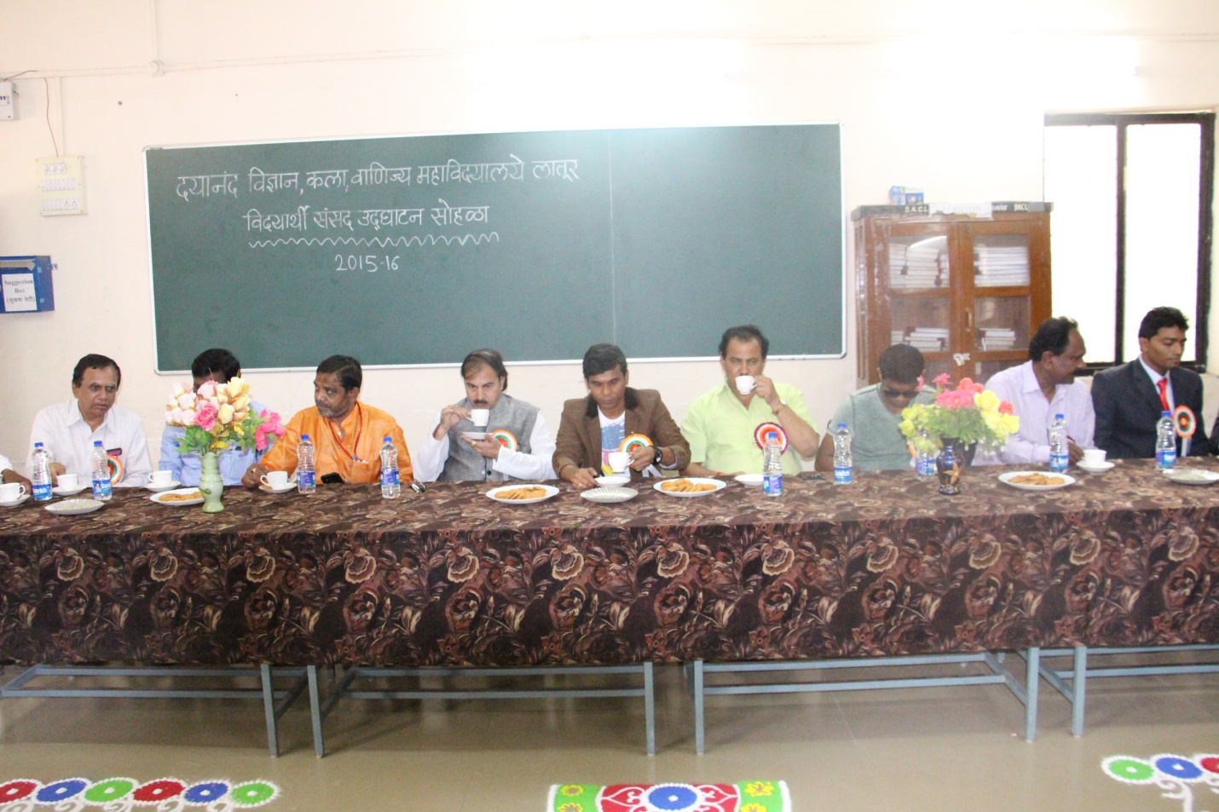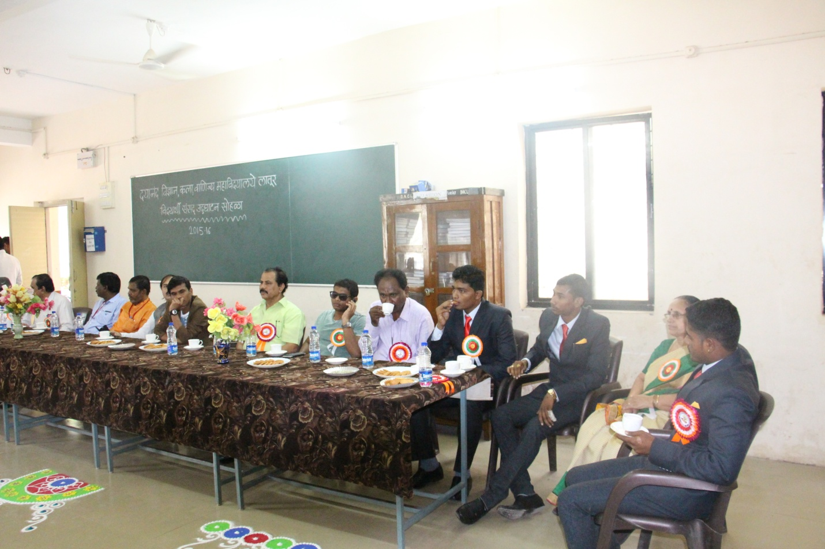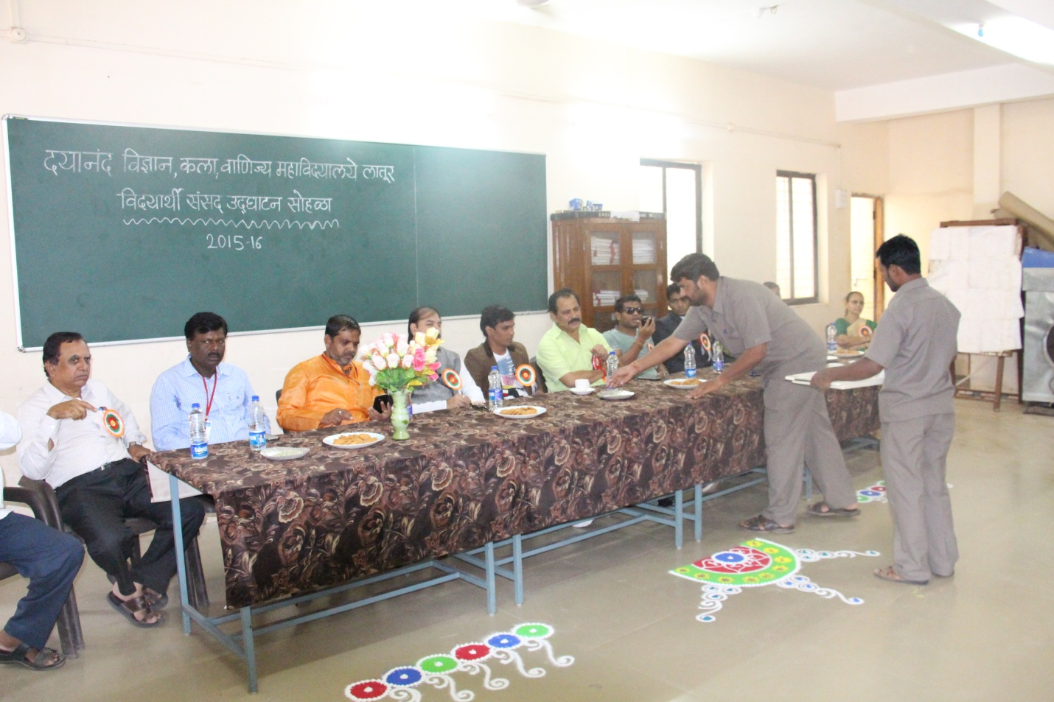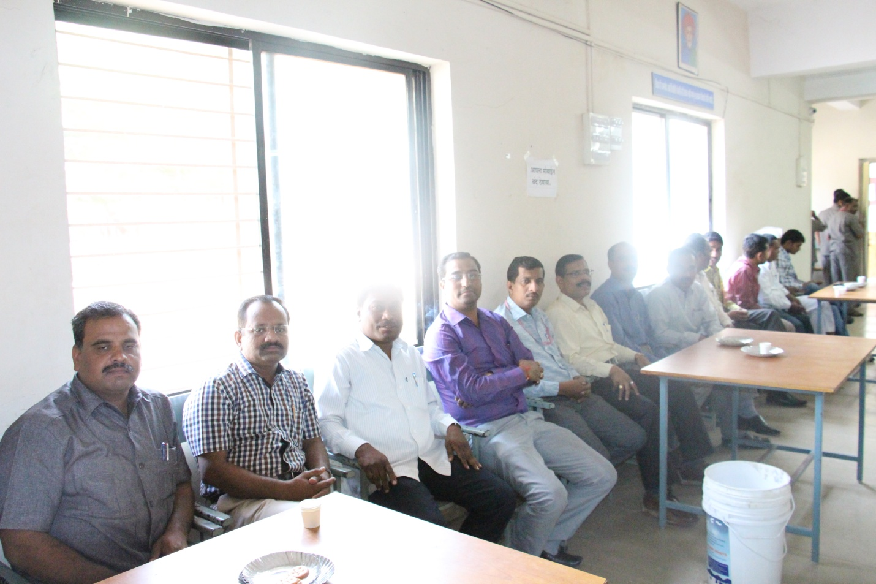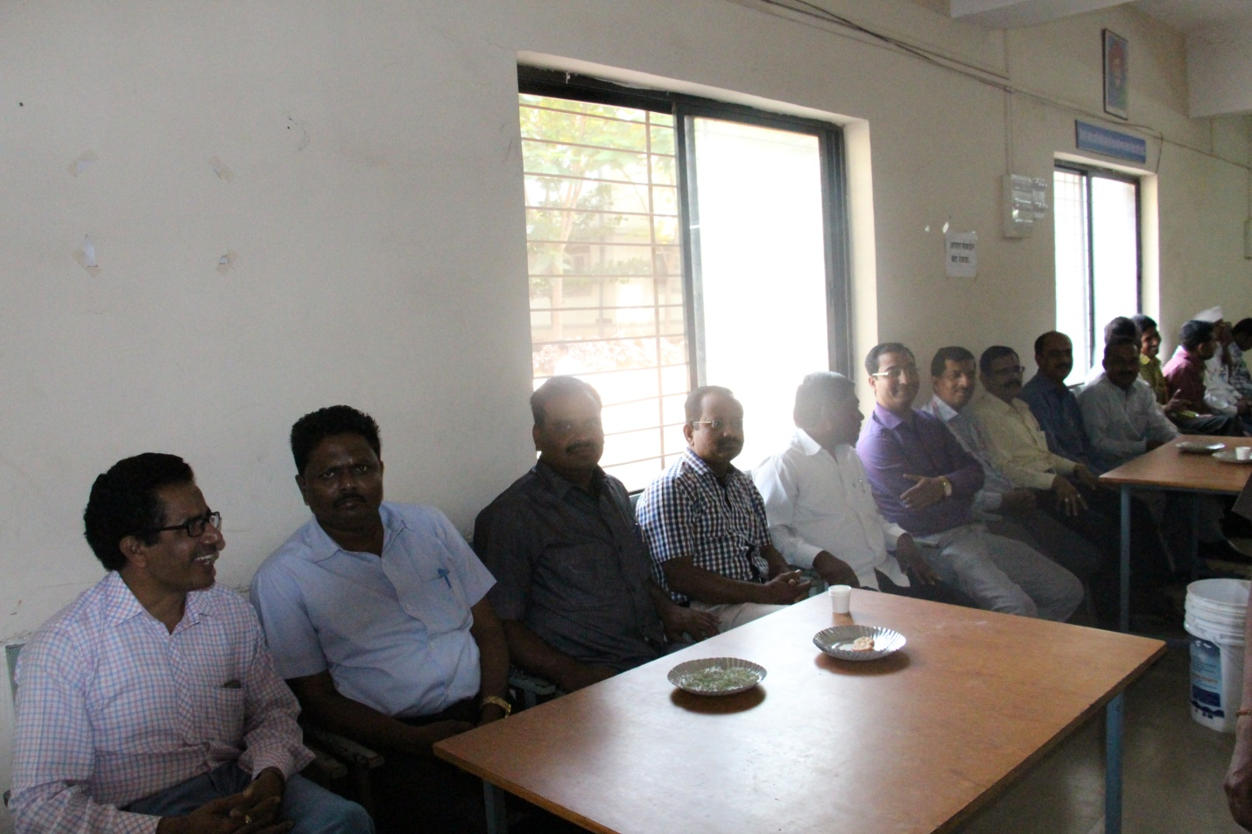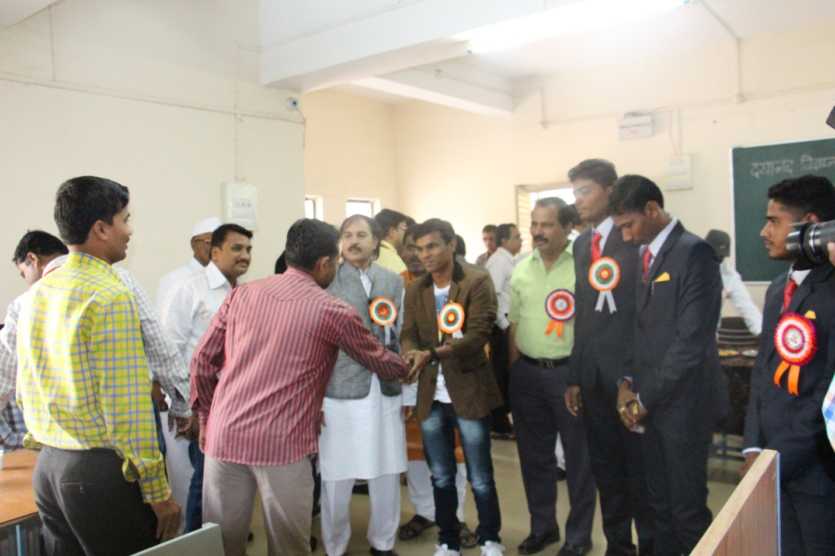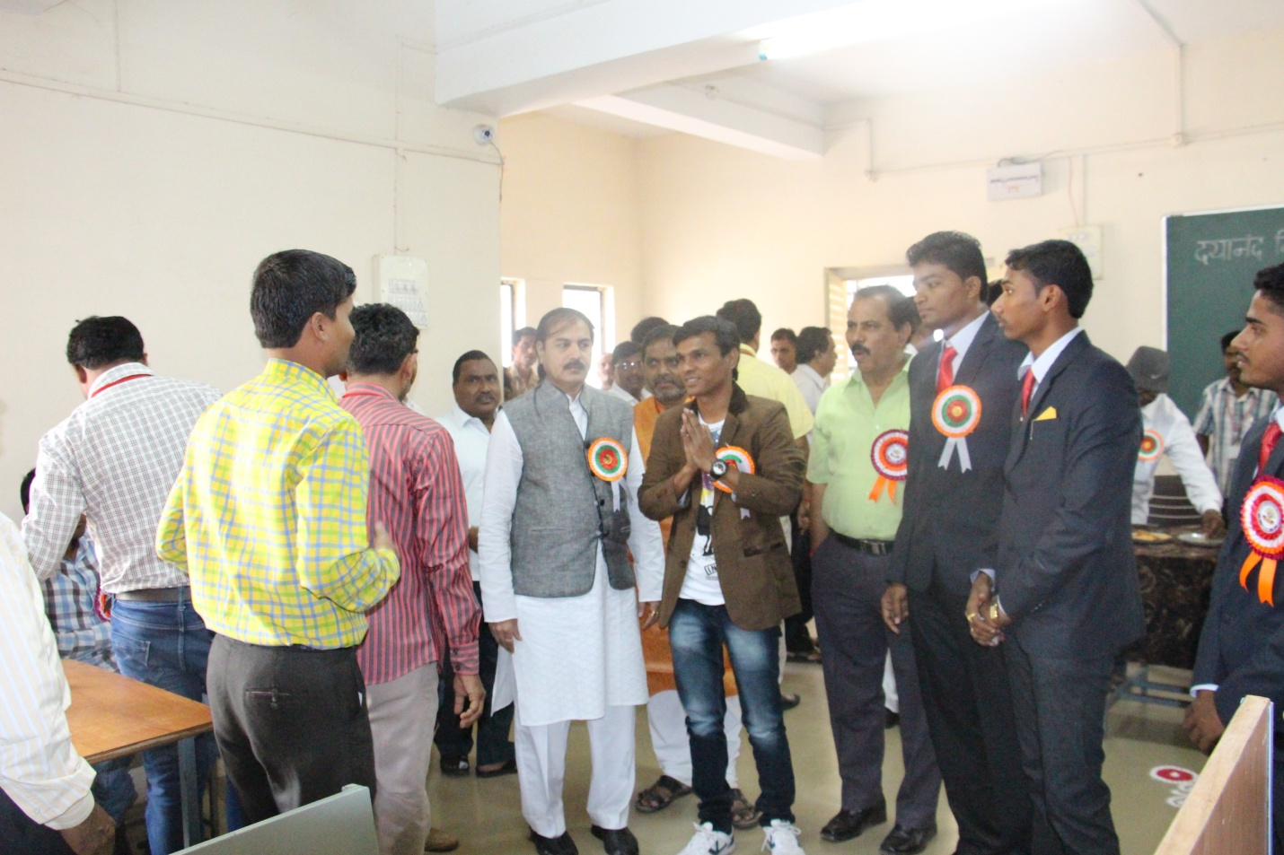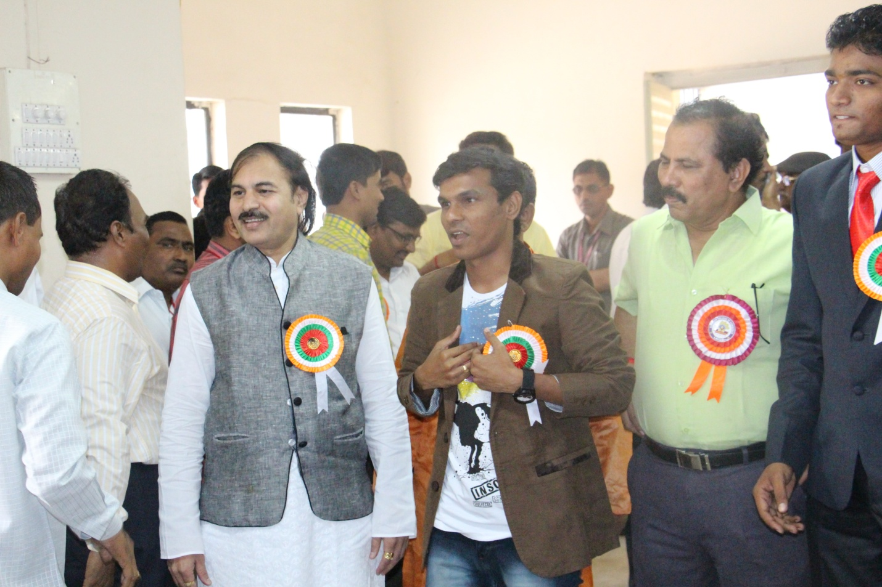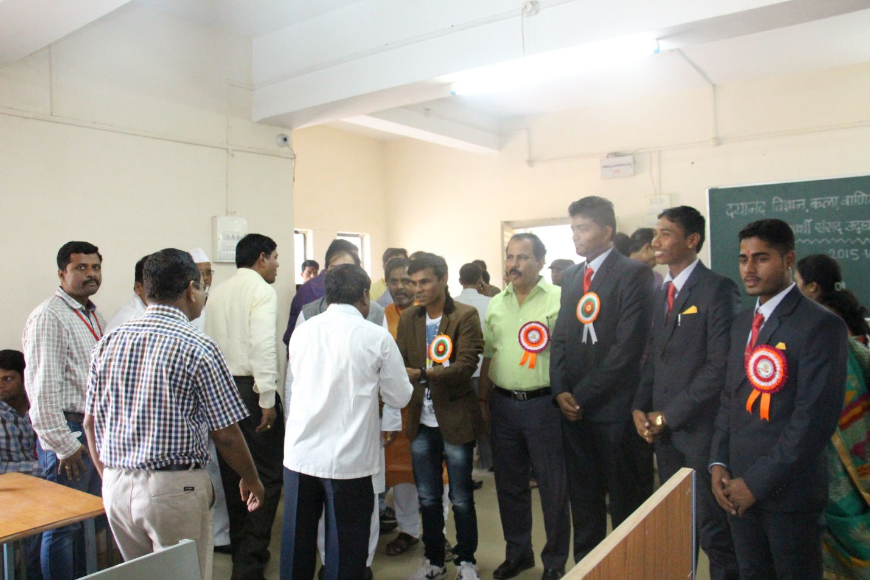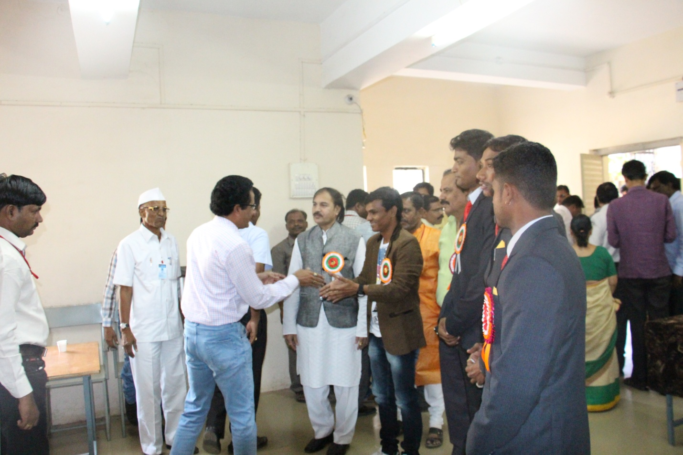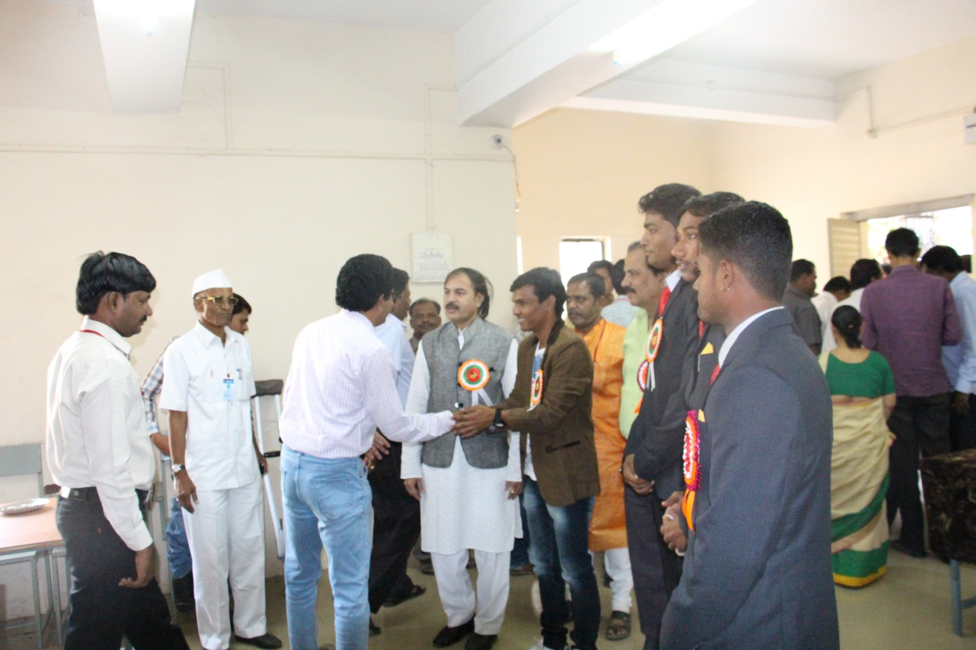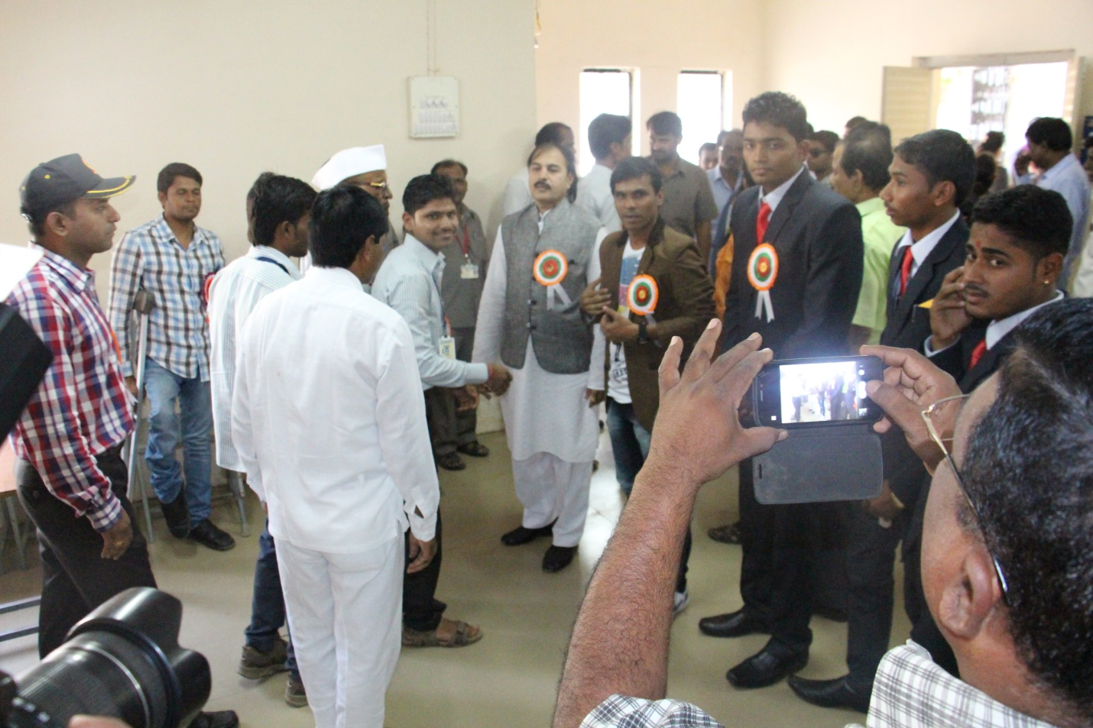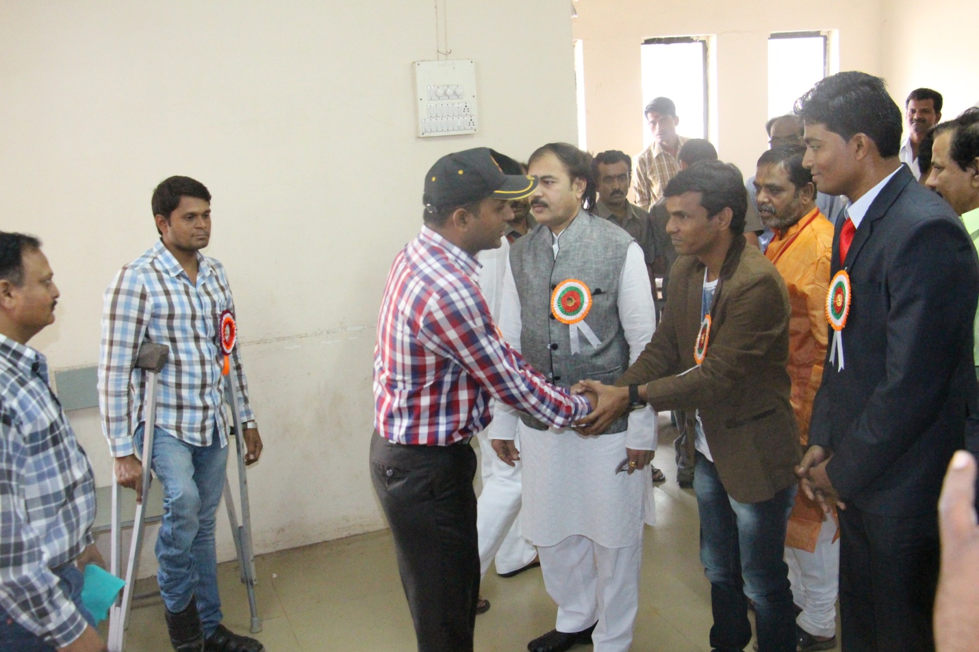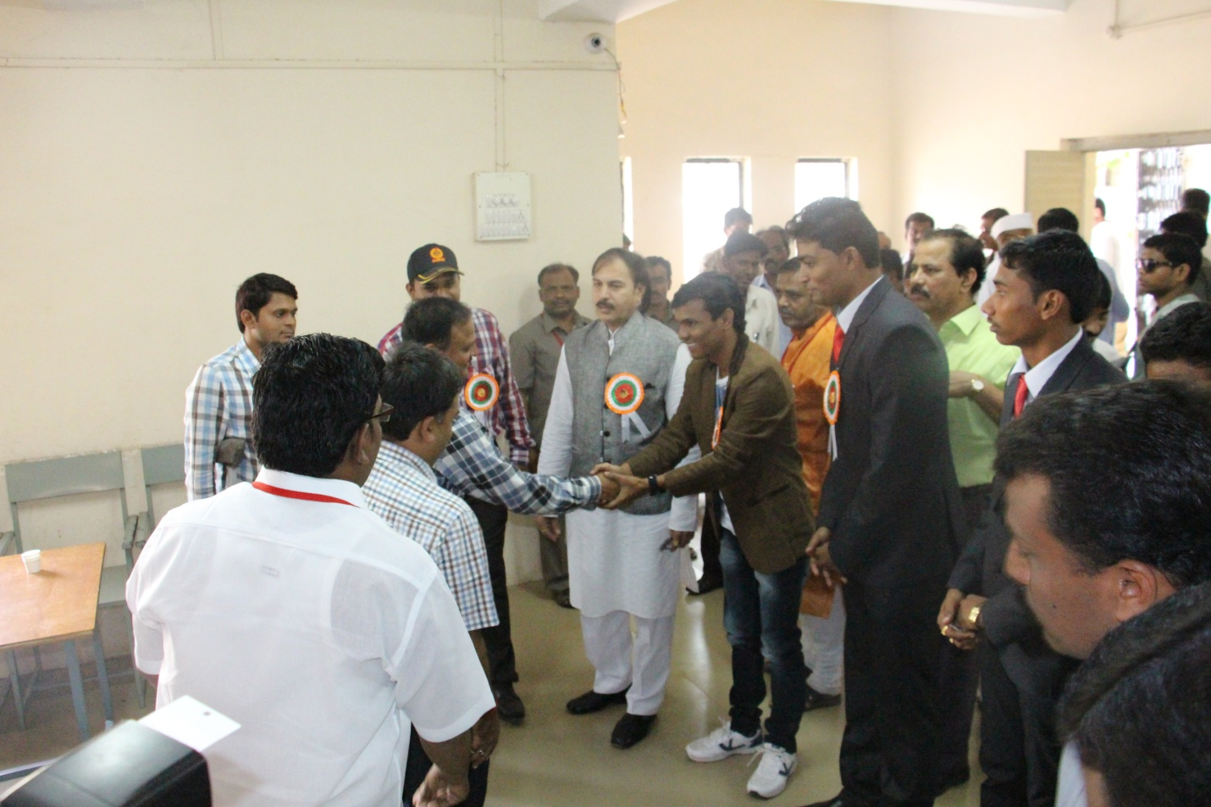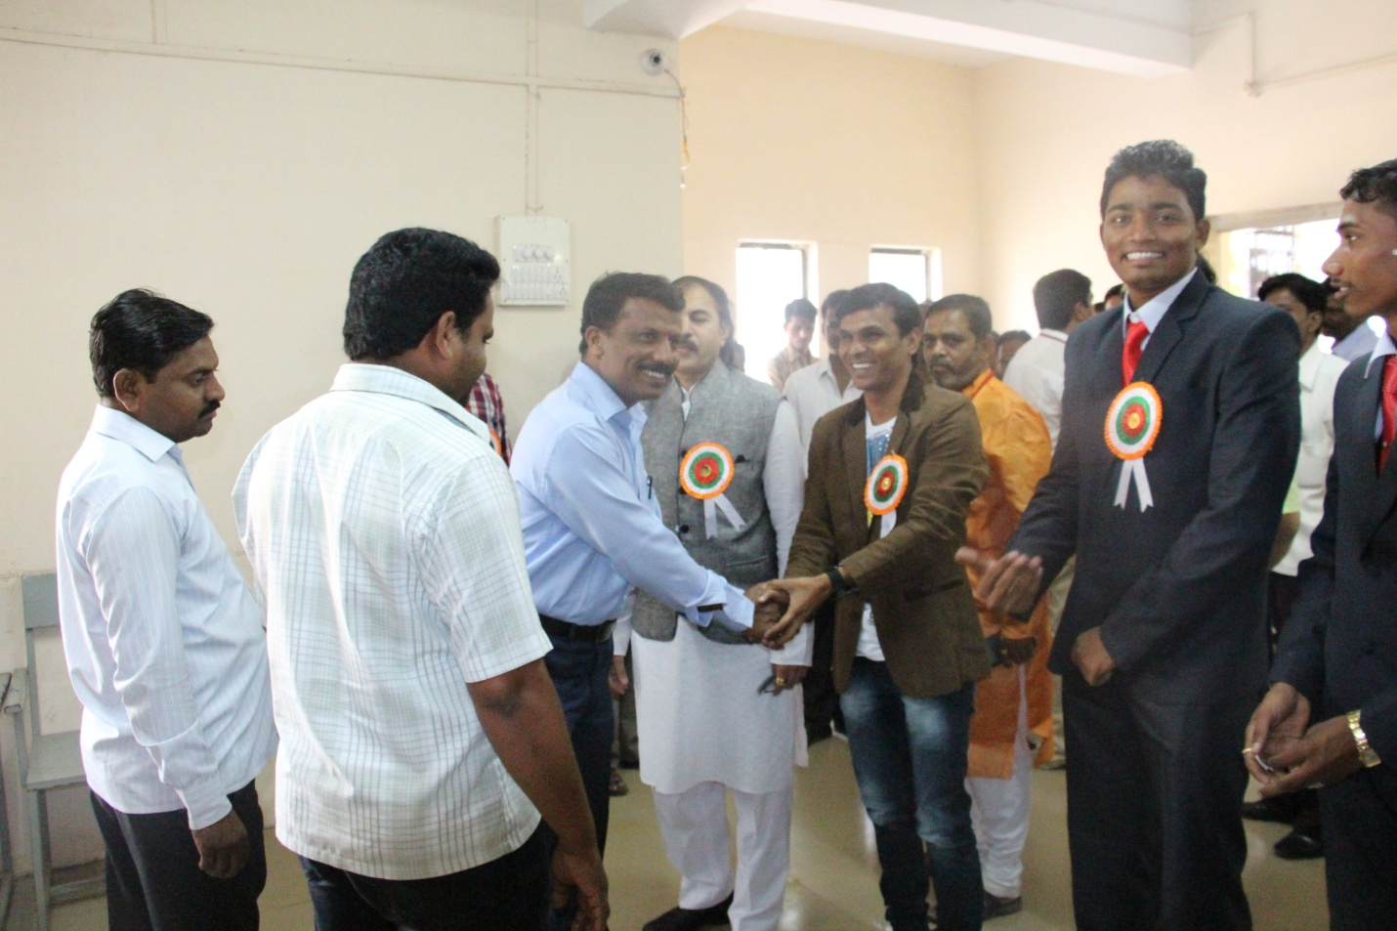
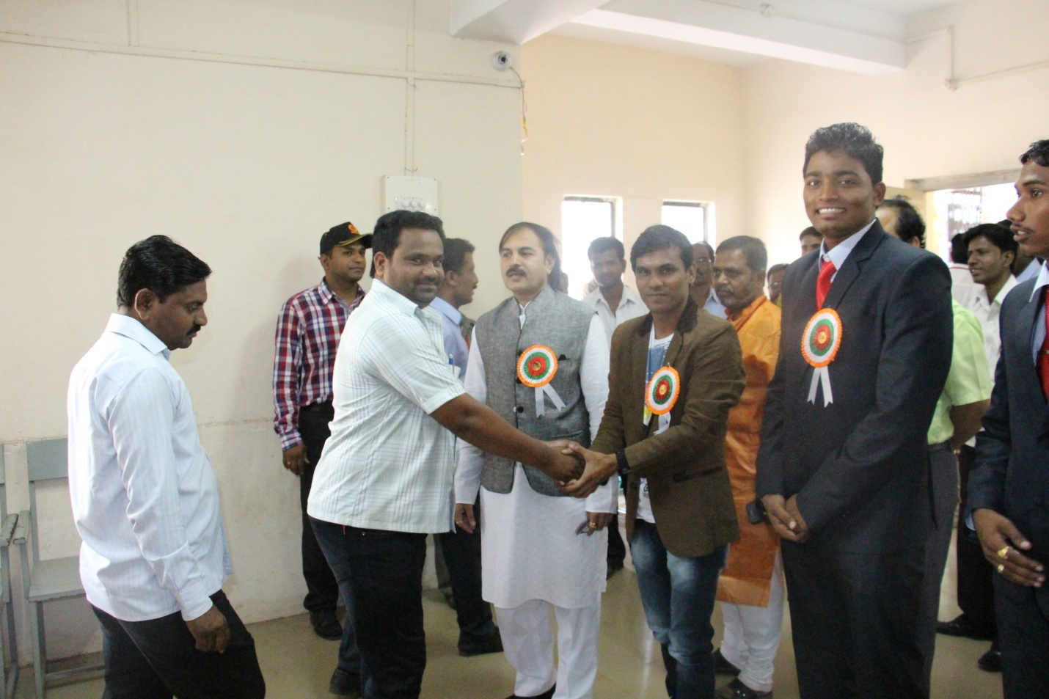
Photo gallery health check up
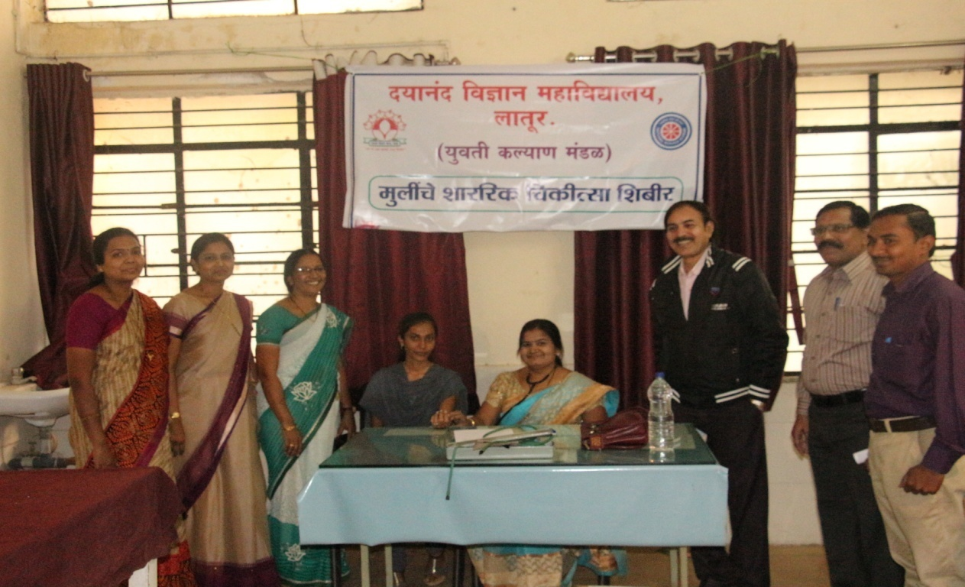
Student Health Checking activity by Dr. Sangita Bajaj along with Prinical Dr. J. S. Dargad, Dr. A. M. Chougule and other staffs
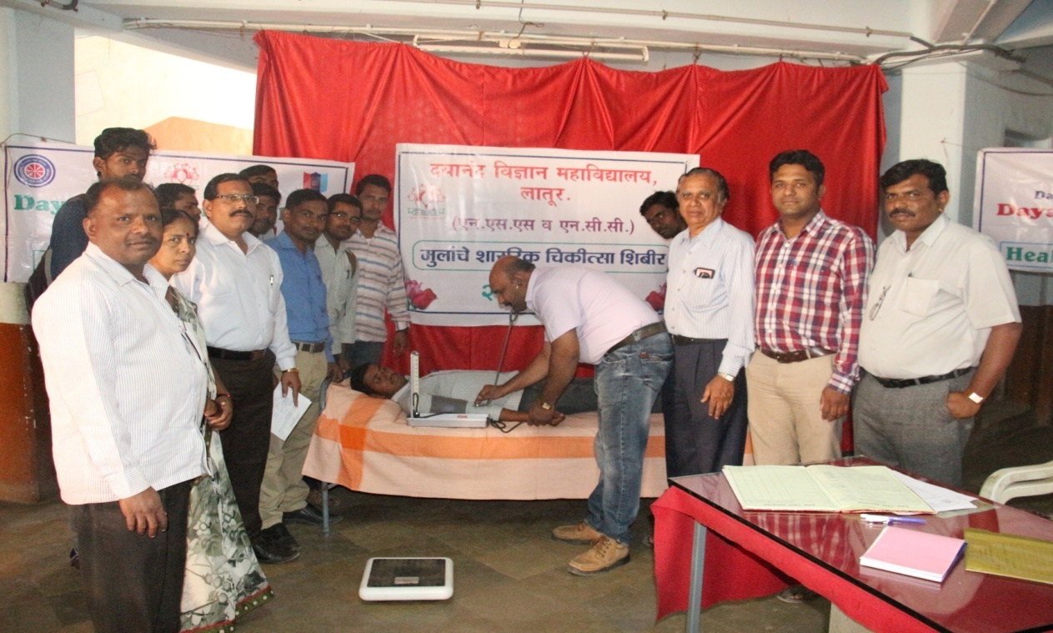
Student Health Checking activity by Dr. Datta Giriji along with Vice-Prinical M. B. Deshmukh, Dr. A. M. Chougule and other staffs.

