Dayanand Science College Latur
Student Council
2016-2017
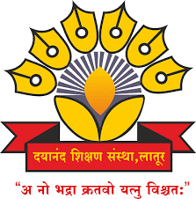

Dr.J.S.Dargad
Principal
Dayanand Science College Latur

Proffesor-In-Charge
Dr.A.M Chougule
Head
Dept.Of Industrial Chemistry

Committee (2016-2017)

Sr.No. | Name of Member | Designation
01 | Dr, A.M Chougule | Professor –In- Ch arge
02 | Prof M.M Pandit | Member
03 | Dr . M. A, Bembade | Member
04 | Dr, V, A Choudhari | Member
05 | Prof, G,H,Bane | Member
06 | Prof. R. K .Jadhav | Member
07 | Prof .A.V.Bhosale(Jr) | Member
08 | Prof .M. T Bajpai(Jr) | Member
 | - | -

Activities (2016-2017)

Sr.No. | Name of Activities | Date | Chief Guest
01 | Organised Health check up programme | 10 Jan 2017 | 1.Dr.Avinah Patil  (general Physician Latur)  2.Dr.Sangita Bajaj  (Gynecologist)
02 | Annual Social Gathering |  | Opening ceremony | Concluding ceremony
 |  |  | Prof. Dipak Deshpande(Comedy Emperor Zee Tv) | Hon,Dr.J.SDargad  PrincipaI,  Dayanand Science College Latur

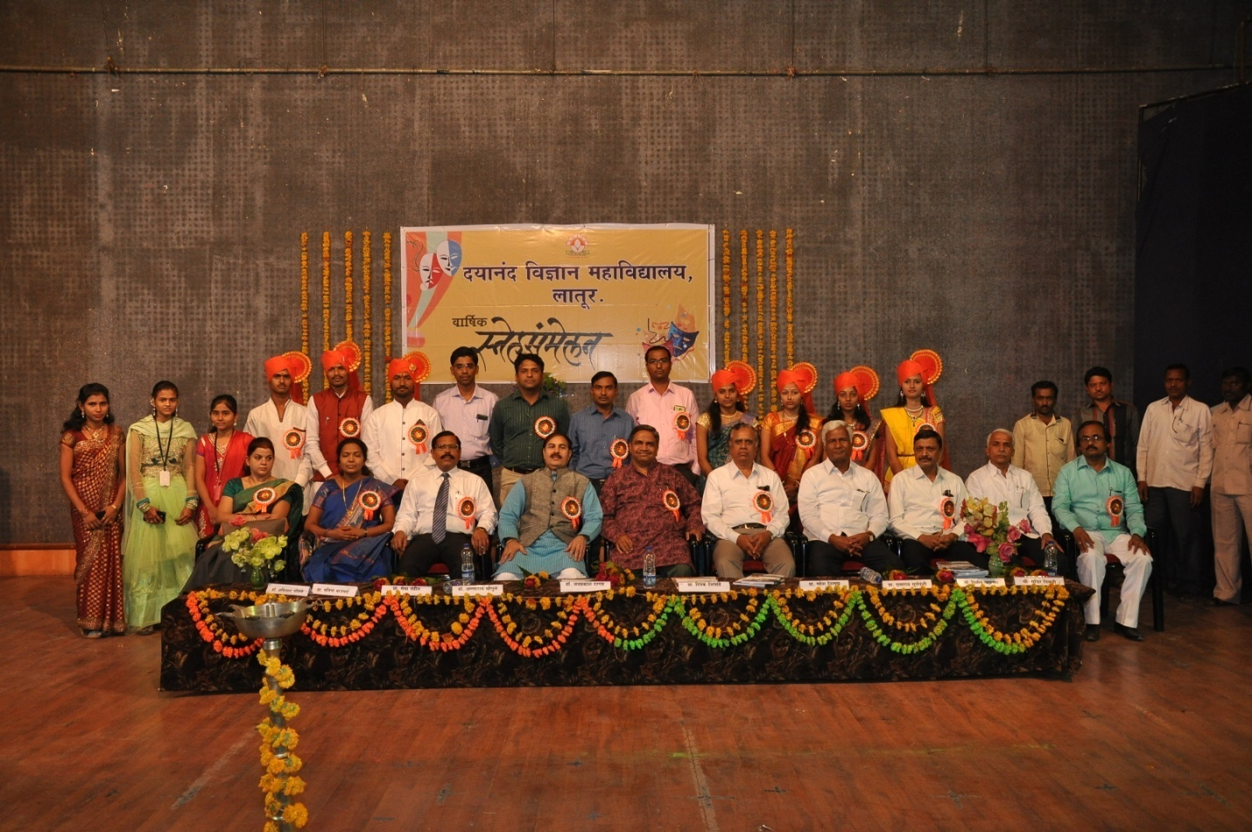
student representative NSS, NCC, LR and student welfare commit with chief guest Hon. Shri.Dipakji Despande and Hon. Dr.J.S.Dargad Principal,Dayanand Science collegte Latur along with Vice Principal Hon. M.B Deshmukh, proffesor- in-charge Dr A.M Chougule and members
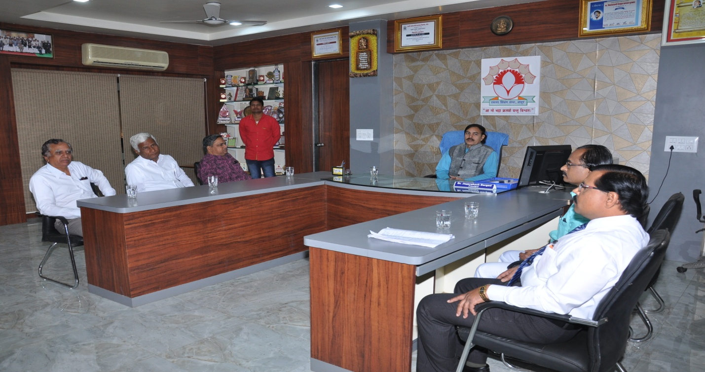 Hon.Principal Dr.J.S.Dargad discussing with Hon.Dipakji Deshpande Chief Guest of Student council before opening ceremony of student council
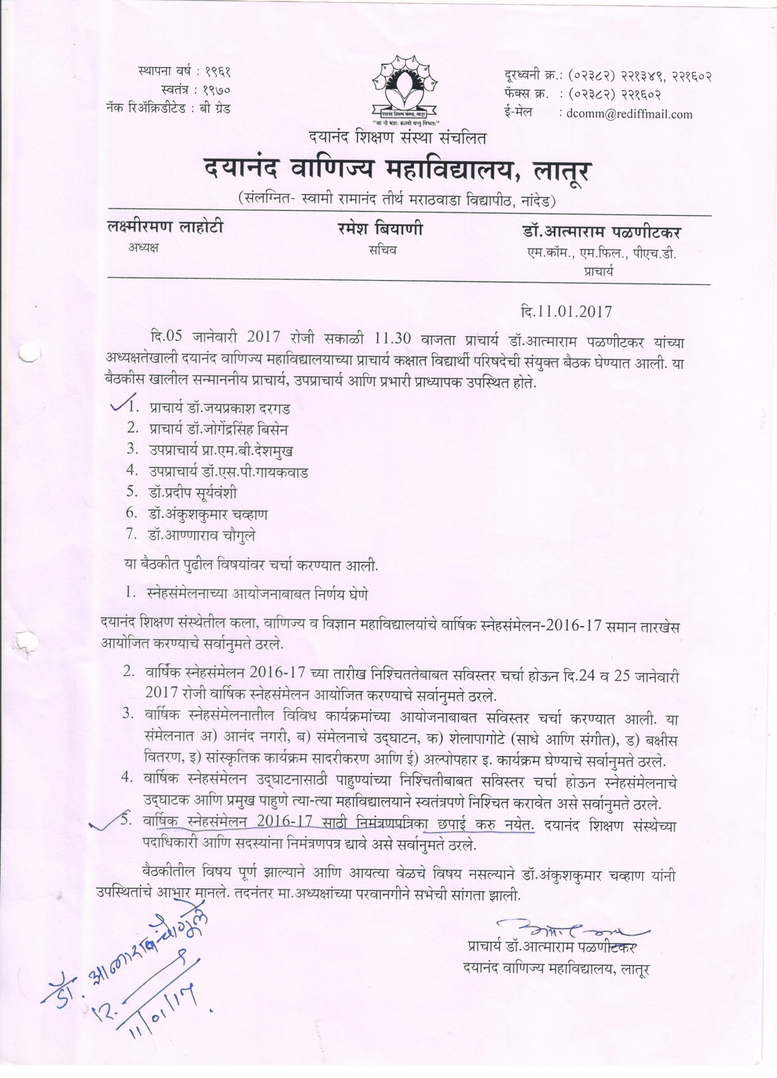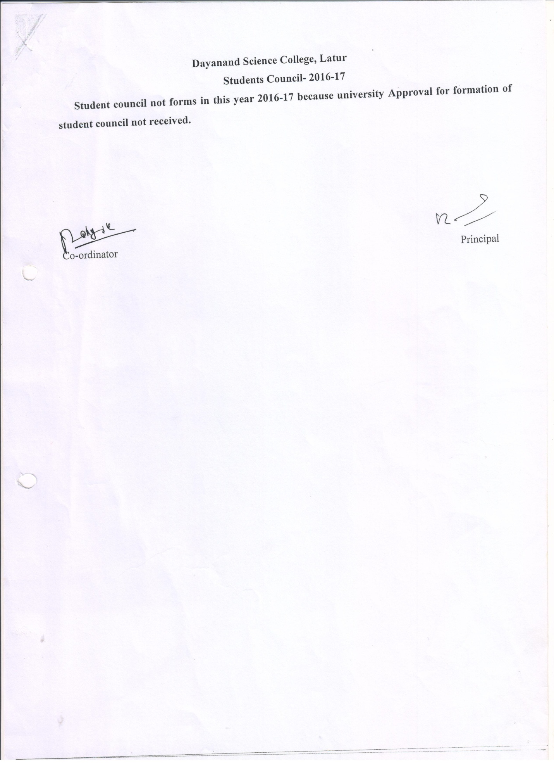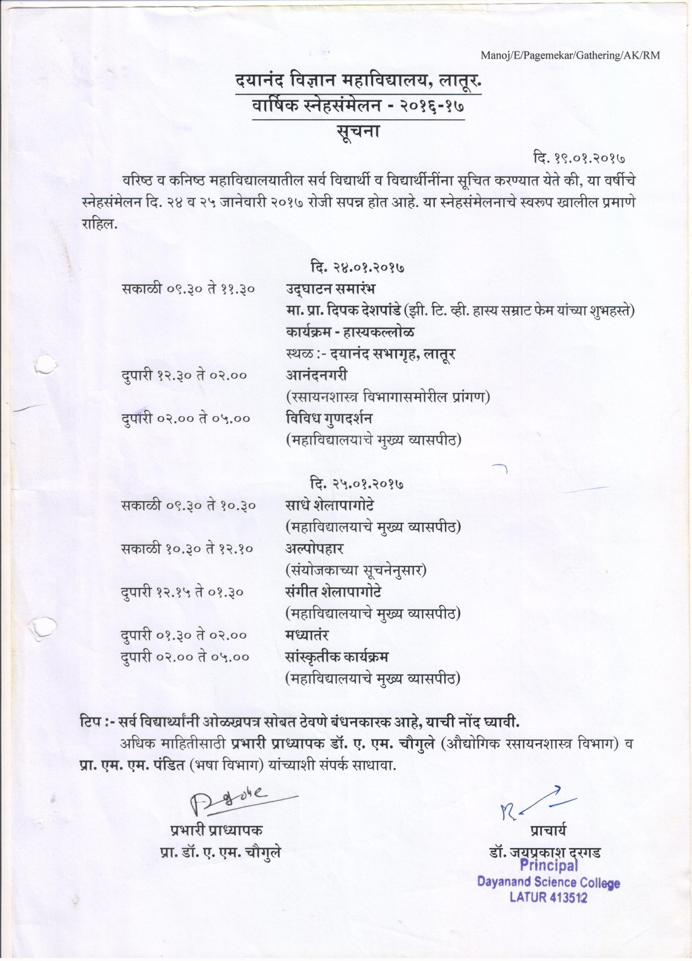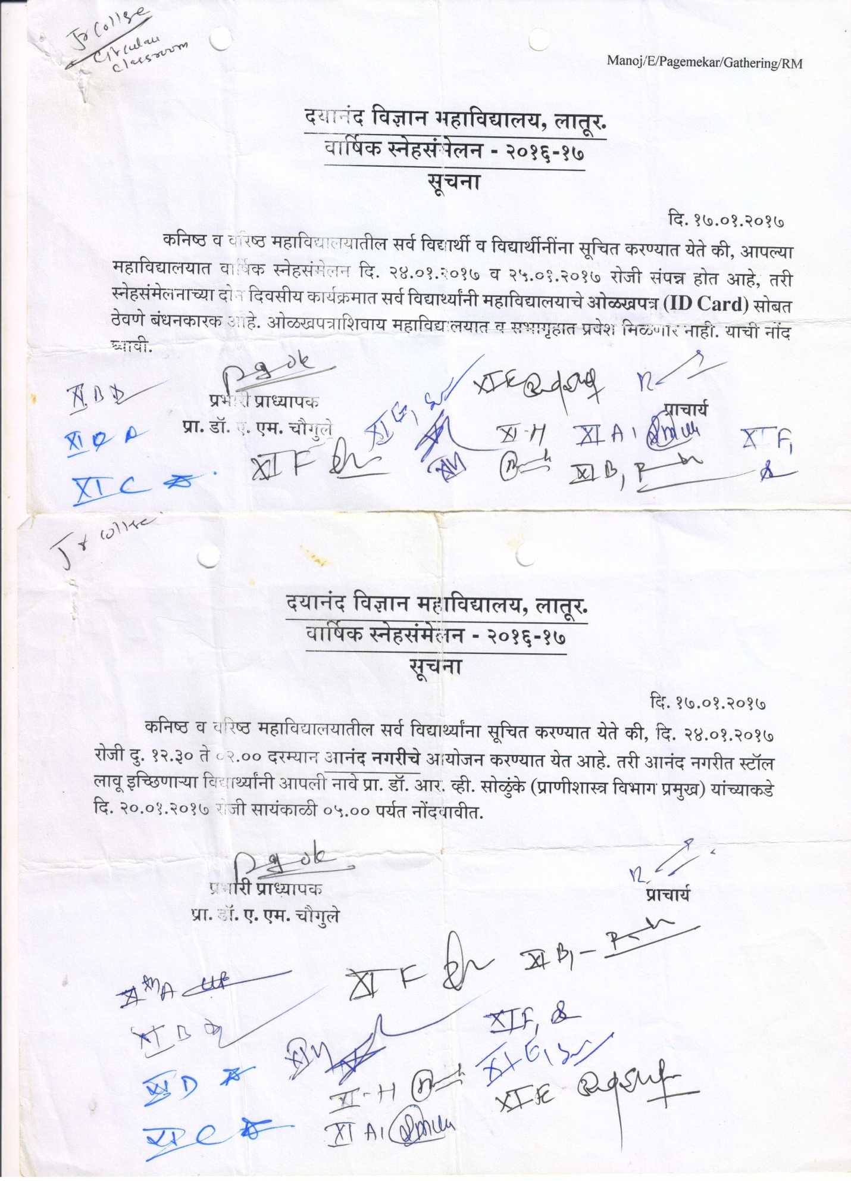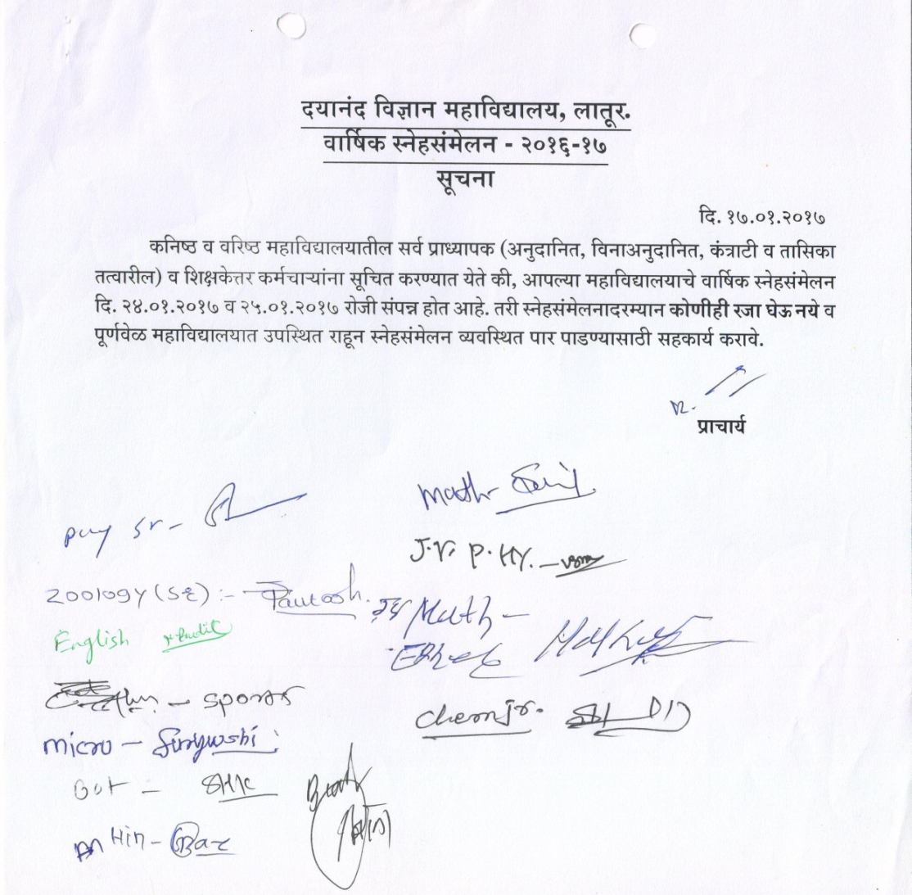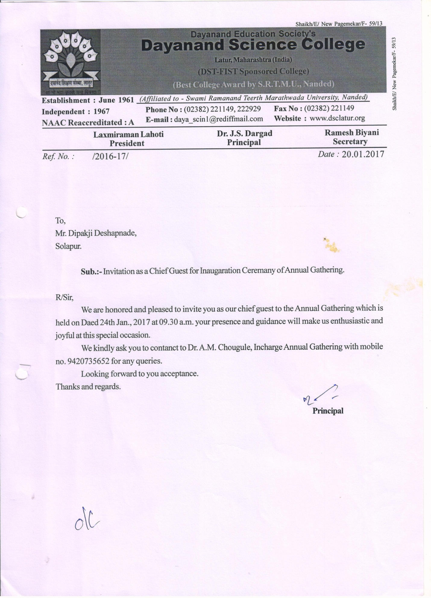
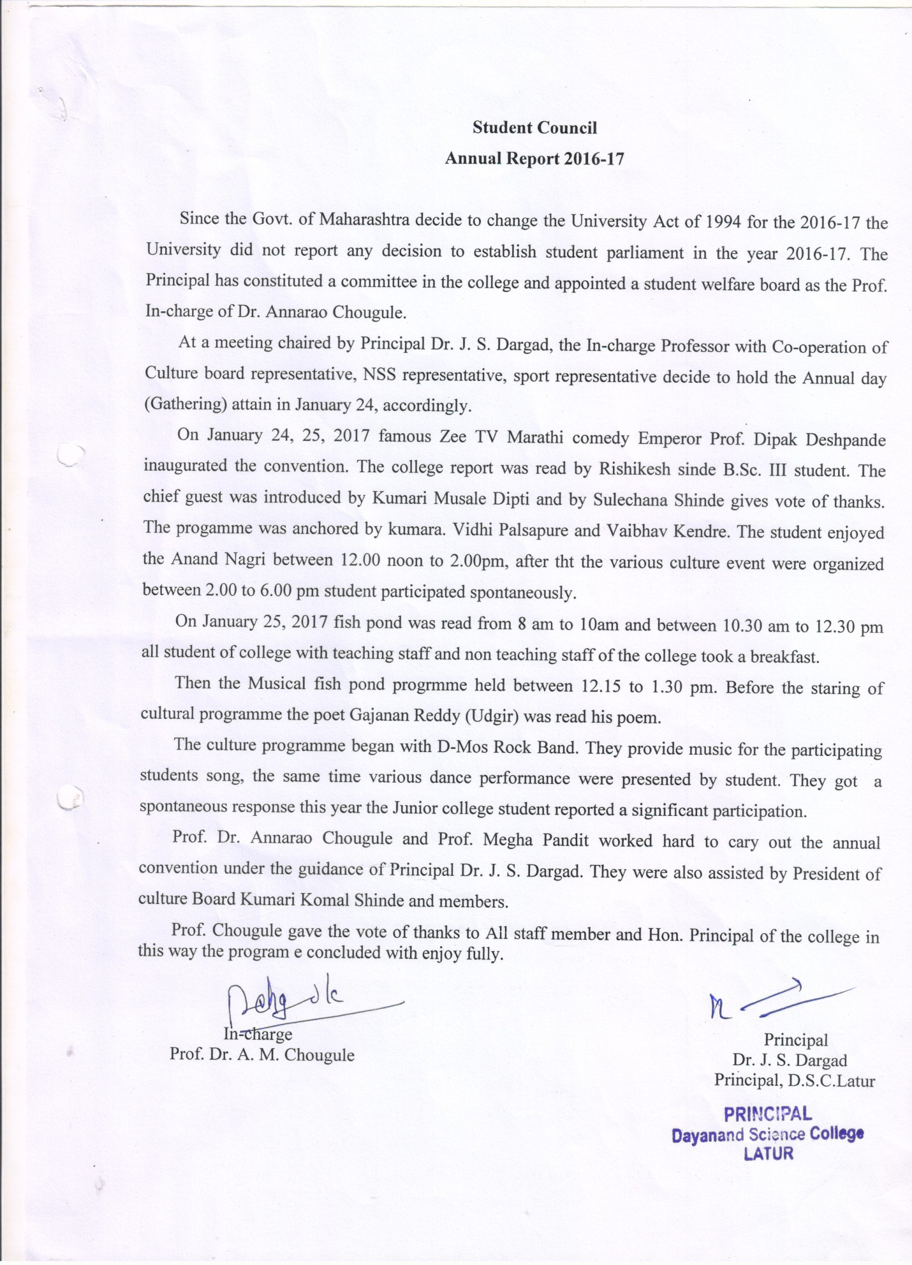
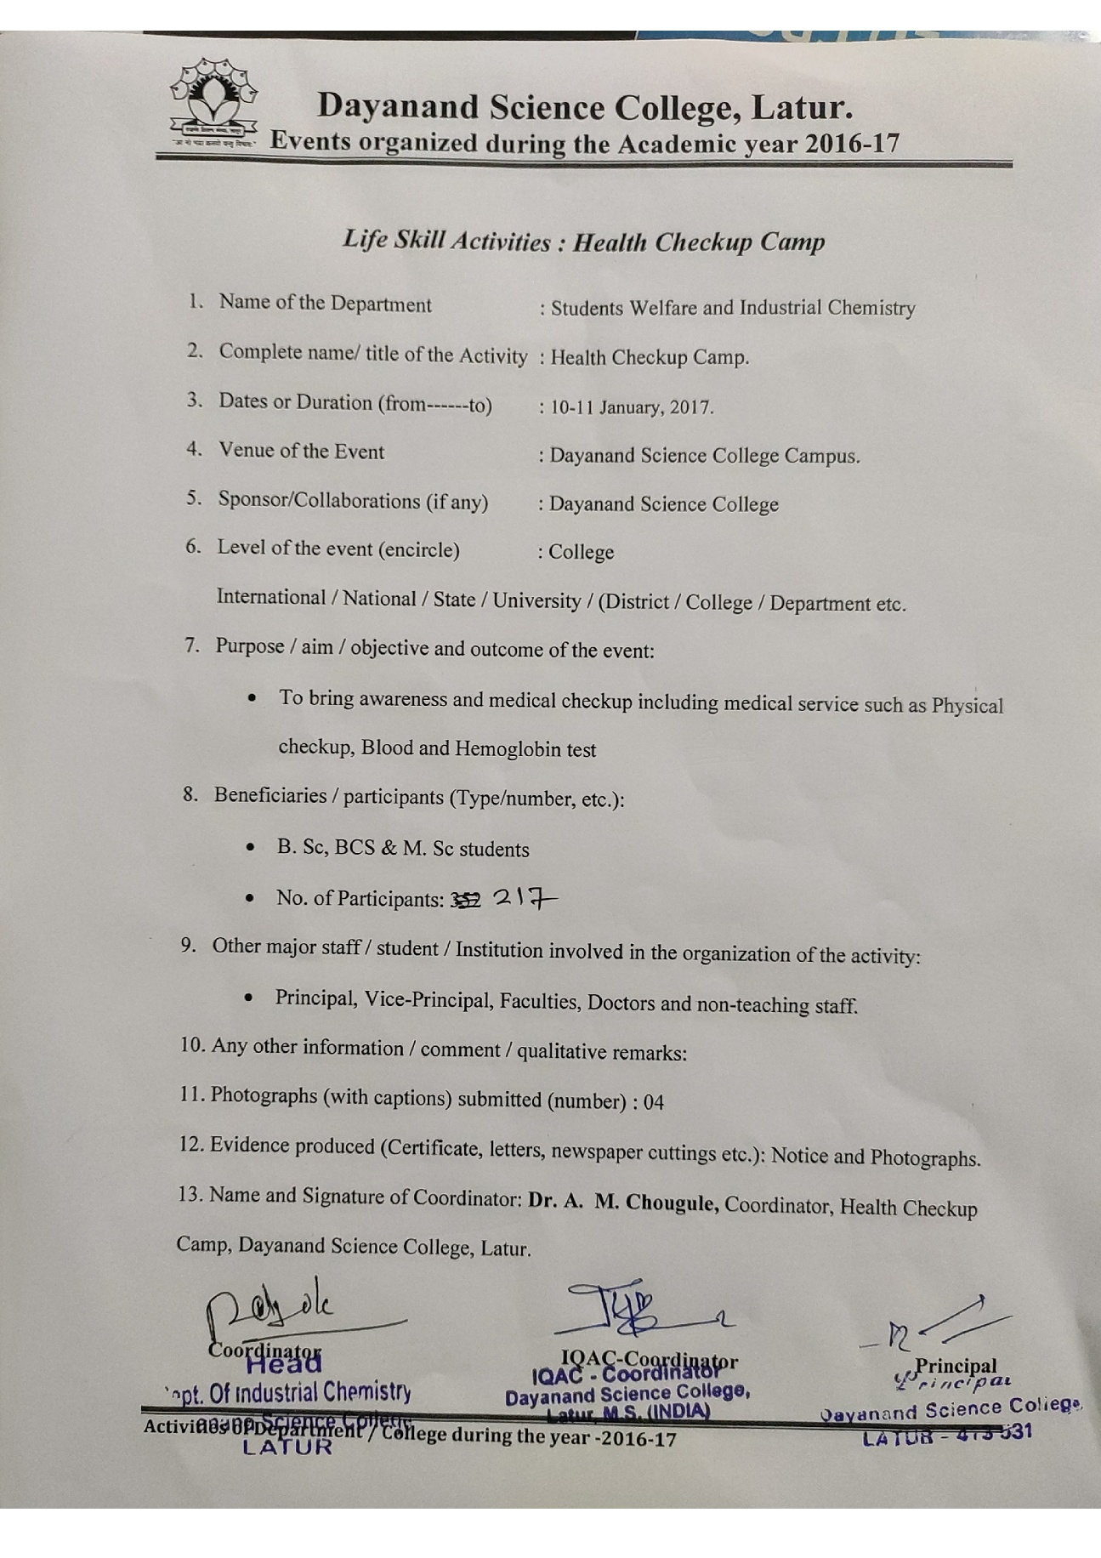
Photo Gallery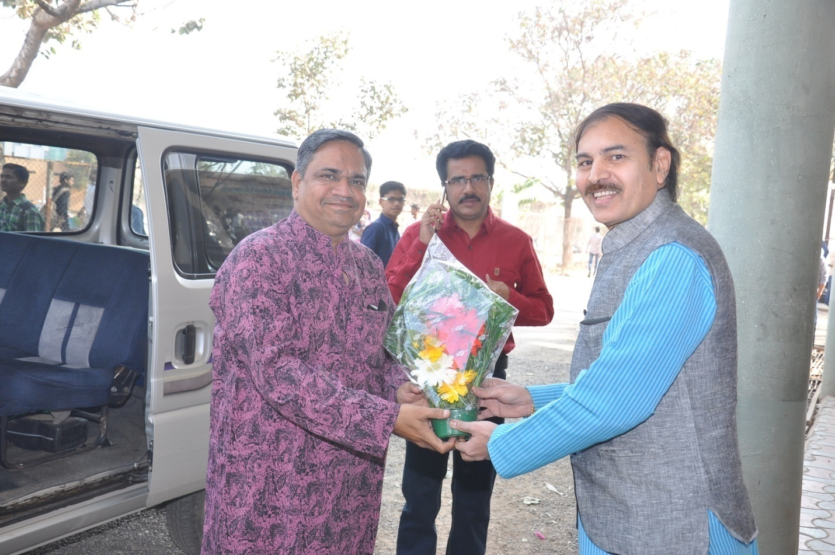
Hon. Principal Dr J.S Dargad Feliciated to Prof.Dipakji Deshpande Chief Guest annual function when he entered in college premices
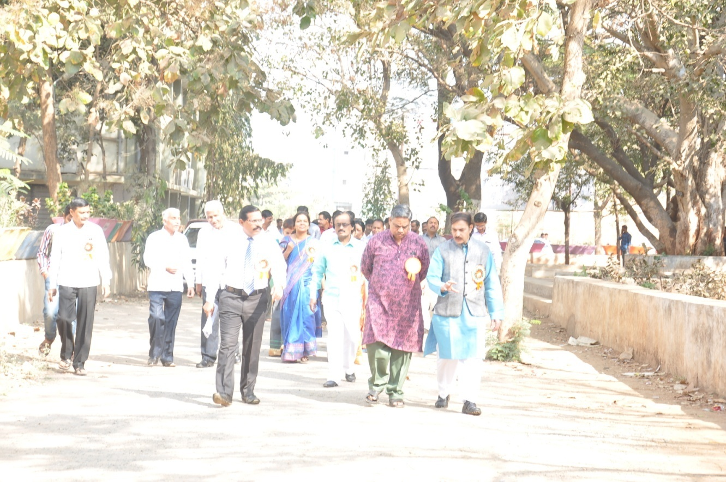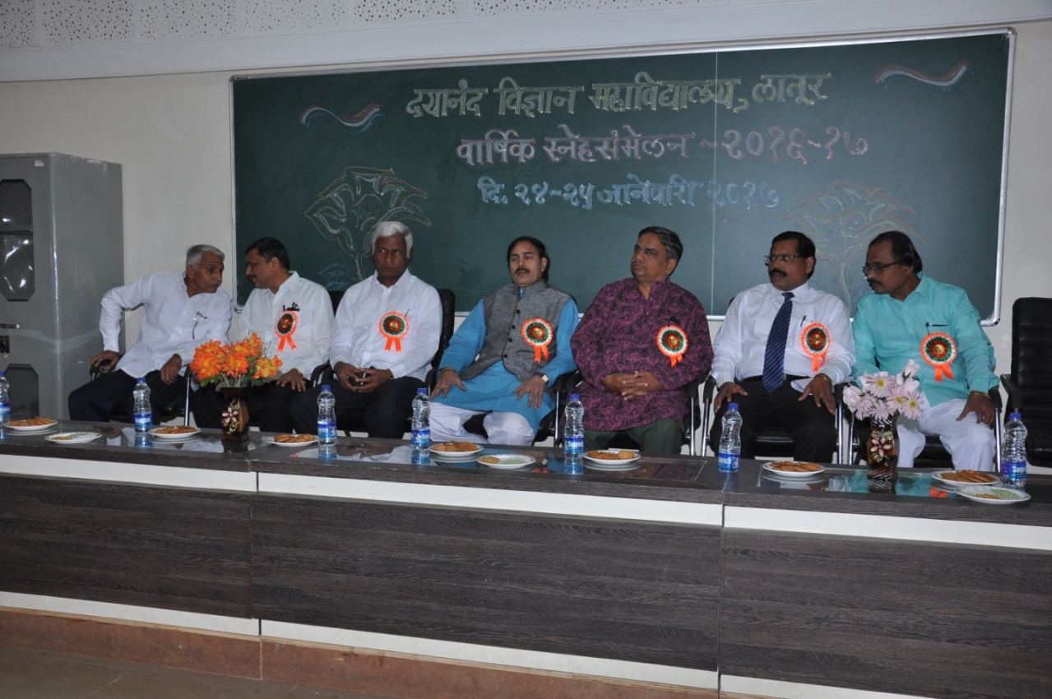
Prof.Dipakji Deshpande Chief Guest Dipakji Deshpande present in introduction programme with staff along with Hon. Principal Dr.J.S Dargad and Student welfare committee

ffffree

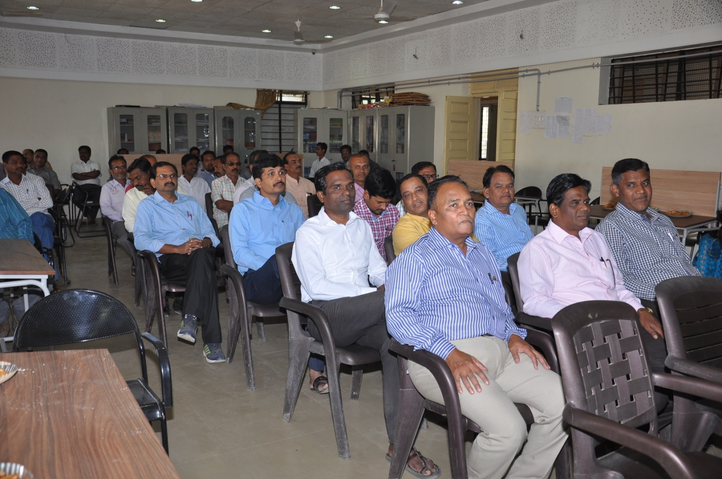
Staff present in introduction programme
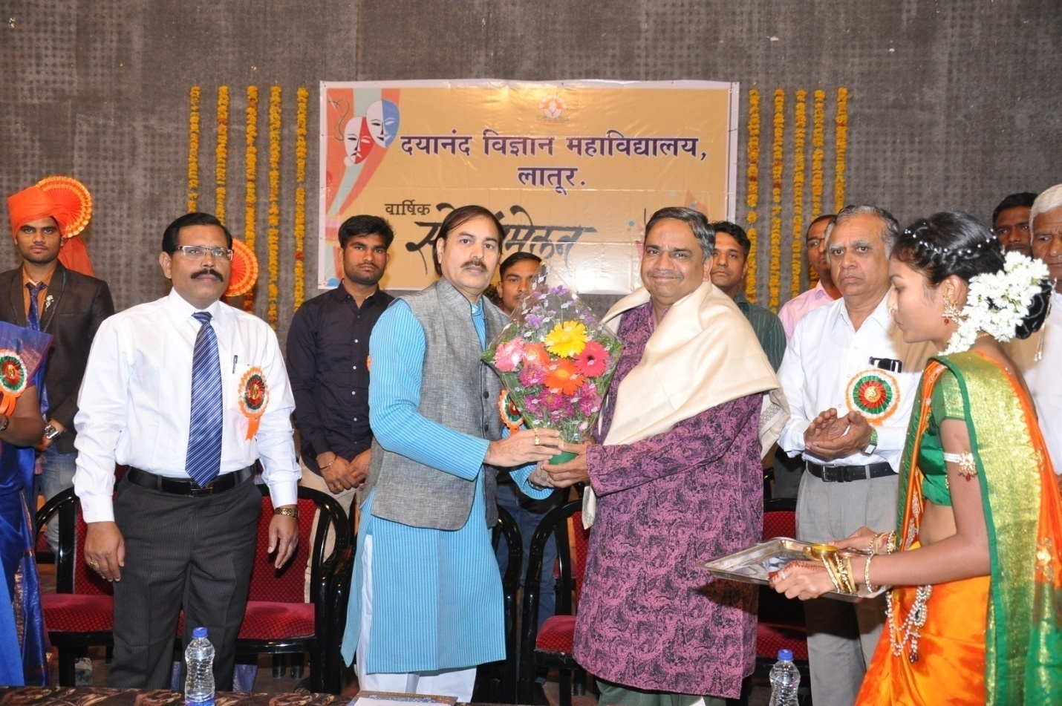
Hon. Principal Dr J.S Dargad Feliciated to Prof.Dipakji Deshpande Chief Guest in opening Ceremony annual function
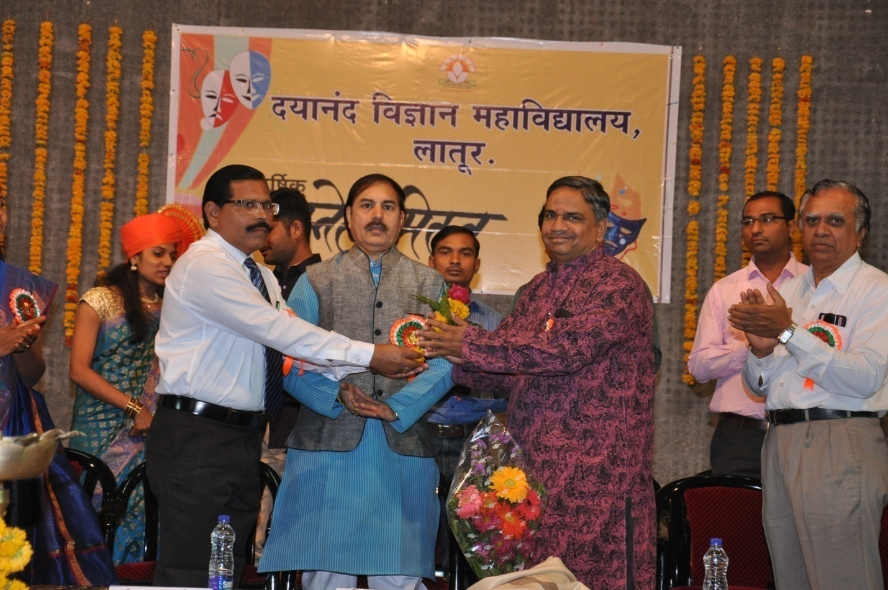
Proffesor- in-charge Dr A.M Chougle Feliciated to Prof.Dipakji Deshpande Chief Guest in opening Ceremony annual function.

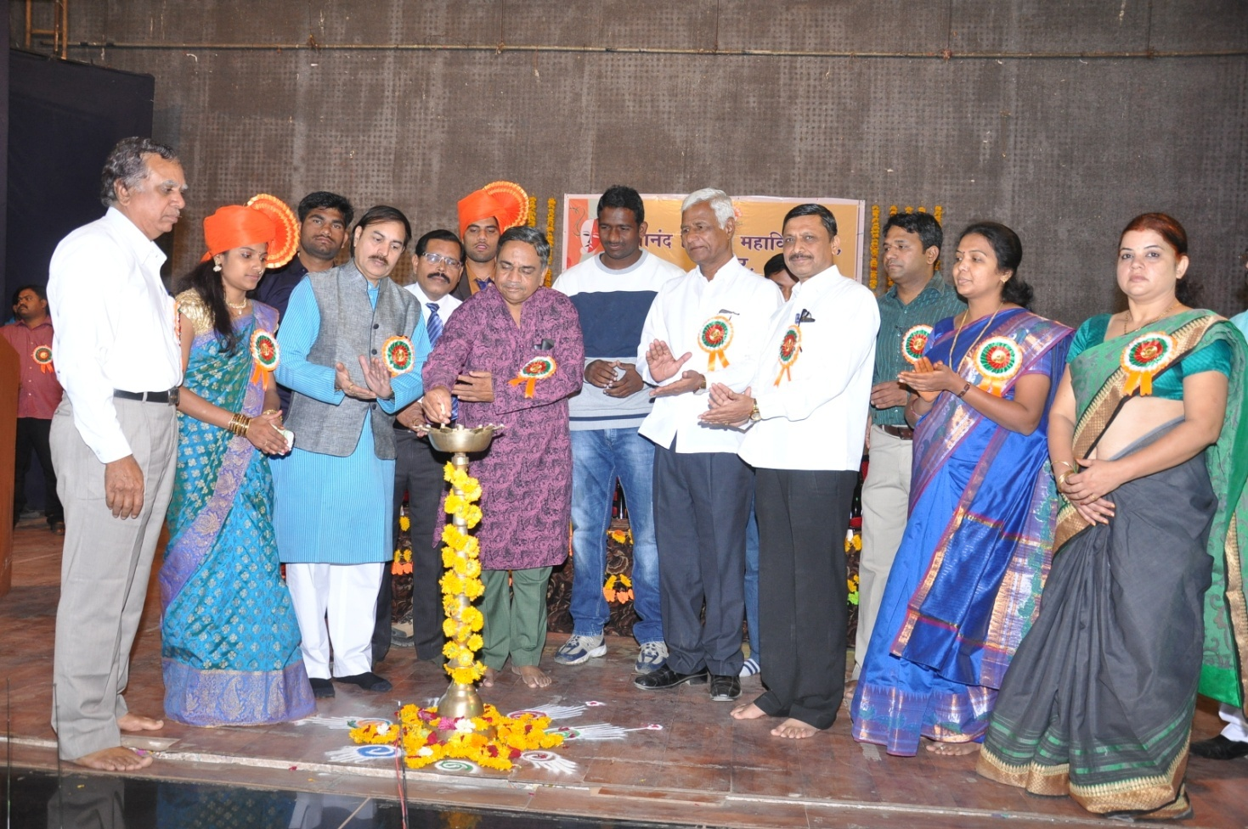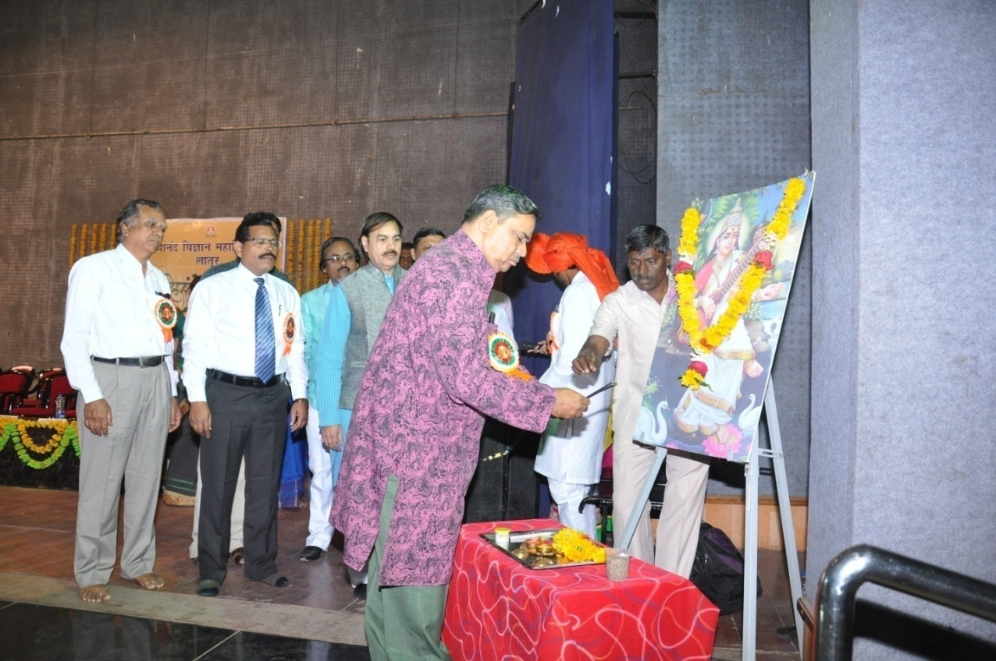
Prof.Dipakji Deshpande Chief Guest in opening Ceremony annual function.
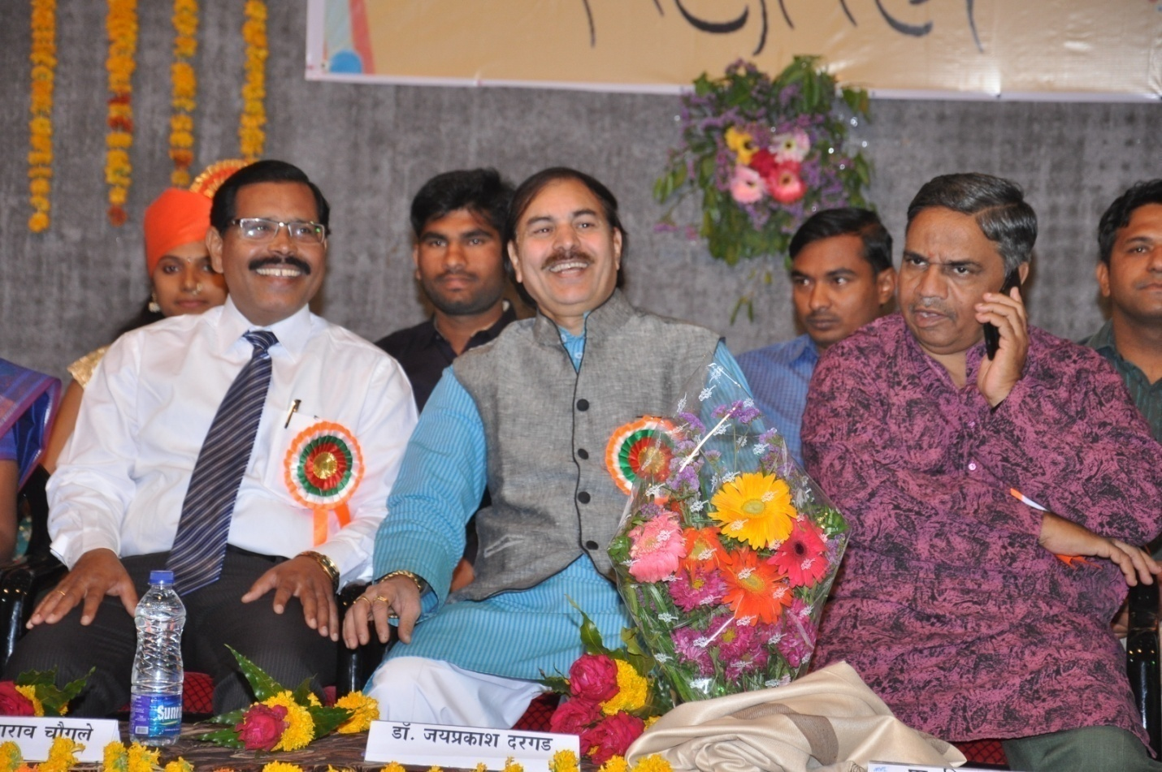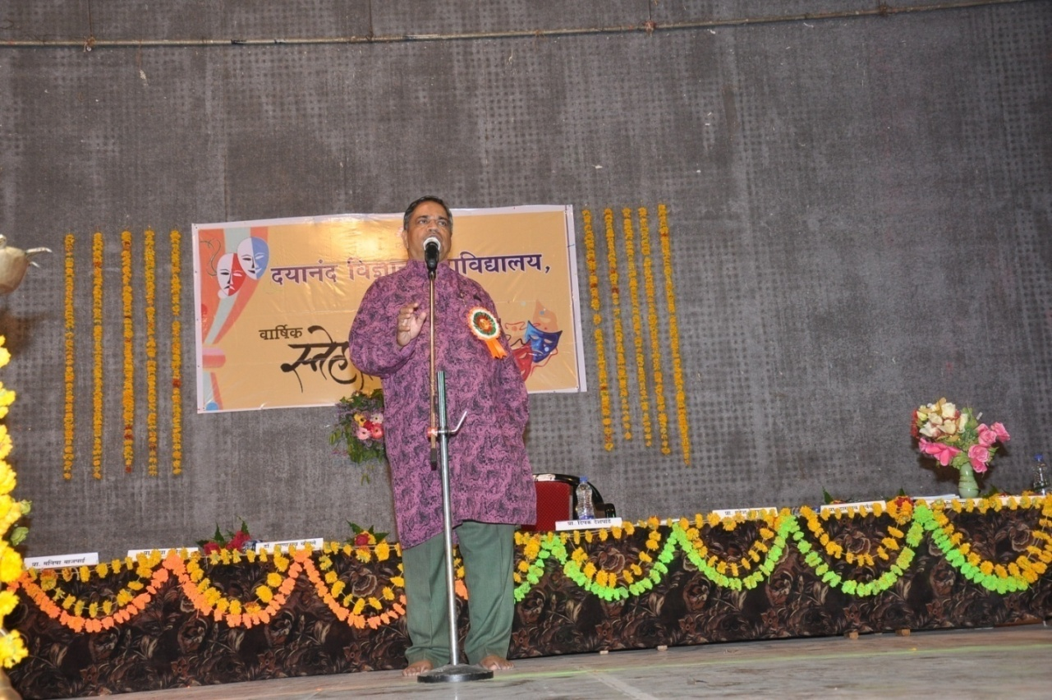
Prof.Dipakji Deshpande Chief Guest in opening Ceremony annual function Presenting his act.

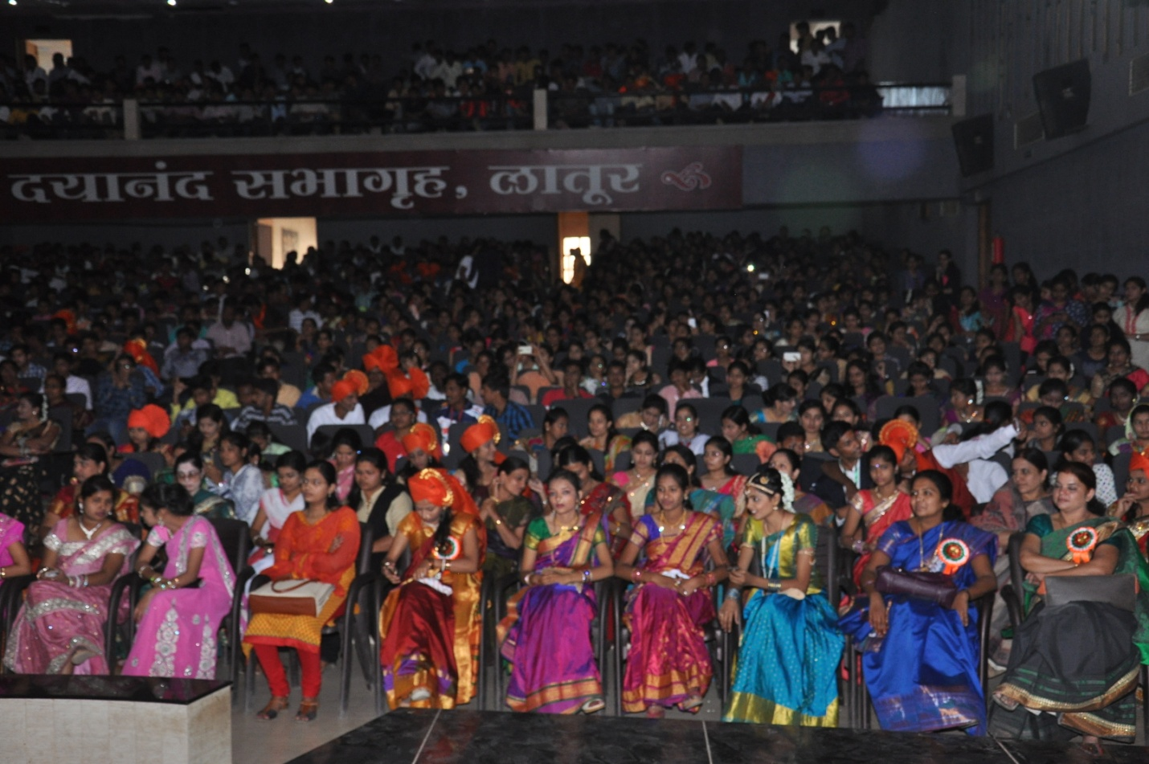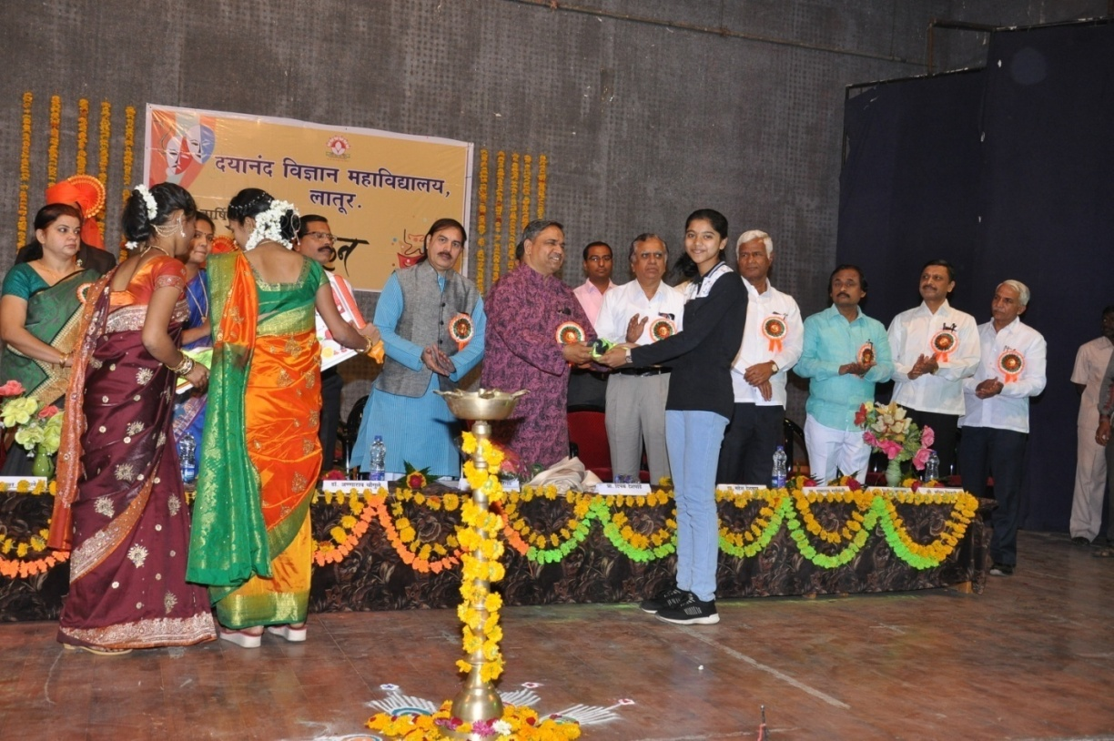
Prof.Dipakji Deshpande Chief Guest in opening Ceremony annual function Felicited to Special achievement students.

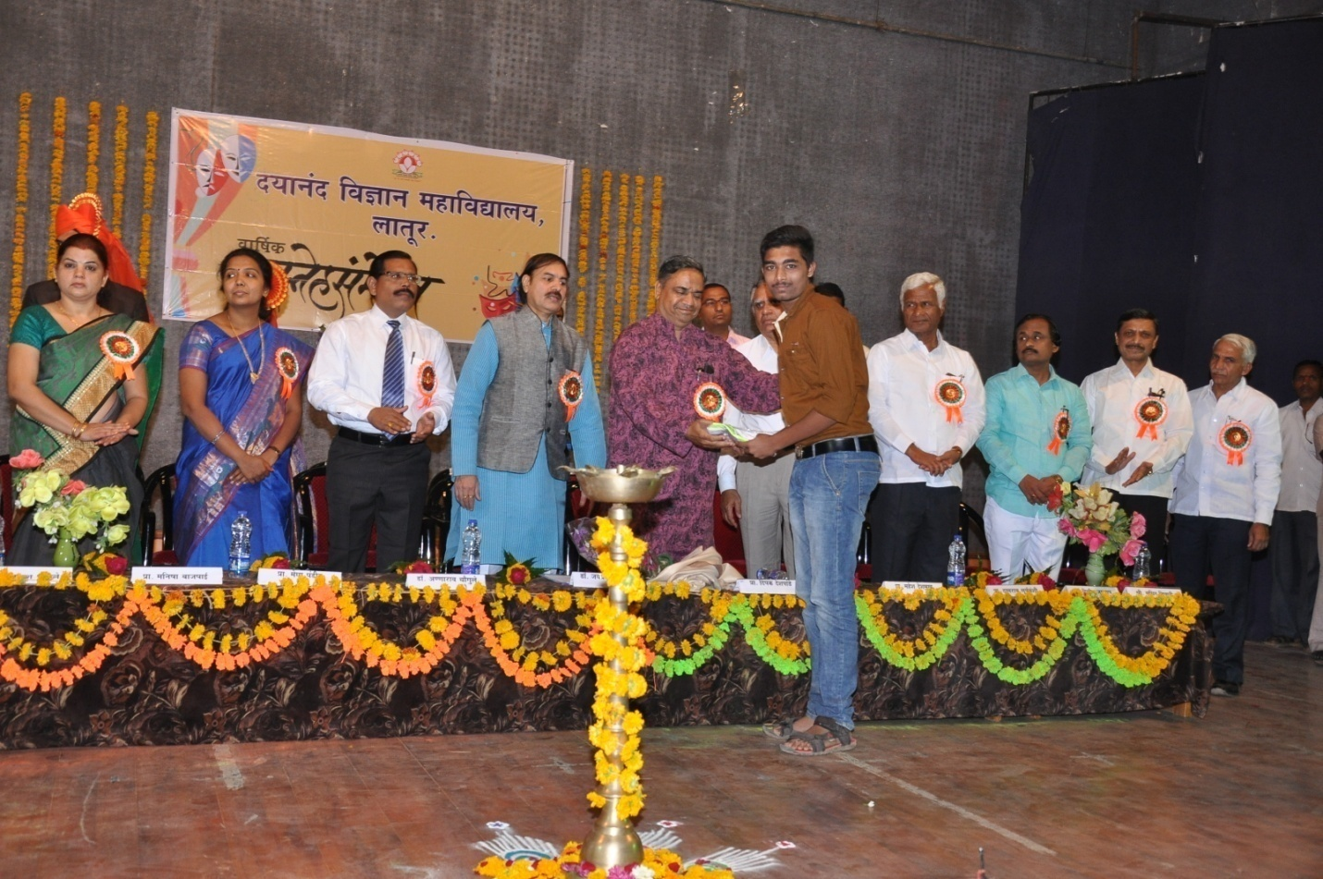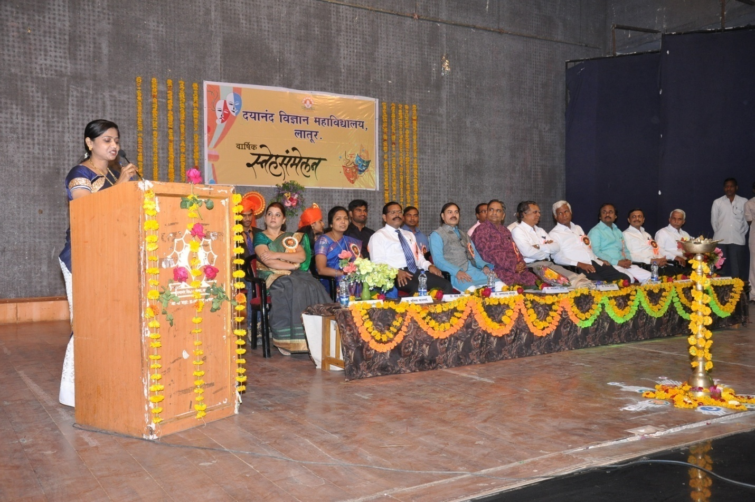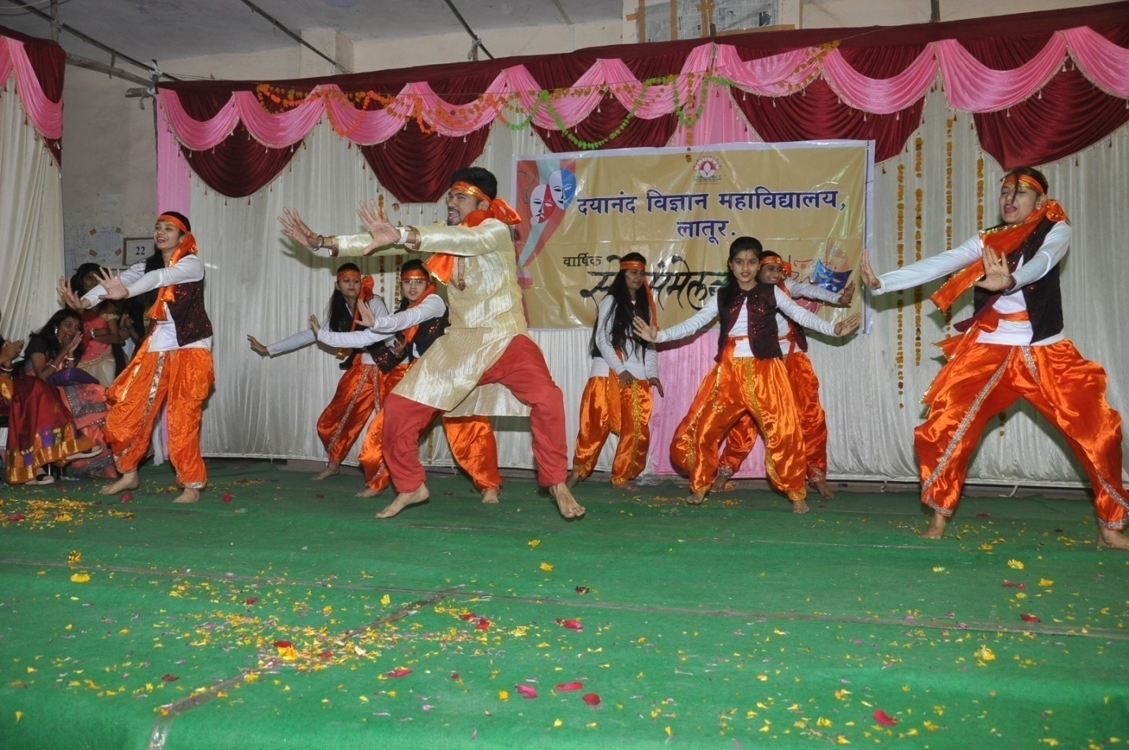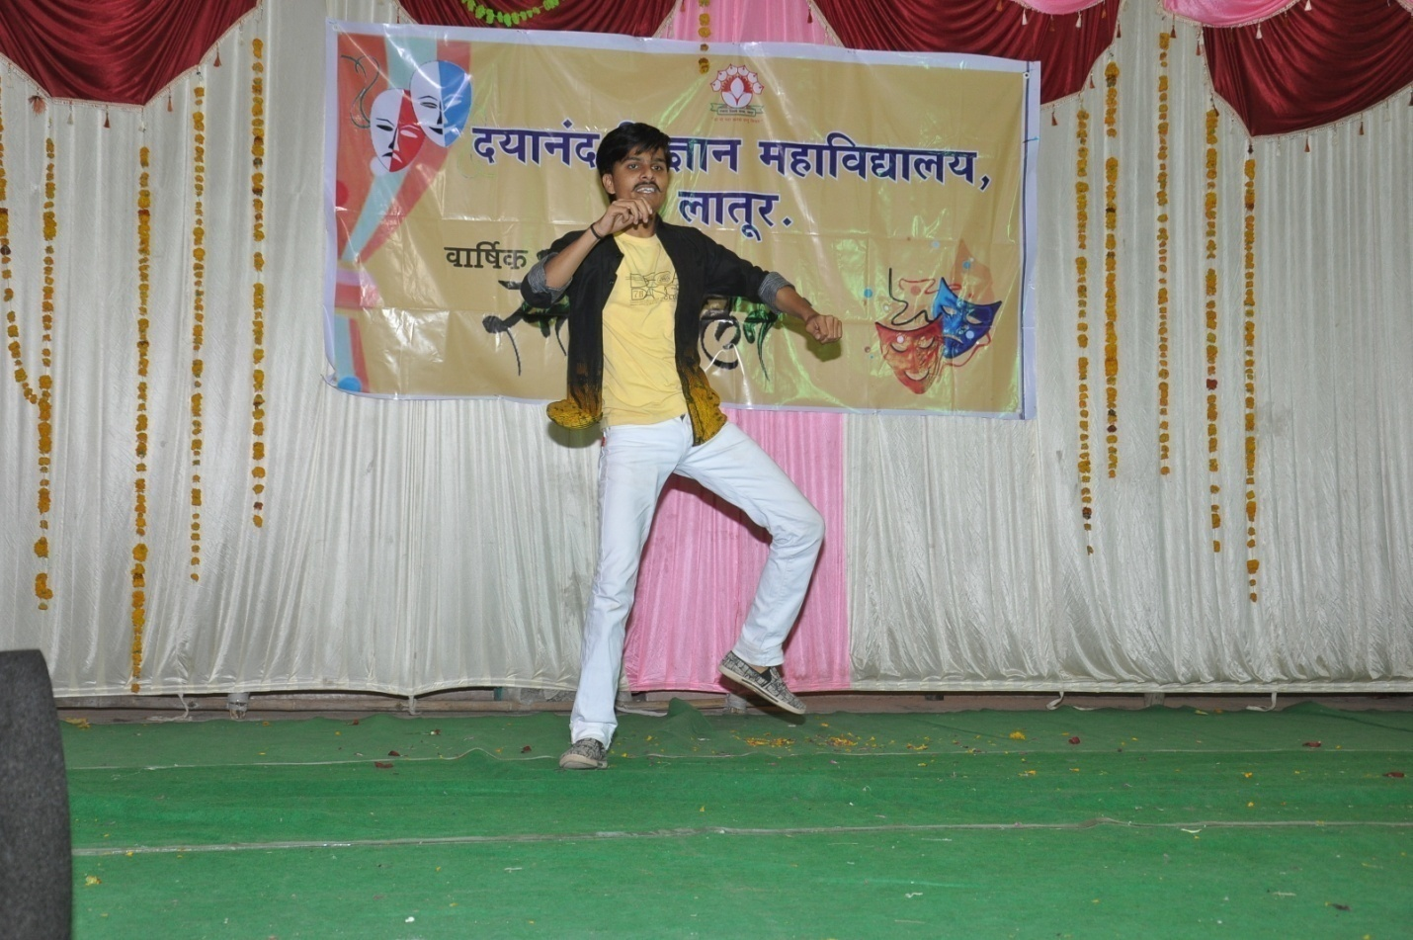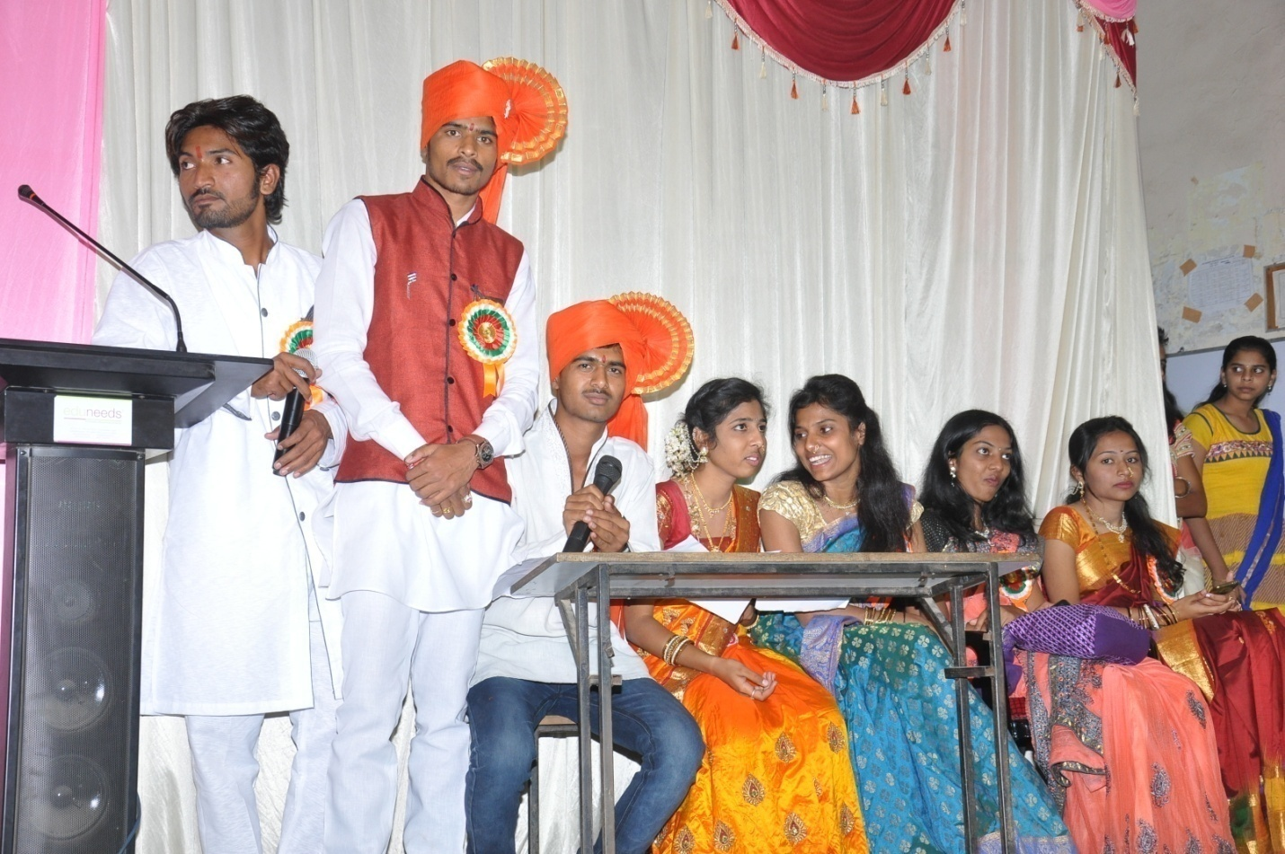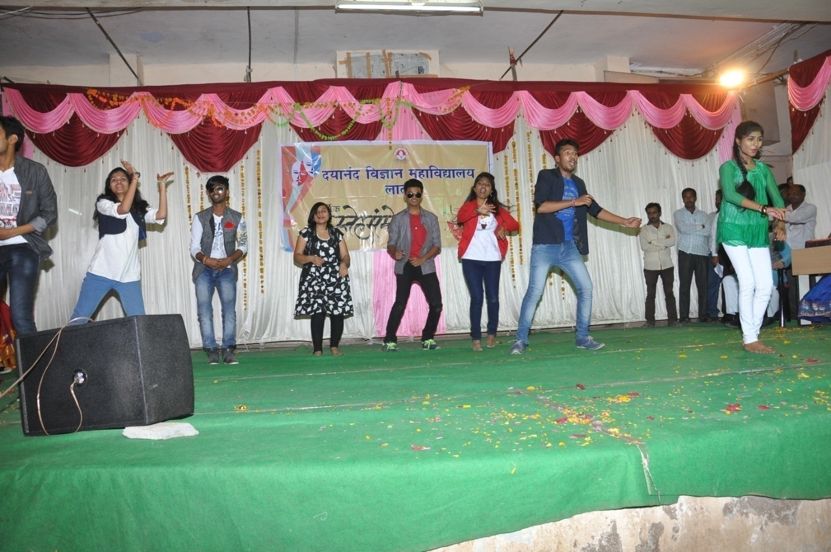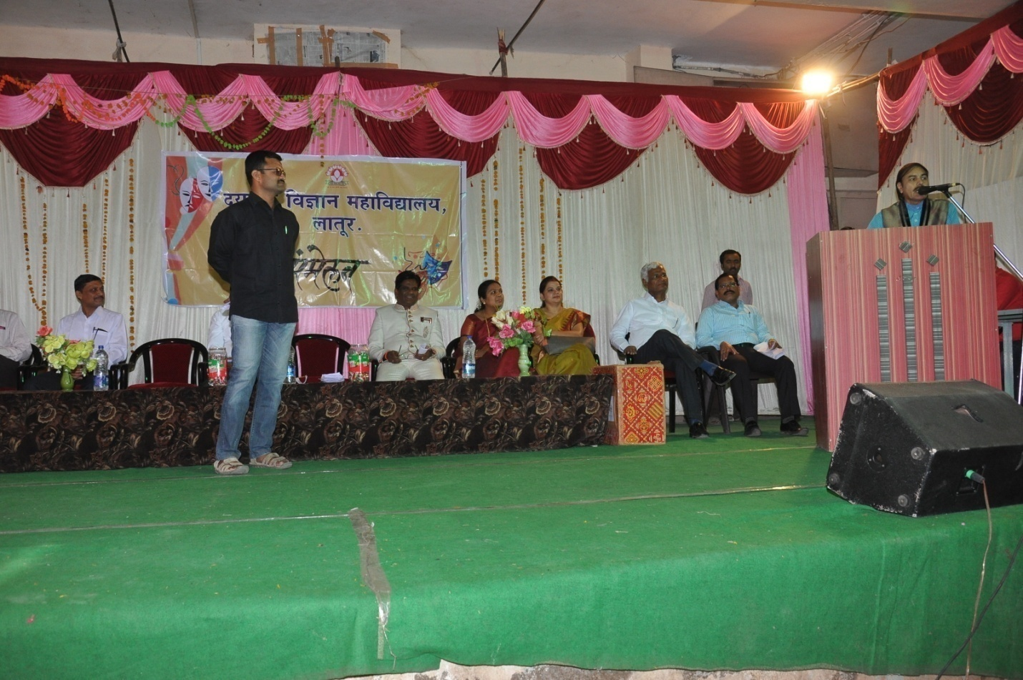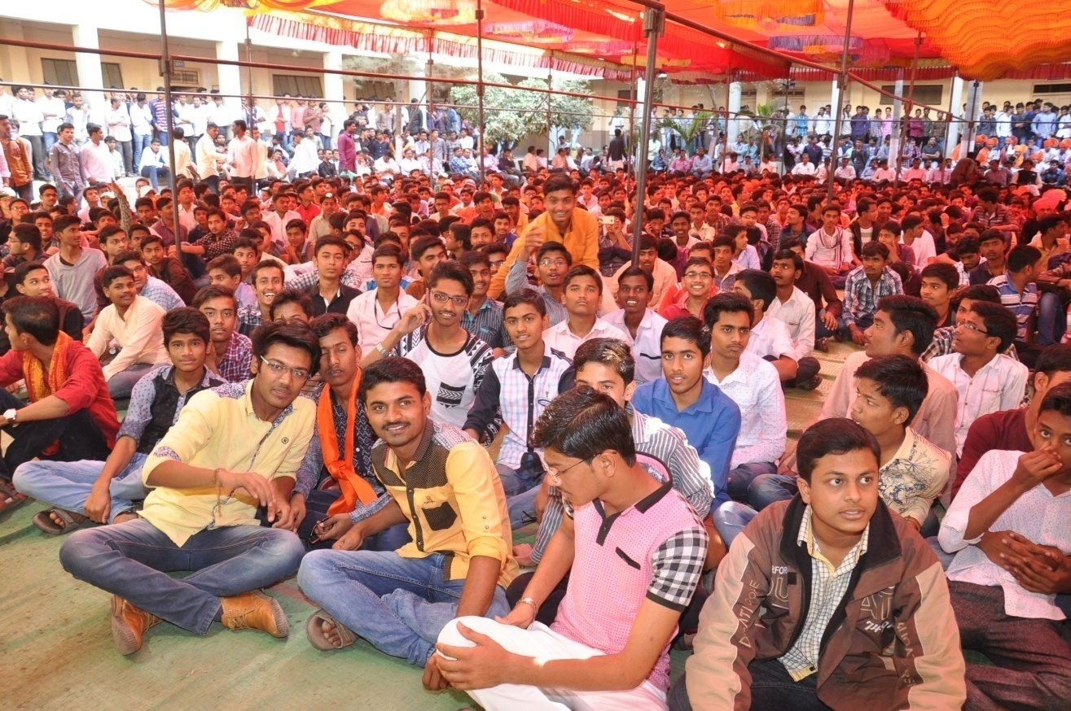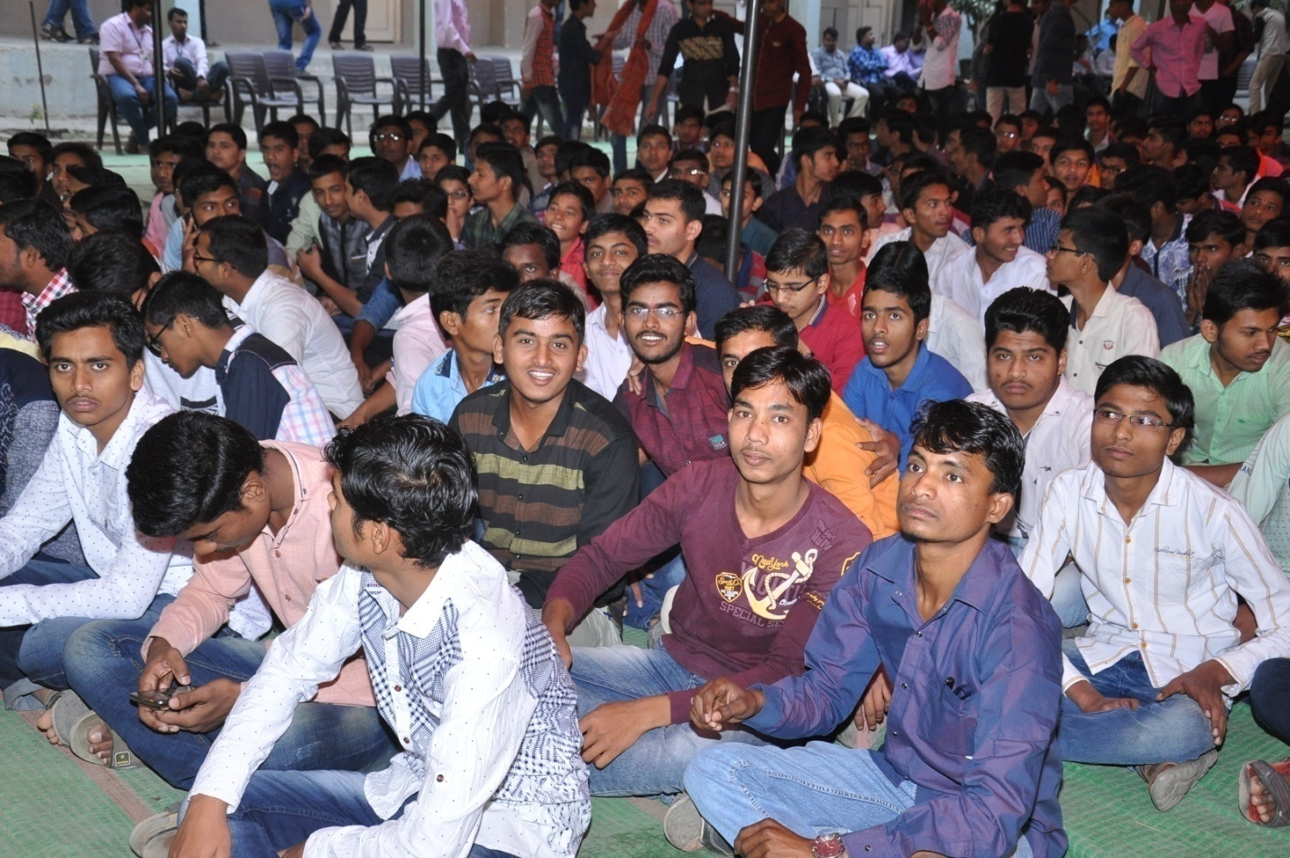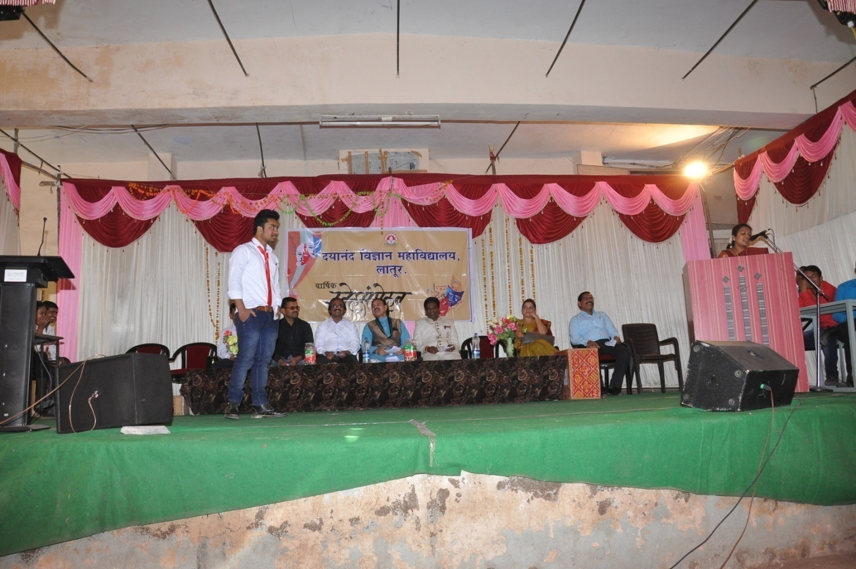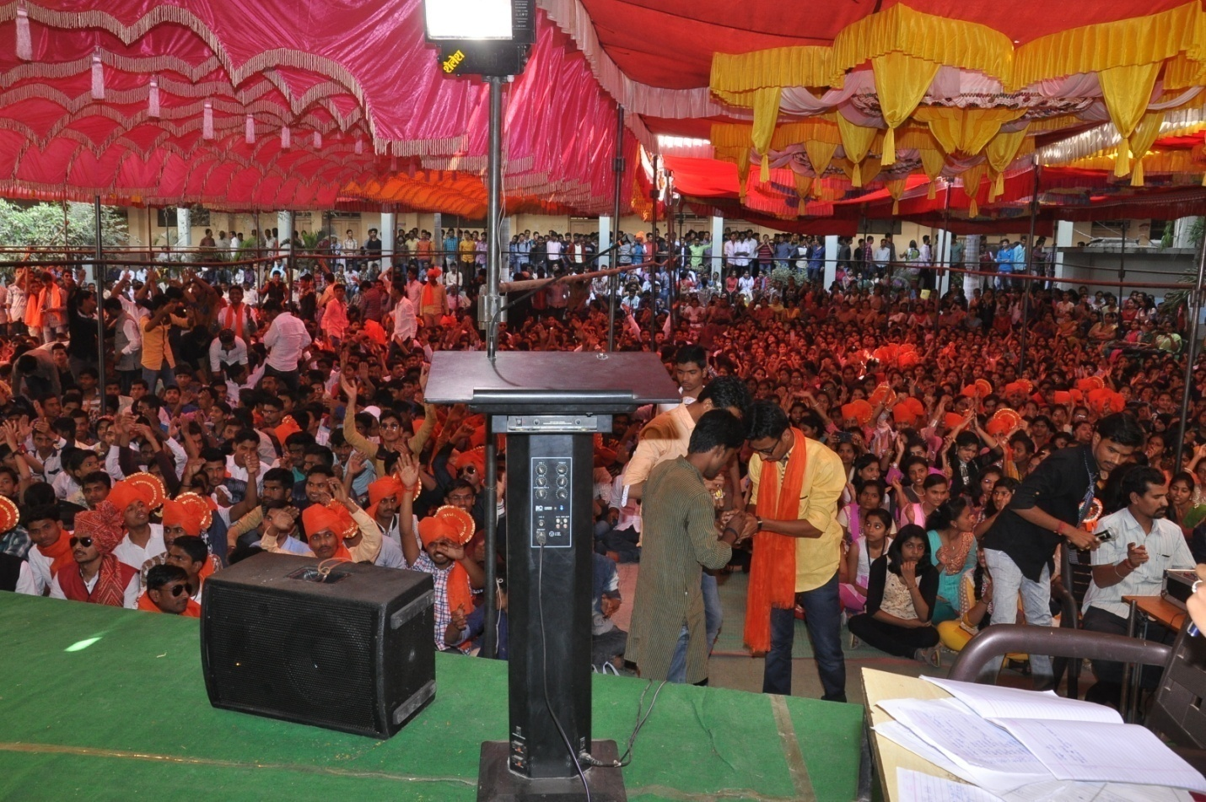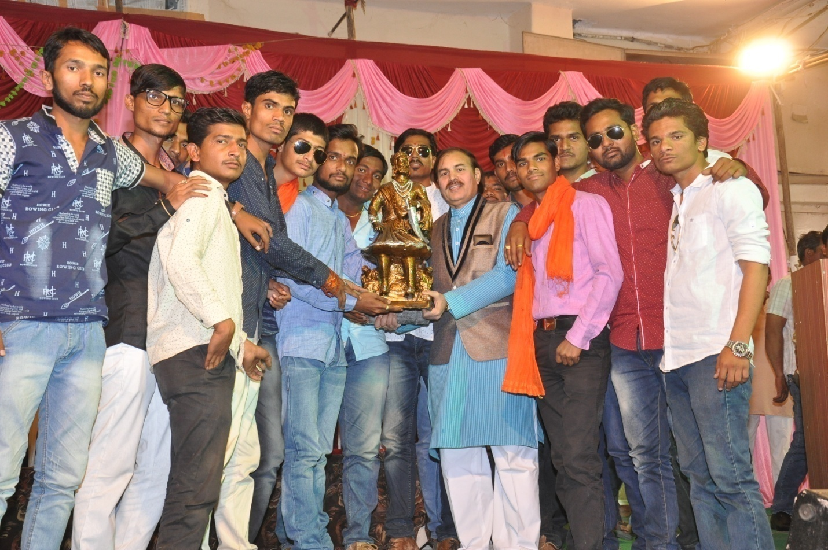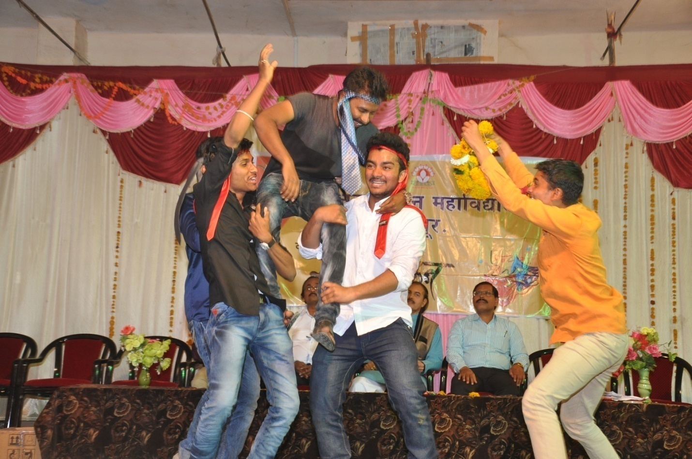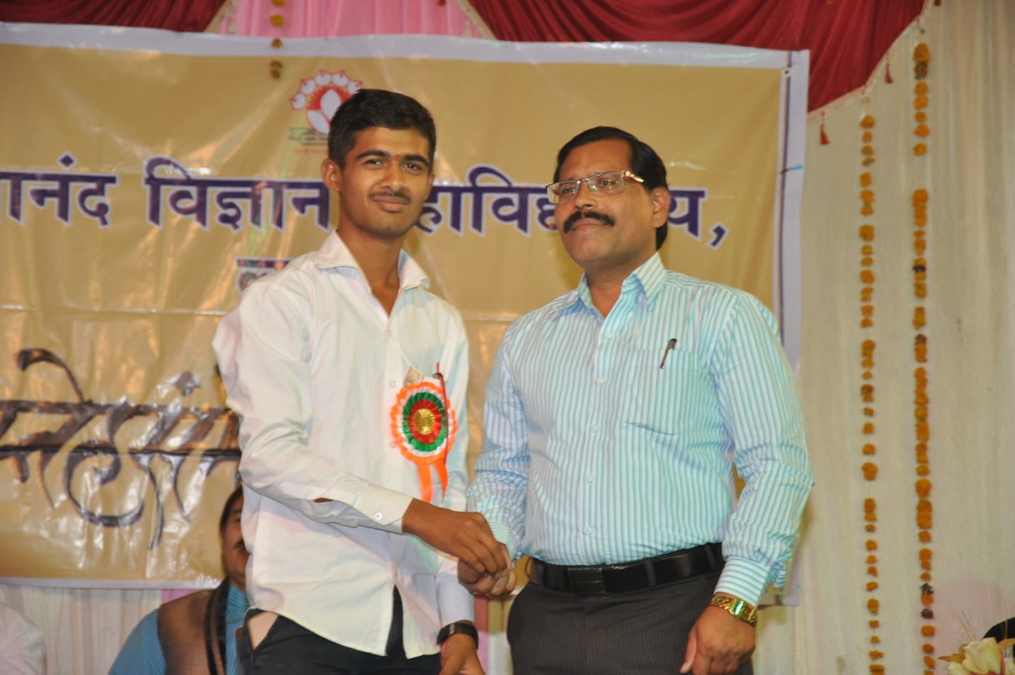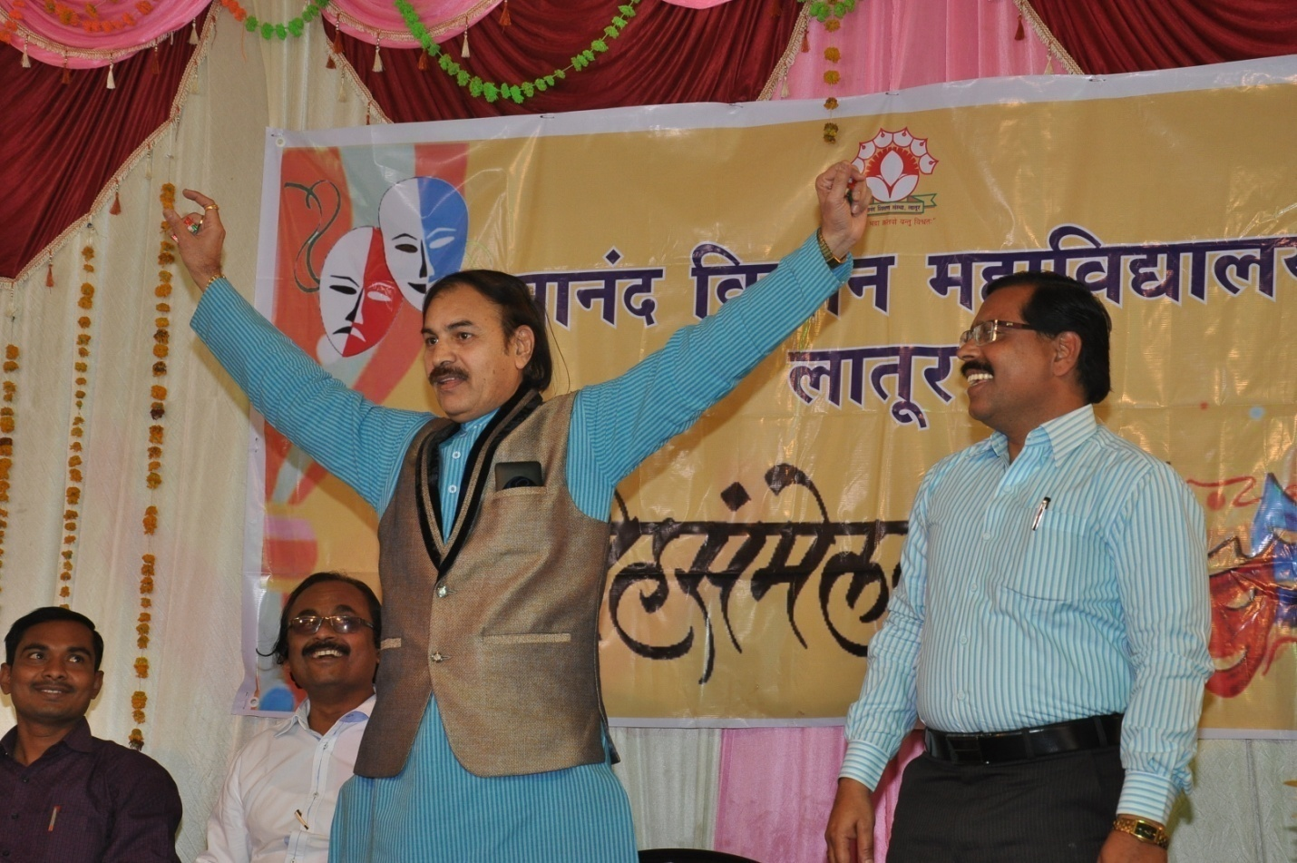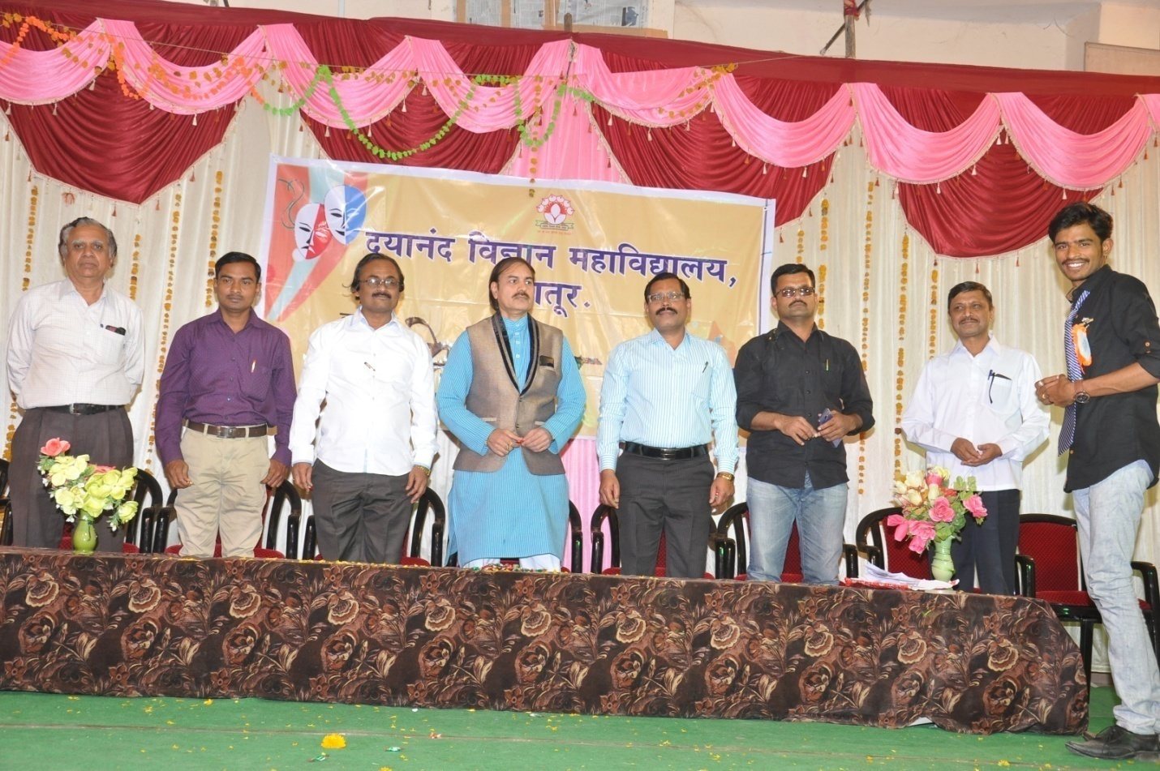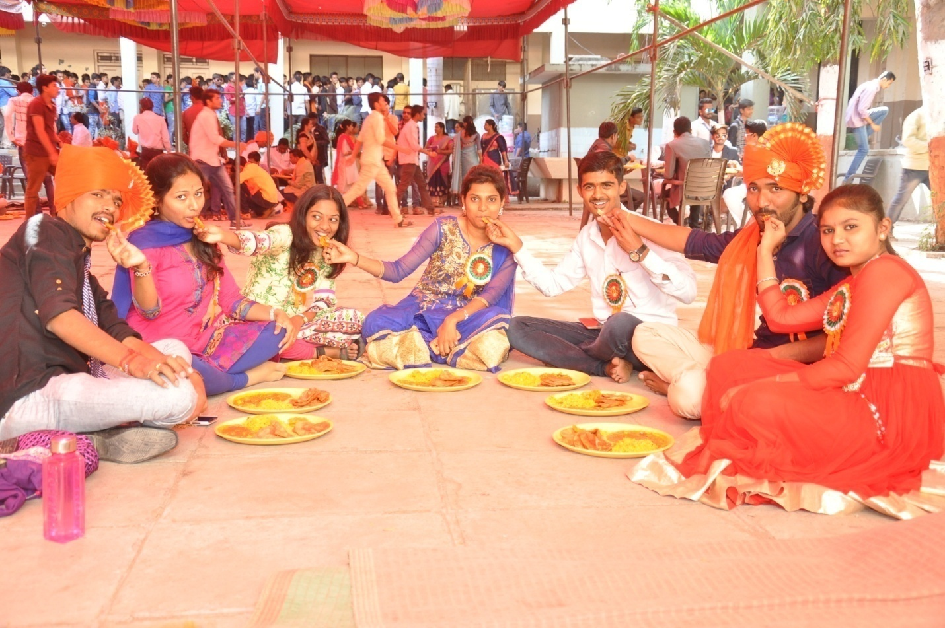

Hhhhhhh

Photo gallary health check up

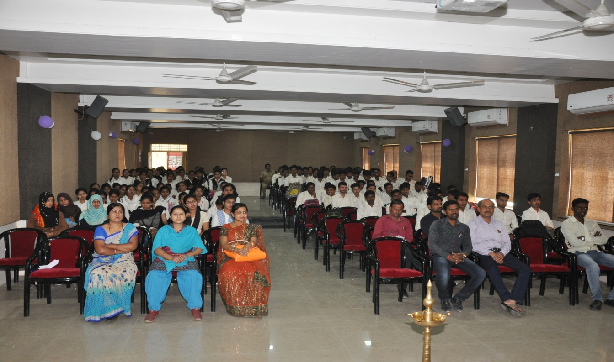

Health issues guidance to students and college staffs by Dr. Sangita Bajaj

Healt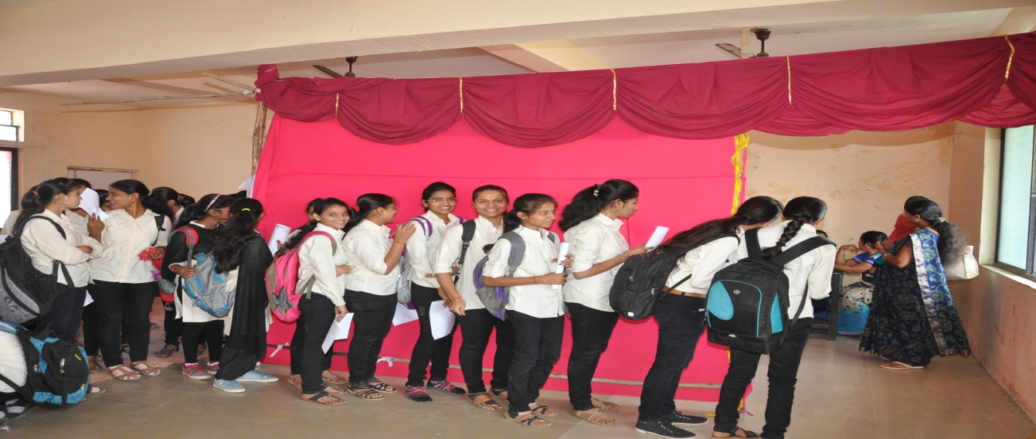
Medical health checkup for college students by Dr. Sangita Bajaj
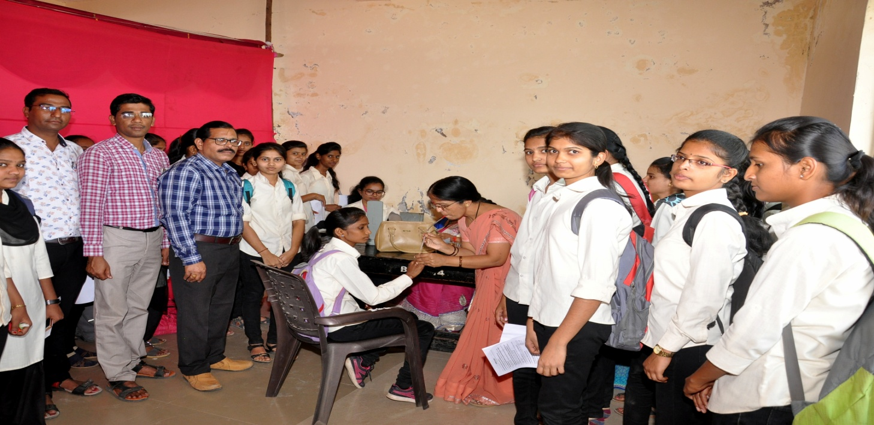
Blood group checking activity

