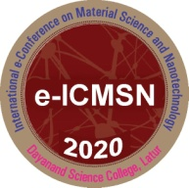**International e-Conference on Material Science**

**and Nanotechnology (e-ICMSN-2020)**

**(December 17 – 19, 2020)**

**---------------------------------------------------------------------------------------------------------------------------------------------**

**Title of Research Paper in First Line**

**Second Line**

A. B. Author1, C. D. Author2, E. F. Author3

1st Author, author's affiliation, line of address  
 author's email address

2st Author, author's affiliation, line of address  
 author's email address

3st Author, author's affiliation, line of address  
 author's email address

Abstract

The original unpublished abstracts are invited for presentation in the conference. An abstract consisting of maximum 400 words and typed in MS Word (Times New Roman, justified, font size 12). Abstract must contain title (font size 14 and bold), author’s name (font size 12) and their affiliation (font size 11) (Department, Institution name, City, Country). Accepted abstract will be notified via email to the corresponding author. The abstract will be published in abstract book of the conference. The abstracts may kindly be sent to the convener by email: icmsn2020@gmail.com, <https://forms.gle/2VcNGddoBVkwSwJq6>

***Keywords:*** *At most five keyword may use*